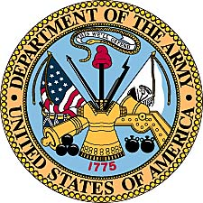
Alvin E. Houtman
United States Army
(1951-1953)

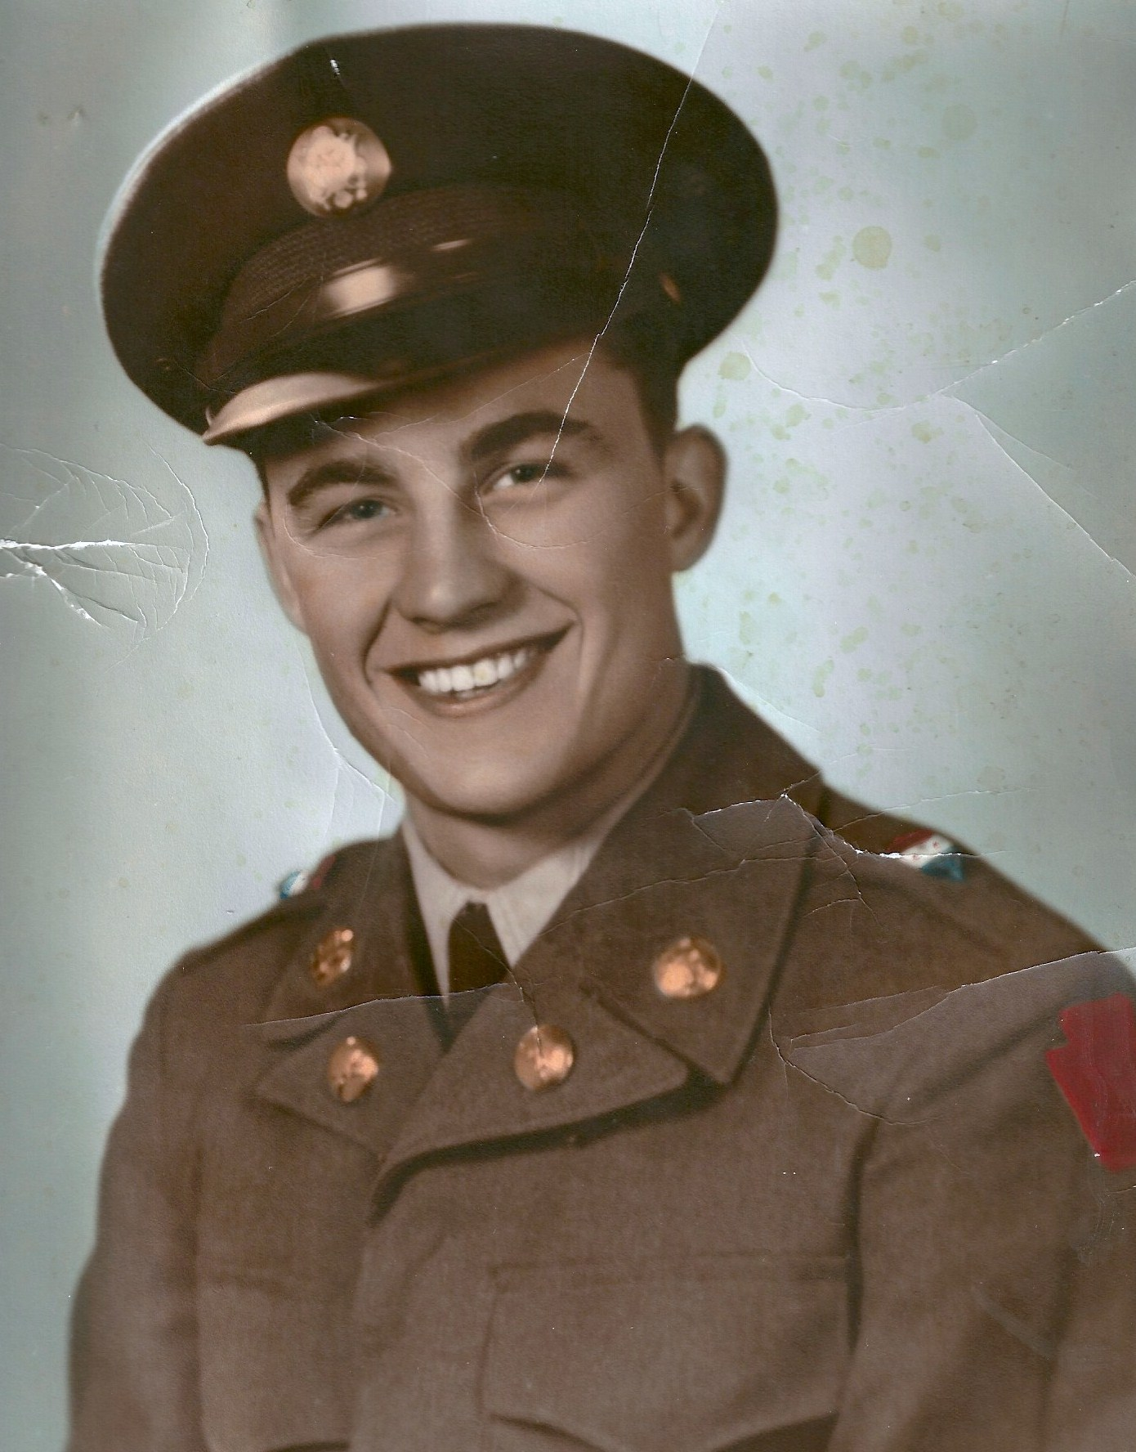
Alvin E. Houtman, in an early military photo in 1951.

Alvin Edmond Houtman
United States Army (1951-1953)

Alvin Edmond Houtman was born December 8, 1930, to John and Frieda Houtman, in Kansas City, Kansas. His father was a Dutch immigrant, while his mother Frieda was a child of recent German immigrants. The Houtman family would grow up in Kansas City, Kansas, and enlarge to include a total of ten children. Al graduated from Wyandotte High School and then enlisted in the United States Army as the Cold War and the Korean Conflict heated up.

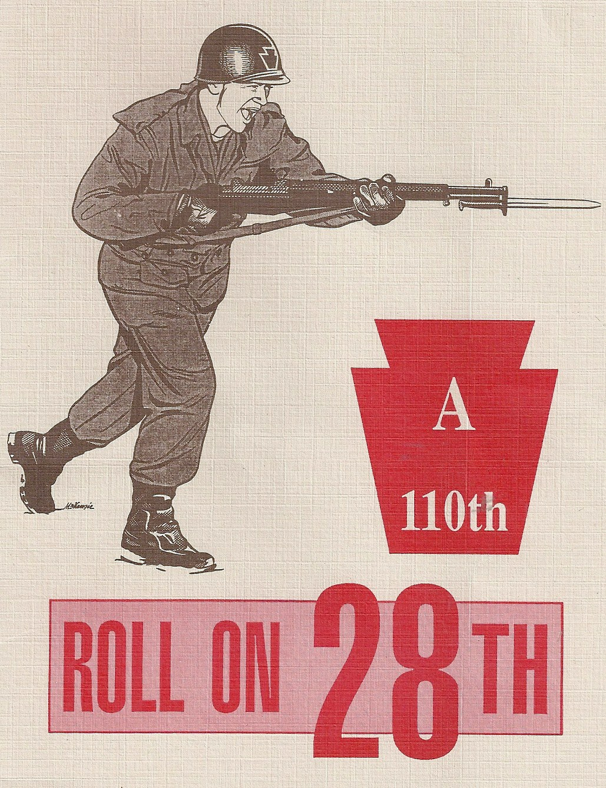

Alvin Houtman was assigned to the Twenty-Eighth Infantry Division at Camp Atterbury, Indiana. The 28th Infantry was part of the Pennsylvania National Guard, which was called up in September, 1950. Nicknamed the “Bloody Bucket” Division by the Germans during World War II, the unit has a long history dating all the way back to 1747. It was officially named in 1917 during the call-up to World War I.

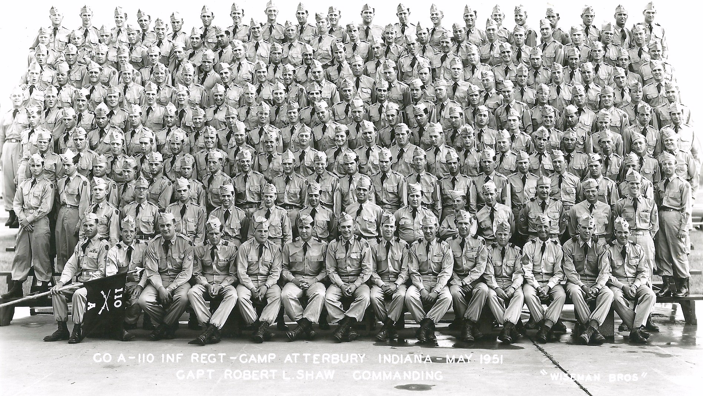
Alvin Houtman is 5th row from bottom, right hand side in unit photo of Co. A, 110th Inf., at Camp Atterbury, Indiana. (US Army photo)

In 1952, the Army decided to send the 28th to Germany and the tense, divided city of Berlin. Al was assigned to a motor pool as a driver and during his career in Germany drove both large supply trucks and served as a driver for officers. Other members of his original training group were sent to the Korean War.
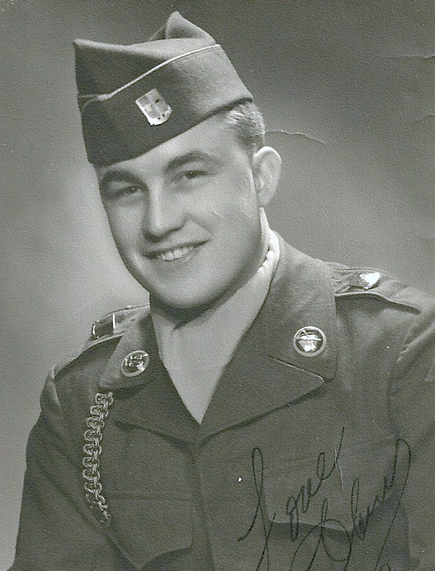
1951 military photo.

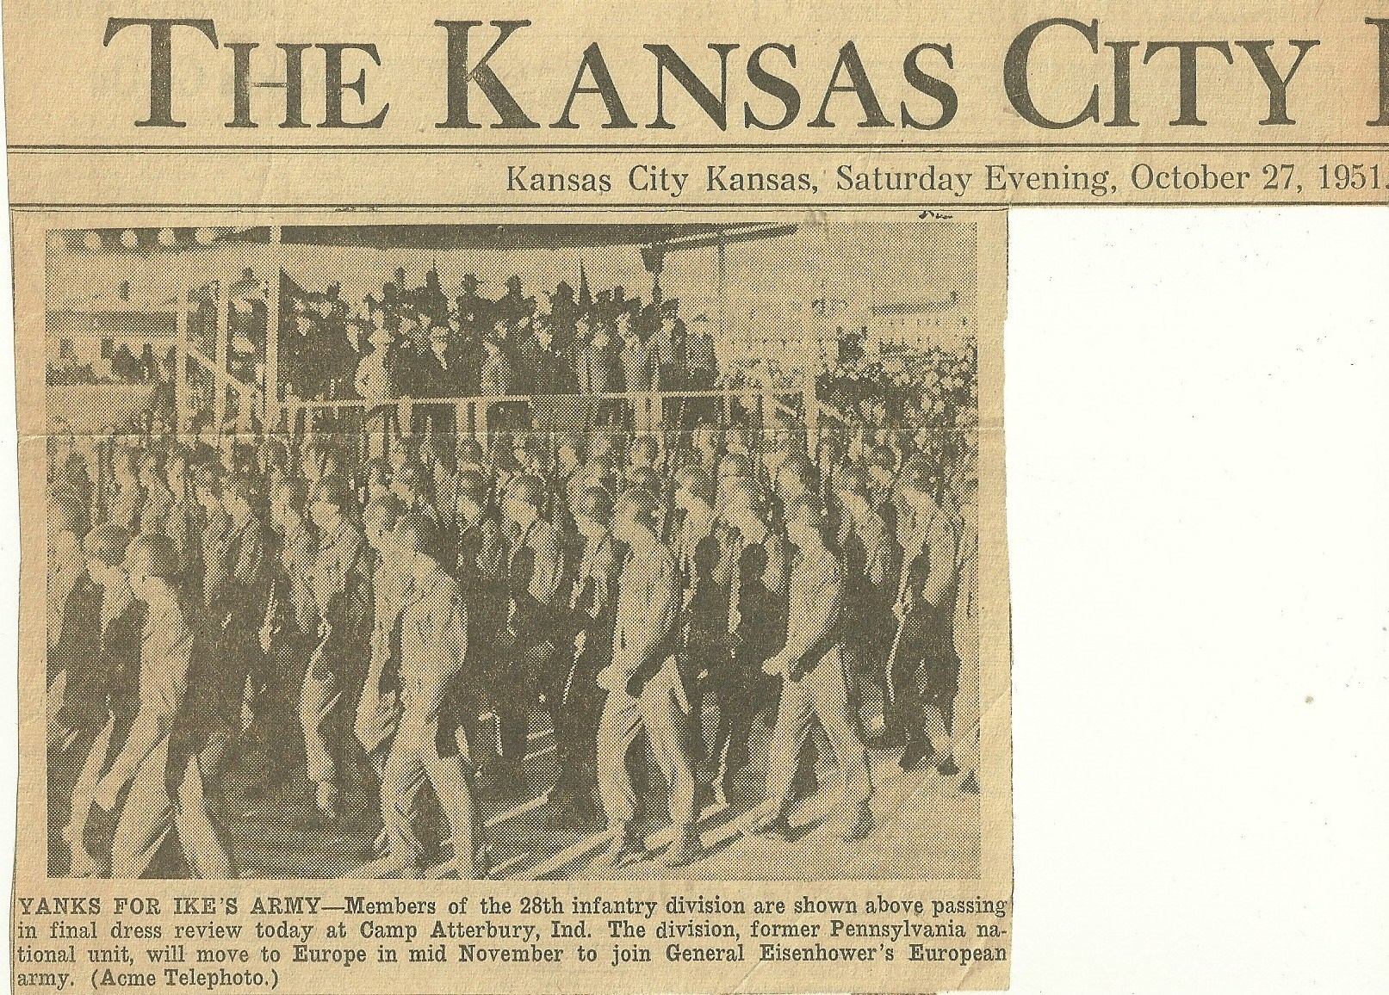
Newspaper clipping from the KANSAN Newspaper, October 27th, 1951.

The tension in the Western nations was strong during the early 1950’s, with the United Nations and the US already fighting in Korea against the Communist factions there. The Cold War pressures with Russia in Europe made the divided city of Berlin, Germany another hot spot. Additional troops were being poured into Berlin to support activity of the US military as Russia set up the Berlin Wall and controlled a number of Soviet Bloc countries. Alvin Houtman and the 28th were soon on its way to Germany.

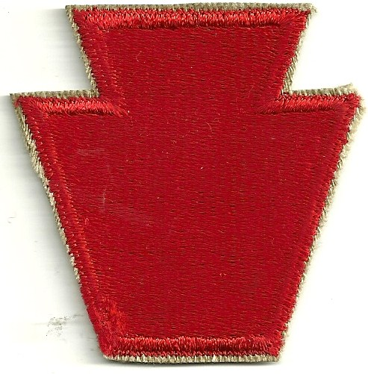
28th Infantry shoulder patch.

His wife Barbara recalls Al talking about his favorite experience as a driver for an officer. “Because they escorted convoys of trucks with supplies,” she said, “Al got to speed and pass other vehicles whenever they needed to get to the front.” “He really enjoyed being an officer’s driver.”

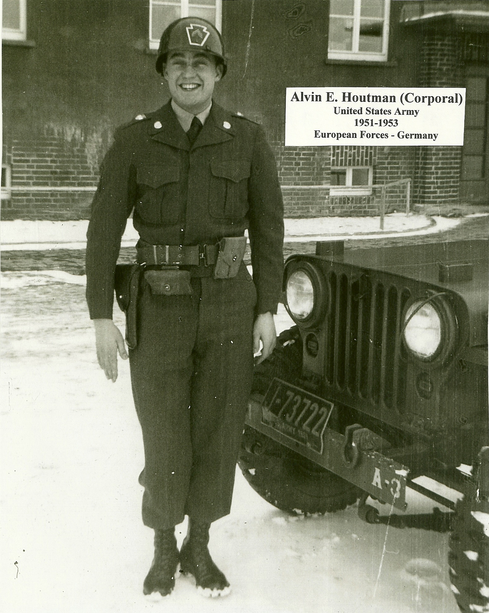
Alvin Houtman in front of the officer’s jeep he drove
in Germany in 1952-1953.

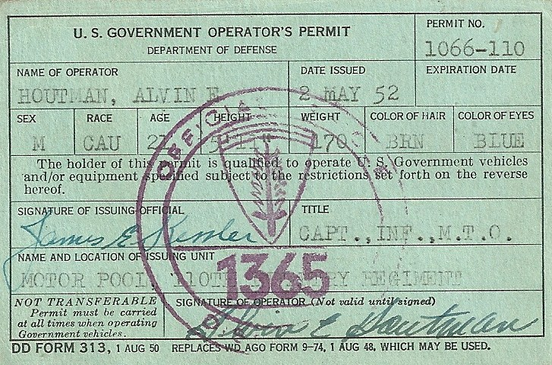
Military driver’s license for Alvin Houtman.

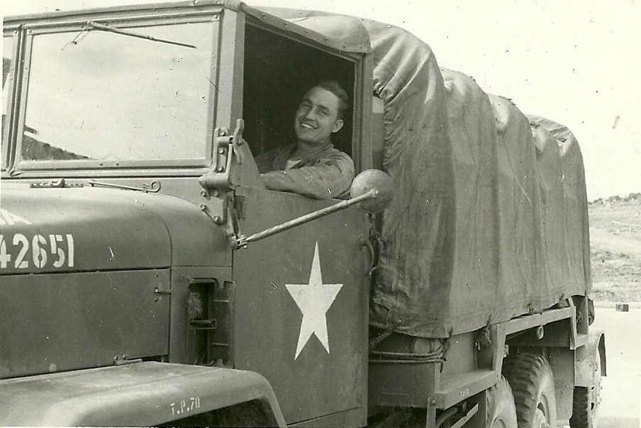
Alvin driving a large truck in Germany during November of 1953.

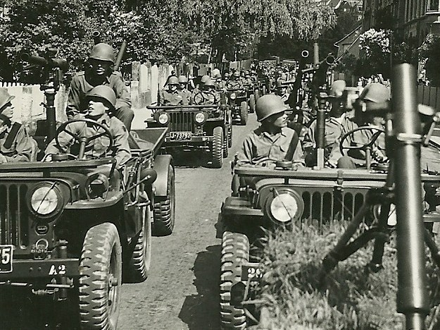
Unit of 28th Infantry military vehicles lining up to begin a parade in Germany.

Alvin Houtman during winter field exercises in Germany,
February, 1952, standing in snow up to his knees.
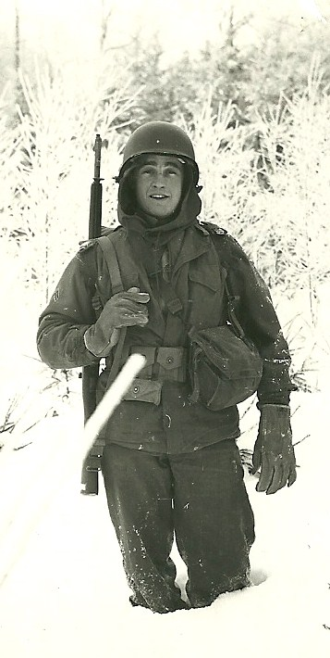
Duty in Germany had its “ups and downs.” Field duty in the harsh German weather could be cold and boring. Restrictions of materials also kept the soldiers on limited rations at times. However, there were also opportunities for the soldiers to travel in parts of Germany and to enjoy the culture and liquid refreshments available at various locations.

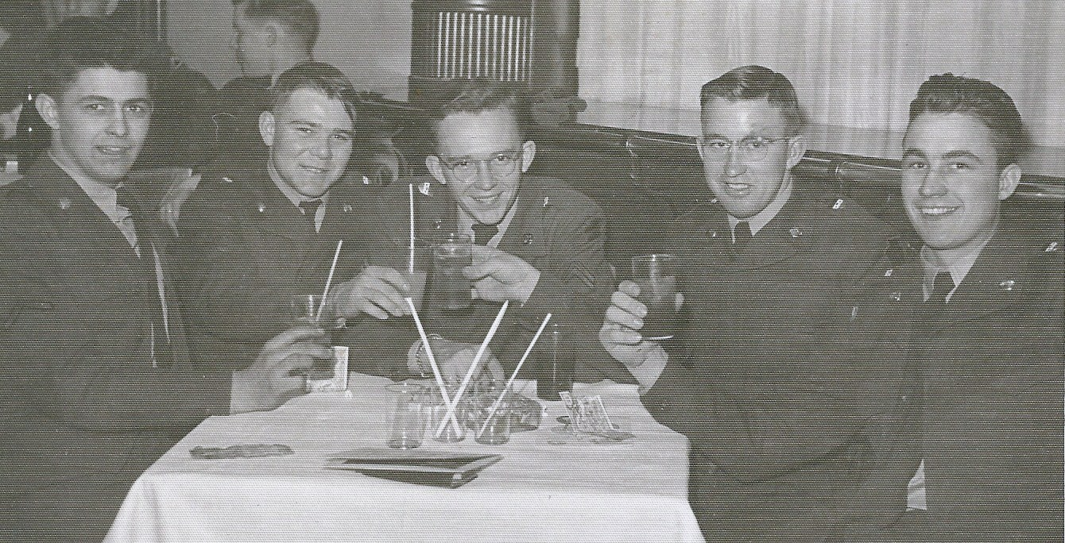
Al Houtman (far right) at the Eucom’s Winter Wonderland retreat in Garmisch.

Soldiers stationed in Europe were issued military script much like their counterparts serving in the Korean War thousands of miles away. They also received ration cards for supplies, as Europe was still suffering the effects of World War II at the time of the Berlin occupation. Military script was to be used only on official United States installations, but because of its value it brought a good price on the Black Market. Although the pay of American GIs was considered low by American standards, it was very substantial in comparison to the earnings of Germans still recovering from Hitler’s destructive actions.

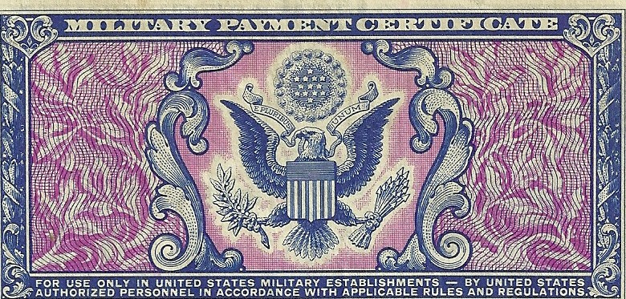

Military script issued to Alvin Houtman in Germany. It is approximately actual size.

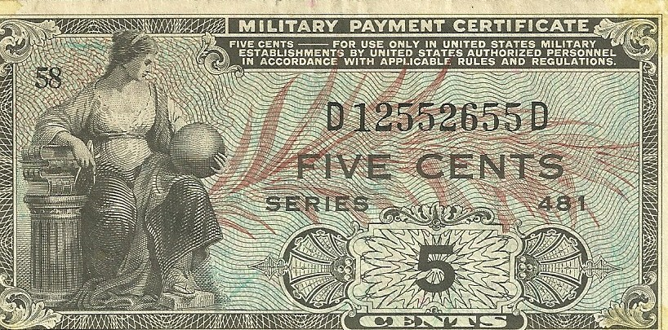

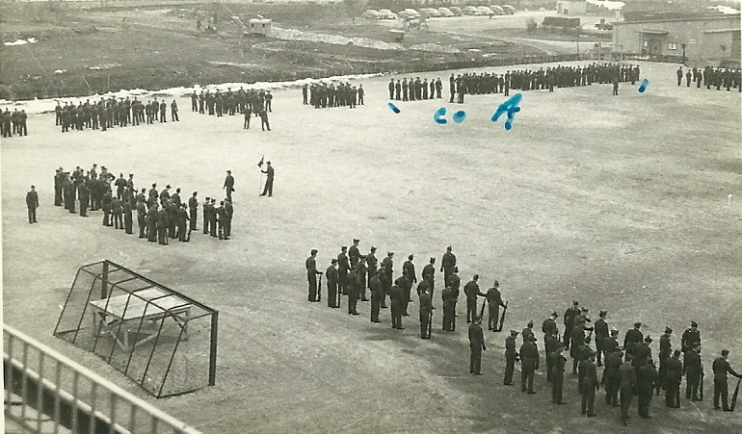
Retreat formation (waiting for the lowering of the flag) at Kusern, Germany, March of 1953. Alvin Houtman has marked his Co A in the top right corner.

After completing his enlistment, Alvin Houtman was Honorably Discharged in 1953. After returning home he would marry his wife Barbara and raise a family of four girls and one boy. The couple would later attend reunions with the Pennsylvania National Guard and laugh about how a Kansas boy ended up with a group of New Englanders.

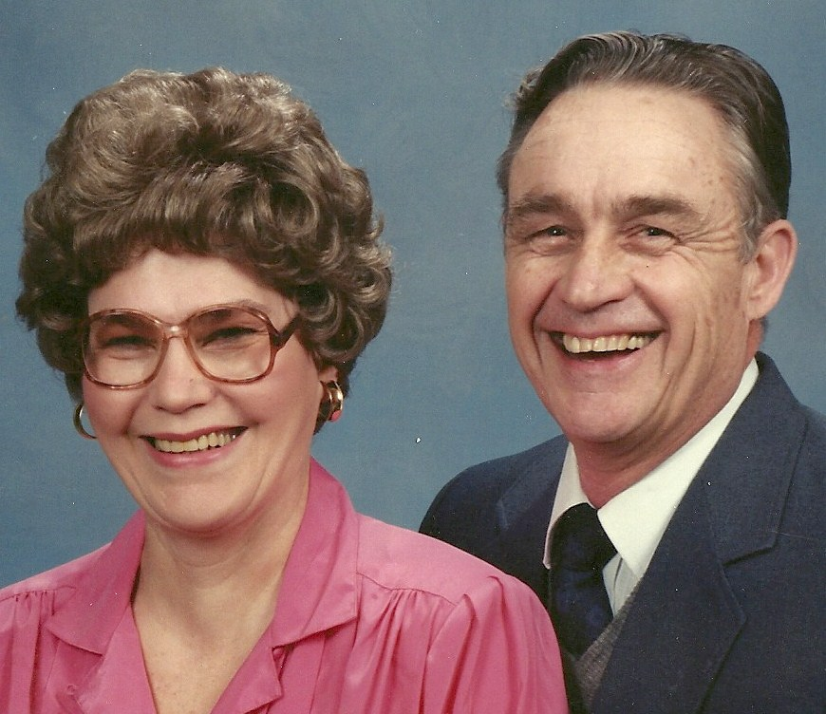
Barbara and Alvin Houtman, 1991.
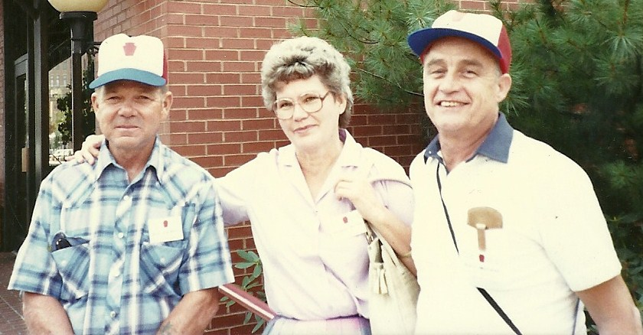
Till Necciai (left), Barb Houtman, and Al Houtman at a reunion of the 28th Infantry in Pennsylvania, in the early 1990’s.

Eventually the family moved west to rural Leavenworth County, Kansas near Bonner Springs. There would be 18 grandkids and after retiring from Proctor-Gambles in Kansas City, Kansas, the family would grow to include at least 14 great grand children. Alvin Houtman would pass away September 1, 1997, after suffering a stroke.

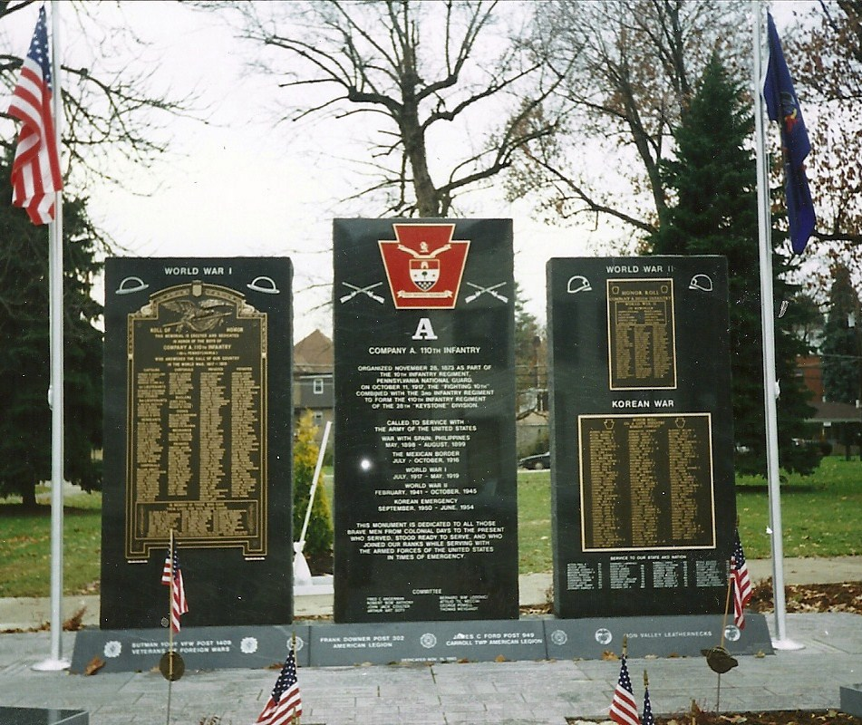
Monument dedicated November 11, 1995, to Company A, in Monongahela, Pennsylvania.

