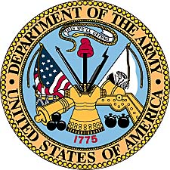

Jon Christopher Johnson
United States Army
(1974 - 1978)

Jon Chris Johnson was born December 10, 1956, the fourth of six children of Gordon and Naomi Johnson. Although his first name was Jon, his second name Chris would be the moniker that everyone came to know him by. Much of his early life would be spent in Kansas City, Kansas, with the family and he would graduate from Wyandotte High School where his father was a teacher. During his early years he would have two passions, the theatre and military history.

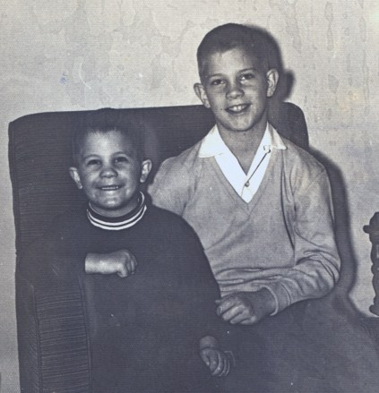
Chris as a preschooler with older brother Tim.

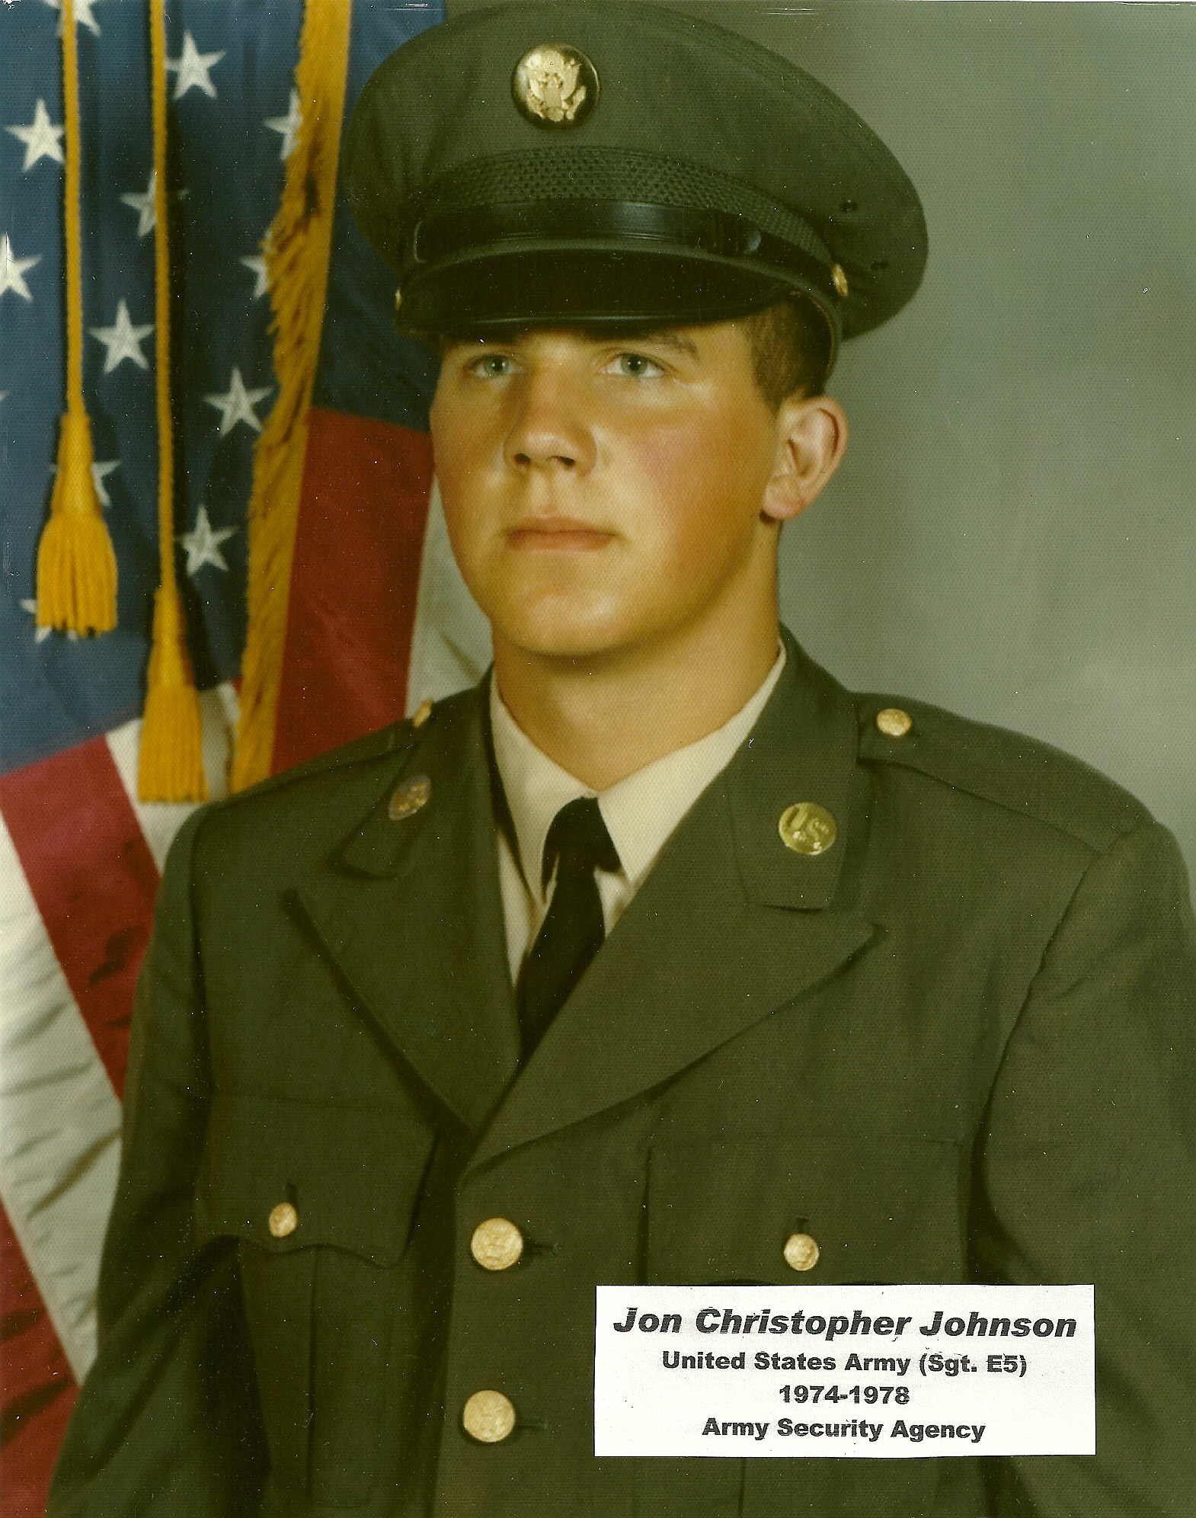

Chris Johnson enlisted in the United States Army at age 17. Shown above is his military picture at age 18, just after completing “boot camp.”

In August of 1974, Chris was sent to basic training at Ft. Ord, California. One of his favorite memories of basic was the rifle range that overlooked the Pacific Ocean. Shooting at the range was much to his liking and he qualified as “Expert.” He recalls, “I shot exceptionally well during night fire when someone accidentally sent a tracer round over by me. It helped me a great deal to see my silhouette target.”

Shortly after graduation ceremonies at Ft. Ord, he got into a taxi with a couple of other soldiers and went across Monterey Bay to the Presidio for his next assignment. Later he would be reimbursed for the transportation for his move with a check from the military for 64 cents, not enough to cover the cost of the taxi ride.

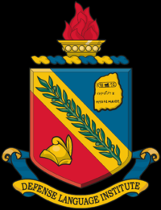
Emblem of the DLI, Defense Language Institute.

Because of his gift of memory and intellect, Chris Johnson would be moved into the military’s Defense Language Institute at the Presidio of Monterey, California. There he would study and learn Russian and other Slavic dialects. DLI at the Presidio of Monterey, California, is the Department of Defense's primary foreign language school. Military service members study foreign languages at highly accelerated paces in courses ranging from twelve to 63 weeks in length. Although the Presidio is under the jurisdiction of the United States Army, there are Navy, Marine Corps, and Air Force officers on post, and all four branches provide students and instructors.

During his early military service training, the young soldier would take trips to Southern California to visit relatives living there. His first Thanksgiving included a visit to southern California to share the holiday with family. It was during his travel south that Chris first experienced the animosity of anti-Vietnam war activists, who actively mistreated any active military personnel simply because they had a uniform on.

Chris’ next station was Goodfellow Air Base. Goodfellow Air Force Base was a non-flying United States Air Force base located in San Angelo, Texas. As part of Air Education & Training Command (AETC), Goodfellow's main mission was cryptologic and intelligence training for the Air Force, Army, Navy and Marine Corps. This is where he received training in MOS 98G (Golf) or Voice Intercept Operator. At this post he learned that the Air Force has the best food.

His next assignment was Ft. Devens, Massachusetts, starting in December of 1975. Learning how to live in a tent in Massachusetts in winter, the young trainee received additional classified training in MOS as an intercept operator.

As training came to an end, the young soldier was guaranteed a station in Europe. However, by the time he was done with MOS, Army staff advised that so many soldiers were re-enlisting that “if he went to Europe he would be so low ranking he would end up washing trucks.” Given the choice to remain stateside, Chris was soon assigned to Ft. Mead, Maryland. A few weeks later he was at the National Security Agency.

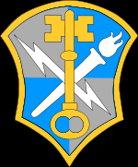
Intelligence Security Command

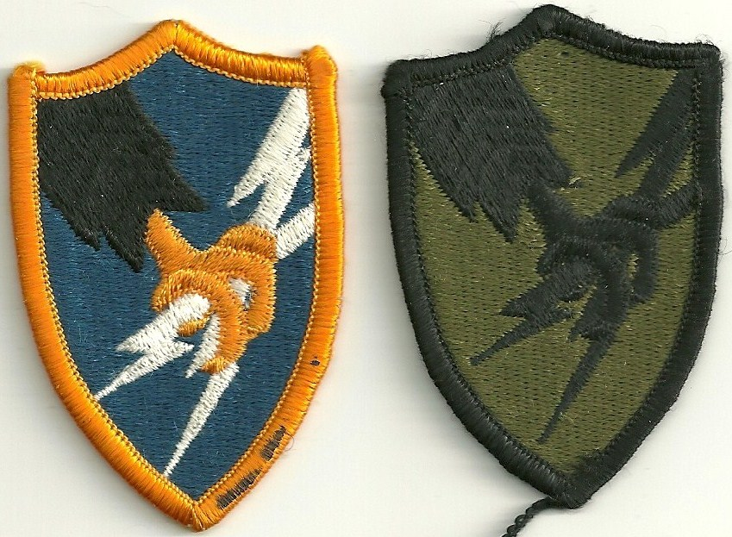
US Army Security Agency emblems, dress and subdued.

Because his duty station with the National Security Agency was highly classified, Chris cannot discuss much of what he did for his final years in service. However, he does say he did not work in his original MOS and instead worked as a 98 C (Charlie) Intelligence Analyst. Officially stationed at Ft. Meade, he will say that totally by accident he got mixed up in some significant projects and excitement.

Jon Chris Johnson reached the rank of Sergeant while in the military and after extending his tour for another 6 months, he was Honorably Discharged from the United States Army in February of 1978. His commendations and service records remain sealed as “Top Secret.”

Chris Johnson at the 2008 US Army commissioning
ceremony of his namesake, nephew Kris Johnson.

