Harley Anderson
United States Army Air Corps
(1941-1946)
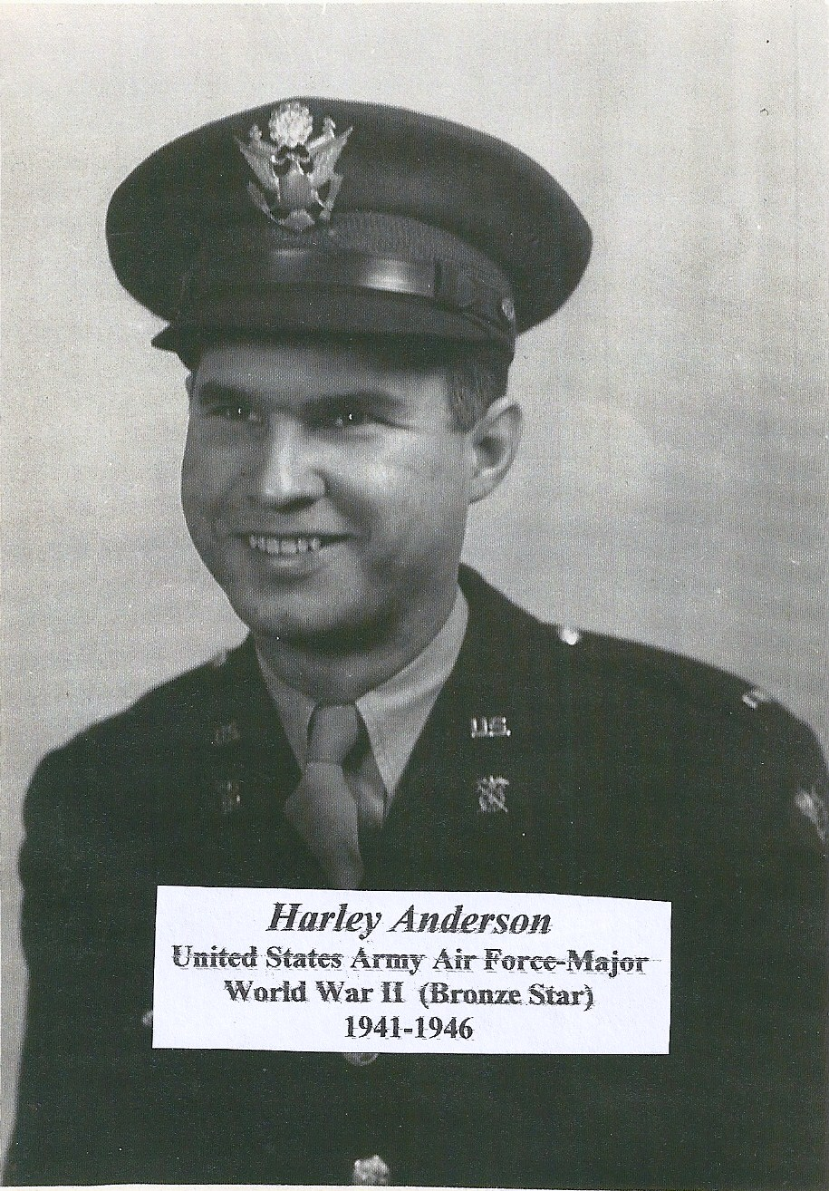
Family photo of Major Harley Anderson
Harley Anderson
United States Army Air Corps
(1941-1946)

Not long after graduating from the University of Kansas in Lawrence, Harley L. Anderson was drafted into the Army. In August of 1941, Harley entered the service and eventually served in the Air Corps throughout his tour of service. His boot camp was in North Carolina and subsequently was chosen for Officers Candidate School.

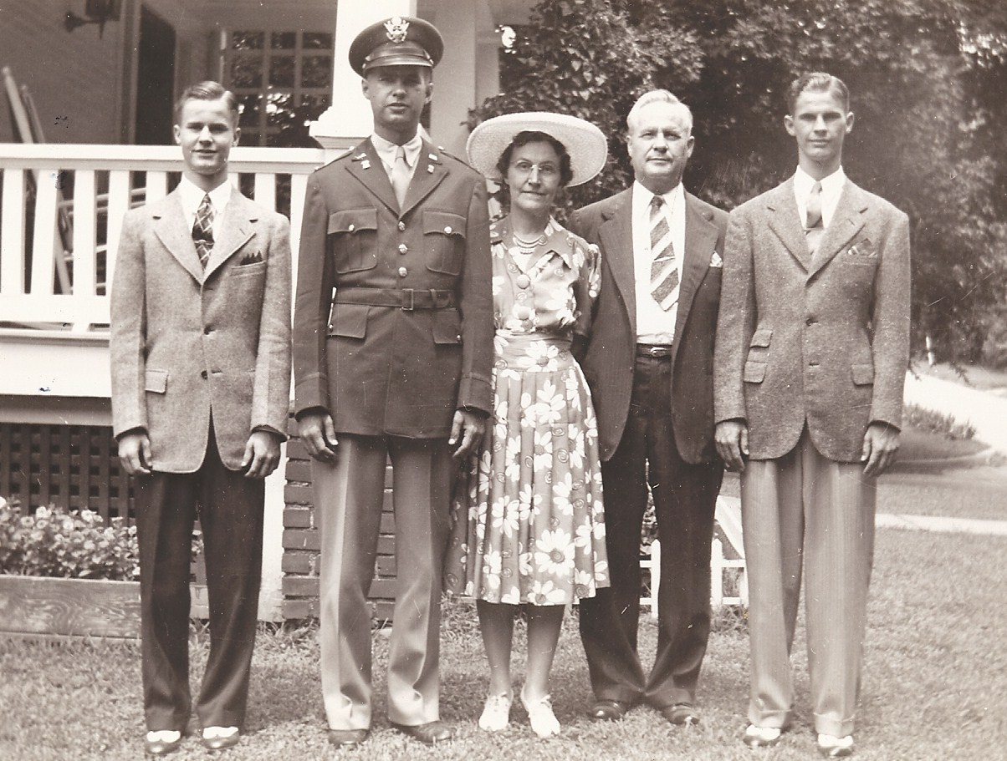
The Luther Anderson family in Kansas City, Kansas on Eaton Street.

After commissioning, he was sent to Edwards Air Force Base in Victorville, California. In 1943, he left for England and vividly remembered the ship ride over the Atlantic Ocean to join the war. After viewing the movie “Titanic” in 1997, he noted that it reminded him of his long journey across the sea.

The United States Army Air Forces (USAAF) was the military aviation arm of the United States of America during and immediately after World War II. A predecessor to the United States Air Force, at its peak there were over 2.4 million men and women in service and nearly 80,000 aircraft in 1944. The USAAF had 783 domestic bases in December 1943. By the time the Germans were defeated in Europe, the Air Corps had about 1.25 million men stationed overseas and operated from more than 1,600 airfields worldwide.

Harley was a Quartermaster Supply Officer assigned to posts in England, North Africa, and the Canary Islands. Prior to Harley’s return to the United States, he was a member of the 379th Bomb Group stationed at Kimbolton Airfield in England, a B-17 bomber base.

Kimbolton, England, the home of the 379th Bomb Group.

The 379th Bomb Group began operations with the 8th Air Force, May 19, 1943, and received a Distinguished Unit Citation for operations over Europe from May 1943, through July, 1944. The group engaged primarily in bombardment of strategic targets such as industries, oil refineries, storage plants, submarine pens, airfields and communications centers in Germany.

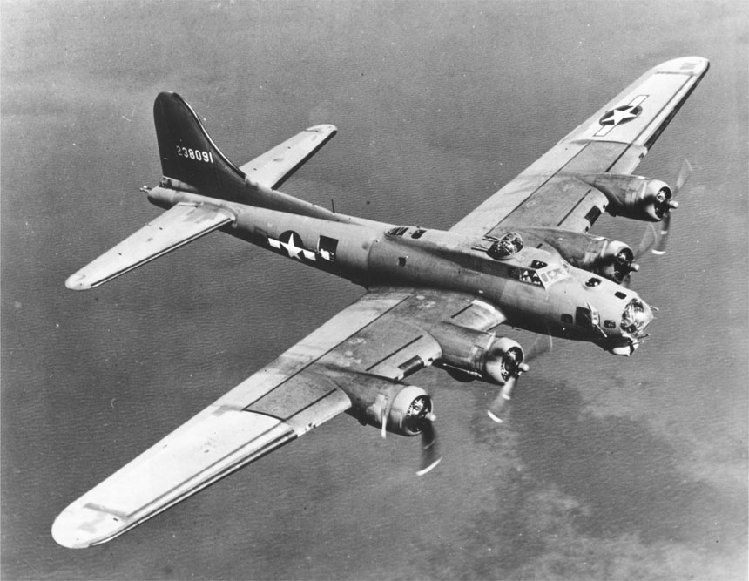
Boeing B-17 "Flying Fortress" levels off for a run over target. The
B-17 weighed about 60,000 lbs., carried a bomb load of 6000 lbs.,
at a speed of approximately 300 miles per hour.
On several occasions the Group attacked targets in support of ground forces. The combat record of the 379th was the most successful of all the Eighth Air Force heavy bomber groups.
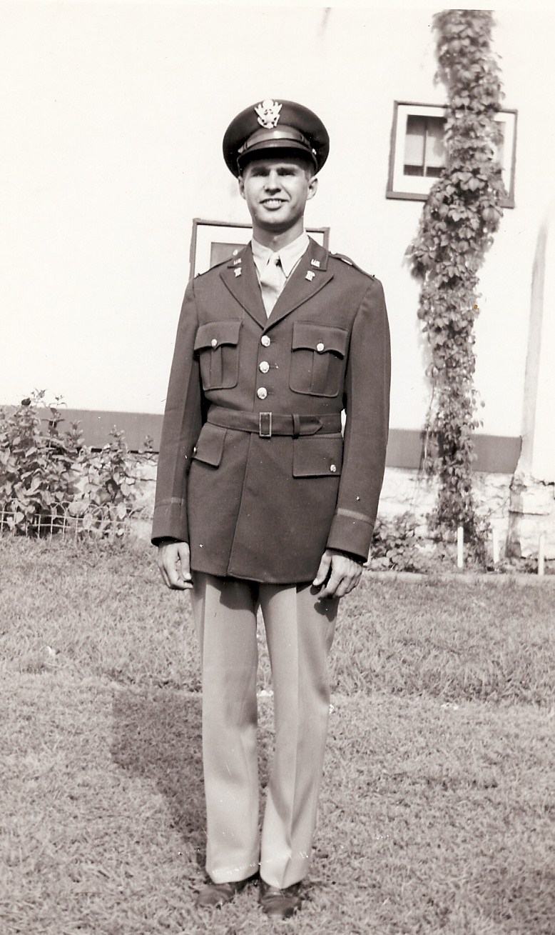
Young Lieutenant Harley Anderson (family photo)

Harley Anderson made many acquaintances during his service years. When the war ended, the commander of the base, Stuart Darlington of the British Royal Air Force, took down the US Flag that had flown over the base and kept it. His wife Rita, knew that Harley was a good friend of her husband and after he passed away she gave Harley the flag that her husband had kept under the bed for almost 40 years.

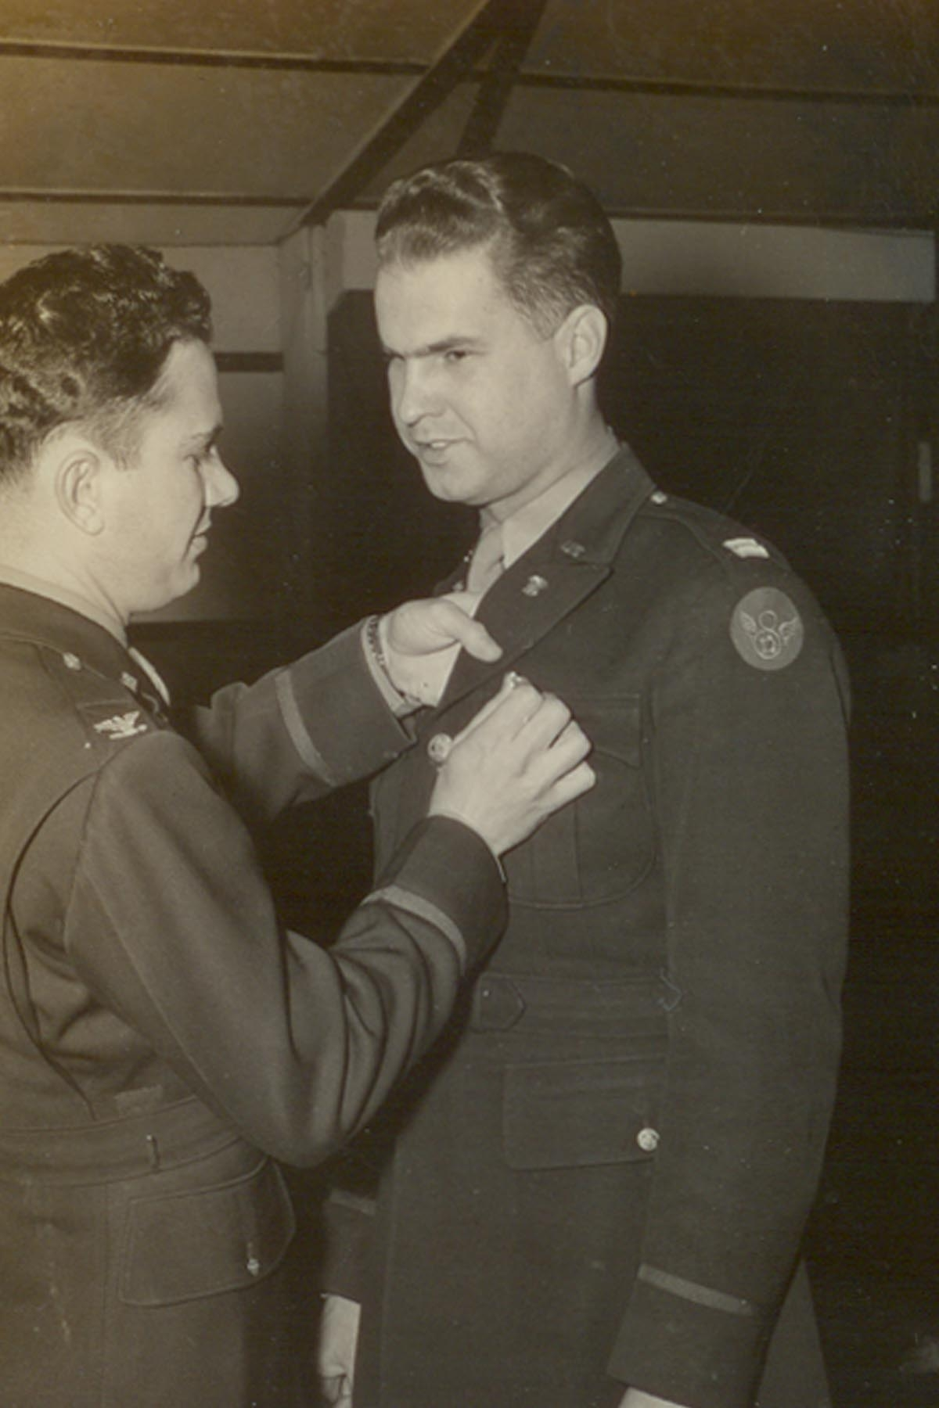
Harley Anderson receiving his promotion to Major in
1945. (Family photo)

By the time of his discharge in 1946, Harley had attained the rank of Major in the 8th Army Air Force. The Army made an attempt to recruit him for a career as a military officer, but he declined and returned to Kansas City. This decision made his parents happy, as they were glad to have their son home. However, he had served his country well and received many citations and decorations, including the Bronze Star.

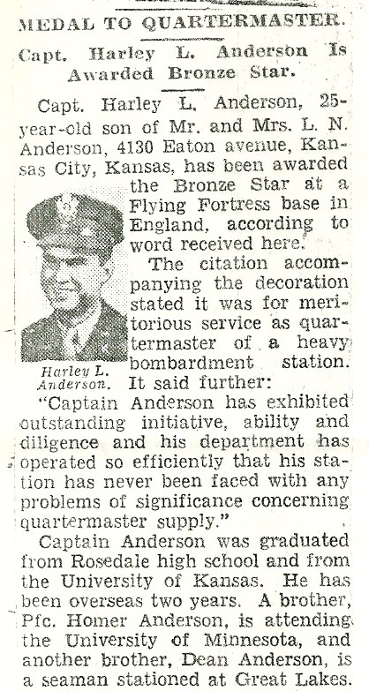

Article in the Kansas City Star, noting the
awarding of the Bronze Star to Harley Anderson,
who was a Captain at the time of the citation.
(Article from Anderson family archives)

After the war, Harley Anderson first worked for the US Department of Labor as a field representative, then went to work for the Carter-Waters Corporation as a manager of their heavy construction sales department. He would remain with the company for 37 years. He retired in 1984 at age 65.

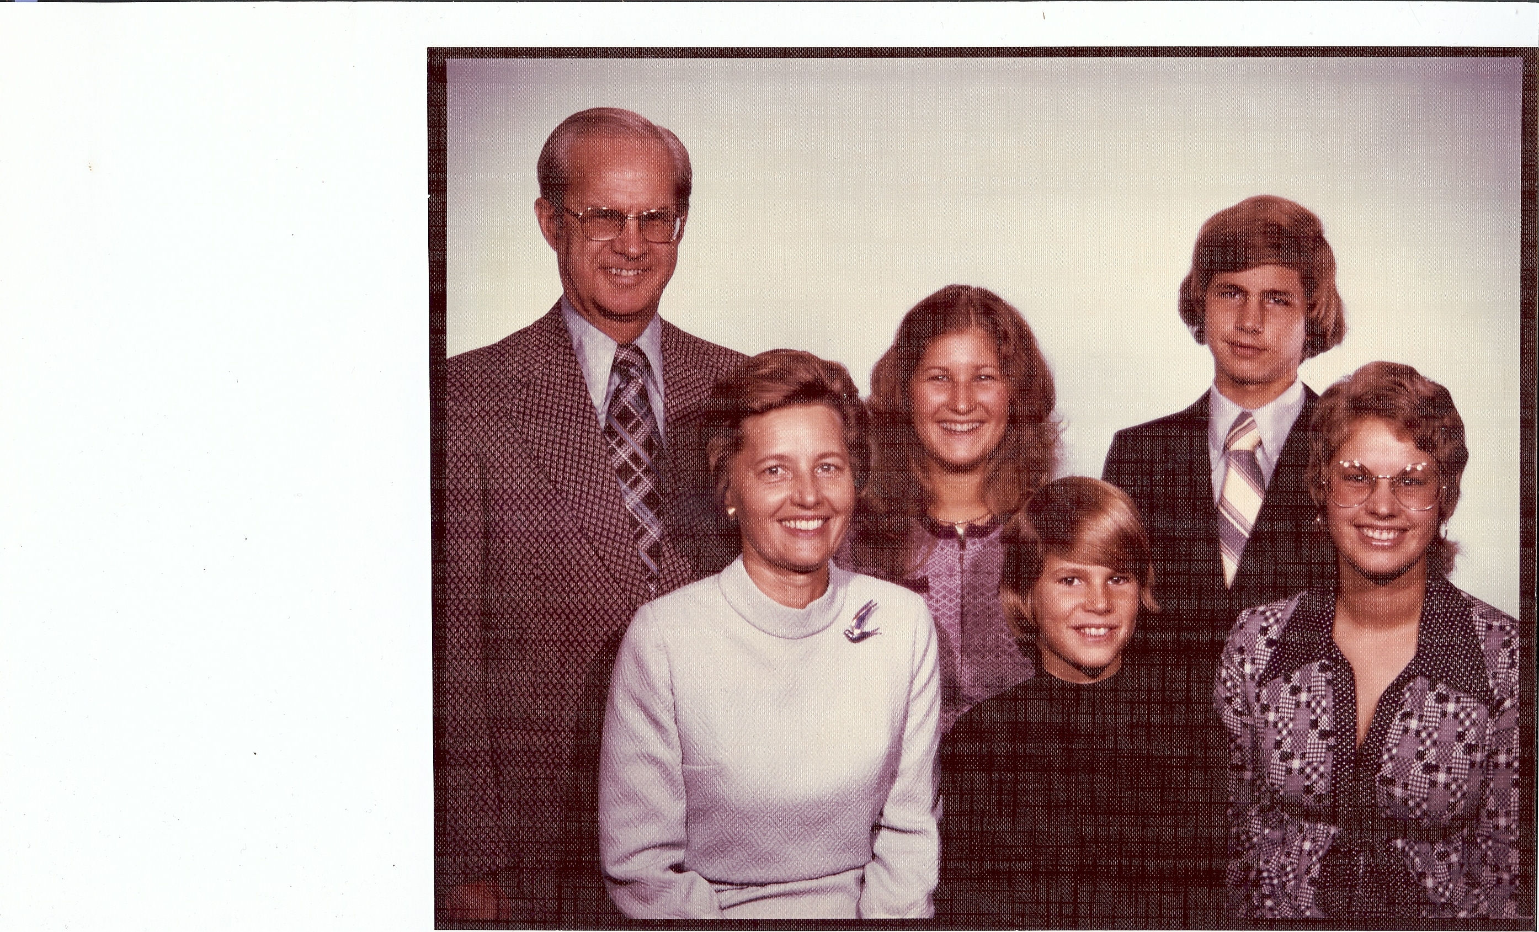
Harley (54), Geneva (44), Ingrid (20, David (11), John (17), and
Kris (18), Anderson, in a 1973 family photo.

Harley and Geneva (Wallerstedt) of Lindsborg, Kansas, were married in 1951 after dating since 1948. They would raise their family in the Kansas City suburbs and would remain active in their church and community.

