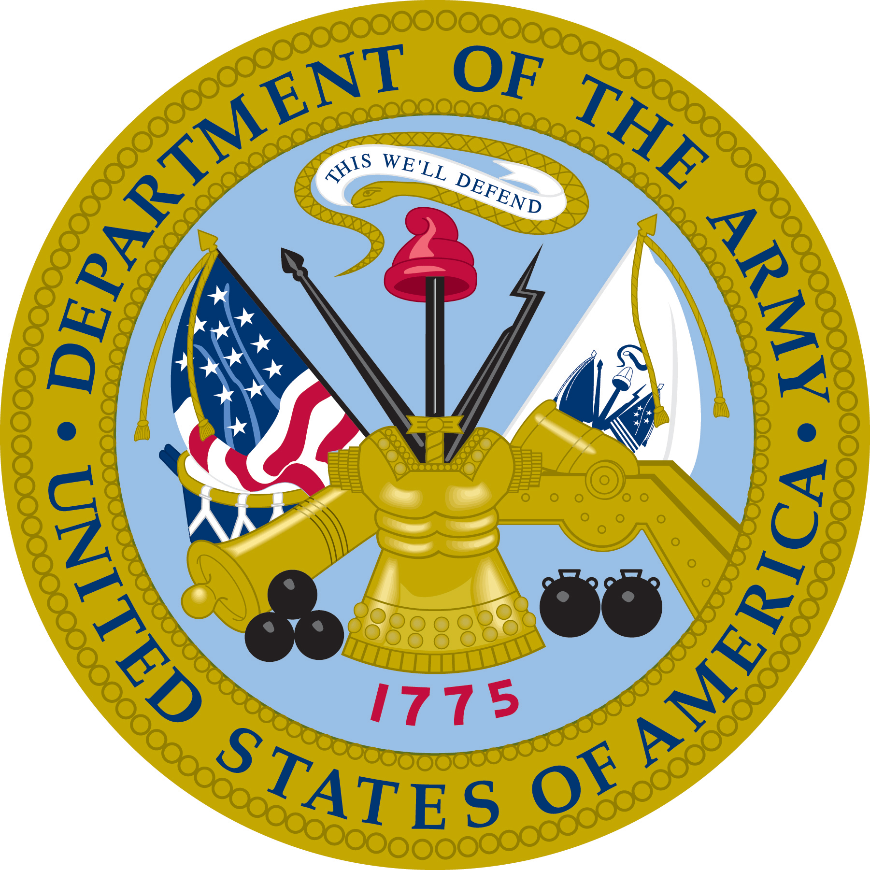

Jacob V. Schleigh
Army of the Republic
The Civil War (1862-1865)

Jacob V. Schleigh, was born in Dayton, Ohio, on October 22, 1842.
At the age of 20, he would on August 15, 1862, enlist in the Union Army to serve, “three years or for the duration of the war.” He was registered into the United States service just a few days later at Peoria, Illinois, on August 27, 1862. Jacob would become the first of a long line of extended family members to become part of the Department of the Army of the United States of America. He would also be the first and only family member to join the battle between the North and the South, the Civil War.

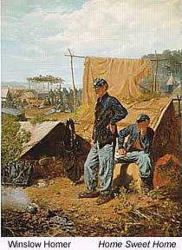
As a private of Capt. Orlando Fountain’s Company “E,” 86th Regiment, Illinois Volunteer Infantry, with Col. David D. Irons commanding, Jacob Schleigh was detailed as a teamster. The unit joined in the pursuit of Bragg and on the 8th of October participated in the Battle of Perryville, Kentucky. There the unit held the advance and on October 11th marched after Bragg in his retreat to Crabb Orchard, Kentucky. They would continue across the south and eventually the regiment would participate in the Battle of Chickamouga, Georgia. Numerous other engagements would follow as the regiment became part of Sherman’s “march to the sea.”
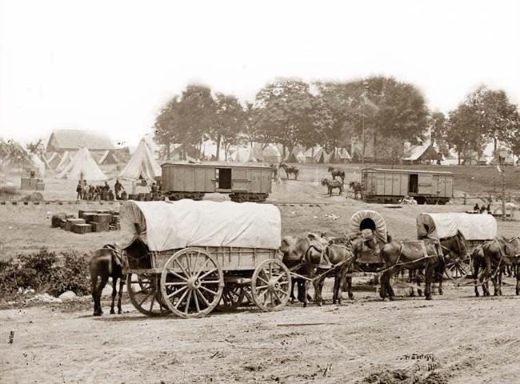
This photograph was taken in 1862 in the south and has a nice view of a Civil War camp, including supply wagons. This picture was taken by George Barnard, who was working for Mathew Brady.

U.S. Army wagons during the Civil War were normally pulled by either four horses or six mules. In his memoirs, General Sherman writes, "An ordinary army-wagon drawn by six mules may be counted on to carry three thousand pounds net, equal to the food of a full regiment for one day." Military records also show that the regular Union Teamsters like Jacob Schleigh were joined by negro teamsters along the way as recently freed slaves were allowed to join the war effort.

Sherman’s “march to the sea,“ followed his successful Atlanta campaign of May-September 1864. Sherman ordered his troops to burn crops, kill livestock, consume supplies, and destroy civilian infrastructure along their path. Foragers, known as "bummers", would provide food seized from local farms for the Army while they destroyed the railroads and the manufacturing and agricultural infrastructure of the state. The twisted and broken railroad rails that the troops heated over fires and wrapped around tree trunks and left behind became known as "Sherman's neckties".

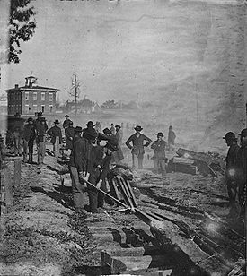
Sherman’ s troops destroying rail lines along the march.

For teamsters like Schleigh to keep and maintain the wagons and animals, life was not easy. The hours were long and the work difficult. To keep his teamsters moving with supplies during the war, General Sherman gave explicit orders:
VI. As for horses, mules, wagons, belonging to the inhabitants, the
cavalry and artillery may appropriate freely and without limit, discriminating, however, friendly. Foraging parties may also take mules or horses to replace the jaded animals of their trains, or to serve as pack-mules for the regiments or brigades. In all foraging, of whatever kind, the parties engaged will refrain from abusive or threatening language, and may, where the officer in command thinks proper, give written certificates of the facts, but no receipts.

– William T. Sherman , Military Division of the Mississippi Special Field Order 120, November 9, 1864.

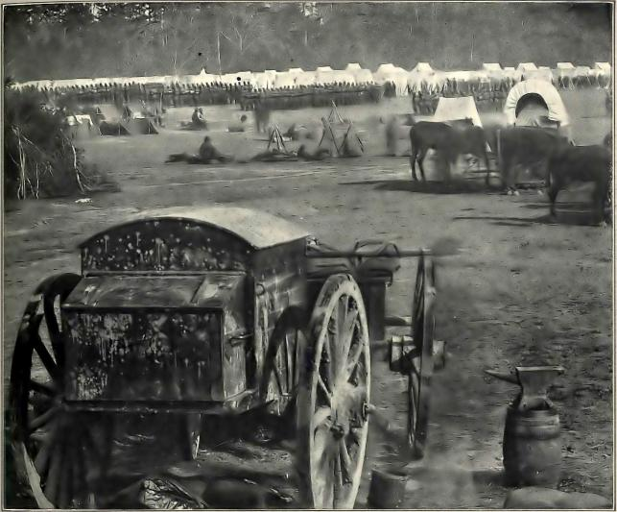
Civil war wagons with mules in the foreground, similar to the wagons driven by Jacob
Schleigh as a teamster for the Union Army from 1862-1865. This photo was taken at the camp of McClellan's Army of the Potomac in the spring of 1862.

Jacob Schleigh was discharged from the Union Army on June 21, 1865. After the Civil War he became a member of Chase Post, No. 101, Department of Kansas, Grand Army of the Republic. The Grand Army of the Republic was a fraternal organization composed of veterans of the Union Army who had served in the American Civil War. The GAR was among the first organized advocacy group in American politics. Jacob would serve the post as a Commander and as a Quartermaster.

Two years after leaving the Army, Jacob V. Schleigh would marry Mary Ellen Hannah of Beattie, Kansas. The two were married at Knoxville, Illinois, on November 20, 1867. After their marriage Jacob and Mary made their home at Camp Grove, Stark County, Illinois. Then in 1874, they traveled overland in a “Prairie Schooner,” to the present town site of Summerfield, Kansas, where they located on a farm.
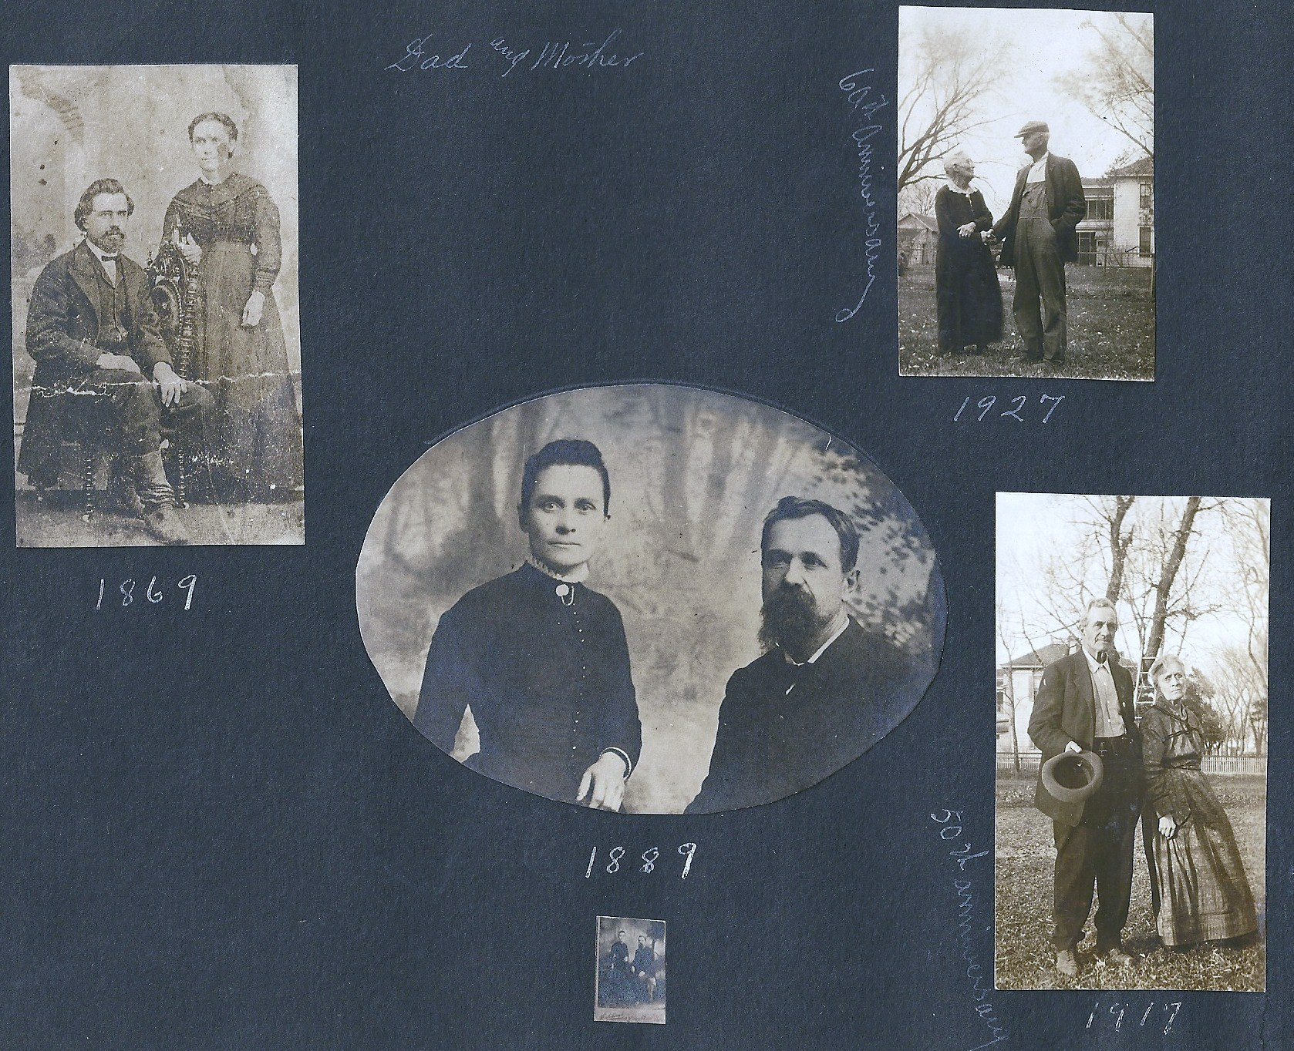
Jacob and Mary Schleigh, from the family Memory Book, written by sisters
Vada (Ida Nevada) and Myrtle Schleigh part of the Cope family collection.

In 1876, they moved to Beattie, Kansas where they took charge of the “Sherman House,” for a few months. They bought property in the west end of town where 41 years later they would celebrate their Golden Wedding Anniversary. In the history books of the town, Jacob is referred to as “Jake,” and makes the interesting notation, “The young folks delighted in teasing Mr. Schleigh on Halloween night.”
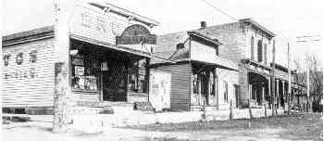
Main street of Beattie, Kansas, in 1889.
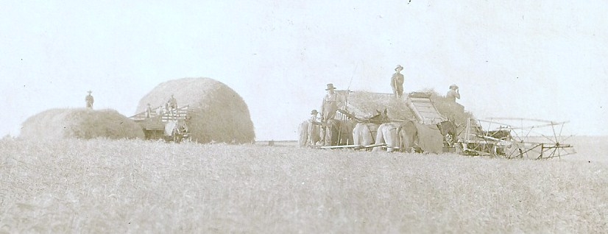
Family postcard from the collection of Mary Jean Cope, showing a harvest
scene from the plains of Kansas.

The marriage of Mary and Jacob Schleigh would produce eight children, three boys and five girls. Jacob would pass away in Beattie in 1930. His daughter Ida Nevada Schleigh, born May 21, 1875, would eventually marry Wesley Don Cope and produce one son and two daughters. Jacob Schleigh’s grandson from that marriage, Wesley Merritt Cope, would become the next family member to serve in the U.S. Military.

Thus, from the days of the American Civil War and the life of Jacob Schleigh in the 1800‘s, the family military history begins.

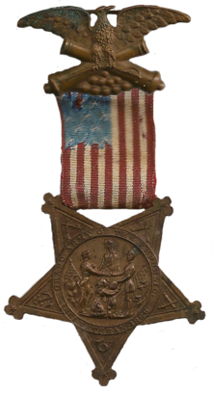
Medallion of the Grand Army of the Republic

