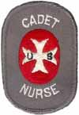

Naomi (Neville) Johnson
United States Nurse Corps
(1944-1947)

Naomi N. Johnson was born in Osage City, Kansas on March 25, 1926 to Irene Anderson Neville and Charles Neville. The family lived in and around the Osage County area and were part of the Swedish American community in that region. Naomi had an older sister Barbara and after the death of her father, a younger sister Elizabeth when her mother remarried Walter Hamler.
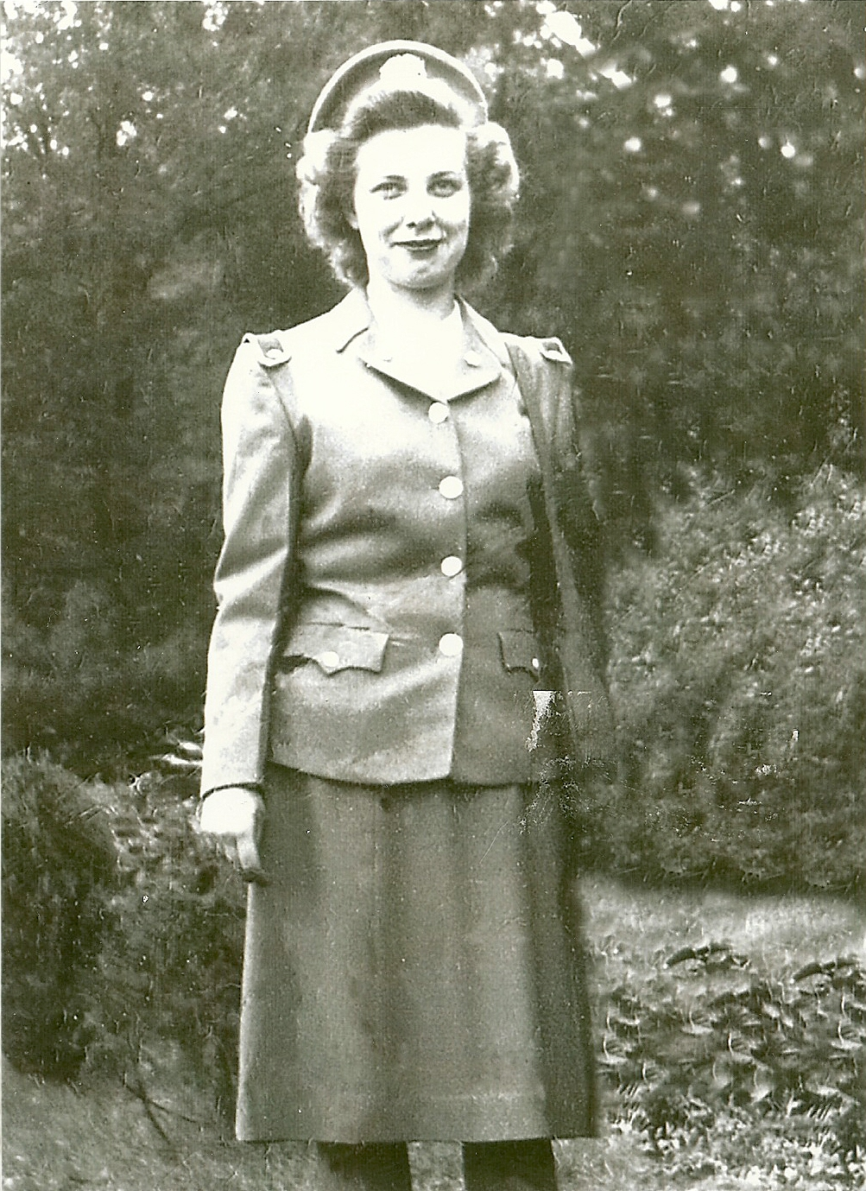
Naomi N. Johnson in her US Nurse Corps dress uniform (1944).

As with many rural American families, the depression and the early war years impacted the life style of the family. Naomi remembers her early school years as “very simple.” The family was active in the local Swedish Covenant Church. On the farm there were chores and once rationing began, few opportunities to drive a car. Her mother Irene once commented to her grandchildren about food rationing, “yes they even made hamburger with other sources than beef. Their butcher sign said, ‘one-to-one,’ which really meant one horse, one rabbit.”

Finishing up high school in the third year of the World War II, Naomi signed up for the United States Cadet Nurse Corps. The US Cadet Nurse Corps was a uniformed service created by congress during World War II to provide essential services by supplying nurses for military, federal government, and essential civilian hospitals for the duration of the war. Cadet nurses took and signed a pledge and were given an ID card with a serial number.

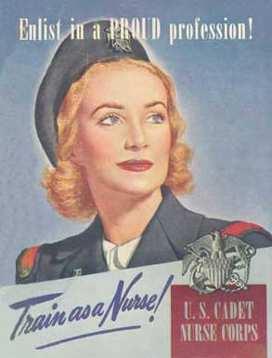
US recruitment poster during early years of World War II.

HISTORY OF THE U. S. NURSE CORPS

Congress created the U. S. Cadet Nurse Corps to fill the nursing shortage created by World War II. Former members have no standing with the state or federal veterans' departments. Recent legislation in Congress to change their status has failed.

In 1943, with no end in sight to World War II, the United States faced a shortage of qualified nurses. Rep. Frances Bolton of Ohio introduced the Nurse Training Act. Congress quickly passed the act and President Roosevelt signed it on June 15. The act set up a program to train women to become nurses quickly. Women qualified for the program if they were between the ages of 17 and 35, were in good health, and graduated with good grades from an accredited high school.

Once accepted into the program, women received a stipend and a scholarship to cover the cost of nursing school and room and board. They were expected to graduate within 30 months.

Nursing schools almost universally qualified for the program. To participate, schools needed to be accredited, affiliated with a hospital, and have adequate staff and facilities. The federal government gave nursing schools aid to help them meet the standards.

By the time the program graduated its last students in 1948, more than 124,000 nurses received training and more than 1,100 of the nation's 1,300 nursing schools participated. Public health historians also credit the program with creating a more academic approach to nursing. Previously, nurses' training resembled apprenticeship - style training. The federal government's investment in nursing schools also had a long-term positive impact on nursing education.
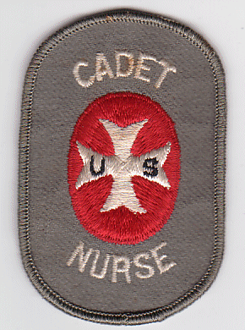

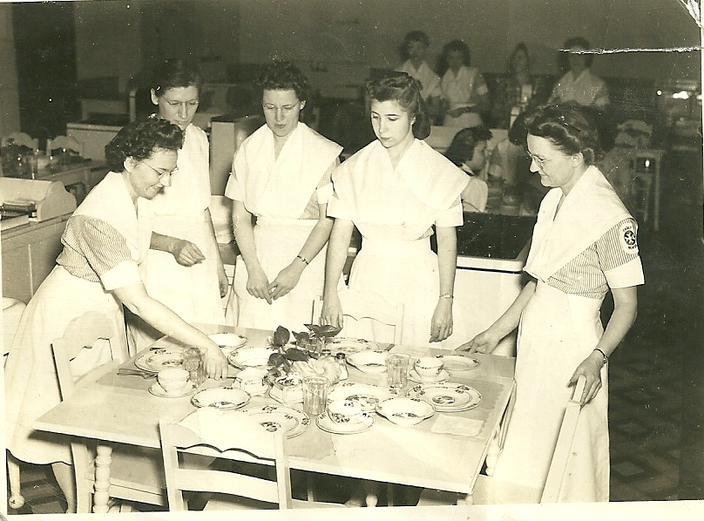
Cadet nurses in clinical garb in Topeka, Kansas during training.
(photo by Naomi Johnson)

President Harry S. Truman issued Executive Order 9575 declaring, “The Commissioned Corps of the Public Health Service to be a Military Service and a Branch of Land and Naval Forces of the United States during the period of the present war.” (June 28, 1945) The Cadet Nurses wore clinical work uniforms with the Cadet Nurse insignia or dress uniforms.

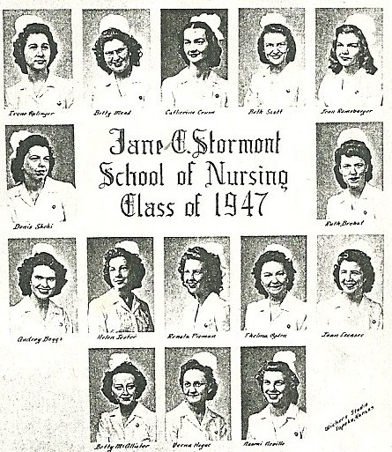
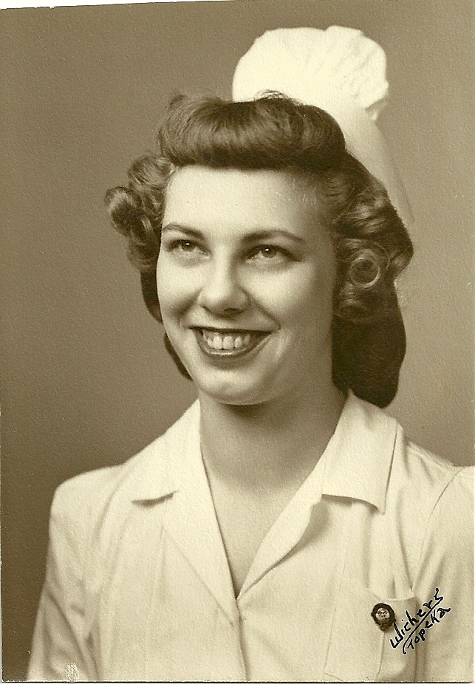
Naomi N. Johnson in her nursing uniform.

Naomi remained in the states for her three year enlistment, serving from 1944 to 1947. She completed her training at nearby Storemont Hospital in Topeka, Kansas and worked there during her enlistment. When her service duty was over, she returned to college and completed additional work at North Park College in Chicago. She also worked at Swedish Covenant Hospital in Chicago.

In Chicago she met and married Gordon Johnson, a teacher who had served in the US Navy during the war. They would have six children and lived most of their lives in northeast Kansas. Naomi Johnson continued her career in nursing, working at Bethany Hospital in Kansas City, Kansas until her retirement. Most of her nursing career at Bethany was involved with the Obstetrics Department

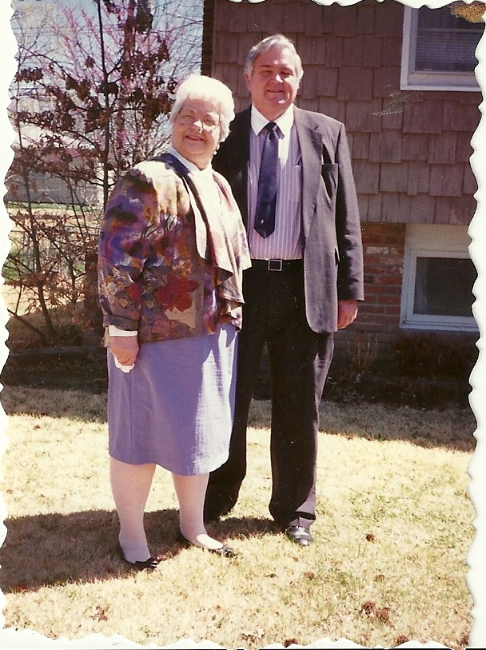
Naomi & Gordon Johnson in the 1980’s at their
home in Shawnee, Kansas.

Naomi N. Johnson passed away on March 2, 2005. She is buried at the National Cemetery in Leavenworth, Kansas.

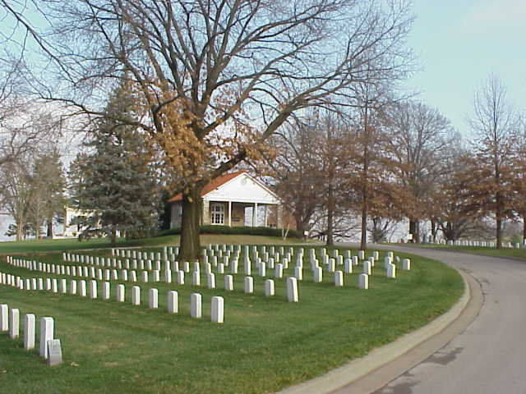
Entrance to the Leavenworth National Cemetery.

