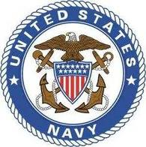

Jon T. Tumilson
Petty Officer 1st Class - United States Navy
1995-2011

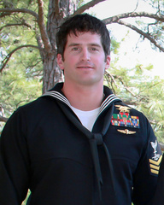
Petty Officer 1st Class
(SEAL/Enlisted Surface Warfare Specialist) Jon T. Tumilson.
Jon Thomas Tumilson
Special Warfare Operator First Class, U.S. Navy

The press release from the Department of Defense was brief, but devastating on 11 August, 2011:

“DOD Identifies Service Members Killed in CH-47 Crash. The Department of Defense announced today the deaths of 30 service members who were supporting Operation Enduring Freedom. They died Aug. 6 in Wardak province, Afghanistan, of wounds suffered when their CH-47 Chinook helicopter crashed.” With the news of the war’s single most deadly combat losses came the names, including that of Navy SEAL Jon Thomas Tumilson.

The following day the Department of Defense released a second press release, this time giving a brief biography of each of the military personnel who died.

Friday, 12 Aug 2011, 12:45 PM EDT
Special Warfare Operator Petty Officer 1st Class (SEAL/Enlisted Surface Warfare Specialist) Jon T. Tumilson, 35, of Rockford, Iowa. Petty Officer 1st Class Tumilson, 35, was a native of Rockford, Iowa. He enlisted in the United States Navy in July, 1995.

He graduated from Recruit Training Command, Great Lakes, Illinois in September, 1995. Petty Officer 1st Class Tumilson completed Basic Underwater Demolition/SEAL School, Coronado California in April, 2002. He served in three West Coast based Special Warfare Units from October, 2002 to August, 2009. He served in two East Coast based Special Warfare Units from August, 2009 to August, 2011.

Tumilson’s awards include the Navy and Marine Corps Commendation Medal, Joint Service Achievement Medal, Navy and Marine Corps Achievement Medal (2), Presidential Unit Citation, Combat Action Ribbon, Navy Unit Commendation, Navy Meritorious Unit Commendation, Navy ‘E’ Ribbon (3), Navy Good Conduct Medal (5), National Defense Service Medal (2), Armed Forces Expeditionary Medal, Afghanistan Campaign Medal, Iraq Campaign Medal, Global War on Terrorism Expeditionary Medal, Global War on Terrorism Service Medal, and Sea Service Deployment Ribbon (4) Rifle Expert Medal, and Pistol Expert Medal.
While the news was devastating to family and friends, what took place next was not a mourning of his death, but a celebration of his life. All around the country, people who knew him began to remember the way he lived life and to create tributes to his life.

In San Diego a local runners group organized a tribute run near Mission Bay. Said organizer Kevin McCrary, “He was the toughest man I ever met,” adding, “And he was the most gentile man I ever met.” Tumilson, was an active runner and competed in triathlon events in the San Diego region when assigned there with the Navy Seals. He was last based in Virginia Beach as a member of the elite commando group SEAL Team Six.

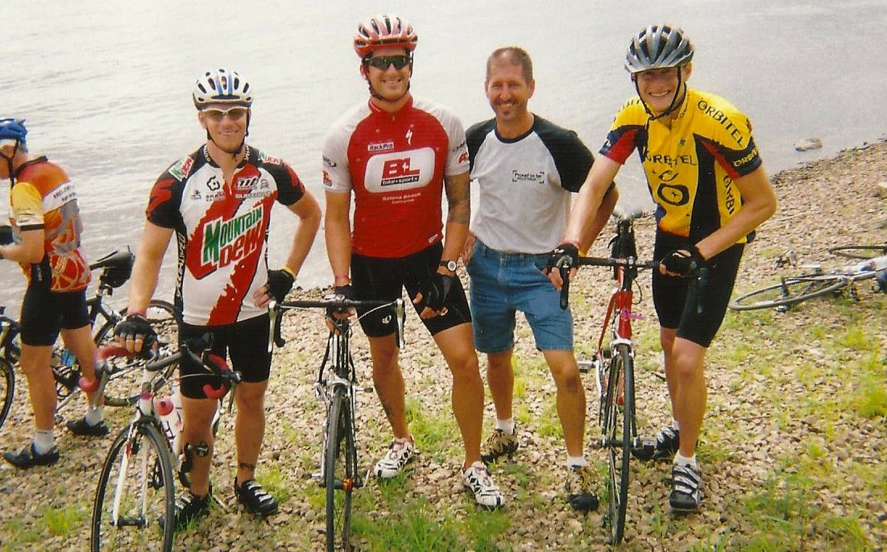
Tumilson pictured with friends at a triathlon event.

“He was a very big country boy with goals and a love for our way of life,” said Mccrary in a local newspaper article. "Remember his smile and attitude. He always went for it. We will miss the big man.”

Another runner Jason Lewis who was also quoted said, “He was a large guy in stature and even larger in life.” Lewis added, “He was an inspiration, a hero and something that every young boy wishes to grow up to be."

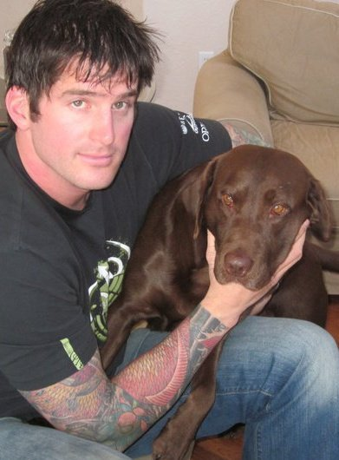

Jon Tumilson with his beloved dog Hawkeye.

One of the most revealing news articles to cover the life of Jon Tumilson, was written in a home state newspaper the DesMoines Register by Daniel Finney.

Written by DANIEL P. FINNEY
DesMoines Register.com

Rockford, Ia. - Floyd County is known for bricks and marble, but perhaps the toughest thing to come out of this region was delivered in July 1976, the same year they closed the clay pit here.
The package came to the home of George and Kathleen Tumilson, not in stone, but in the shape of their newborn son, Jon Thomas Tumilson.
Tumilson grew up to be a U.S. Navy SEAL, one of the most highly trained and elite members of the nation's military. He was among 30 Americans killed when a Taliban rocket-propelled grenade shot down a helicopter in Afghanistan Saturday. Tumilson was 35.
Rockford is a town of about 850 people. And when the news came that their native son died in the decade-long war, that town known for bricks and tiles cracked a little. Even those who didn't know Tumilson personally feel the loss.
"It doesn't really hit you until it hits home," said Paul Bisgard, superintendent of Rudd-Rockford-Marble Rock schools, where Tumilson graduated in 1995. "I'm a patriotic supporter of all our military men and women, but it isn't like World War II or Vietnam. Then, everybody knew somebody who died in the war. Now, that isn't true. This wakes you up."
Tumilson was the last of George and Kathleen Tumilson's three children. They had two older daughters, Joy and Kristie.
Jon Tumilson was remembered as an adventurous small-town boy.
Mark Biggs, neighbor to the Tumilsons for 30 years, got to know Jon Tumilson as a toddler. Biggs' father worked on motorcycles in his spare time and had a garage full of bikes.
The boy liked to climb atop the bikes and pretend he was roaring down the highway, Biggs recalled. Biggs' father occasionally turned the key and let the boy beep the bike's horn.
"One day, Jon would've been about 3, Dad turned the key, but instead of hitting the horn, he hit the start button," Biggs said.
The bike lurched forward off it its kickstand and fell over on the lad. Father and son Biggs quickly extracted the wailing Tumilson from the mess. He howled all the way home.
The boy grew up to master his own three-wheel ATV, running it all over town and in nearby fields.
Tumilson worked alongside his father on construction jobs in the summer. George and Jon Tumilson helped build Biggs' auto repair shop. Biggs and Jon Tumilson screwed bolts into the rafters of the steel building on the southeast edge of town. "It would get so hot up on that roof, and he never complained, not once," Biggs said. "I never heard him complain about hard work, or ball practice or cutting weight for wrestling or even basic training in the Navy. Nothing. You asked him to do something, he did it."
Tumilson played football for the Rudd-Rockford-Marble Rock High School Warriors. He was popular enough to be elected homecoming king in the fall of 1994. His season on the field earned him all-district honors. He wrestled his way to conference and sectional championships. He also ran track.

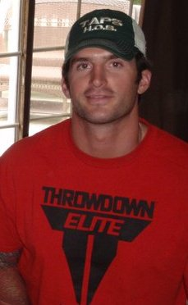
Jon Tumilson

Probably the biggest event of his high school years was when a Navy recruiter visited his junior year. His path to the best of the best began there.
"I remember when he was recruited," Biggs said. "He was so proud. It was exactly what he wanted to do."
After he made SEAL, townsfolk recall the lean, sinewy man running the streets of town - and nearby towns - for hours on end each day.

"He was always running," said Dennis Ginther, 68, a Rockford native who grew up with Tumilson's father. "He would say hello, but he was always staying in shape."
Biggs remembered seeing Tumilson hustling along the shoulder of Iowa Highway 14 between Rockford and Charles City, which is about 15 miles east of Rockford.
Biggs rolled down his window and hollered at his young friend. Tumilson plucked his headphones out of his ears, but kept running in stride. Briggs slowed down his truck. They chatted for a bit. "He wasn't breathless," Briggs said. "He was just talking like he was sitting down at rest. It was hotter than heck that day, and he's just chugging along."
Briggs offered him a ride. "Heck, no," Briggs recalled Tumilson saying. "I've got another 30 miles to go."
Few in Rockford knew what Tumilson did as a SEAL. The unit works top-secret missions, and Tumilson told few tales other than from training. In one section of the training, Tumilson and fellow SEAL recruits were taken airborne, blindfolded and flown in circles until completely disoriented. The plane flew the recruits off shore until they were out of sight of land. They were ordered to jump out of the plane and find their way back to base.
How did he do it?
"You just do it," Biggs recalled Tumilson saying.
In recent trips home, Tumilson talked of retiring from the Navy. He would have had 20 years in by 2014. He discussed applying to the CIA or U.S. Secret Service.

That day will never come.
Biggs looked up at the roof of his auto shop and remembered happier times.
"I just expect him to drive up in that ATV," Biggs said, tears welling in his eyes, "and I know that isn't the way it's going to be."

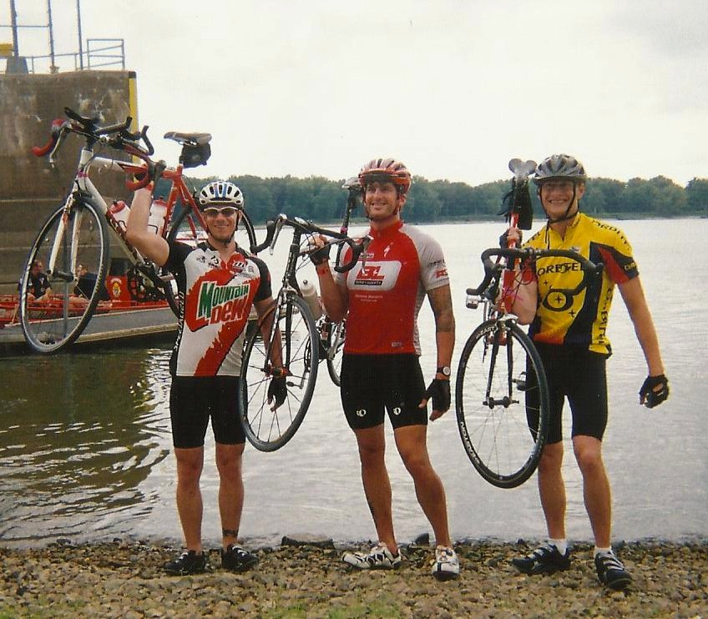

Cycling friends after competition.

The Tumilson family appreciated the outpouring of love and support coming from around the nation, but they want people to remember that 30 people lost their lives that day. "We should remember each and every one who suffered on 9/11 and all those who have lost their lives since in support of our nation and the Afghan nation," Darby said in a news interview.

While those that hear that message from his parents will honor their wish to respect and pray for all the war’s heroes, it will be the memory of Jon that they keep in their heart.

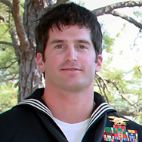

(dedicated to Jon’s memory by his cousin Lisa)

