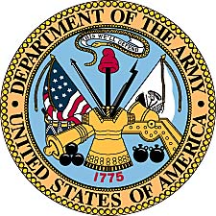

Vanessa Arevalo Jones
United States Army
(2003-2012)

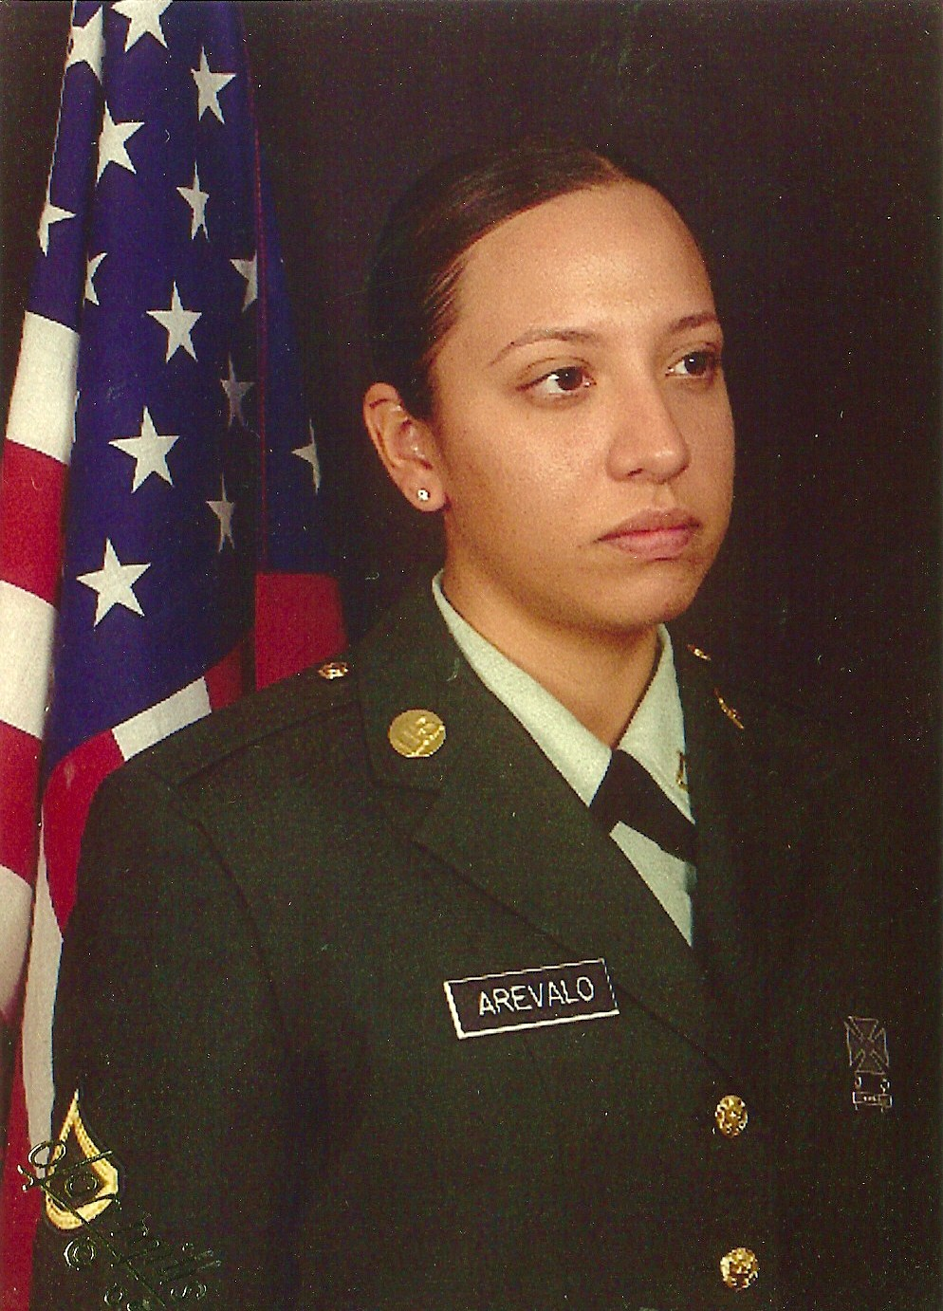

Vanessa Arevalo Jones in 2004 during her first leave home.
Vanessa Arevalo was born in Tucson, Arizona, Dec. 8. 1983. She was second of five girls born to Richard and Sandra Arevalo. A member of her high school band where she played the flute, Vanessa graduated in 2002 from Cholla High School in Tucson. She next attended Pima Community College for two years, before enlisting in the United States Army in 2004.

Basic training for Vanessa was at Ft. Jackson, South Carolina. She then traveled to Ft. Sam Houston, Texas for specialized training as a “medical logistics specialist.” This duty assignment deals with supplies and the medical property book for “CSH” and “MASH” assignments. Her first duty station was with the 67th Combat Support Hospital in Wurzburg, Germany.

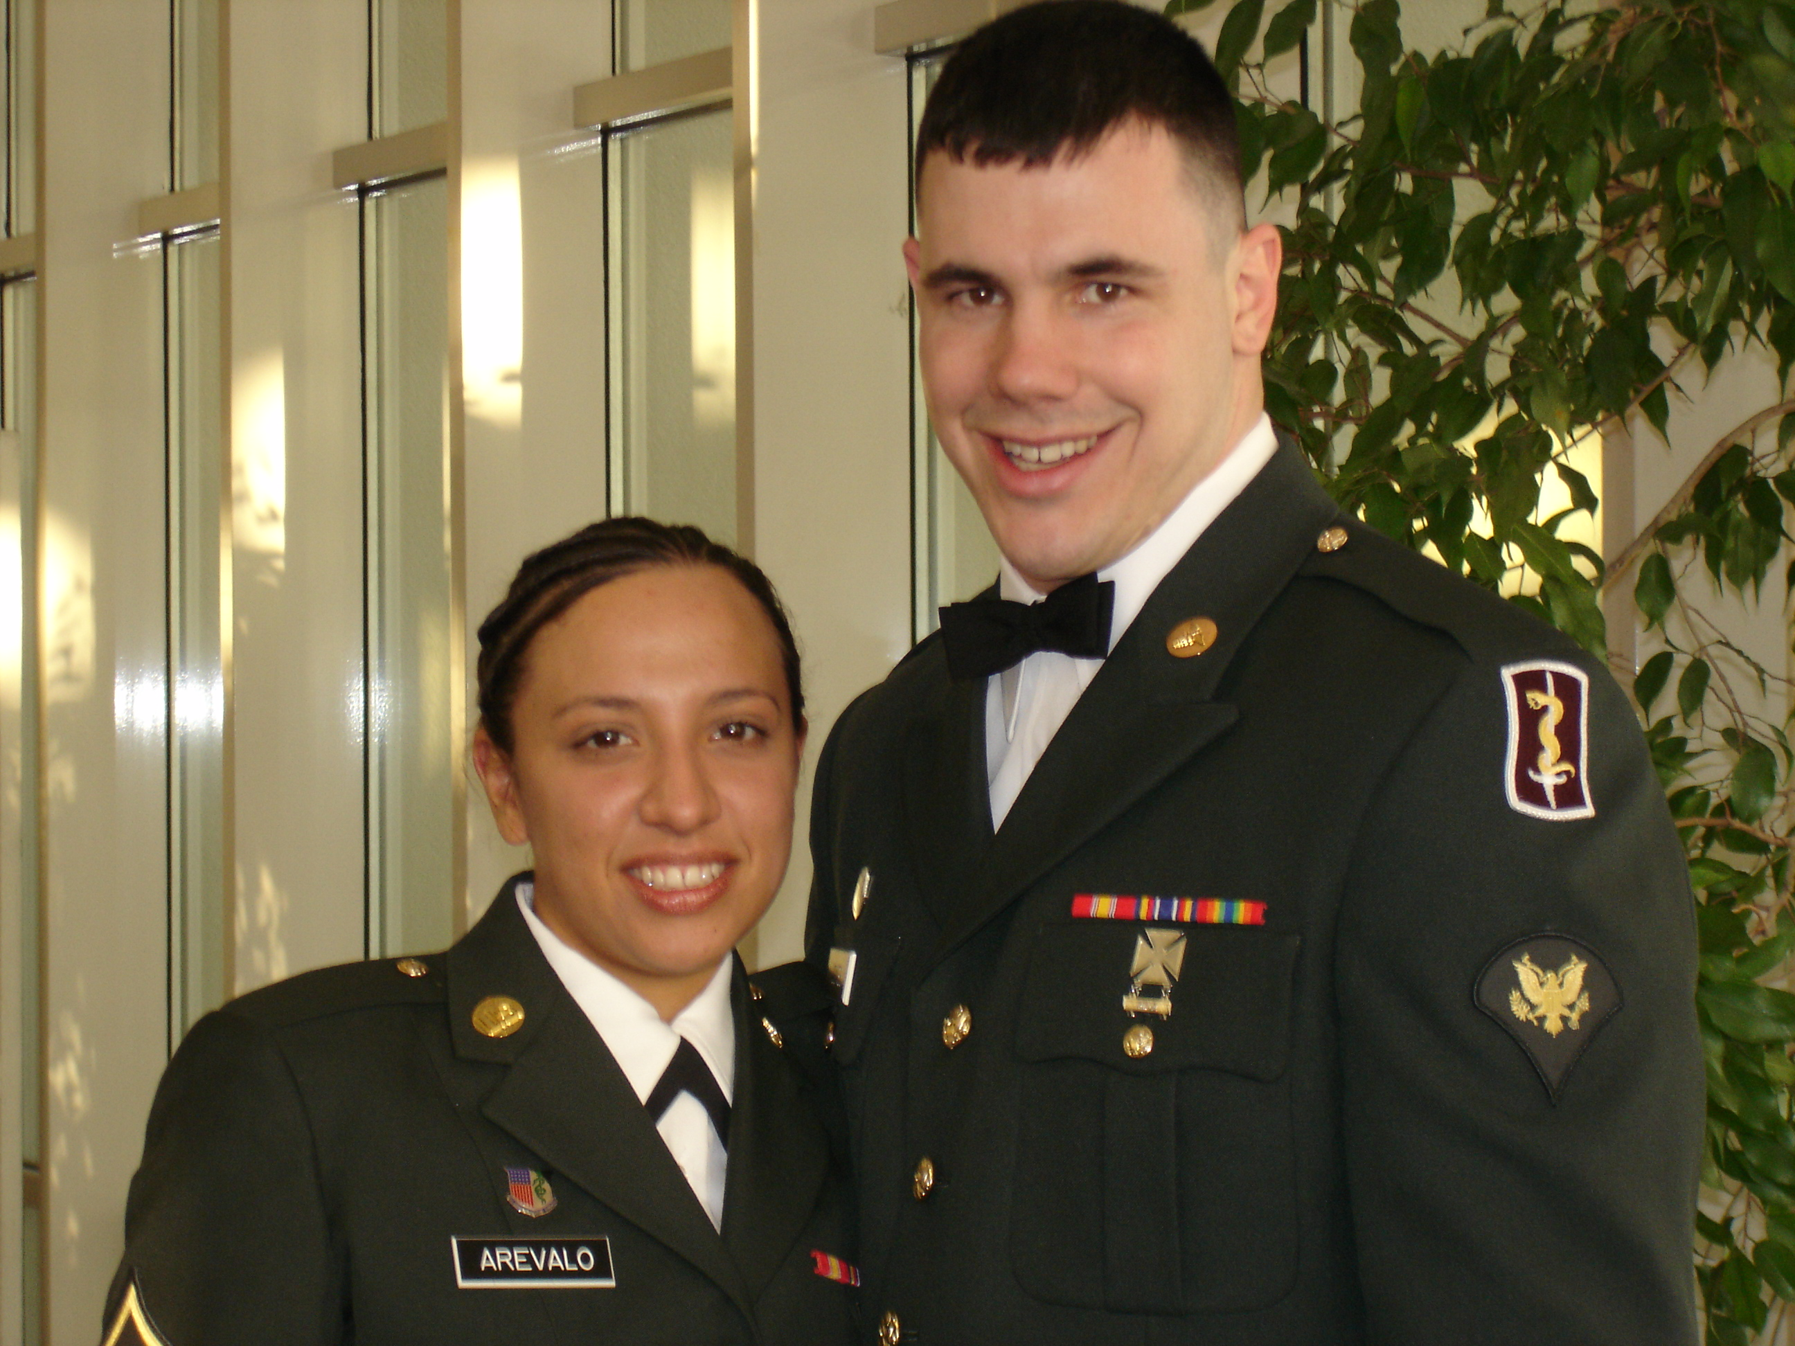
Vanessa with future husband Branden Jones at the “Dining Out,” formal
67th CSH dinner in Germany at the beginning of 2005.

During October 2005, Pakistan was hard hit by a devastating earthquake. Especially affected were the poor northern mountain regions, where medical aid was almost non-existent after the earthquake. The United States deployed emergency aid to the region and the 212 MASH Unit was sent to Muzaffarabad. They remained in Pakistan until February of 2006, treating first the injured and then the impoverished.
Duty during the 5 month deployment involved long hours of work, followed by periods of boredom. Soldiers were highly restricted to the post due to security concerns over possible attempts by terrorists to kidnap or injure American servicemen. Vanessa was able to make one trip into the surrounding town, where she purchased a rug. The town itself was a picture of devastation, with many buildings reduced to rubble. Many Pakistani residents were living in temporary tent cities during the harsh winter weather.

Because of the high visibility of the 212’s rescue aid, many dignitaries stopped by at the hospital, including Angelina Jolie
and husband Brad Pitt, Vice President Dick Chaney, and Secretary of Defense Donald Rumsford. Vanessa personally spoke with and was photographed with Rumsford during his visit.

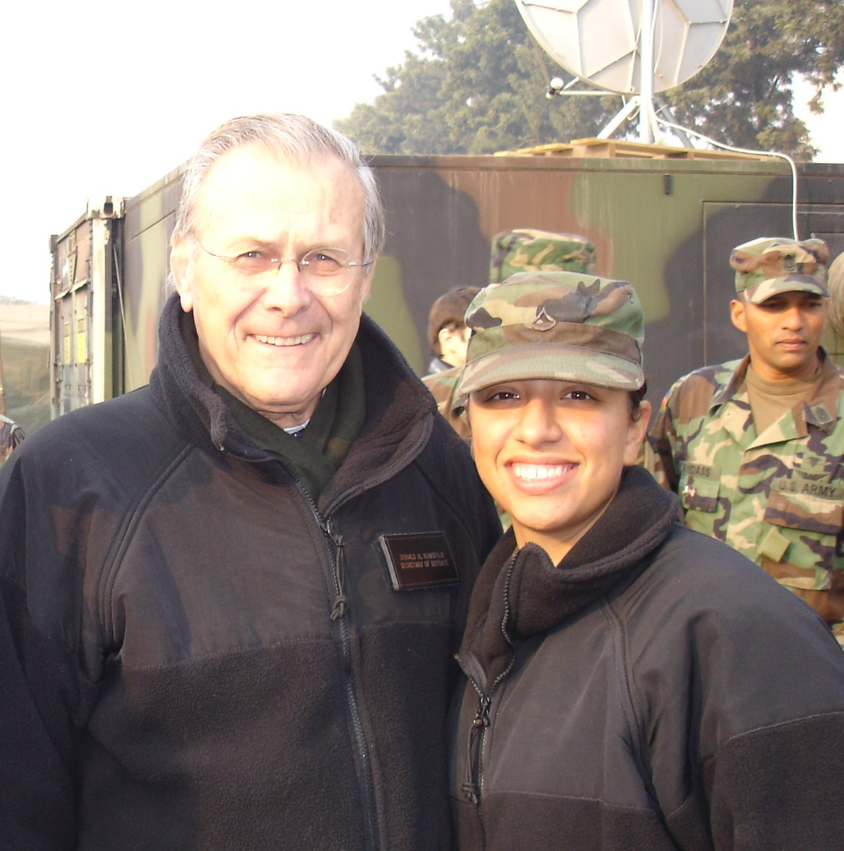
Secretary of Defense Donald Rumsfield with Vanessa Arevalo at
the 212 MASH Unit in Pakistan, during Christmas of 2005.

The unique “Jingle Truck” driven by Pakistani’s.

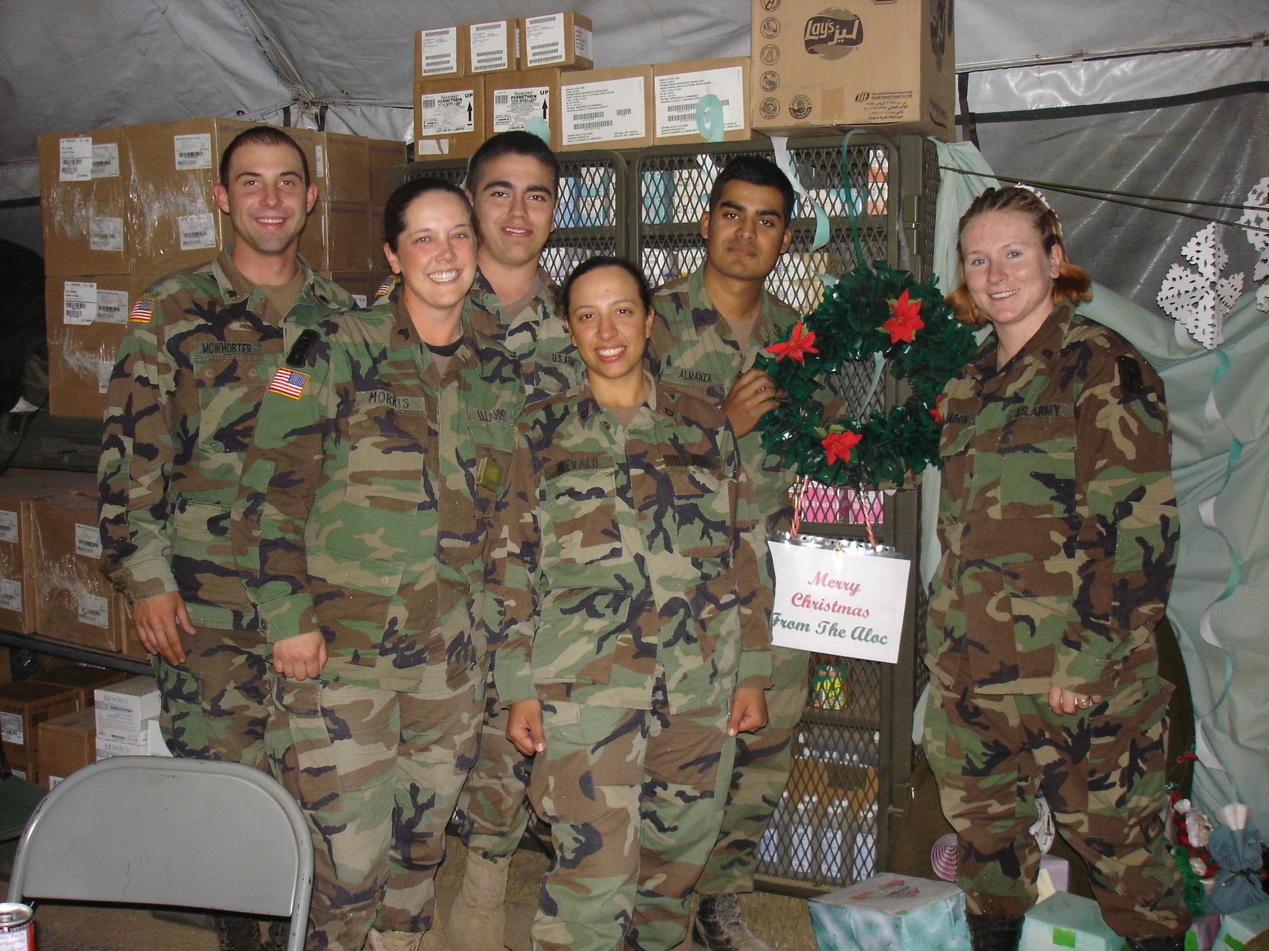
Vanessa with shop workers from Medical Supplies during the 2005
Christmas season.

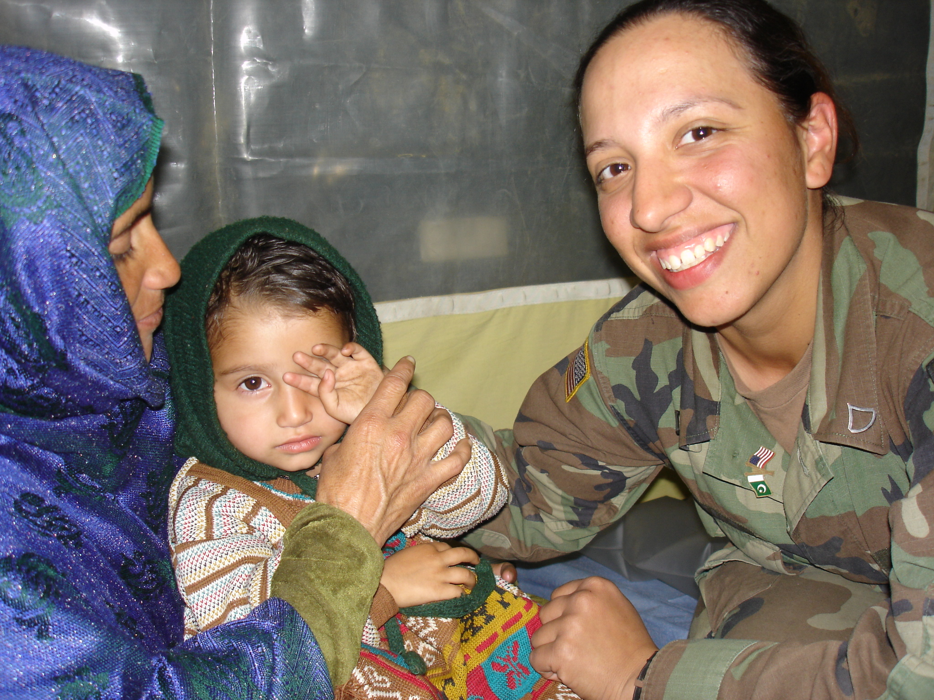
Vanessa comforts one of the many young Pakistani
patients at the emergency hospital.

While her regular assignment involved supplies, all staff were regularly called on to assist the medical staff when the frantic pace of emergency medical care got too busy. On one occasion the quiet, unassuming soldier was assisting the operating theatre when she was called on to carry off an amputated leg and foot. When the leg spasmed involuntarily as she carried it down the hall, Vanessa clinched hard and held it at arm’s length and muttered something unintelligible as she continued to the “burn pit.”

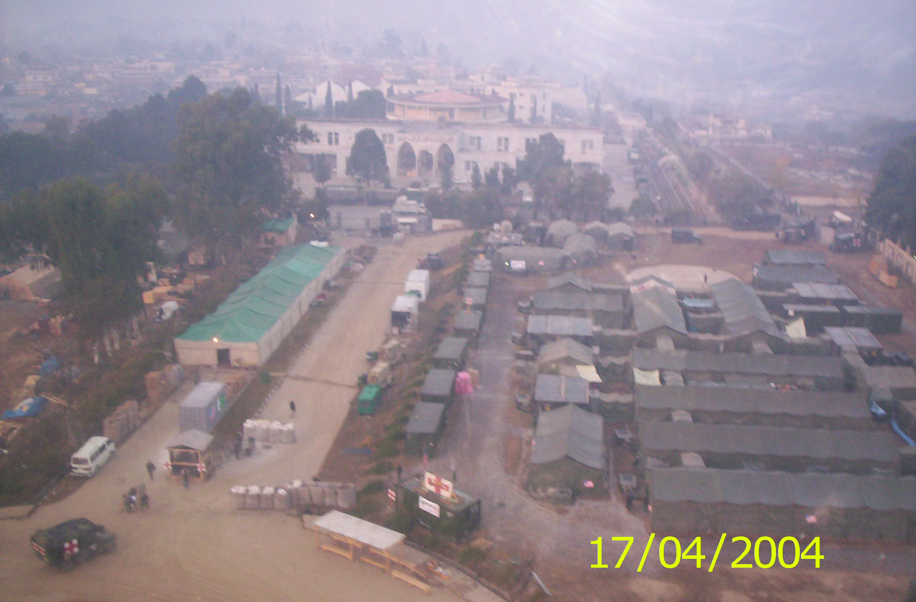
212 MASH at Muzaffarabad, as seen from helicopter. (date incorrect)
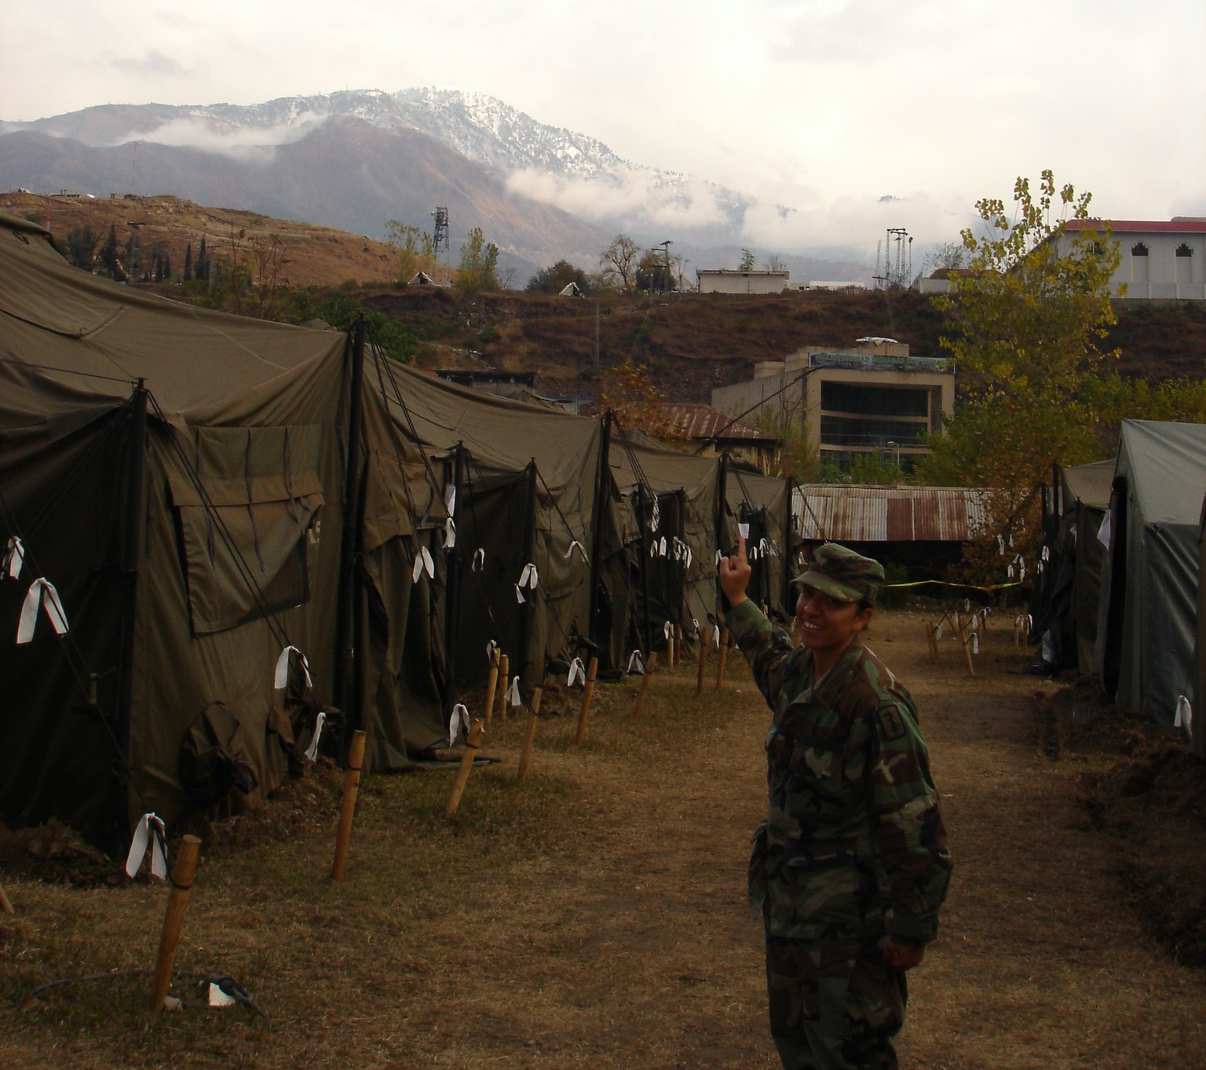
Vanessa points to the snow covered mountains of Pakistan from
the MASH living quarters where the soldiers lived.

A tent city alongside the river, where thousands of homeless
Pakistani’s gathered after the earthquake.
Vanissa in Wurzburg, Germany, looking down on the city from the castle.

After deployment to Pakistan, Vanessa returned to Germany where she completed her overseas tour of duty with the 67th CSH and MEDAC, when the CSH was deactivated. She also changed her last name to Jones, as she married fellow soldier Branden Jones, a medical technician with the same unit.

Vanessa and Branden on a trip to Venice, Italy, during their tour of duty to Germany.
The newly-wed married couple returned to the United States, where they were both assigned to Ft. Lewis, Washington. Vanessa began duties at that post, finishing up with the 5th Brigade, BSB. With the birth of a son Brayden in 2007, Vanessa made the decision to leave full time military service. On September 21, 2008, she was honorably discharged from the US Army.

Her service awards included the Global War On Terrorism Expeditionary Medal, the Army Achievement Medal, the Joint Unit Commendation Medal, the Army Superior Unit Award, and a Good Conduct Medal.

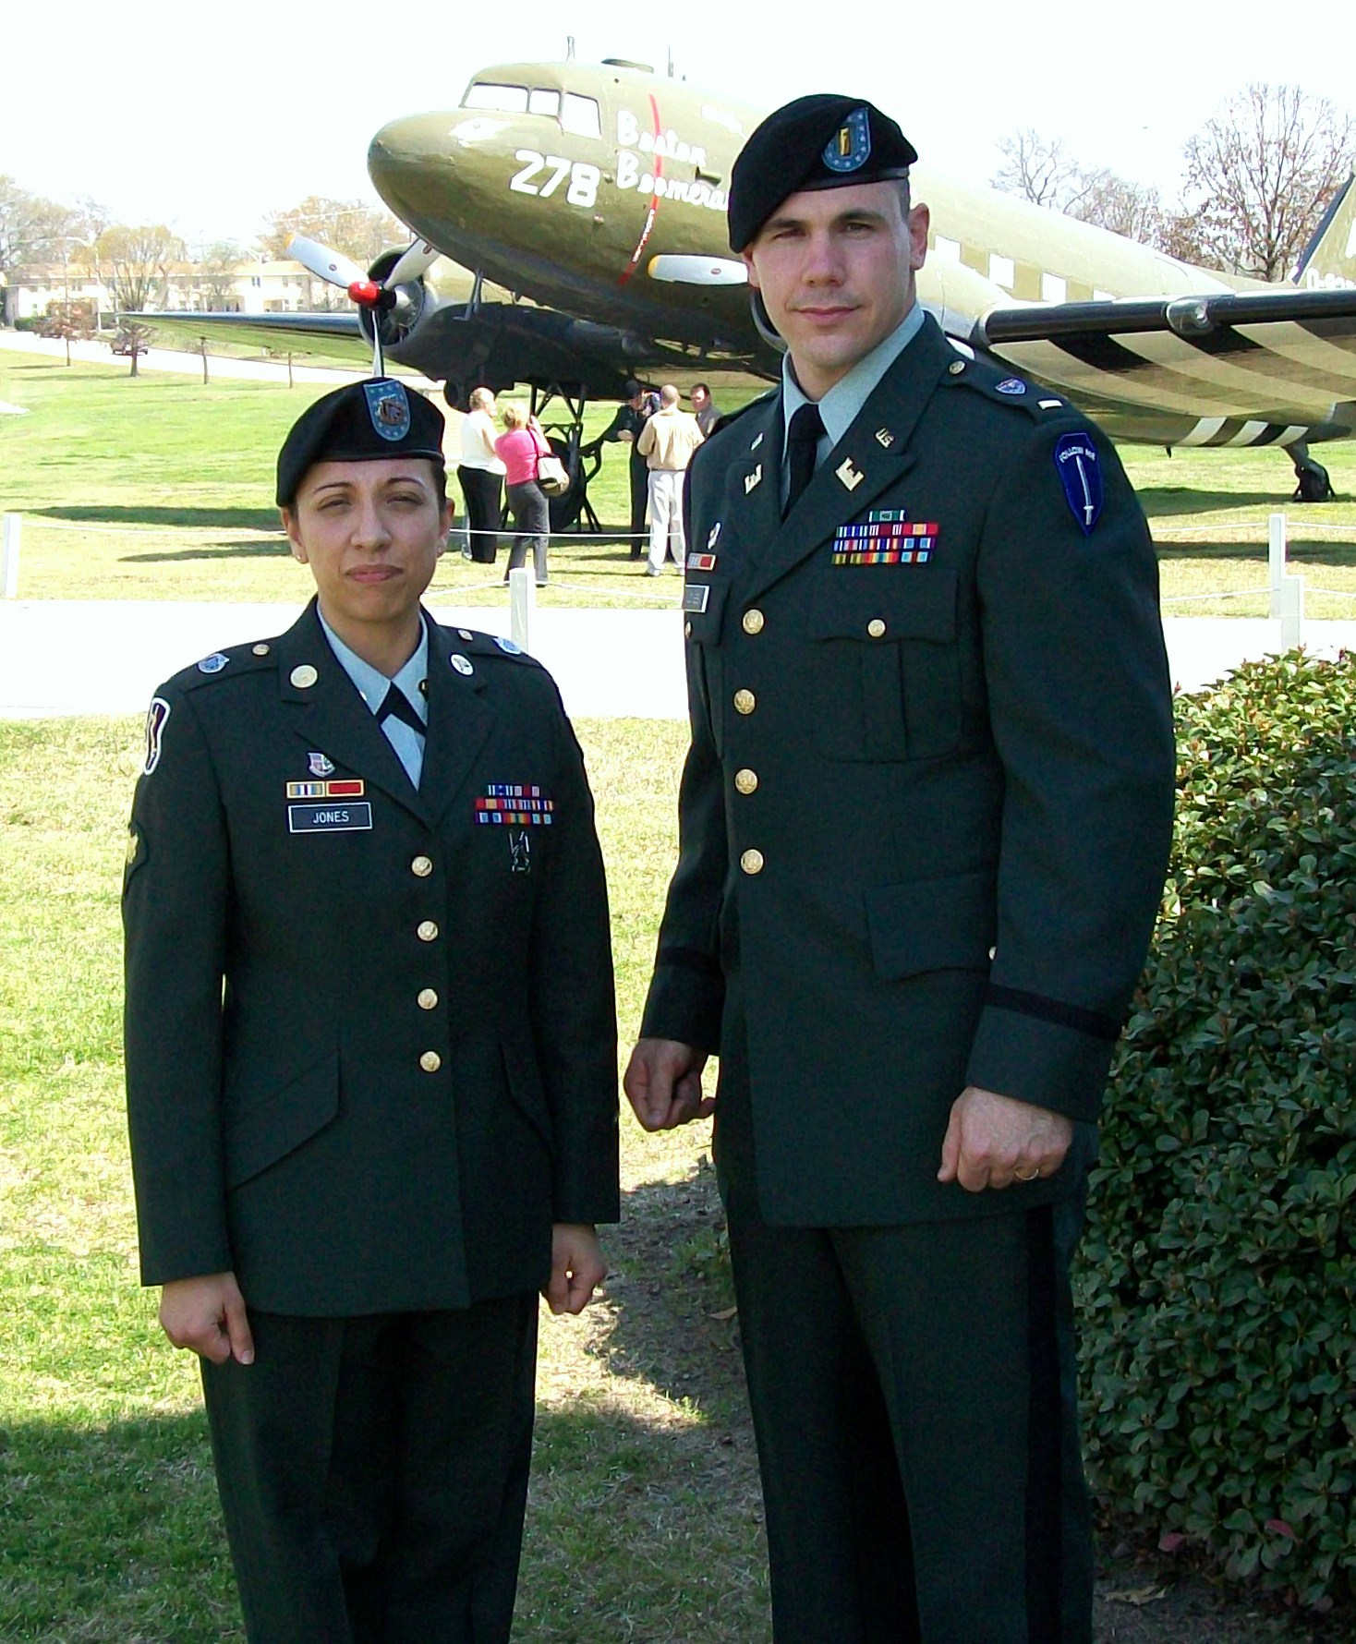
Vanessa and Branden Jones at Ft. Benning, Georgia
March 8, 2009

However, Vanessa Arevalo Jones took no time off from service duty, enlisting in the United States Army Reserves the day after full time duties ended. When husband Branden, now a Lieutenant in the Engineers Corps, was assigned to Ft. Riley, Vanessa was assigned to the 445th Medical Detachment: Veterinary Service, Independence, Missouri. She served as an automated logistics specialist for the Army Reserves unit.
In addition to raising her young son Brayden and continuing in the Army Reserves one weekend each month and two weekends each summer, Vanessa continued to work on completing her college education through outreach services at Ft. Riley. As a student through Upper Iowa University, majoring in Business Administration, Vanessa completed “on-line” classes towards her Bachelor’s Degree. On May 6th, 2011, in ceremonies at Kings Field House at Ft. Riley, Major General Vincent K. Brooks, Commanding General of the 1st Infantry and Ft. Riley presented her with her degree. Vanessa graduated “with honors” with a Bachelors of Science degree.

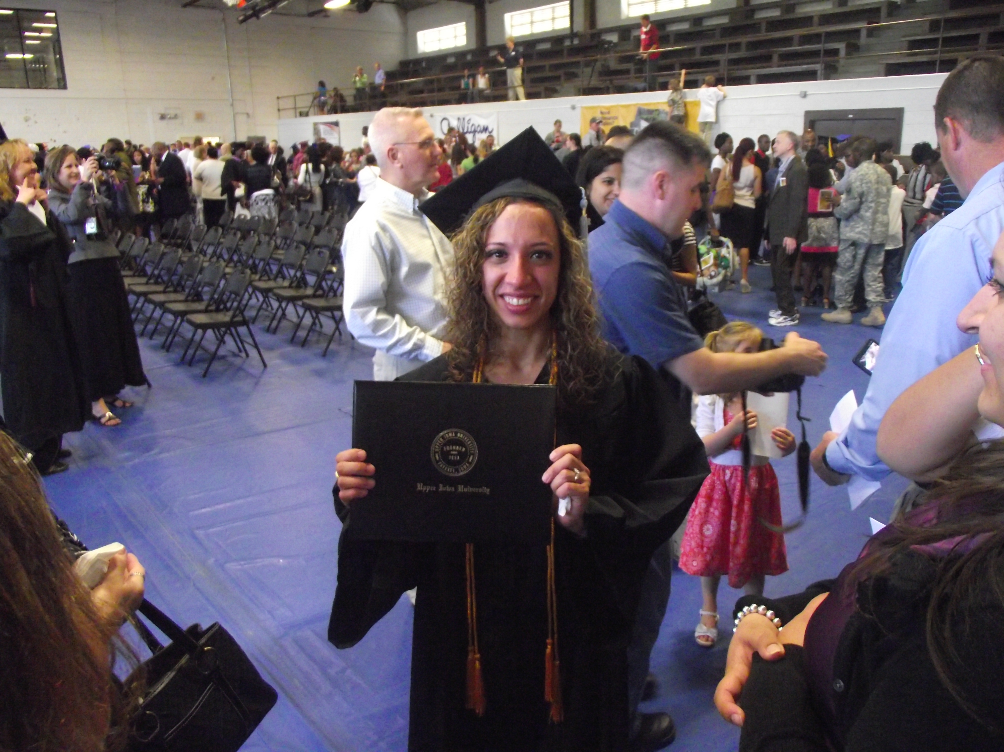
Vanessa displays her hard earned diploma to family after ceremonies at
Kings Field House at Ft. Riley, Kansas.

The 445th Medical Detachment where Vanessa served, was a unique component in the US Army. A veterinary service, the unit was comprised of vets and other related specialists who worked with local populations during deployments, to further agricultural development and better relations between the military and the locals. She served as an automated logistics specialist for the Army Reserves unit, the same capacity she worked with in her assignment to regular medical detachments.
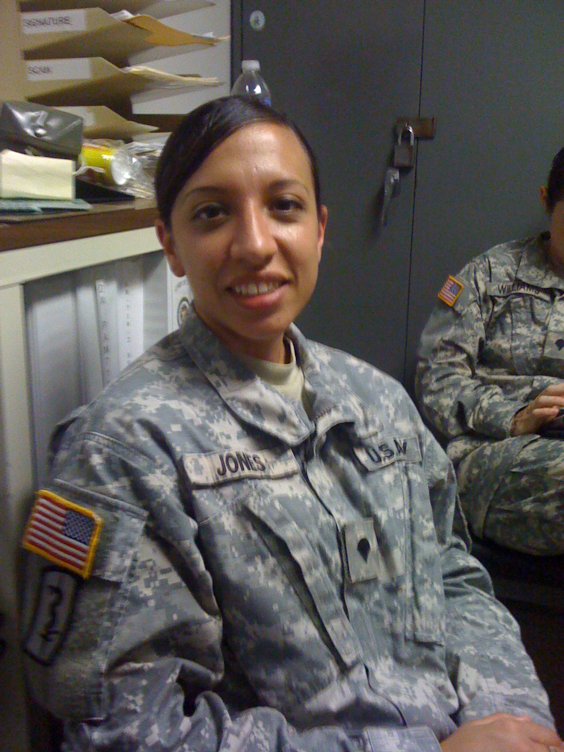
Vanessa on duty in Independence, Missouri with the 445th Medical
Detachment Reserve Unit in 2011.

Vanessa Jones would complete her nine years of service to the United States Army in February of 2012. Finishing her final three years in the Army Reserve, she would muster out February 29th, 2012. Her decision to leave was impacted by continuing assignment changes for her husband Branden, whose advancement through the ranks as an Army Engineer Officer made dual careers in the military difficult.

