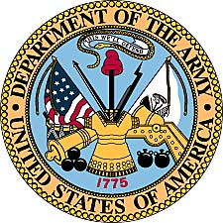
Walter L. Jones
United States Army
(1950-1952 & 1954-1955)

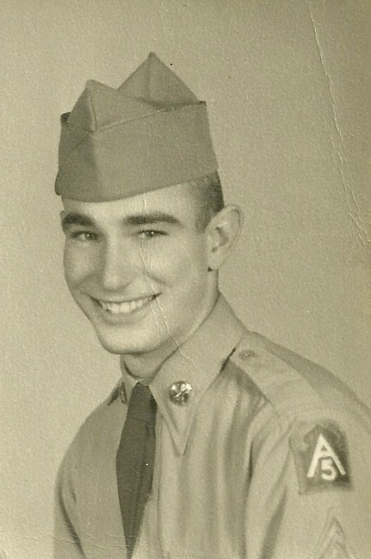

Walter Luther Jones was born December 27, 1932 in New Broomfield, Missouri. The son of pastor Walter M. and Edith Mae Jones, he spent most of his teen years in Leavenworth, Kansas. Growing up in the Leavenworth area he competed in sports and was a standout in baseball and football. To his family and friends he has always been known as “Luke.”

Walter L. Jones practices on the range in basic with one of the machine guns.
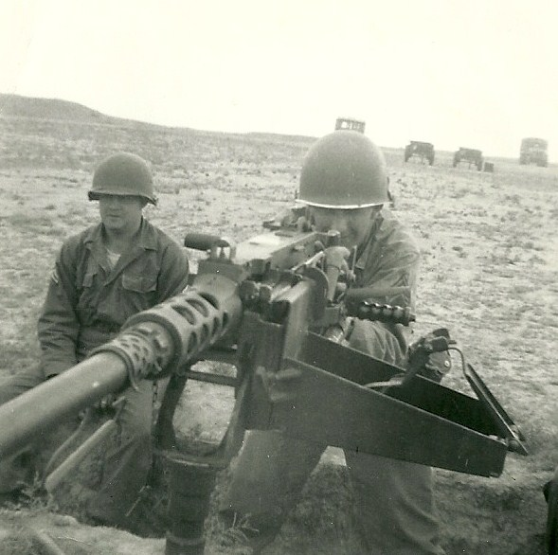

In 1949 at the age of 17, Luke joined the Kansas Army National Guards 174th Military Police Detachment in Leavenworth. His basic training was completed at Ft. Leonard Wood, Missouri or as many referred to the post, “Fort Lost In the Woods.” With the intervention of the United States and other UN nations in the Korean Conflict, Jones’ National Guard Unit was activated in 1950.

Initial orders assigned Luke to Ft. Sheridan, Illinois. There he worked with prisoner transports and other MP duties until orders came for the 174th MP Unit to travel to South Korea in September 1951. Shipping out from Ft. Lewis, Washington, the soldiers made a stop in Japan before arriving in Pusan, South Korea.

With typical Army efficiency, duty orders for Walter Jones could not be found and he was left behind when the 174th moved out to the lines. After a two week wait, he was reassigned to the 519 Military Police unit and caught a train up close to the 38th Parallel.

Upon arrival to his new post, Jones was again “odd man out,” as no one from his new unit was around. Officers simply told him to go out and hitch a ride and someone would find him. Serving first with C Company of the 519th for three months, he next moved to A Company where he served the rest of his tour.

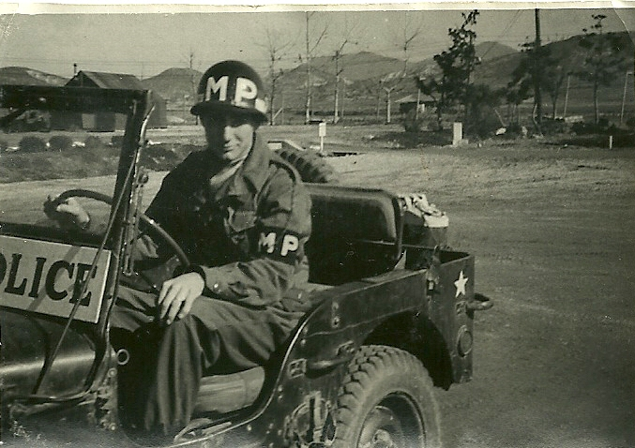
Promoted to Mechanized Vehicle Commander, much of Walter Jones duties
involved patrol on a heavily armed Jeep in the mountains near the MSR.

Military Police units in the Korean Conflict were assigned duties escorting supply convoys and keeping an eye out for infiltrators from the North Korean Army. Spending much of his time on the Main Supply Route (MSR), Jones was always close to the front and the fighting. The constant bombardment of the big guns near the front would take their toll on the young soldier, who would leave the war with permanent hearing loss.

His stories of the war include many close encounters with the enemy. In one situation he came up on heavily armed men at a checkpoint who he suspected were North Korean infiltrators posing as South Korean soldiers. Out numbered and out gunned he calmly spoke to the soldiers as if he suspected nothing, then waved them on. A quick radio call set up a trap that would ensnare the Communist soldiers without any loss of American men.

During the war in South Korea, the United States military issued payment to soldiers in “military payment certificates.” The amounts for the paper money ranged from cents to dollars and was printed on colored paper. Every so often the military would suddenly change it’s money colors to help control the use of military script on the black market.

Posts would suddenly be closed and soldiers would have only a short time to trade in their money for the new issue. Villagers and people outside the post would desperately try to cash in so they would not lose out on their money they had taken doing business illegally with soldiers.

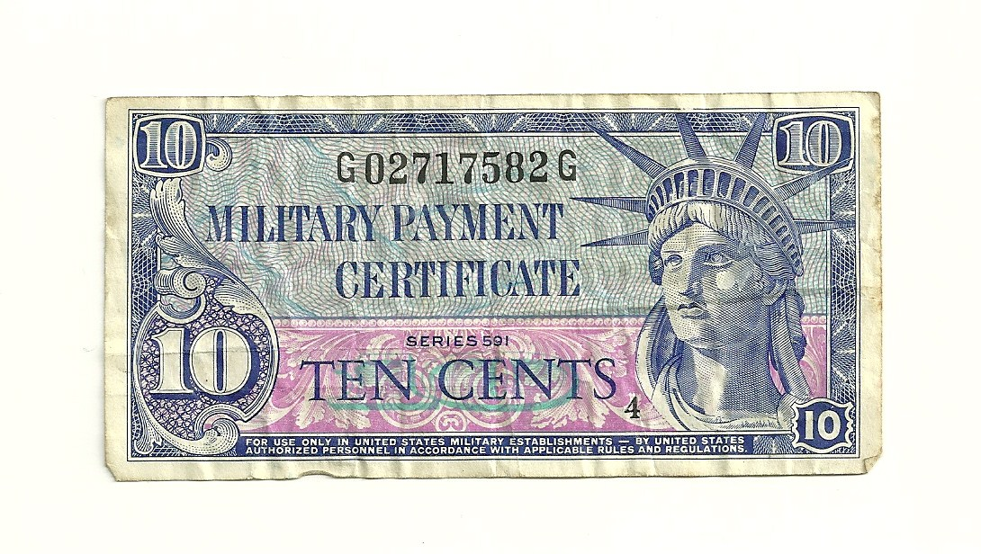
Script brought home by Walter Jones from South Korea.
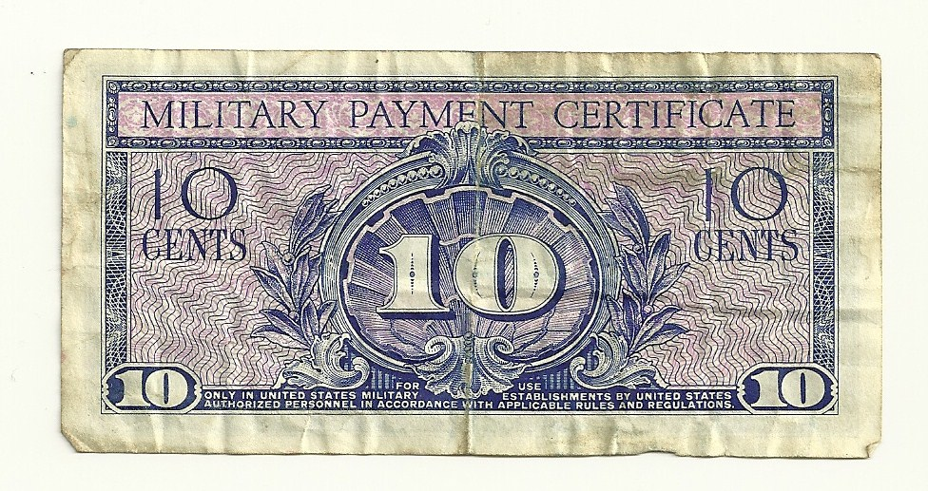
Script is actual size.
Luke Jones near the fighting at Wonju, South Korea on February 13, 1952.
An inscription on the back of the photo reads, “Baby its cold out side!”

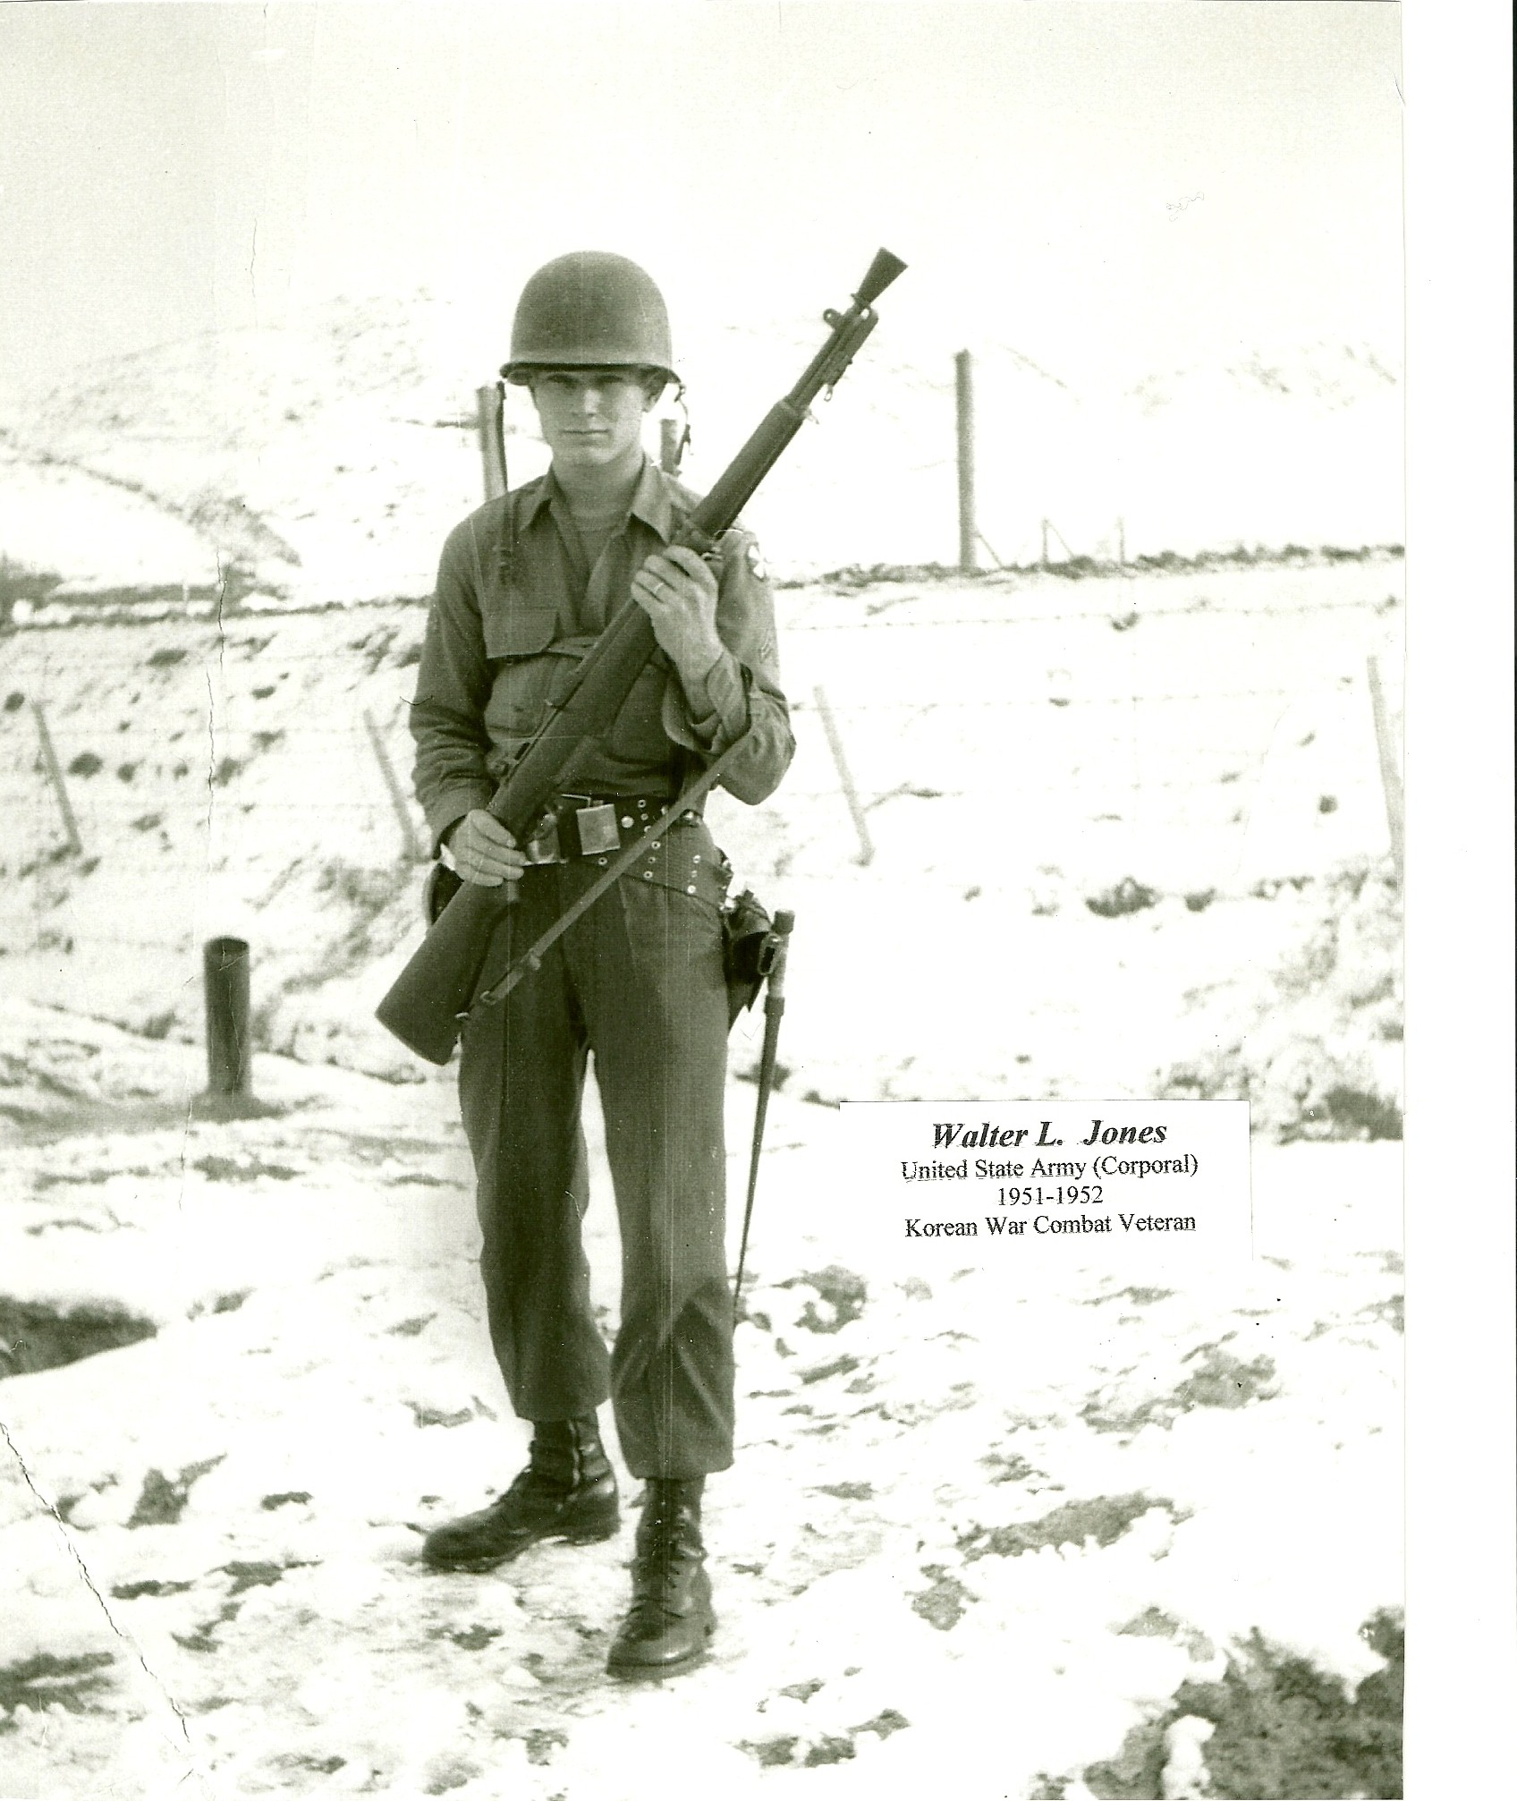

The memories of the causalities and devastation are something that Walter Jones still tries to forget and rarely speaks about. But the pictures in his mind still recall the treeless, lifeless, battle scarred landscape near the 38th Parallel, with the backdrop of burned out vehicles and tanks.

In addition to the Korean Service Medal and the Korean National Award, Walter L. Jones would be issued two Battle Stars for his combat duty during the war, one for Pork Chop Hill and one for Heartbreak Ridge.
One of his most positive memories of the Korean War was the day he helped a South Korean woman deliver a baby. As his patrol was completing house-to-house searches for the enemy, they were surprised to find a woman near delivery and needing aid. It was a brief moment when the horrors of war were put on hold.

He also recalls with a chuckle the day an American P-38 fighter decided to drop down on his patrol convoy and buzz the vehicles at about ten feet over their heads. “I was headed for the rice paddy,” says Jones who believes the airman was just having fun at the expense of the ground troops.

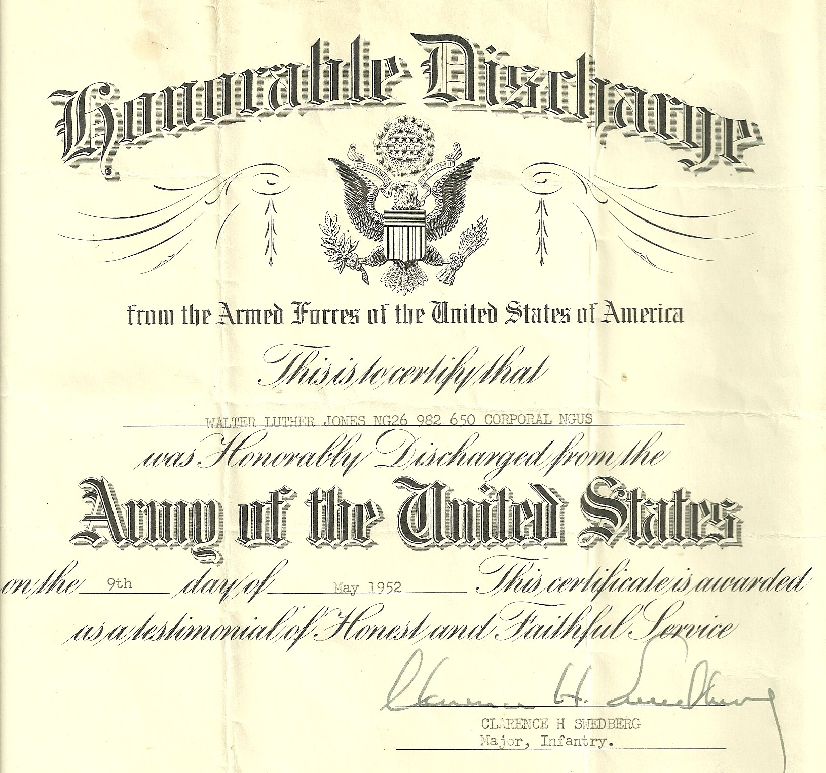
Discharge certificate from active duty in 1952.

Eventually he would complete his full deployment to the Korean Conflict and would return to Ft. Carson, Colorado. There he was discharged from active duty on May 9, 1952. However, Jones would re-enlist in the Kansas National Guard MP Unit where he started his military career. He would serve two more years from 1954-1955 in the Guard before leaving to take care of his growing family.
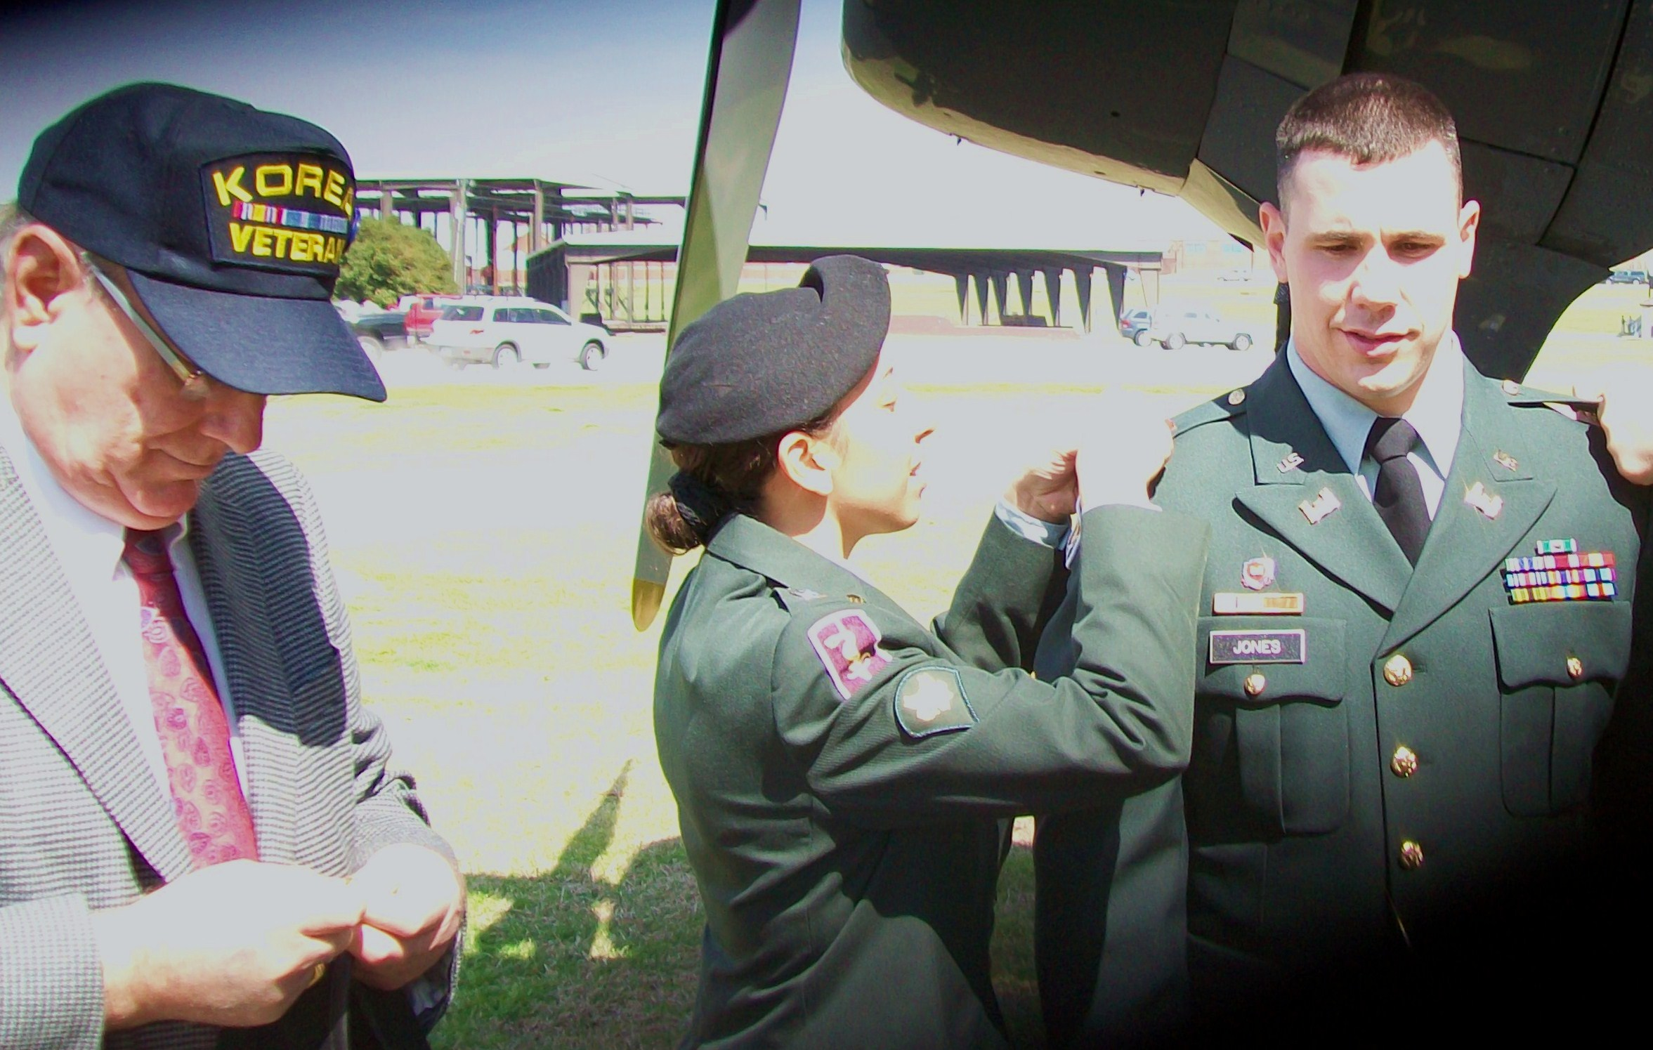
Walter Jones (left) prepares to pin his grandson Branden with his 2nd Lt. bar at
commissioning ceremonies in the spring of 2009 at Ft. Benning, Georgia. Both
Branden and his wife Vanessa (center), join Luke as veterans of a war zone.

Walter Jones was supported throughout his military career by his wife Irma whom he married on April 5th, 1951, while on a prisoner trip to Ft. Leavenworth from Ft. Sheridan. Together they raised three boys, eventually retiring in Kansas City, Kansas, where they spent much of their lives.

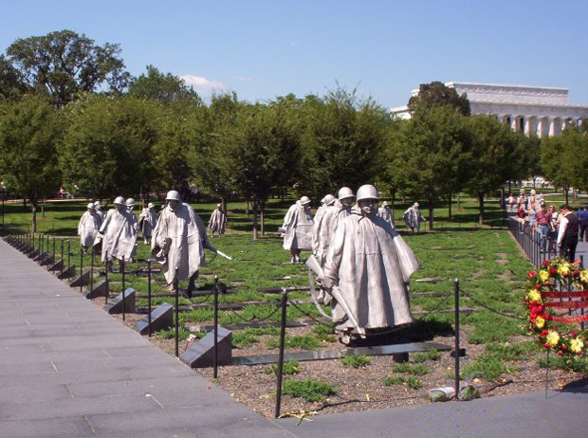
The Korean War Memorial depicts fighting men on patrol. They represent the 1.5 million Army, Navy, Marine Corps, and Air Force men and women who fought in the war. The Memorial was dedicated on July 27, 1995.

