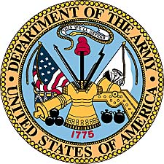

Wesley Merritt Cope
Army of the United States
(1918-1950)

Wesley Merritt Cope was born April 26, 1897, at Axtell, Kansas, in the heart of the northeast Kansas farmlands. He was the only son of Wesley Don Cope and Ida Nevada Schleigh. He was joined by two sisters, Ruth and Esther. His father was an attorney. Other communities in the Marshall County region of northeast Kansas, included Beattie and Summerfield. The area was predominately farmland and is located just south of the Nebraska border.

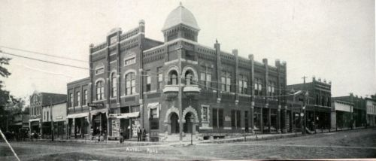
Built in 1905, this corner building housed a bank, telephone office, opera theater, dry goods store, barber shop, drug store and several other businesses in Axtell, Kansas.

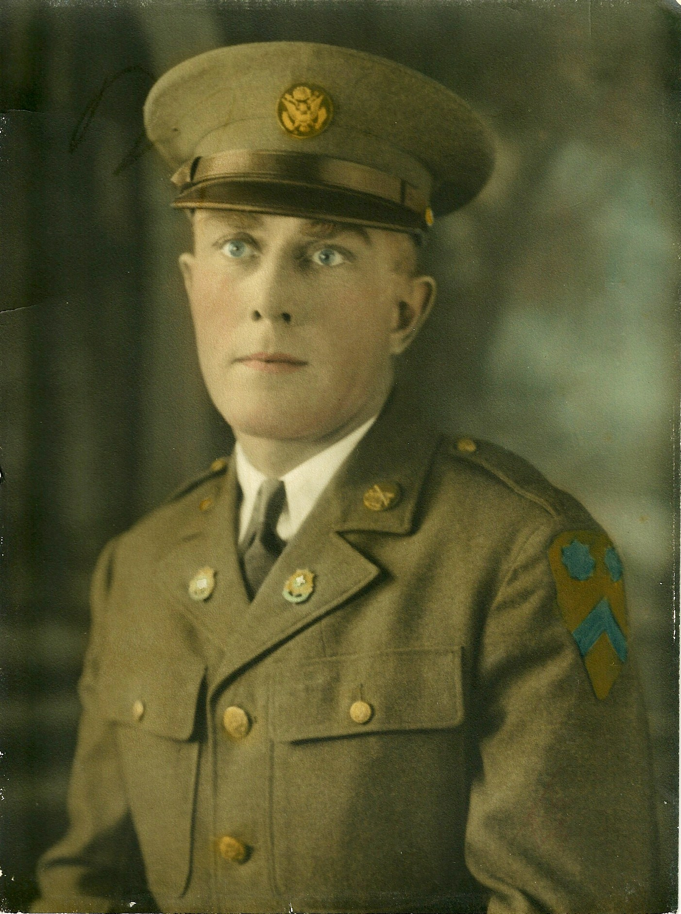
Wesley M. Cope - Army of the United States.

Wesley M. Cope would begin a career in the United States Army with his initial enlistment in 1918, during the First World War. According to military records, Cope is listed as having been born in Summerfield, Kansas, rather than nearby Axtell. His occupation at the time of his original enlistment was given as Teamster for the Railway Express Company of Cushing, Oklahoma. His height was listed as 5’7” and his weight marked as 165 pounds. The military number he would use throughout his enlistment, R4859854.

Throughout the 30 years of his Army service, Wesley Cope would travel to several posts located around the Midwest. His first assignment was to Company A, of the 43rd Infantry. It is believed that his initial training phase was at Camp Travis, Texas.

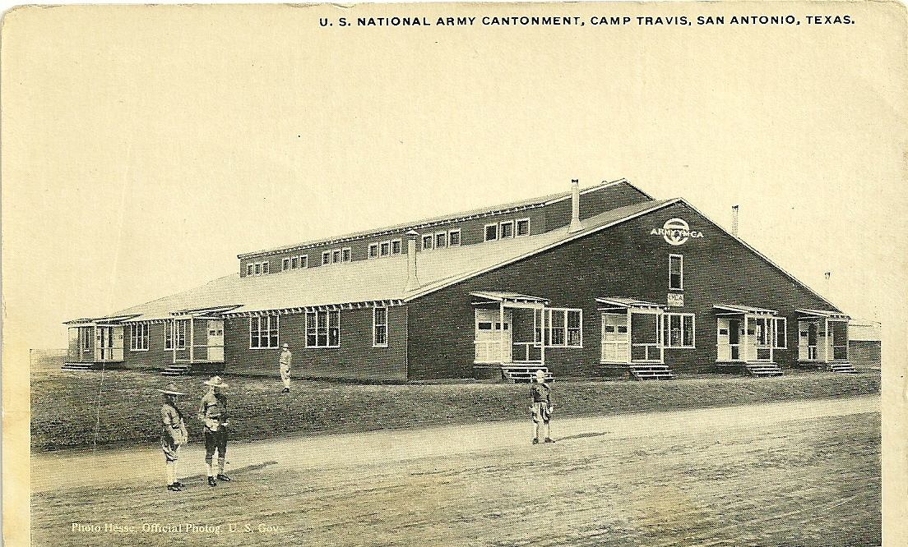
Postcard from the collection of Mary Jean Cope, showing the Army Cantonment at Camp Travis, Texas. It is estimated that the picture was taken sometime around World War I.
When the United States entered World War I, thirty-two training camps were set up. Half of them were "tent cities" and were for National Guard Units while the other half had wooden barracks for the regular Army.
Camp Travis was situated a few miles from downtown San Antonio, adjoining Fort Sam Houston. Originally the name was Camp Wilson, named after the man who "kept us out of war." After WWI ended, Camp Travis would be absorbed into Ft. Sam Houston.
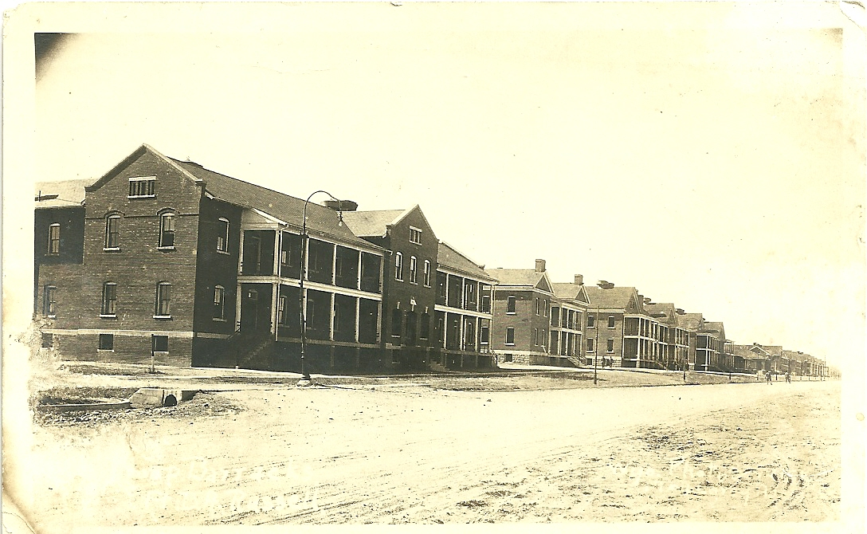

Post cards of early post assignment at Camp Logan. (Cards from collection of Mary Jean Cope)

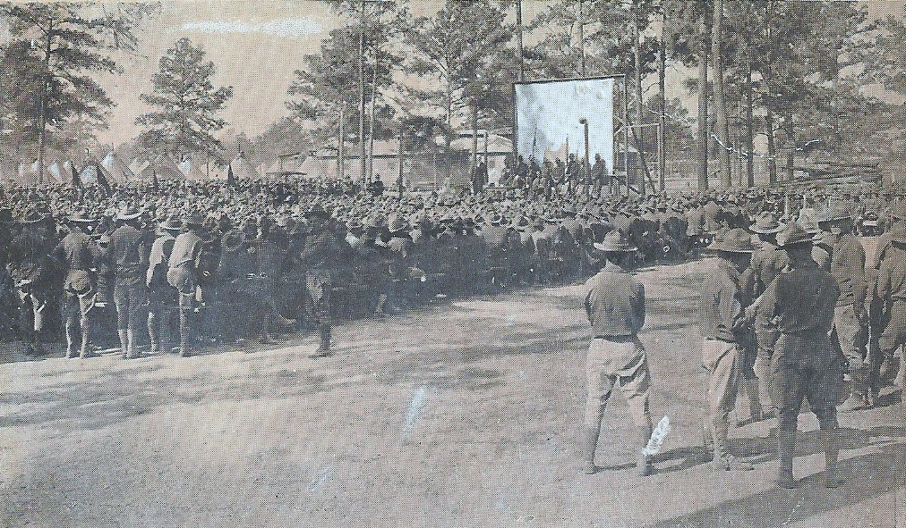

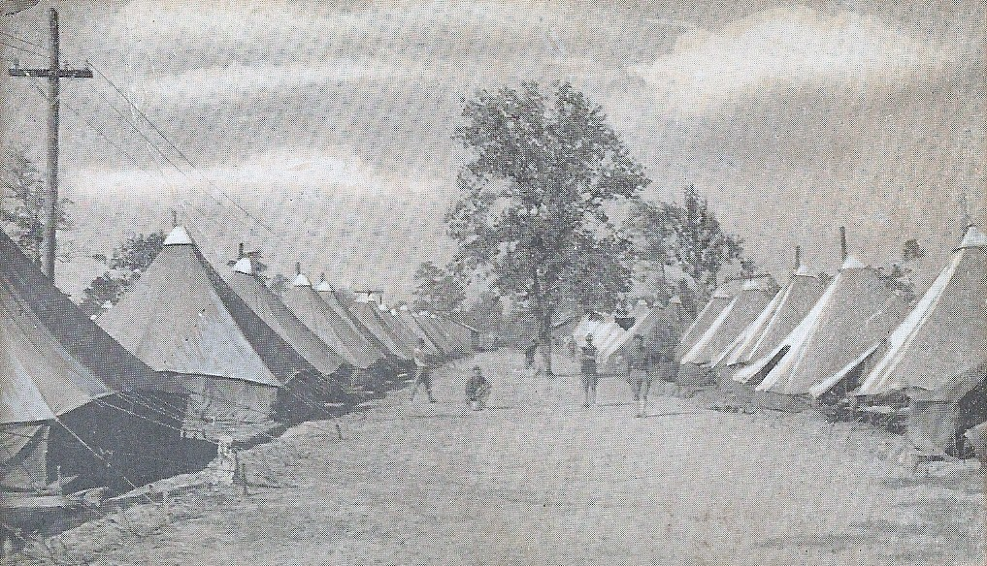
World War I tent camp, set up to house the many draftees during training before heading over to Europe for the “war that ends all wars.” (Post card of Mary Jean Cope)

In his early years in the military, Wesley Cope would box in army camp bouts and establish himself as very handy with his fists. He would also work with the final cavalry divisions of the US Army. Grandson Brad Jones recalls stories about his grandfather’s favorite mount “OP-47.” As was custom at the time, the name of the horse was actually placed on the “dogtag” of the soldier. In stories to his grandchildren, it was always clear how important the soldier’s mount was to him. However, in time as the mounted cavalry was gradually edged out in favor of mechanized forms of travel, Cope would move on to other assignments in the Army.
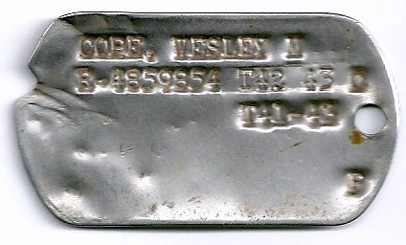
Early “Dogtag” of Wesley Cope, from the collection of his daughter Irma Jones.
As the years went by, Wesley Cope would end up assigned to Ft. Riley, Kansas, a major cavalry post for the United States Army even during the transition to a mechanized force. It was while he was stationed at Ft. Riley that he met his wife to be, Grace Elizabeth Cook McCall, during a visit to nearby Ellsworth, with a buddy. With his union to Grace in the late 1930s, Wesley Cope became father to his wife’s two daughters Fern and Irma. In 1941 the family would add a son Dennis Wesley Cope to the fold. PaPo (pronounced paa po), would be the moniker Wesley Cope would be called by his children and grandkids.

The Cope family would make frequent moves with the Army. Irma Jones remembers changes in schools and locations on almost a yearly basis. One of the first assignments for the new family was at Fitzsimons Army Medical Center, a medical facility of the United States military located in Aurora, Colorado. The facility was founded by the United States Army during World War I, arising from the need to treat the large number of casualties from chemical weapons in Europe.

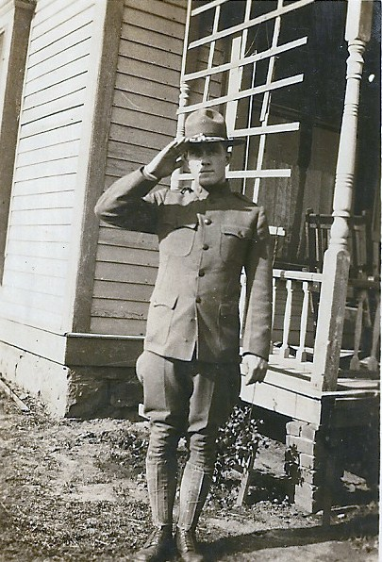
Wesley Cope in an earlier uniform while assigned
to a post in Oklahoma. (Cope family photo)

Later Cope was assigned to Southern Texas, where a hurricane hit the area. Military assignments for Wesley Cope would direct him from Texas to Oklahoma, then Louisiana, and then southern California. With the move to California, the family settled in a home just one block from the ocean in San Luis Obispo. The family could see the waves of the ocean from the window of their home.

One reason for the regular transfers of Wesley Cope, was a chronic problem he had with emphasympia. According to daughter Irma Jones, supervising officers kept Wesley Cope from being sent overseas into combat areas as World War II developed by reassigning him just before deployment of units. It allowed Wesley Cope to remain in the Army without facing the hardships of combat zones with the additional handicap of a lung deficiency.

Wesley Cope would next be assigned to the Army Air Corp and was stationed at Maxwell Airfield in Alabama in the early 1940’s. At Maxwell, near Montgomery, large numbers of airmen were being trained in the bombers being used for war in Europe and the Pacific. On Saturday nights the family would sometimes attend social events at the huge mess hall on post. There a stage would take the place of food lines and soldiers and their families would enjoy music and dancing.

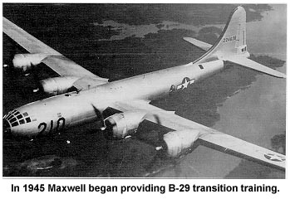
A Super fortress bomber like the ones observed daily by the Cope family, flies above Alabama in this historical file picture from Maxwell Airfield, Montgomery, Alabama.

Because he was older than many of the young cadet airmen, Wesley Cope often befriended young soldiers who ended up at the family home for dinner. There his wife Grace fixed home cooked meals for those cadets away from home. In return, some of the airmen would fly low over the Cope home as they took off on training missions. Flying so low the Cope children could see the soldiers inside the planes, the pilots would tip the wings of their huge bombers as if to say “thanks so much.”

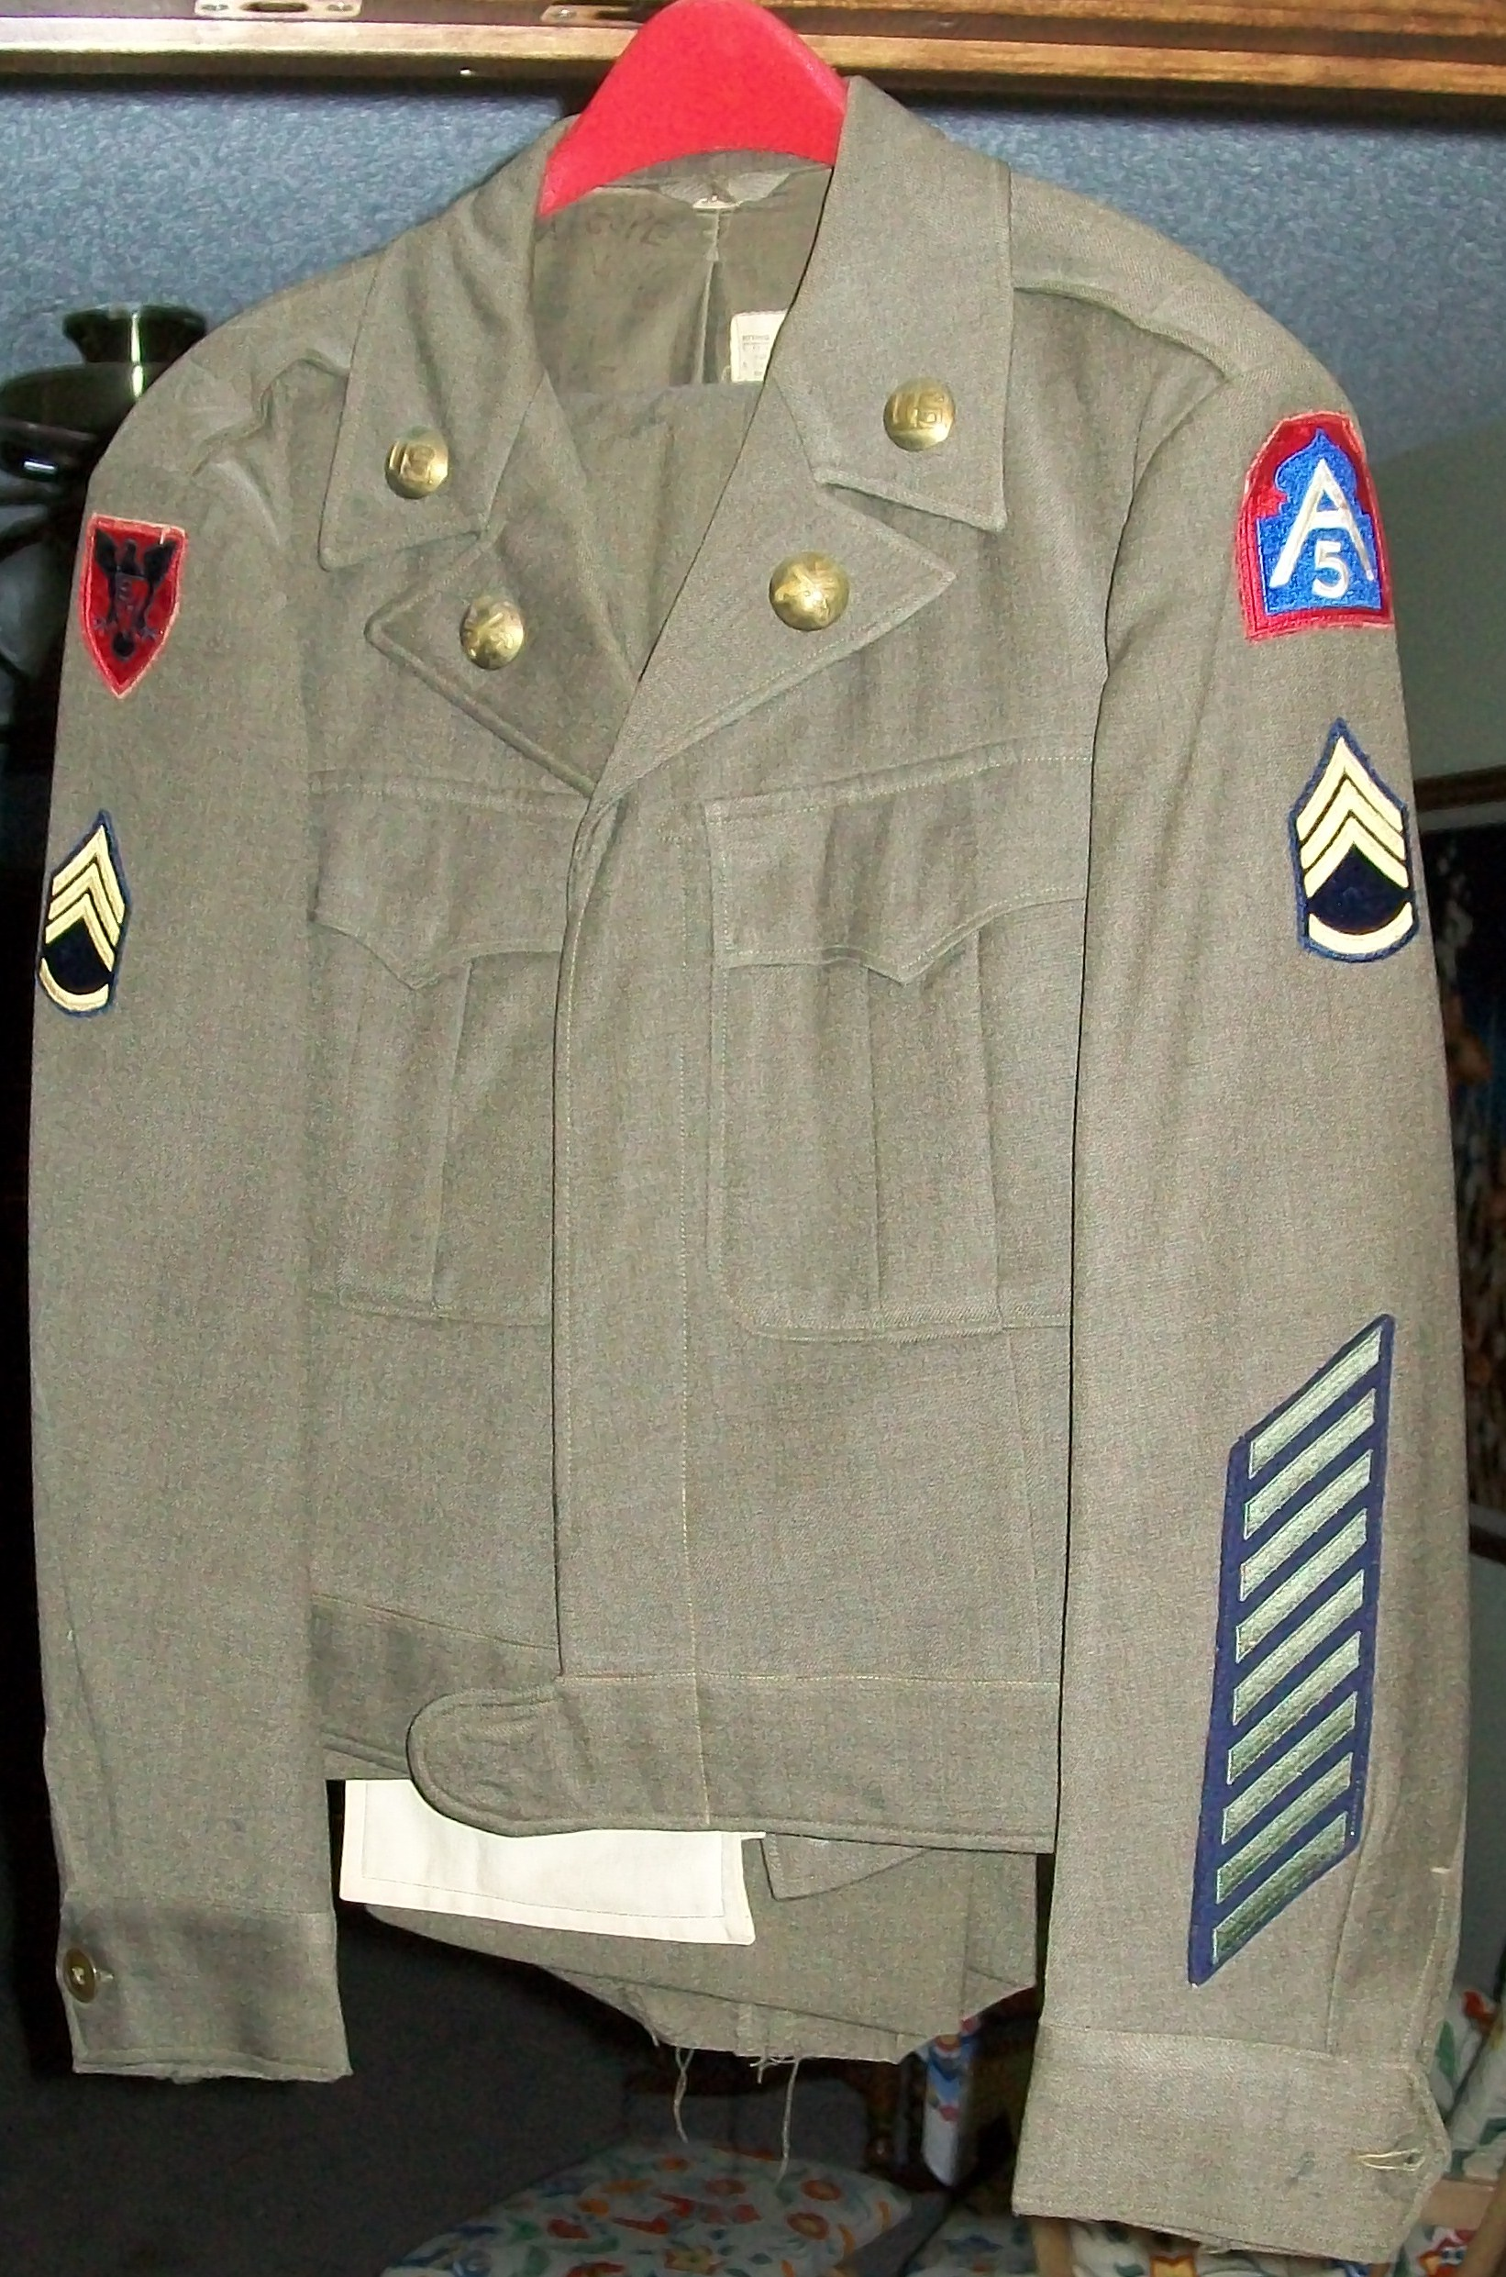
Dress uniform from late in the military career of Sgt. Wesley Cope,
showing the 5th Army patch and 9 of the eventual 11 “hash marks”
for time in service. (Uniform from the family collection of Irma Jones)

Eventually Wesley Cope would be transferred back close to home at the Smoky Hill Bombing Range near Salina, Kansas, and then to the Dakotas. Finally, at the request of his wife, Wesley secured a transfer to Ft. Leavenworth, Kansas, in 1947-1948. At Ft. Leavenworth he would switch over to the MP detachment. Cope remained assigned to Ft. Leavenworth until he took his retirement from the Army, November 30, 1950.
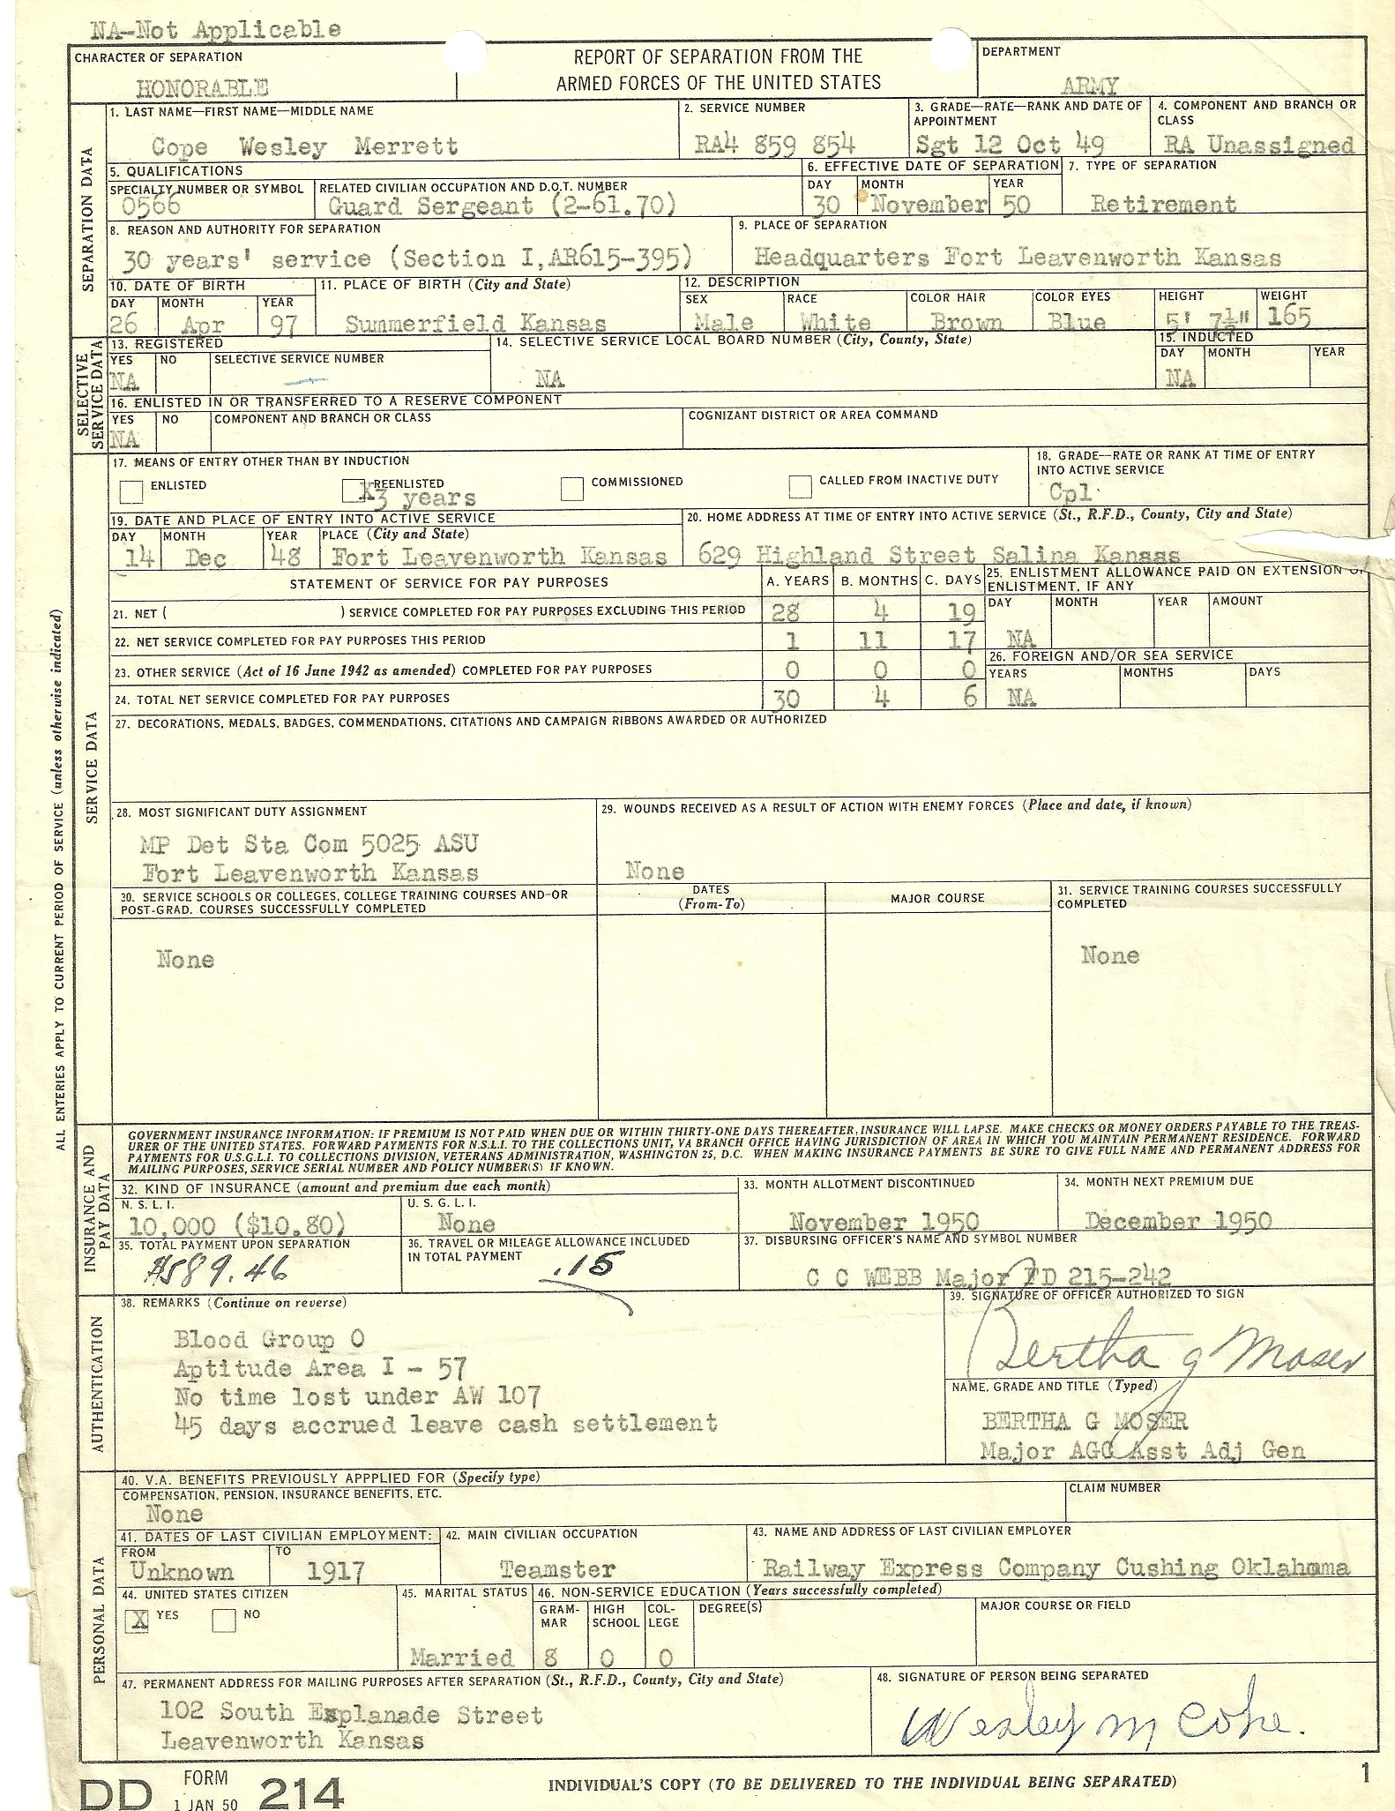

Military “DD-214” discharge records for the retirement of Wesley Merrett Cope in November of 1950. (Records from the family files of Mary Jane Cope)

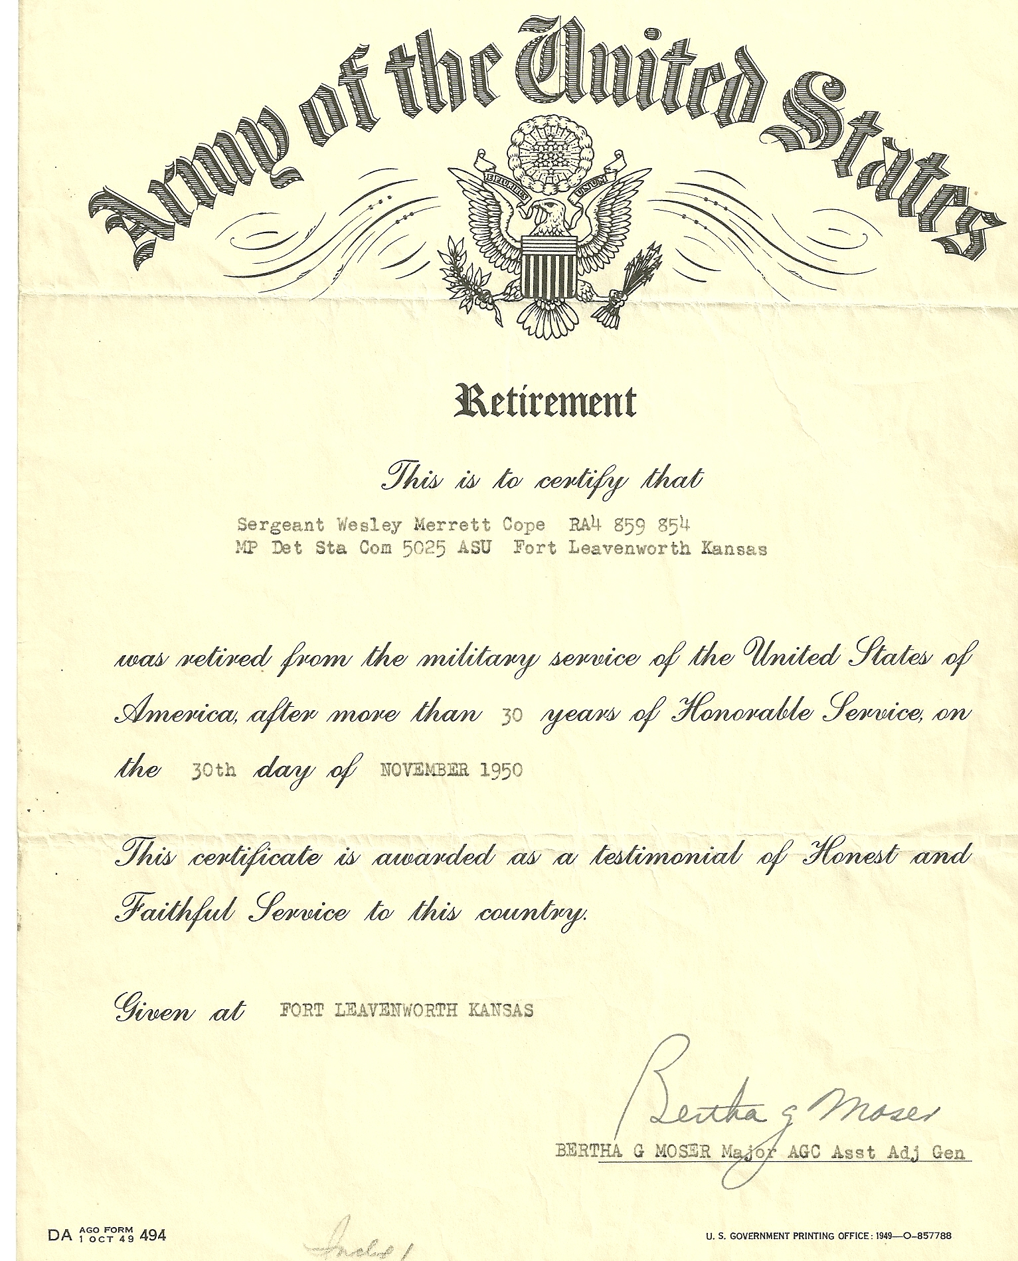
Final discharge document for Wesley M. Cope. (From the family files)

The Cope family remained in the eastern Kansas region after he retired from the military in 1950. Preceded in death by his wife Grace from a car accident in December of 1960, Wesley Merrett Cope passed away in June of 1987 at the age of 90. He is buried in the Sunset Gardens Cemetery just west of Leavenworth, Kansas.

