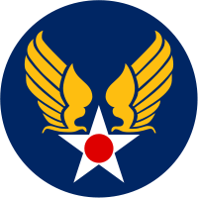

Albert F. White, Jr.
United State Army Aviation
1953-1956

Albert F. White, Jr., was born in San Jose, California, June 2, 1935, to Albert F. and Dorothy (Stoddard) White. In addition to Al, there was also a half-sister Helen Chisholm. His early years were all about Southern California and the LA scene. He attended high school at the famous Hollywood High with the Smothers Brothers and Dave and Rick Nelson. He was both a roller skating bum and a fan of the beach scene and sailing.

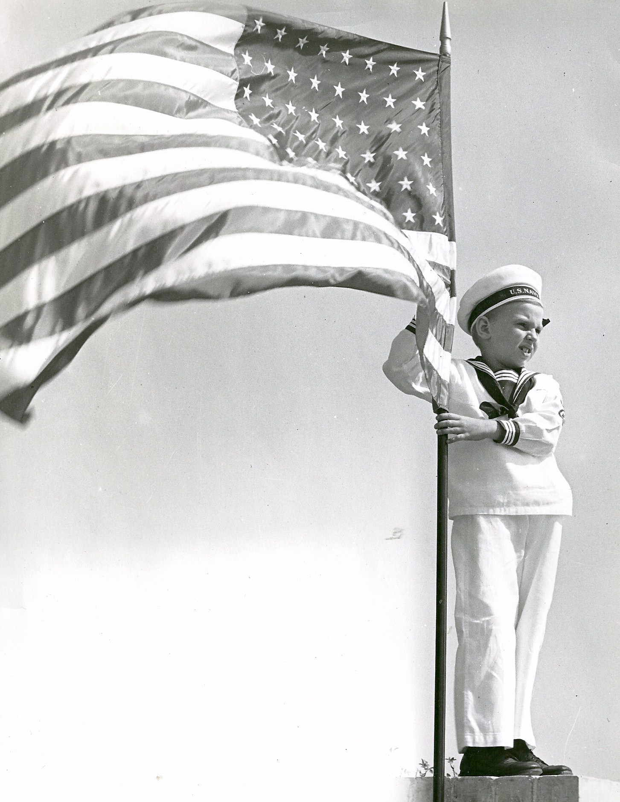
Al White at age 7, posed in a sailor suit with the
American flag, just after Pearl Harbor.

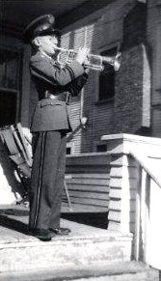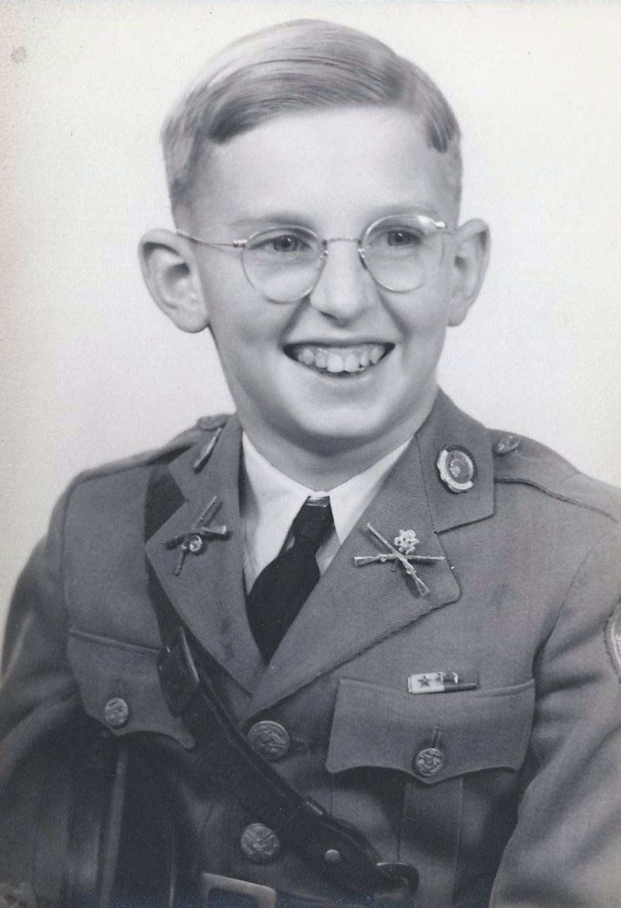
Southwestern Military School uniform in 1946.

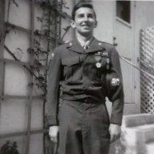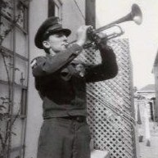
Al White in high school Junior ROTC uniform and with trumpet.

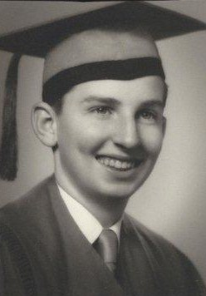
High School graduation photo, Al White

Graduating from high school in 1953, Al enlisted in the United States Army Aviation Corps to be a mechanic and eventually was assigned to work on the helicopters that were becoming part of the new “air cav.” At one point in his early training, the young soldier was offered the option of changing his MOS and going into missiles. He did not switch, but several friends in the military who went into that field ended up launching the first US satellites.

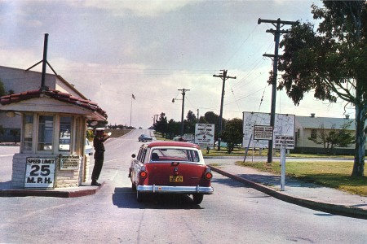
Main gate to Ft. Ord, California in early 1950’s.

Basic training was at Ft. Ord, California, and then followed with stops at Ft. Sill, Oklahoma, San Marcos, Texas (air base), then Ft. Carson, Colorado for reassignment, and then finally Ft. Riley, Kansas where he joined a helicopter outfit. He remembers his time on the Kansas plains as a far cry from the warmth of Southern California.

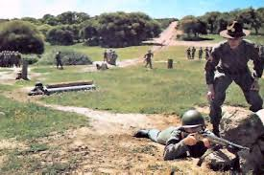
Training course at Ft. Ord.

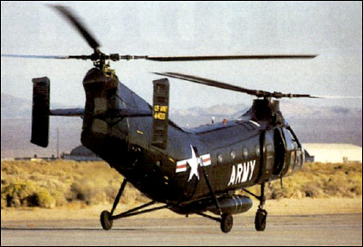
H-21 Shawnee “Flying Banana” helicopter, one of the choppers
serviced by Al White while stationed at Ft. Riley.

Fort Riley was an early beneficiary of the helicopter's increased importance in post-Korean war U.S. Army air missions, becoming home to the 5th Army's first helicopter training facility. In the fall of 1954, when Al White arrived at Ft. Riley, the base was using the H-21 Shawnee “Flying Bananas” and H-25 “Mules,” twin rotor helicopters. The 98th Transportation Army Aircraft Repair Detachment at Fort Riley was the only unit of its type in the 5th Army area in 1954, and serviced all of the planes for the region. Working largely in the hangars at Marshall Field, the unit worked primarily on engines, instruments, and rigging.

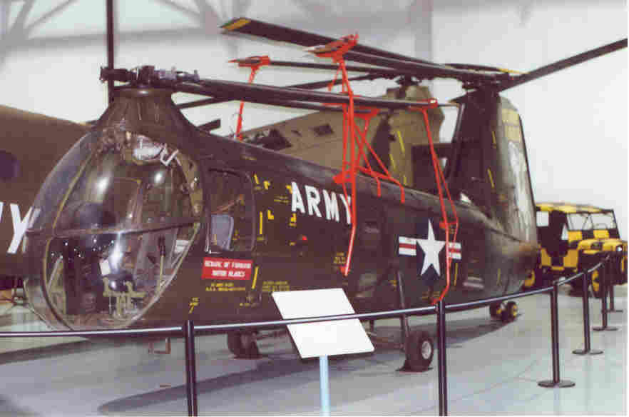

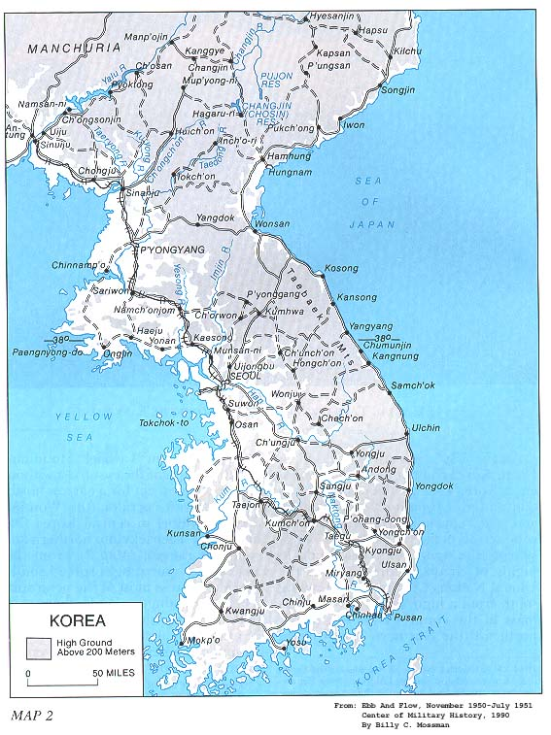
Military map fro early 1950’s of South Korea.

In the winter of January-February of 1955, Albert White was sent to the air base at Munsan-ni, South Korea. Munsan-ni lies along the south bank of the Imjin River. Munsan-ni had a heavy military presence because it reached the South Korean border with North Korea. A combined Army Air facility, the base sent out DMZ flights the first thing every day.

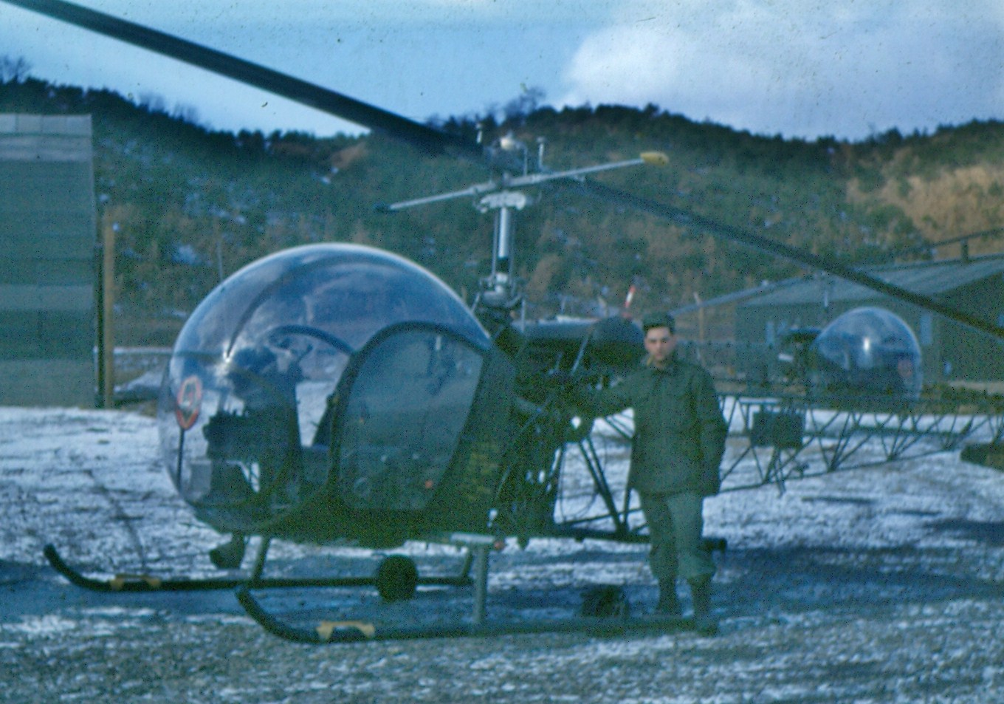
Small helicopter at Munsan-ni in 1955-1956. (Photo by Al White)

Some of his memories of his tour of duty to South Korea include trading plane rides for help building showers. His GI ingenuity provided him with a “bird‘s eye view” of South Korea and the pilots with an opportunity for freshening up.

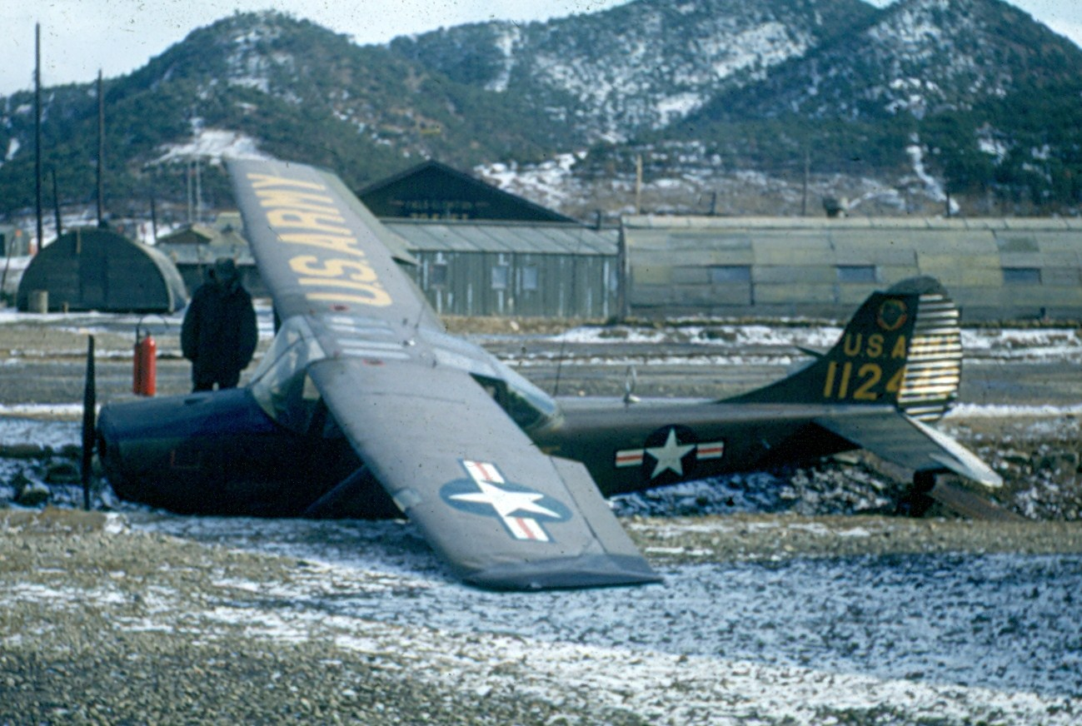
Spotter plane that ran off runway. (Photo by Al White)

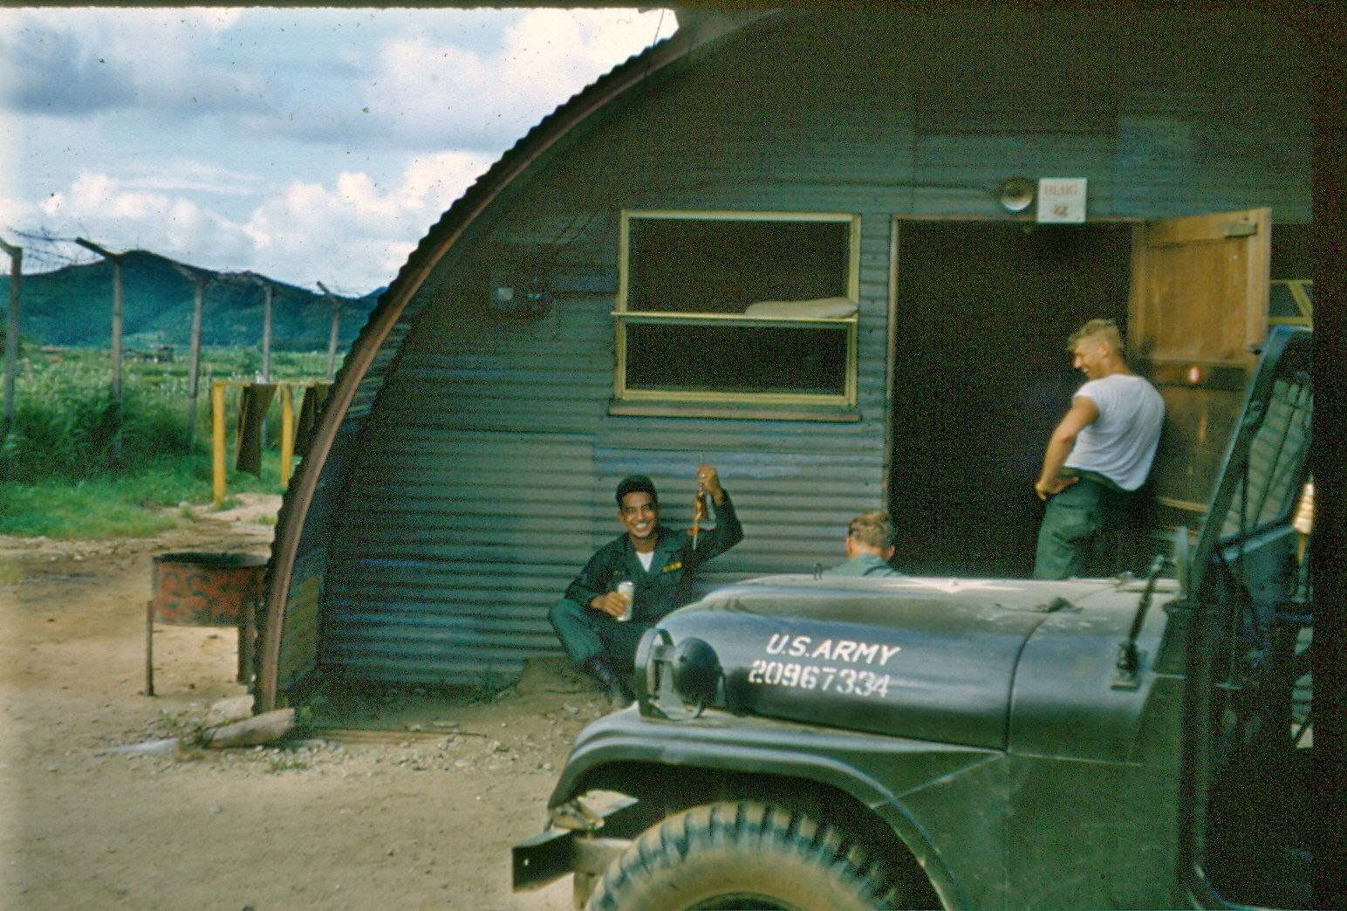
Living quarters at Munsan-ni in the mid-50’s were far from plush. (Photo by Al White)

Al White remembers that beer always tasted the same in South Korea, “crappy,” it did not matter what brand you bought. Enterprising South Koreans would sweat solder the tops off American beer brands and then fill the cans back up with Korean beer and solder the tops back on, keeping the good imported beer for special clients.

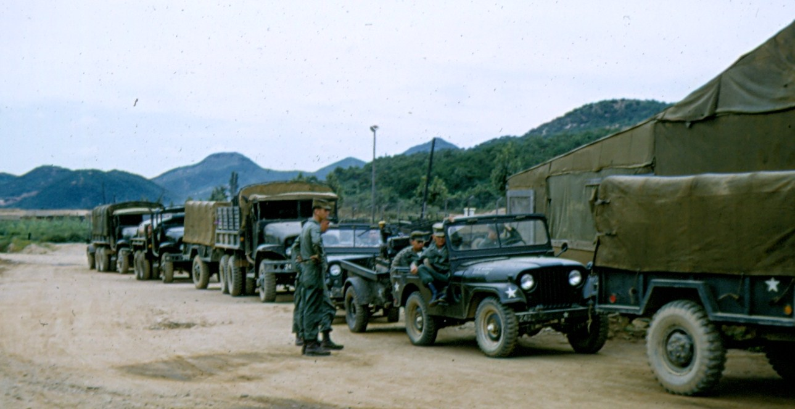
Military convoy in South Korea with supplies for troops in 1956. (Photo by Al White)

One of his more nerve racking events while in South Korea involved flying to Japan on “R & R” from Seoul. As the C-124 plane he was on tried to get up speed to take off, Al questioned whether it would ever get into the air. Later in Yokahama, Japan, he remembers riding three-wheeled transportation that were, “glorified scooters.” The breaks from South Korea to Japan were a welcome relief from the harsh weather and conditions at the post near the DMZ between North and South Korea.

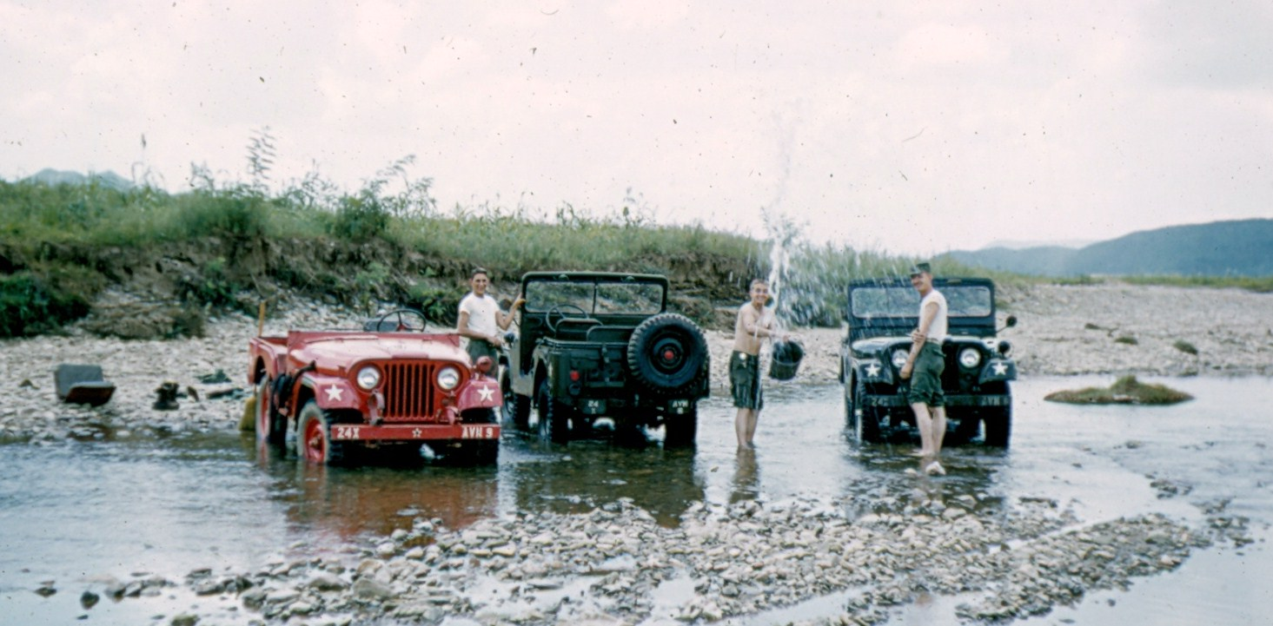
Soldiers wash jeeps in the Imjin River near the post. (Photo by Al White)

As his time in service came to a close, Al White, Jr., was sent back to Ft. Ord, California, where he was Honorably Discharged in October, 1956.

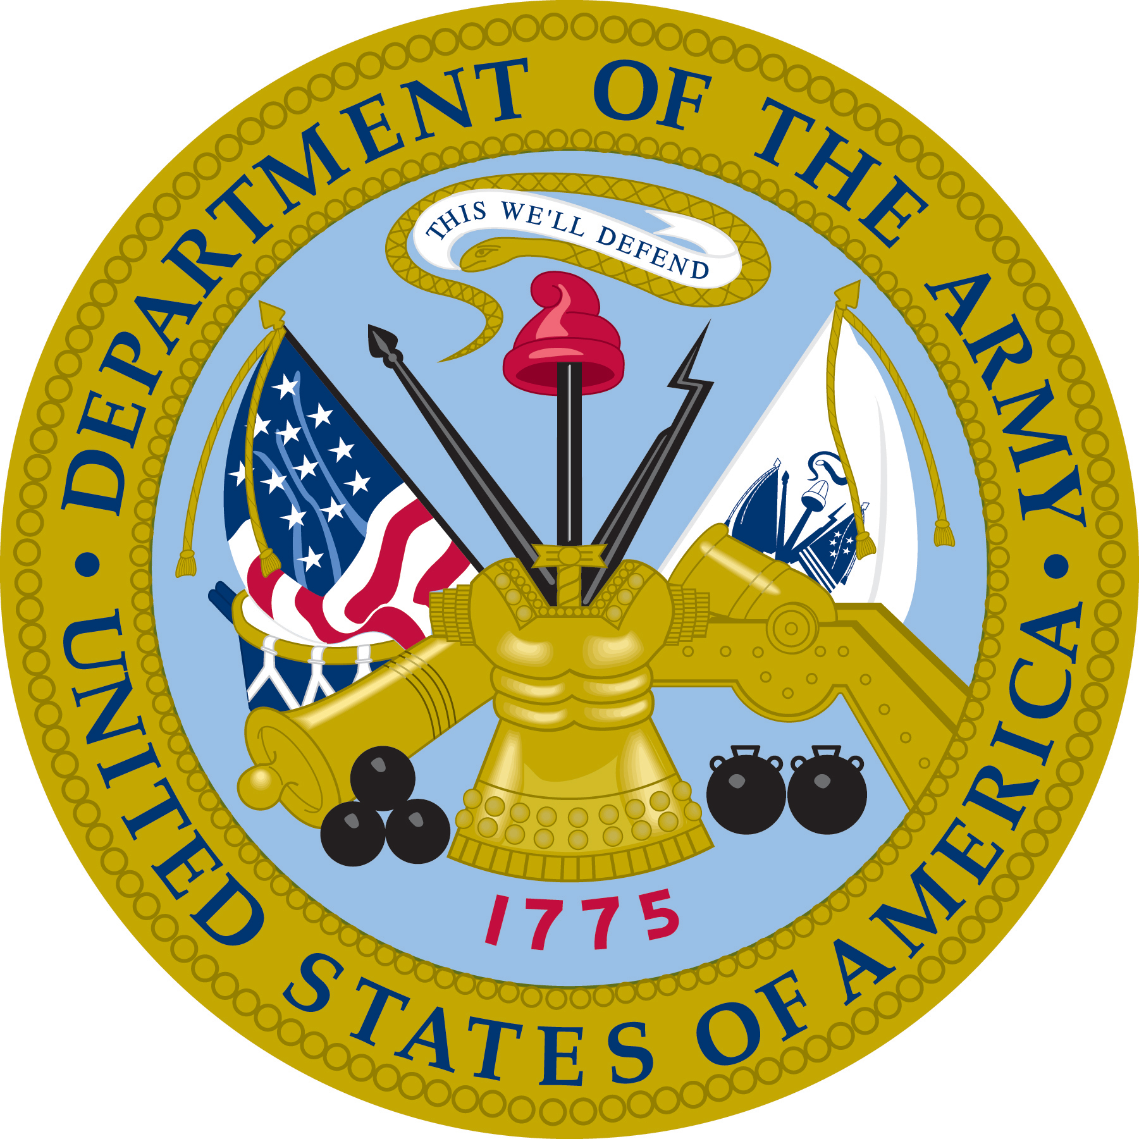

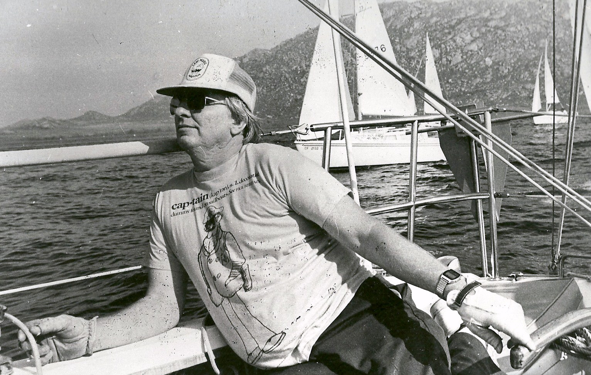
Al White, Jr. relaxes aboard his Catalina 25 Swing Keel at Lake Paris, in
RiversideCounty, California, in the mid-1980’s.

After living and working in Southern California for many years, he would move to Texas in the 1990’s. Al would join the Johnson family in January of 2000, with his marriage to Elizabeth Hamler. The couple is now retired and lives in the Dallas-Ft. Worth area in Roanoke, Texas.

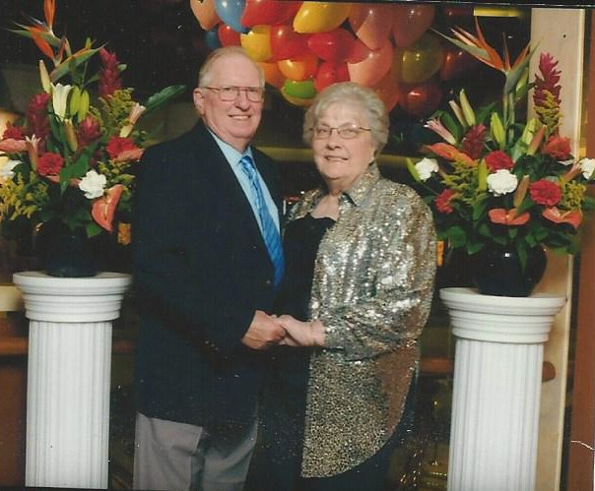
Al and Elizabeth White enjoying a cruise in 2010.

