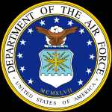

Benjamin Clay Alderson
US Air Force (1980-2002)

Ben Alderson was born in the Teton Mountains in Jackson, Wyoming, July 28, 1962. The oldest of three children born to Clay and Elizabeth Alderson, Ben grew up living in a variety of scenic locations around the country as his father worked for the National Park Service. He graduated from high school in Cedar City, Utah, and immediately enlisted in the US Air Force in July of 1980. The young airman would then spend 22 years faithfully serving his county working on Jet Engines and insuring proper operation of the government’s classified electronic communications systems. He would also traverse the world to fulfill the mission when and where he was needed.
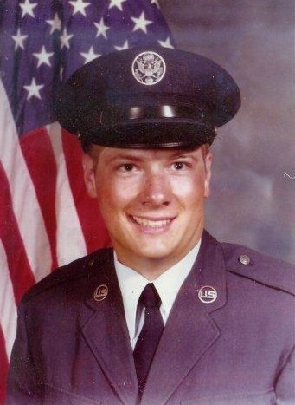
Ben Alderson, age 18, at Basic Training at Lackland AFB, July, 1980.
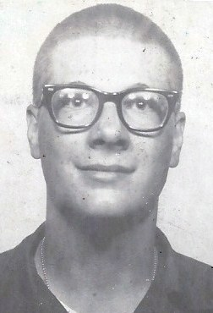
Boot camp photo of Ben Alderson, 1980.

Initially Ben received training in Aerospace Propulsion from the Air Force and worked for about four years as a fighter jet Journeyman Mechanic. His first assignment sent him to Nellis AFB in North Las Vegas, Nevada, just a short distance from his family in Cedar City, Utah. An installation of the Air Combat Command, Nellis is the location of the United States Air Force Warfare Center and is a major training location for both U.S. and foreign military aircrews.

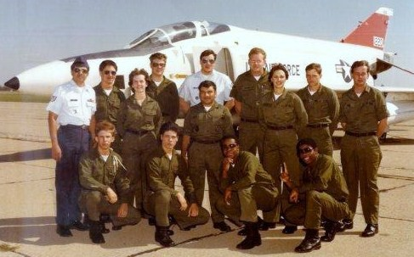
Ben Alderson stands (4th from the left) with other mechanics at Jet Engine
School, in September of 1980, at Chanute AFB, Illinois.
Ben Alderson later moved into the field of electronics, receiving training in computers and electric switching systems, advancing into the high tech field of Secure Systems. In 1984 he received advanced training at Lackland AFB, San Antonio, Texas for Secure Communications Systems Maintenance. The young airman would then spend the next18 years monitoring and keeping in operation some of the government’s classified electronic communications systems.

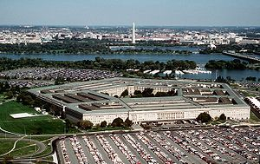
Southwest view of the Pentagon, with the Potomac River in the background.

In 1985, Ben Alderson was assigned to the nation’s capitol to work at the Pentagon for the 1st Communications Squadron and the 7th Communications Group. He remained at this assignment for three years keeping the classified communications lines at the top military post in the United States operational. Working the late night shift much of this assignment, the Airman serviced equipment for the Secretary of Defense, Joint Chiefs of Staff, National Military Command Center, and other DOD leadership. As part of his job he often worked with White House communications to insure secure connectivity between the President and the Secretary of Defense.
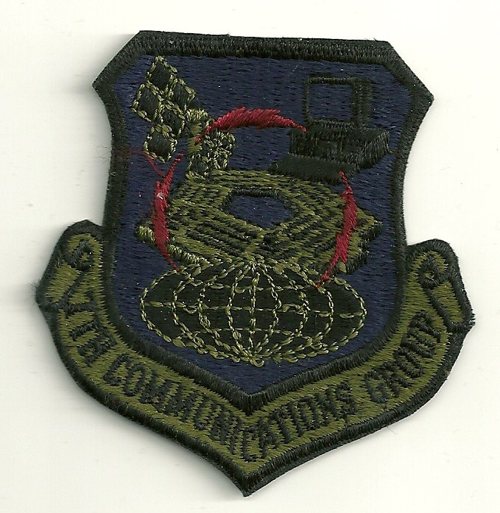
Pentagon Air Force patch.
The next stop in his Air Force career, stationed Ben in Germany from 1988-1990 at the Ruppertsweiler Underground Facilty. This facility was originally an underground bunker created by Hitler to monitor the French. During this tour he was assigned to NATO working on the Initial Voice Secure Network or IVSN telephone switch. During this tour Ben spent almost 6 months deployed to the NATO Communications School in Latina, Italy. Back in Germany, Ben was key to the operation of the NATO telephone switch that insured secure voice communications between the NATO member countries.

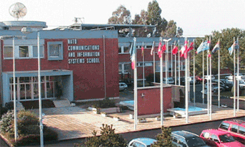
NATO Communication and Information Systems School (NCISS) - Latina, Italy

From Germany, Alderson was scheduled to return to the Pentagon, but at the last moment was diverted to Woomera, South Australia. He would remain “down under” from 1990 to 1992. There his duties involved monitor and repair of dedicated circuits to Peterson AFB, Colorado. These circuits were used for satellite tracking of events in South West Asia, which was critical during the first Gulf War.

Living conditions in the Outback reflected a lack of water and a focus on the military. Of the 1,800 residents of Woomera, everyone either worked for the military or supported them. Water for the community was piped nearly 300miles. To prevent golf balls from rolling away since there was no grass, the local golf course supplied duffers with a small patch of indoor-outdoor carpet.

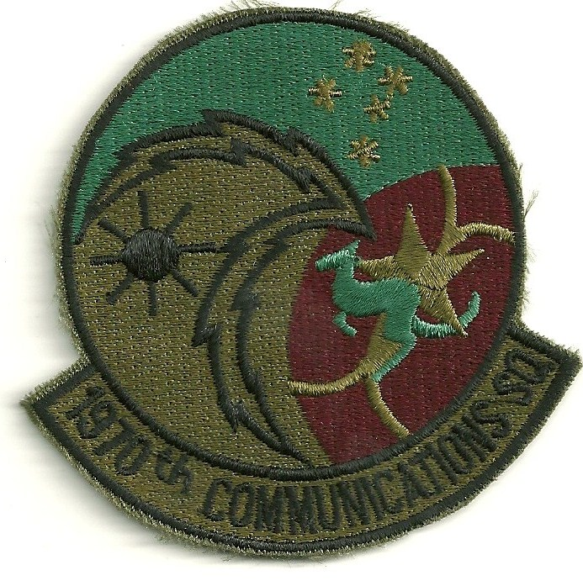
Australian military patch for uniform

After two years in Australia Ben once again jumped over the United States and spent 1991 to 1994 assigned to Alconbury Air Base, England, and stationed at RAF Molesworth. Molesworth Air Base was a very important Air Base during WWII. The Eighth Air Force flew many historic missions out of Molesworth deep into Europe.

Ben was assigned to the Communications Squadron as part of the 10th Air Base Wing and the 423rd Air Base Group. Ben was in England to support the buildup of the Joint Analysis Center (JAC) at RAF Molesworth. In his spare time Ben became very active with the Rod and Gun Club at RAF Molesworth. Ben spent many off duty hours running Paintball, managing the skeet ranges, maintaining the facility and working at the snack bar during special events.

After three very fulfilling tours overseas, Ben was reassigned to Patrick Air Force Base and the 45th Space Wing, Communication Squadron on the eastern coast of Florida. Patrick AFB is the headquarters for military space launches and large missile tests on the East Coast. Patrick AFB is also home of the Air Force Technical Applications Center which monitors nuclear treaty. Ben was in charge of secure communications with sites as far away as the Indian Ocean and the outback of Australia.

The highlight of Ben’s tour at Patrick was a temporary duty assignment to Thomas Dal Moline Air Field in Vicenza Italy. The assignment was to support NATO Air Force flying missions to support operations in Croatia, Bosnia and Herzegovina and Hungary. As the senior communicator Ben made several trips into these countries to assist units on the ground improve their communications. Ben was even called to Gaeta, Italy to provide technical assistance to the 6th Fleet Flagship the USS La Salle. While Ben was not traveling around the theater he oversaw the modernization of communications for 4ATAF Headquarters facility.

While Ben had planned on retiring in Florida, the Communications Squadron was outsourced so he went to Keesler Air Force Base, Mississippi, in 1998 to finish up his military career. Ben was assigned to the 738th Engineering and Installation squadron. Ben was quickly identified as a skilled technician and leader so he was put through Team Chief School and put on the road traveling to bases all over the US training, mentoring and leading young airman in the engineering and installation of secure communications systems.

Ben also trained several future Team Chiefs as well as several young officers wanting to extend their carriers into engineering or command positions. During Ben’s four years at Keesler he averaged over 300 days a year on the road engineering and installing secure systems.

As Ben was preparing to retire, the September 11th attack on the United States happened. Ben was in Florida packing up his household goods to ship to Montana on September 11th. Upon returning to Keesler his supervisor told Ben that he was exempt from stop-loss, but he had to send a team to Al Dafra, so the Air Force communications specialist extended his time and worked with units in the Middle East during the war.

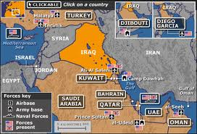
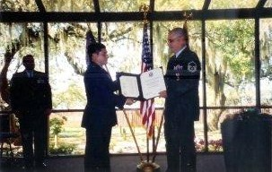
Ben accepts his retirement documents.

Ben Alderson would retire from active military duty with the Air Force on May 31, 2002. At his retirement his supervisor said he did not always do things by the book, but that he always got the job done.

His time with the USAF would span 21 years, ten months, and 21 days. He would leave the service as an E7 Master Sergant. His service record would reflect a number of honors and commendations, including: Air Force Acheivement Medal (OLC), Air Force Commendation Medal 2 OLC’s), Joint Service Commendation Medal (Bronze OLC), and the NATO Medal. He would also receive a number of ribbons for Air Force Service overseas, along with the Air Force Good Conduct Medal and he would qualify as Expert for small arms marksmanship.

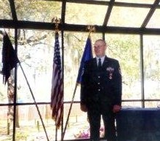

Various Air Force Insignia worn by Ben Alderson.

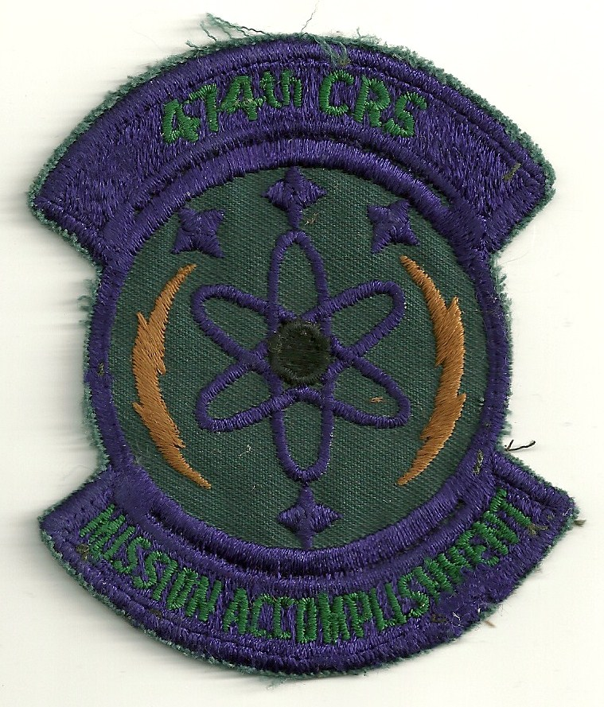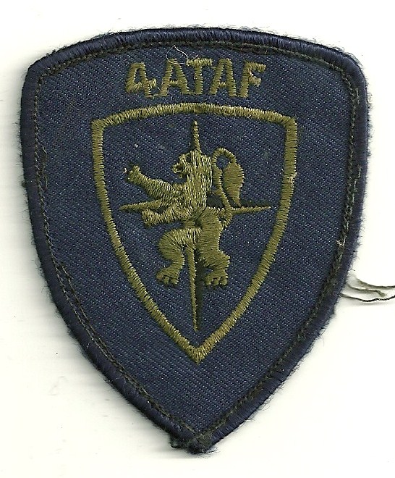
Nellis AFB, Nevada Ruppertsweiler, Germany

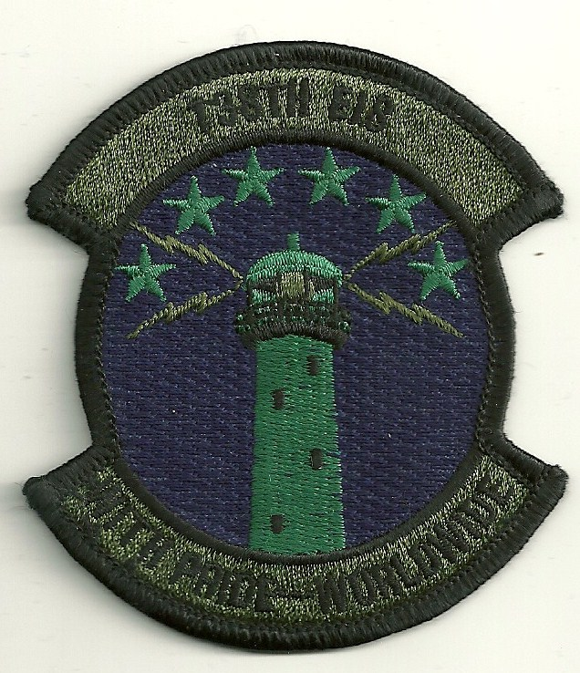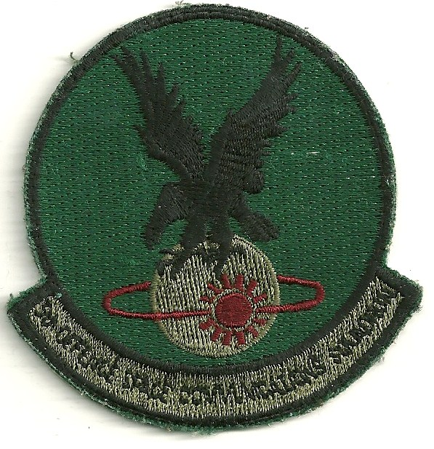
Kessler AFB, Mississippi Patrick AFB, Florida

Upon retirement after 22 years in the Air Force, Ben went to Montanna and took a contract position in charge of the Malmstrom Air Force Base Communications Center. Once again Be identified several ways to improve the way communications were done at Malmstrom. He helped procure new equipment and then trained others how to install and maintain it. He was also called on to provide input on several secutiry and communications issues to improve the way things were done at Malmstrom.

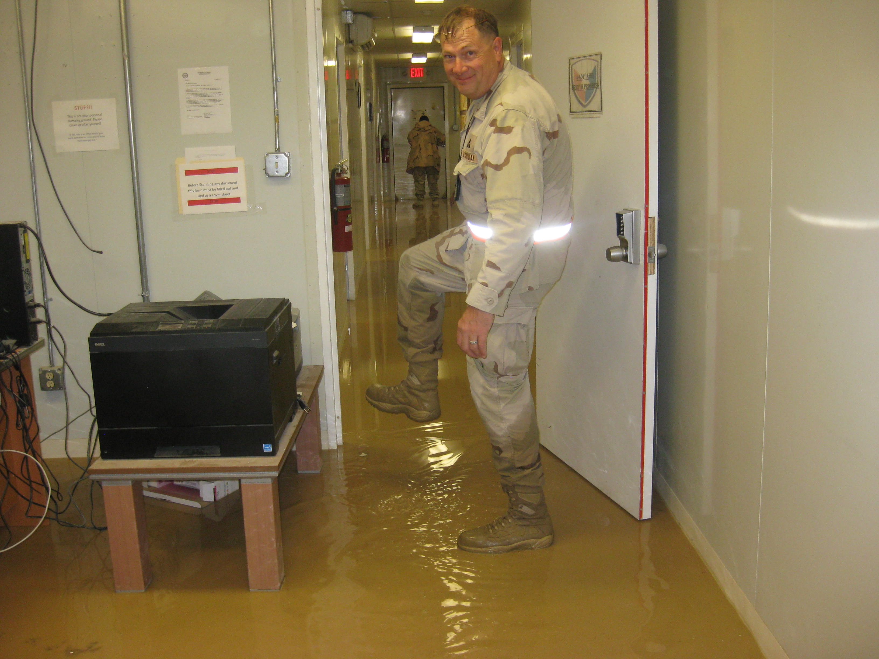
Ben wades through a muddy mess after flooding hits his offices
in Afghanistan in November 2011.

Shortly after the outbreak of the war with Iraq in 2003, Ben was offered a contract position in the war zone. Seeing the opportunity to support the military he packed up and spent much of the next nine years in Iraq and Afghanistan. Even after returning from Afghanistan in 2012, he continued his support of the military by taking a position with the Veterans Administration as an Information Security Officer. As of 2014 he is assigned to the VA offices in Buffalo, New York
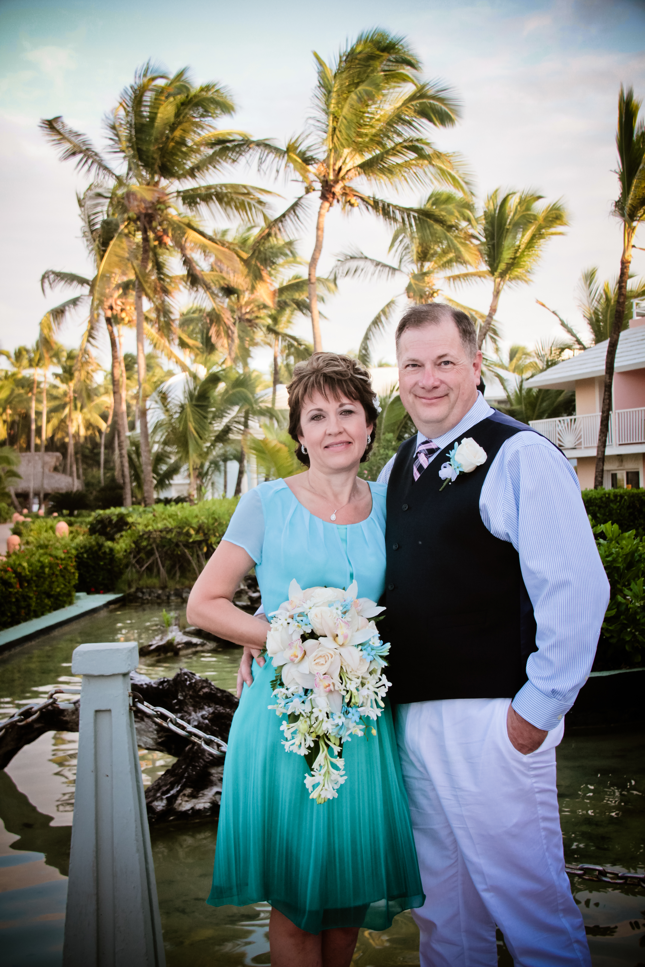
Ben and wife Elena Veselovskaya, December 2013

