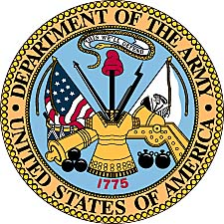
Branden L. Jones
United States Army
(2003-Present)

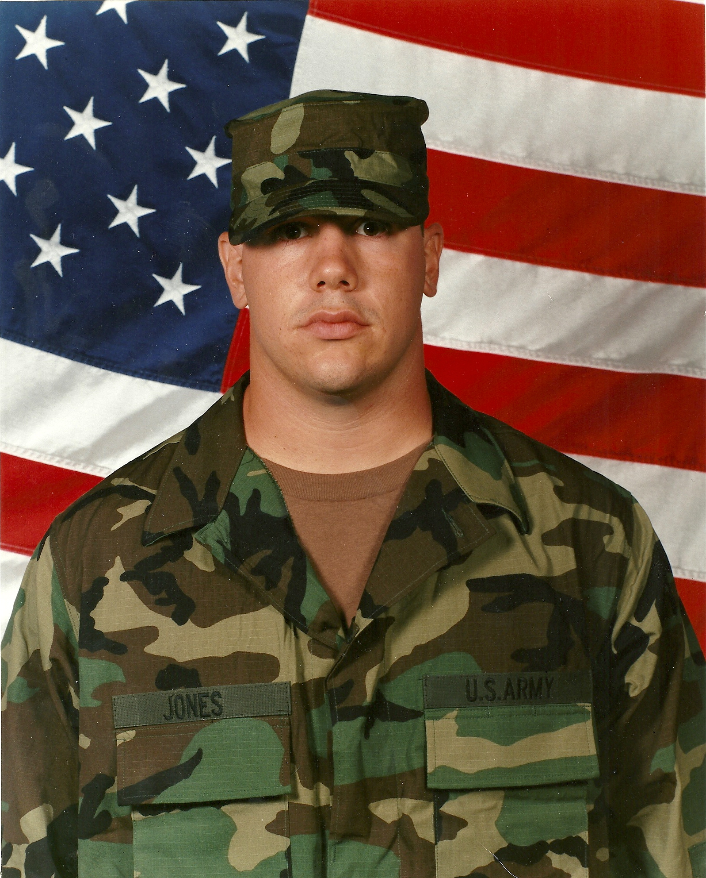
Branden Jones boot camp photo, 2003.

Branden Lee Jones was born April 3, 1981, in Kansas City, Kansas, the son of Greg Alan Jones and Linda K (Houtman) Jones Johnson. Growing up in a blended family, first in KC and then later in Lindsborg, Kansas, Branden was an All Conference performer in both football and track for Smoky Valley High School.

He continued his athletic career at MidAmerica Nazarene University in Olathe, Kansas, where he was a letterman on their nationally ranked football team and earned all league honors in all four years at MNU in track field events. With a BA in Athletic Training, Branden decided to enlist in the United States Army after graduation from college.

Enlisting September 16, 2003, he headed off to Ft. Benning, Georgia for Basic Training. He graduated two days before Thanksgiving. Next, the young soldier traveled to Ft. Sam Houston, San Antonio, for six months medical training at the medical school. His final phase of medical training was completed at the base hospital at Ft. Sill, Oklahoma.

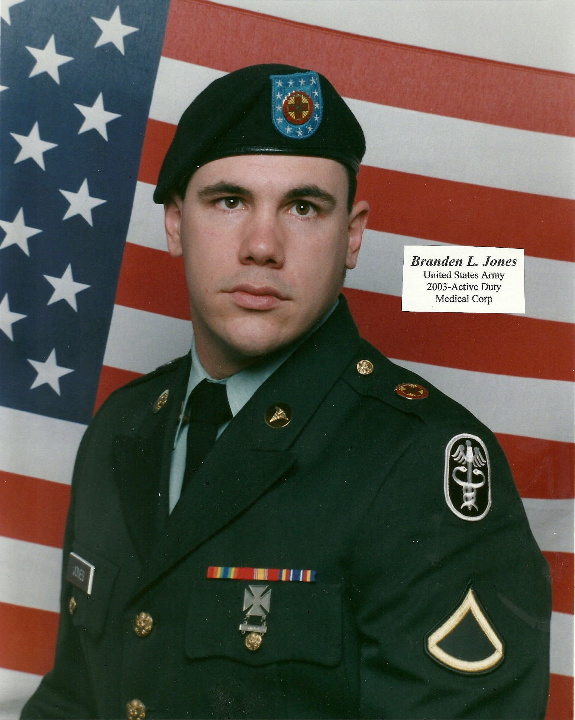
Branden Jones, in the fall of 2004.

In February of 2005, Branden Jones was assigned to the 67th Combat Support Hospital (CSH), Wurzburg, Germany. His primary assignment was that of Medical Technician, but worked much of his duty time as a DEPMEDS. This work involves care of all CASH medical support equipment and transportation.

On occasion the young soldier was called upon to drive the large Army trucks along the German Autobahn. As he recalls his driving on the famed highway, he fondly remembers being passed by vehicles at speeds of 120 plus miles per hour.
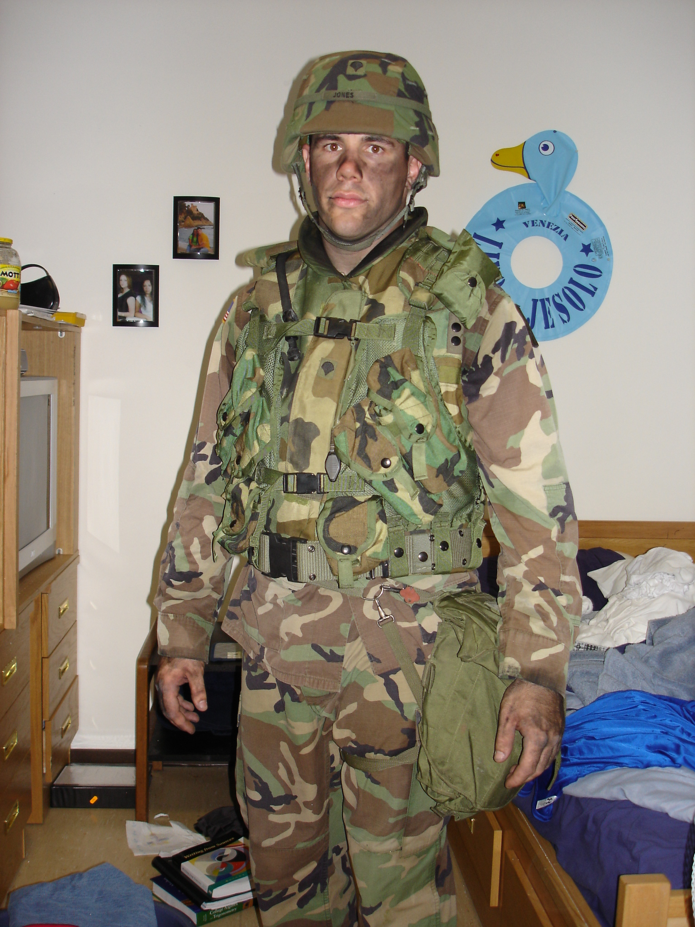
Branden in his room in Germany after field
exercises in 2005. (Photo by Vanessa Arevalo)

The two year assignment to Germany was interrupted in October of 2005, when the 212 MASH unit was deployed to Pakistan for disaster relief after a massive earthquake hit that poor country. The medical detachment deployed with an entire temporary emergency hospital that included 120 regular beds, an ICU, lab, ER, and operating room.

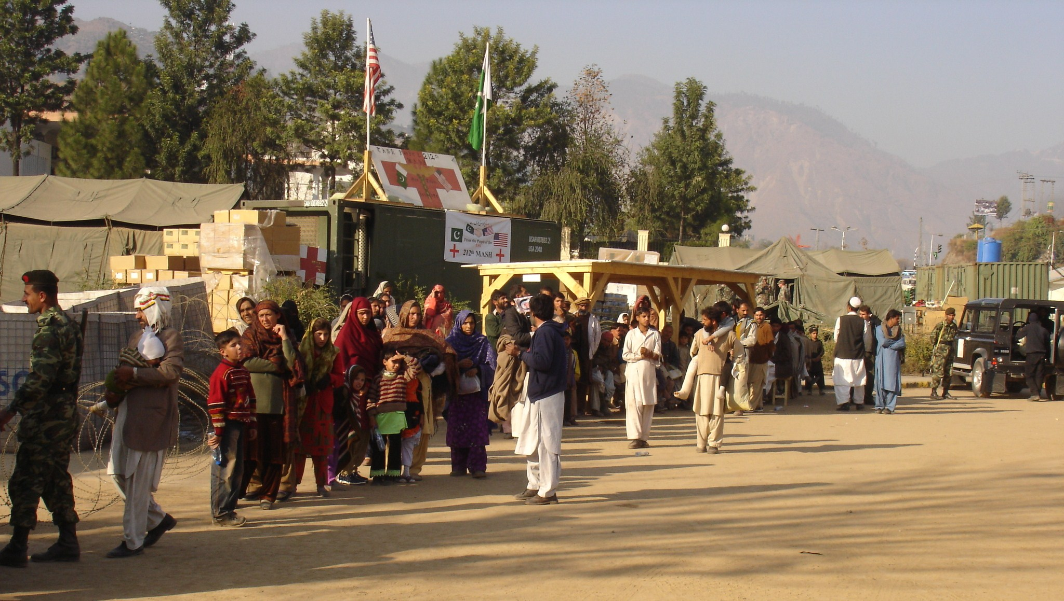
Security checkpoint at the 212 MASH, where long lines formed for medical care.
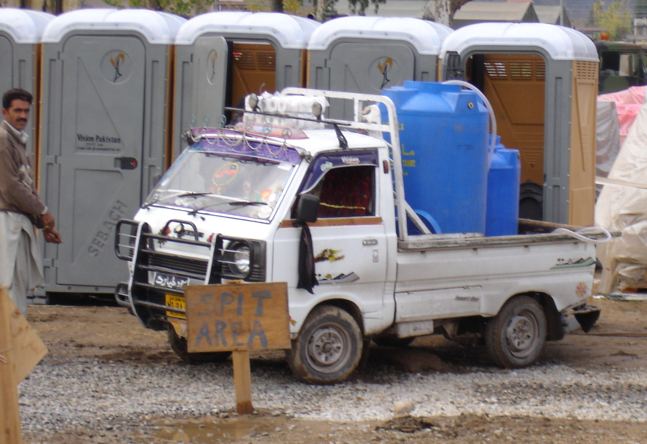
Restrooms during the deployment were portable units,
hand cleaned by Pakistani’s.

Visiting movie star Angelina Jolie, was accompanied by husband Brad Pitt on a
trip to visit the disaster relief effort by the US Army.
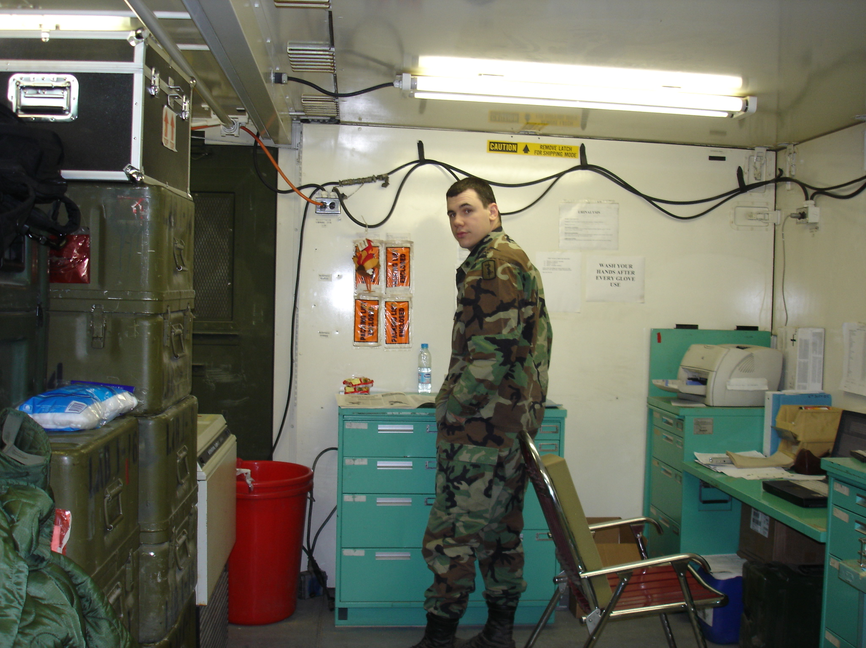
Medical laboratory ISO, providing services for the 212 MASH.

Security for the deployment was high, due to bands of operating Taliban in the region. Soldiers with the 212 MASH were restricted to the hospital area, while Pakistani soldiers provided security. Branden also doubled in “forced protection” duty and was a member of the unit’s Quick Reaction Force (QRF). Late in the deployment, the CIA used rockets and drones to destroy a nearby Taliban terrorist camp and in 2011, America would learn that Osama Bin Laden was hiding in a nearby Pakistani city.

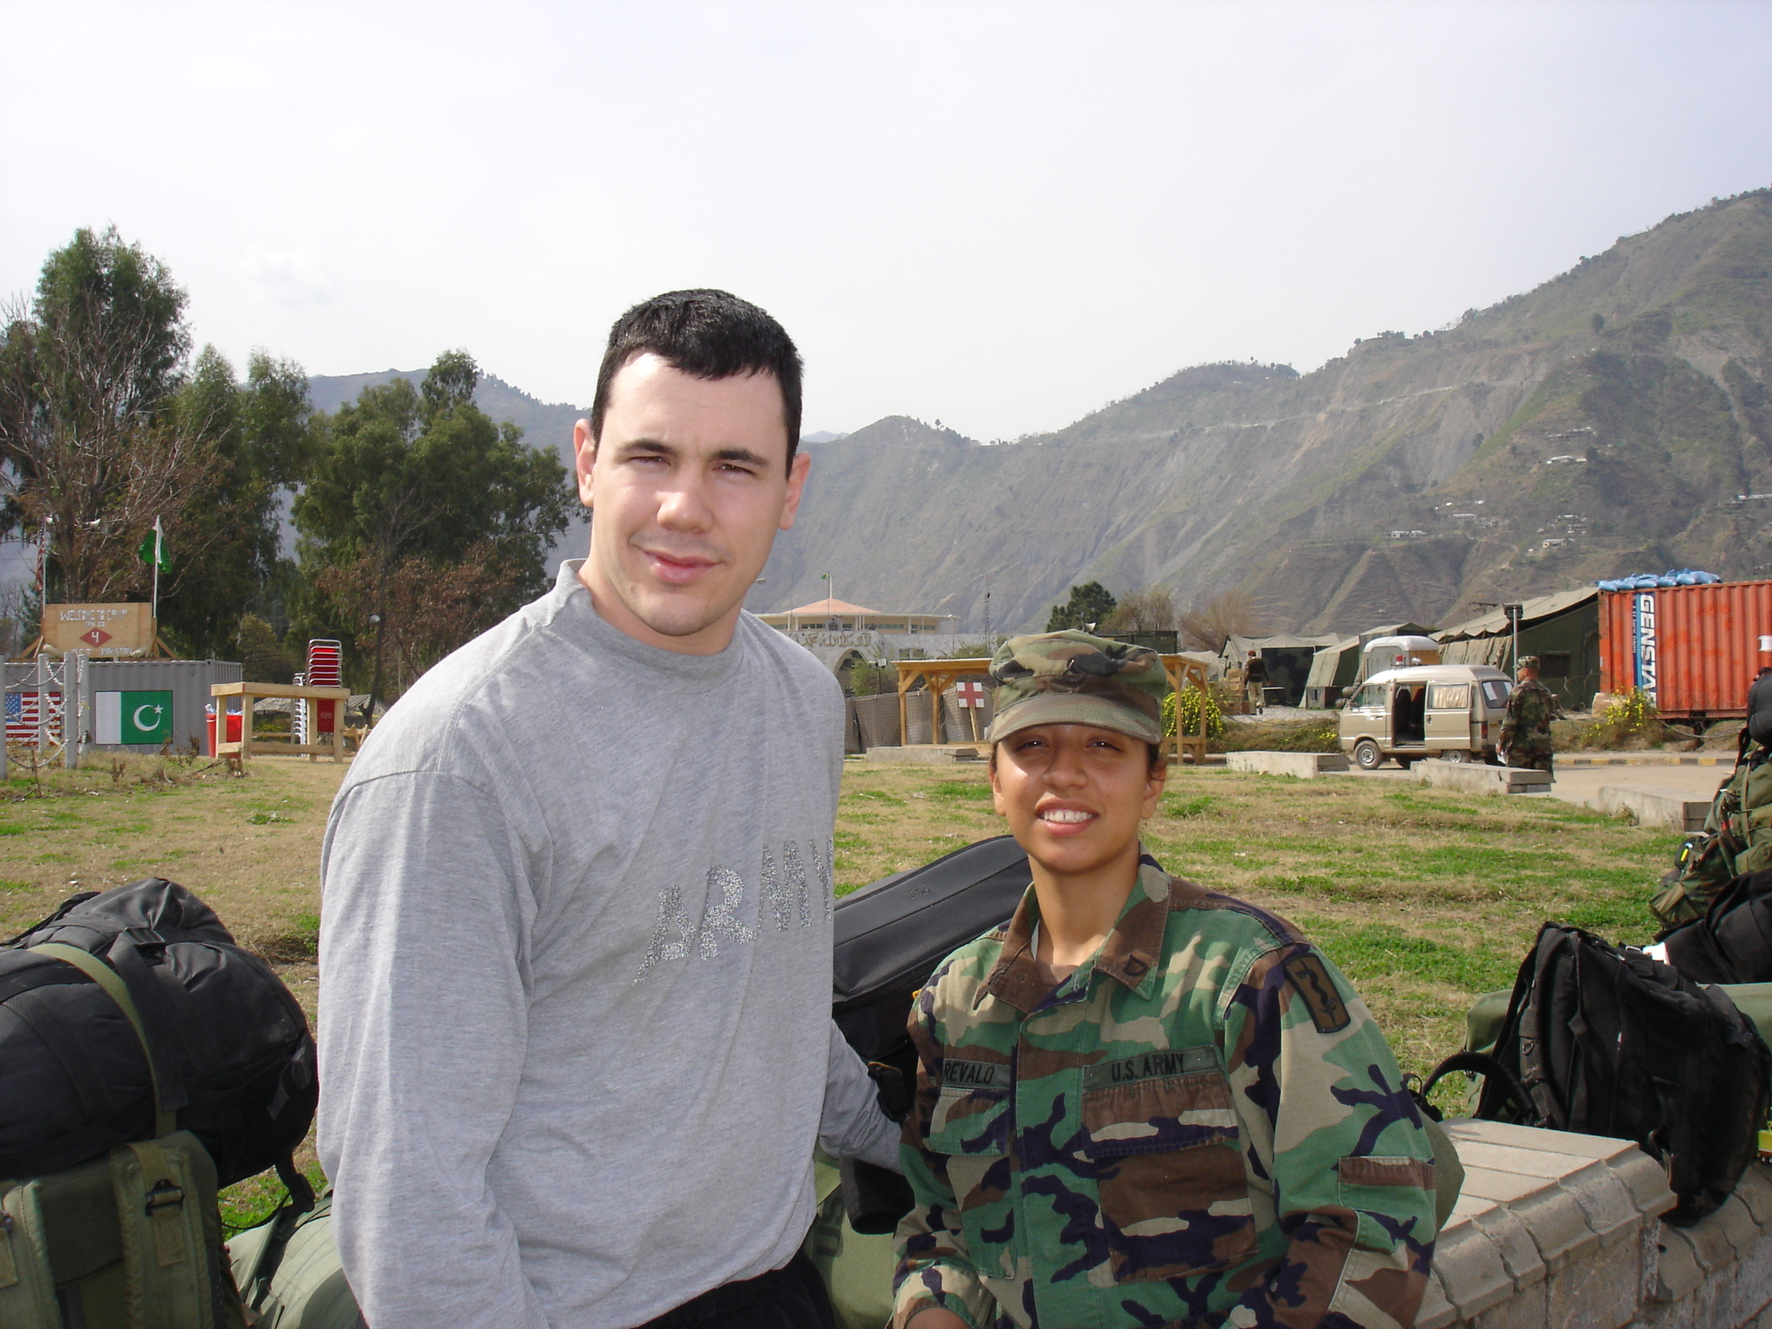
Branden Jones and Vanessa Arevalo at the MASH compound in Pakistan.
The 212 MASH unit returned to Germany in March of 2006, where it began a process of deactivation. Branden returned to the United States in September of 2006 and was stationed at Madigan Army Hospital at Ft. Lewis, Washington, continuing his work as a Med Tech. It was during this time that he competed in the “soldier of the year” and “top medic” competitions, as well as completing the Warrior Leadership Course.

After 5½ years as an enlisted soldier, Branden made the move to officer late in 2008, when he traveled back to Ft. Benning, this time for OCS. He was commissioned a 2nd Lt. in March of 2009. His first salute was from his wife Vanessa. The Department of the Army made the decision to place the new Lieutenant into the Corps of Engineers, the same branch as his younger brother Kristofer Johnson.
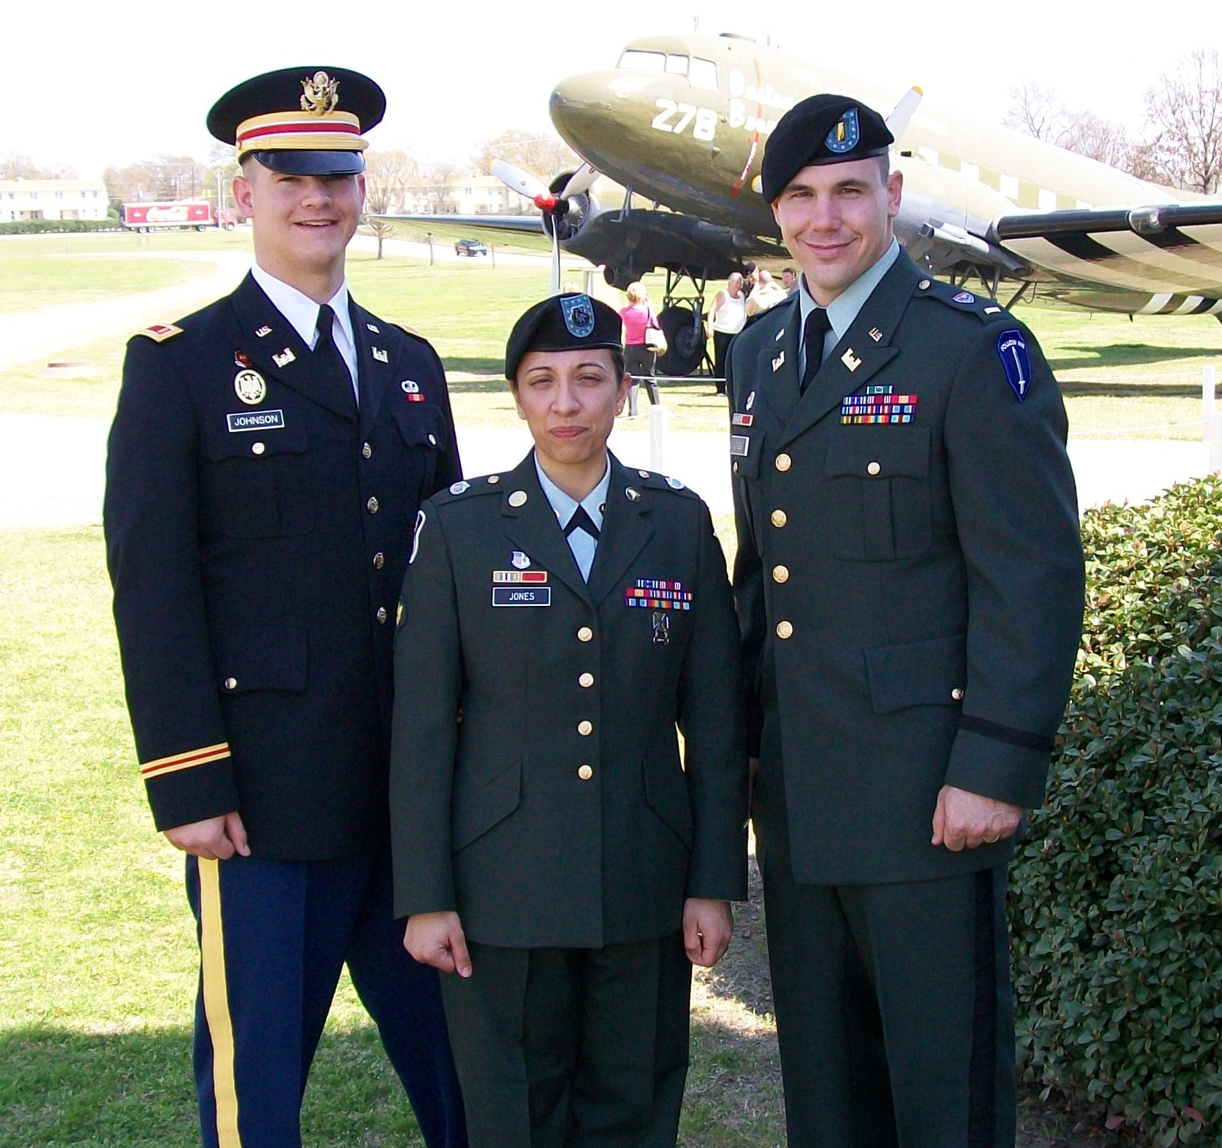
Lt. Kris Johnson, Spec.4 Vanessa Jones, and new
2nd Lt. Branden Jones, commissioning day, March, 2009.

Training for the Engineer Corps came at Ft. Leonard Wood, Missouri. There the new officer mastered a variety of skills from bridge building to demolitions to constructions to route clearance. After graduation from EOBC (Engineer Officer Basic Course), Lt. Jones was assigned to the 1st Infantry Division, 1st Brigade, 1/1 Brigade Special Troops Battalion, at Ft. Riley, Kansas. The family moved to a town home in near-by Manhattan.

“3RD‘s” last training mission in the field, OCS, Ft. Benning, February, 2009.
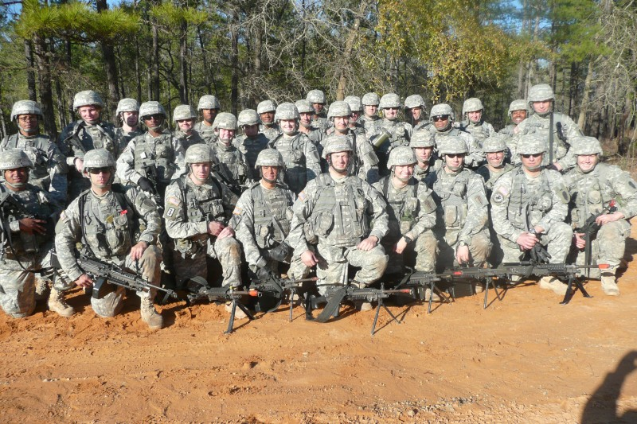

Then in September, 2010, Lt. Jones and the 1st Infantry unit were deployed to Iraq as part of “Operation Enduring Freedom.” A Platoon Leader for a Route Clearance unit, Jones was assigned to Forward Operating Base (FOB) Warrior in northern Iraq near Kirkuk as a 1st Lieutenant.

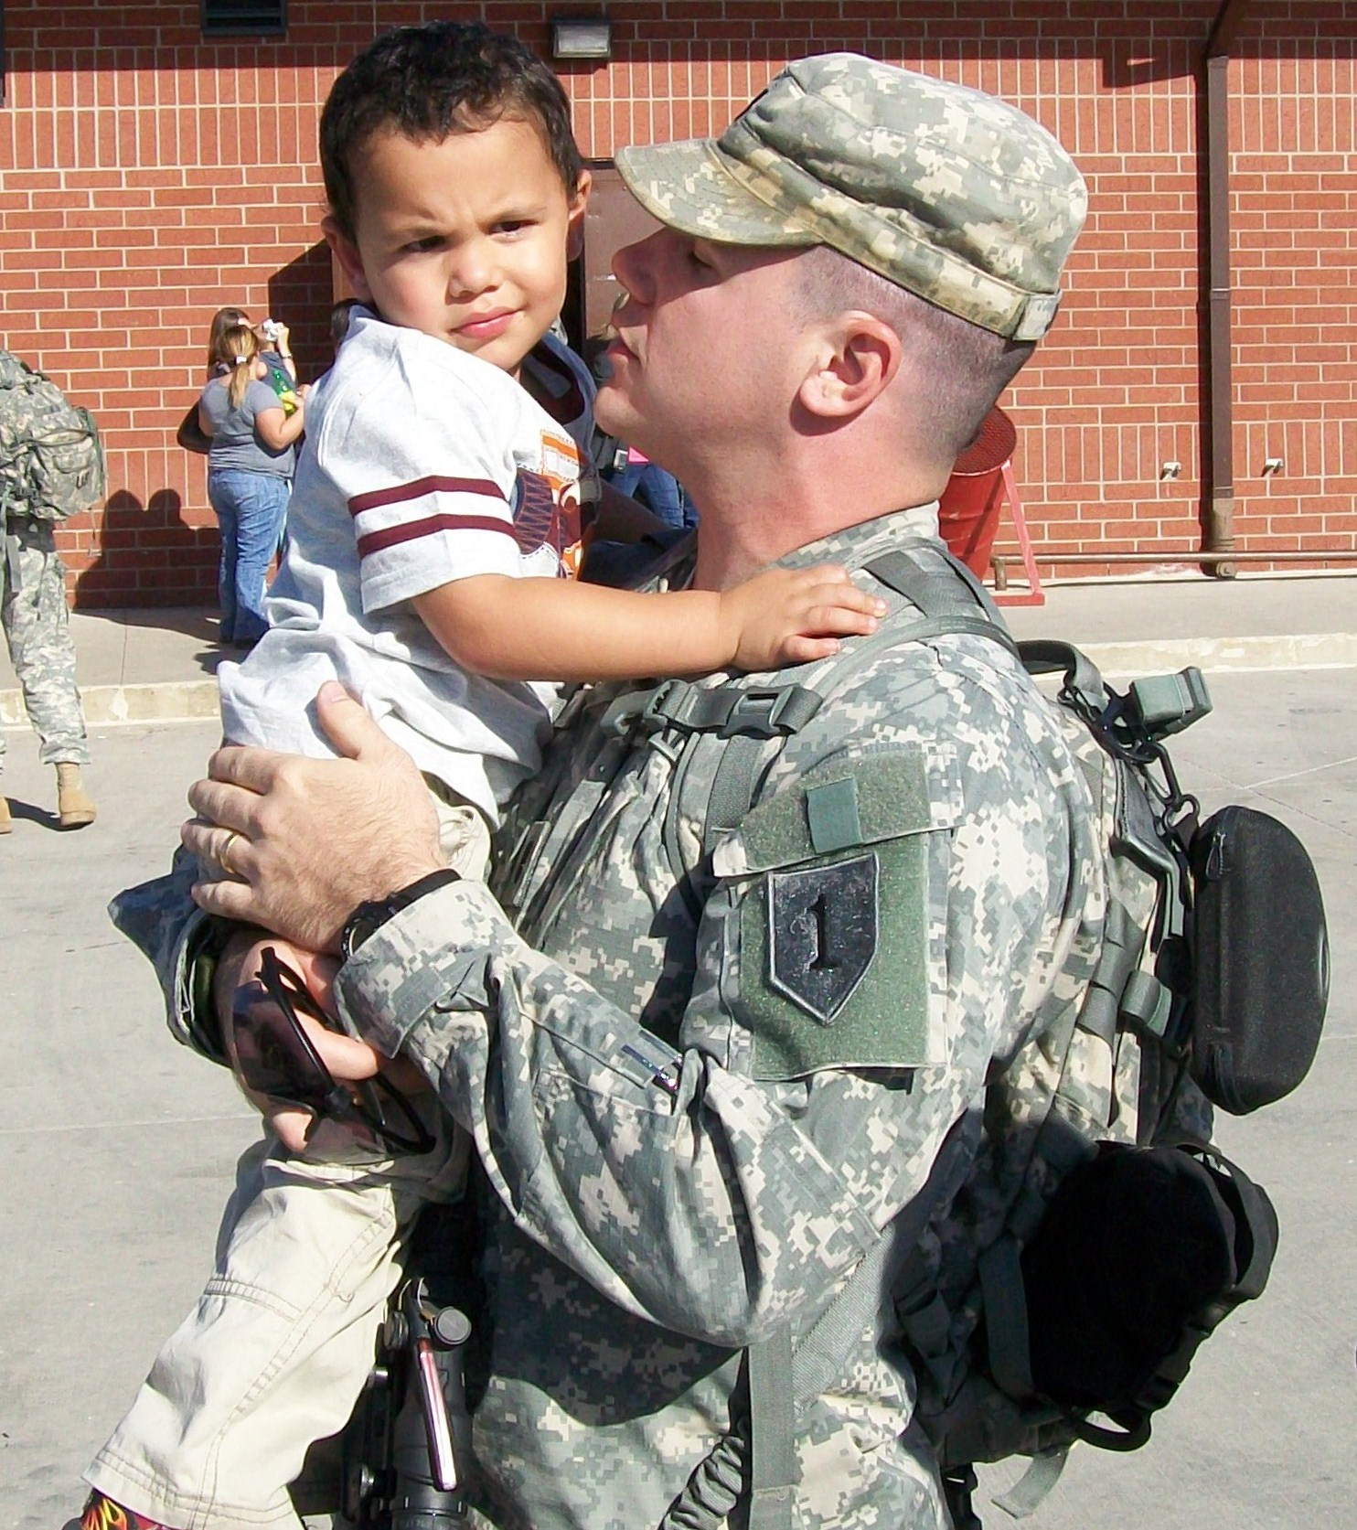
Branden saying goodbye to son Brayden, just prior to departure to Iraq.
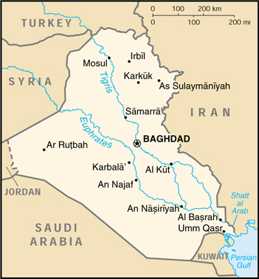
Map of Iraq showing Kirkuk in the north.

Located 180 miles north of Baghdad, Kirkuk sits at the heart of disputed lands that the Kurdish region and Iraqis central government each want to control. Kurds, Arabs and Turkomen are competing to claim Kirkuk and its lucrative oil reserves as their own. The dispute is one of the flashpoints that U.S. official’s fear could boil over into war when American troops leave at the end of 2011 as scheduled.

Duty in the Middle East War in Iraq included patrol of roads and critical access points for possible IED’s and bombs. During the course of the deployment, the Outlawz Platoon under Jones’ command traveled over 12,000 kilometers. They completed about 70 joint missions with the Iraqi and another 50 or so missions individually. The Outlawz also made “presence patrols” in key cities and observation patrols.

Some of Lt. Jones’ time was also spent in training the Iraqi soldiers. American forces worked together with the Iraqi to prepare their military to be able to handle their own security once the American and Coalition Forces left. Training involved a wide variety of duties including IED/Bomb suppression. Jones also supervised field exercises with the Iraqi during training periods. Translators assisted him when speaking to the Iraqi forces.

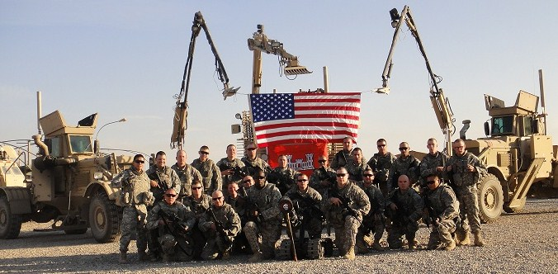
The Outlawz, Lt. Jones’ Route Clearance Platoon in northern Iraq during the fall of 2010. (Branden is 4th from the right, front row in this US Army Christmas card photo)

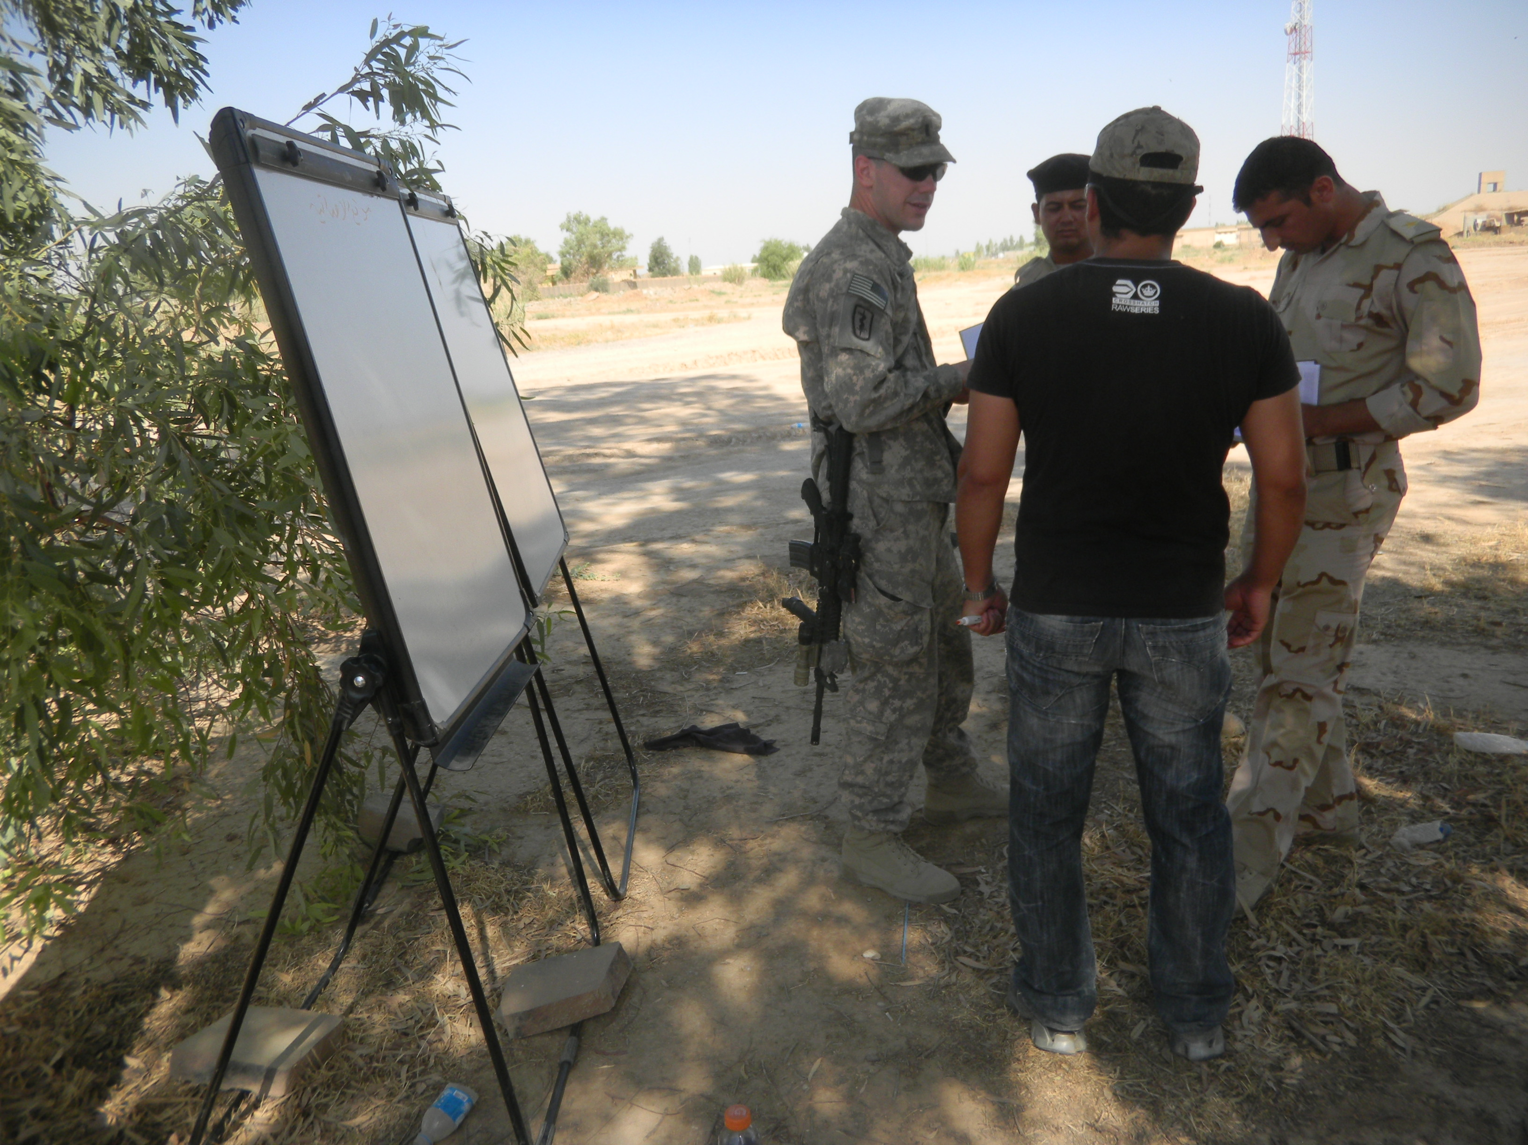
Lt. Branden Jones (center), trains Iraqi soldiers in the field.

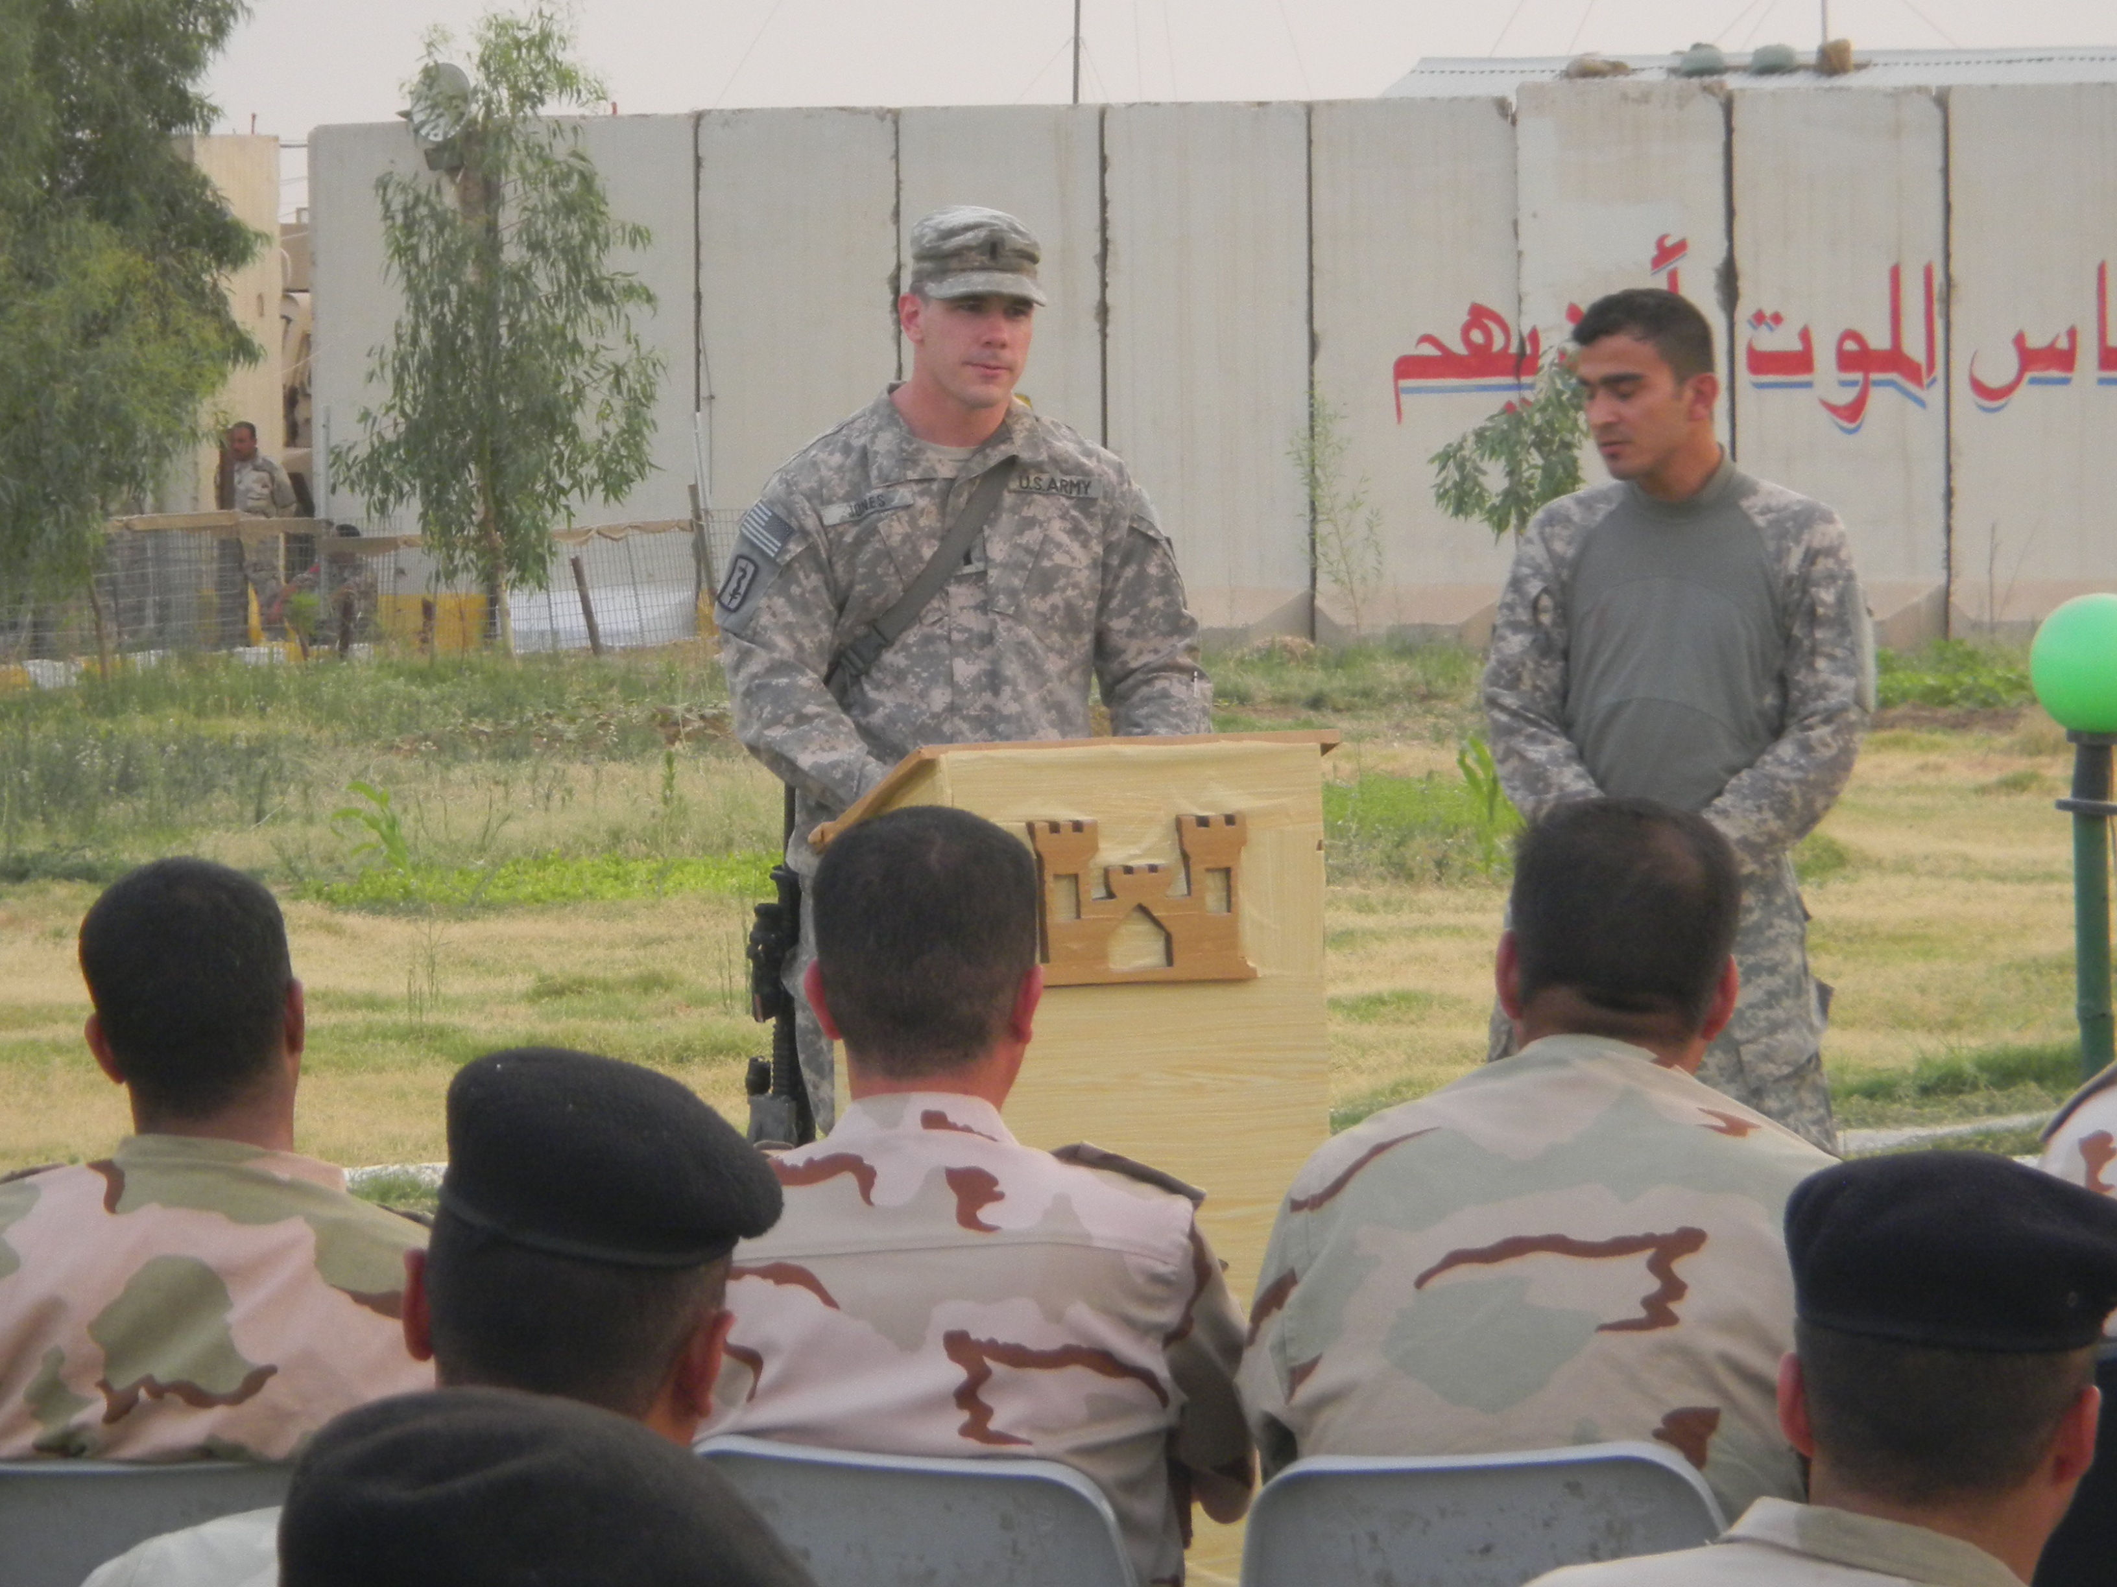
Iraqi soldiers listen as Lt. Jones lectures about bomb procedures.

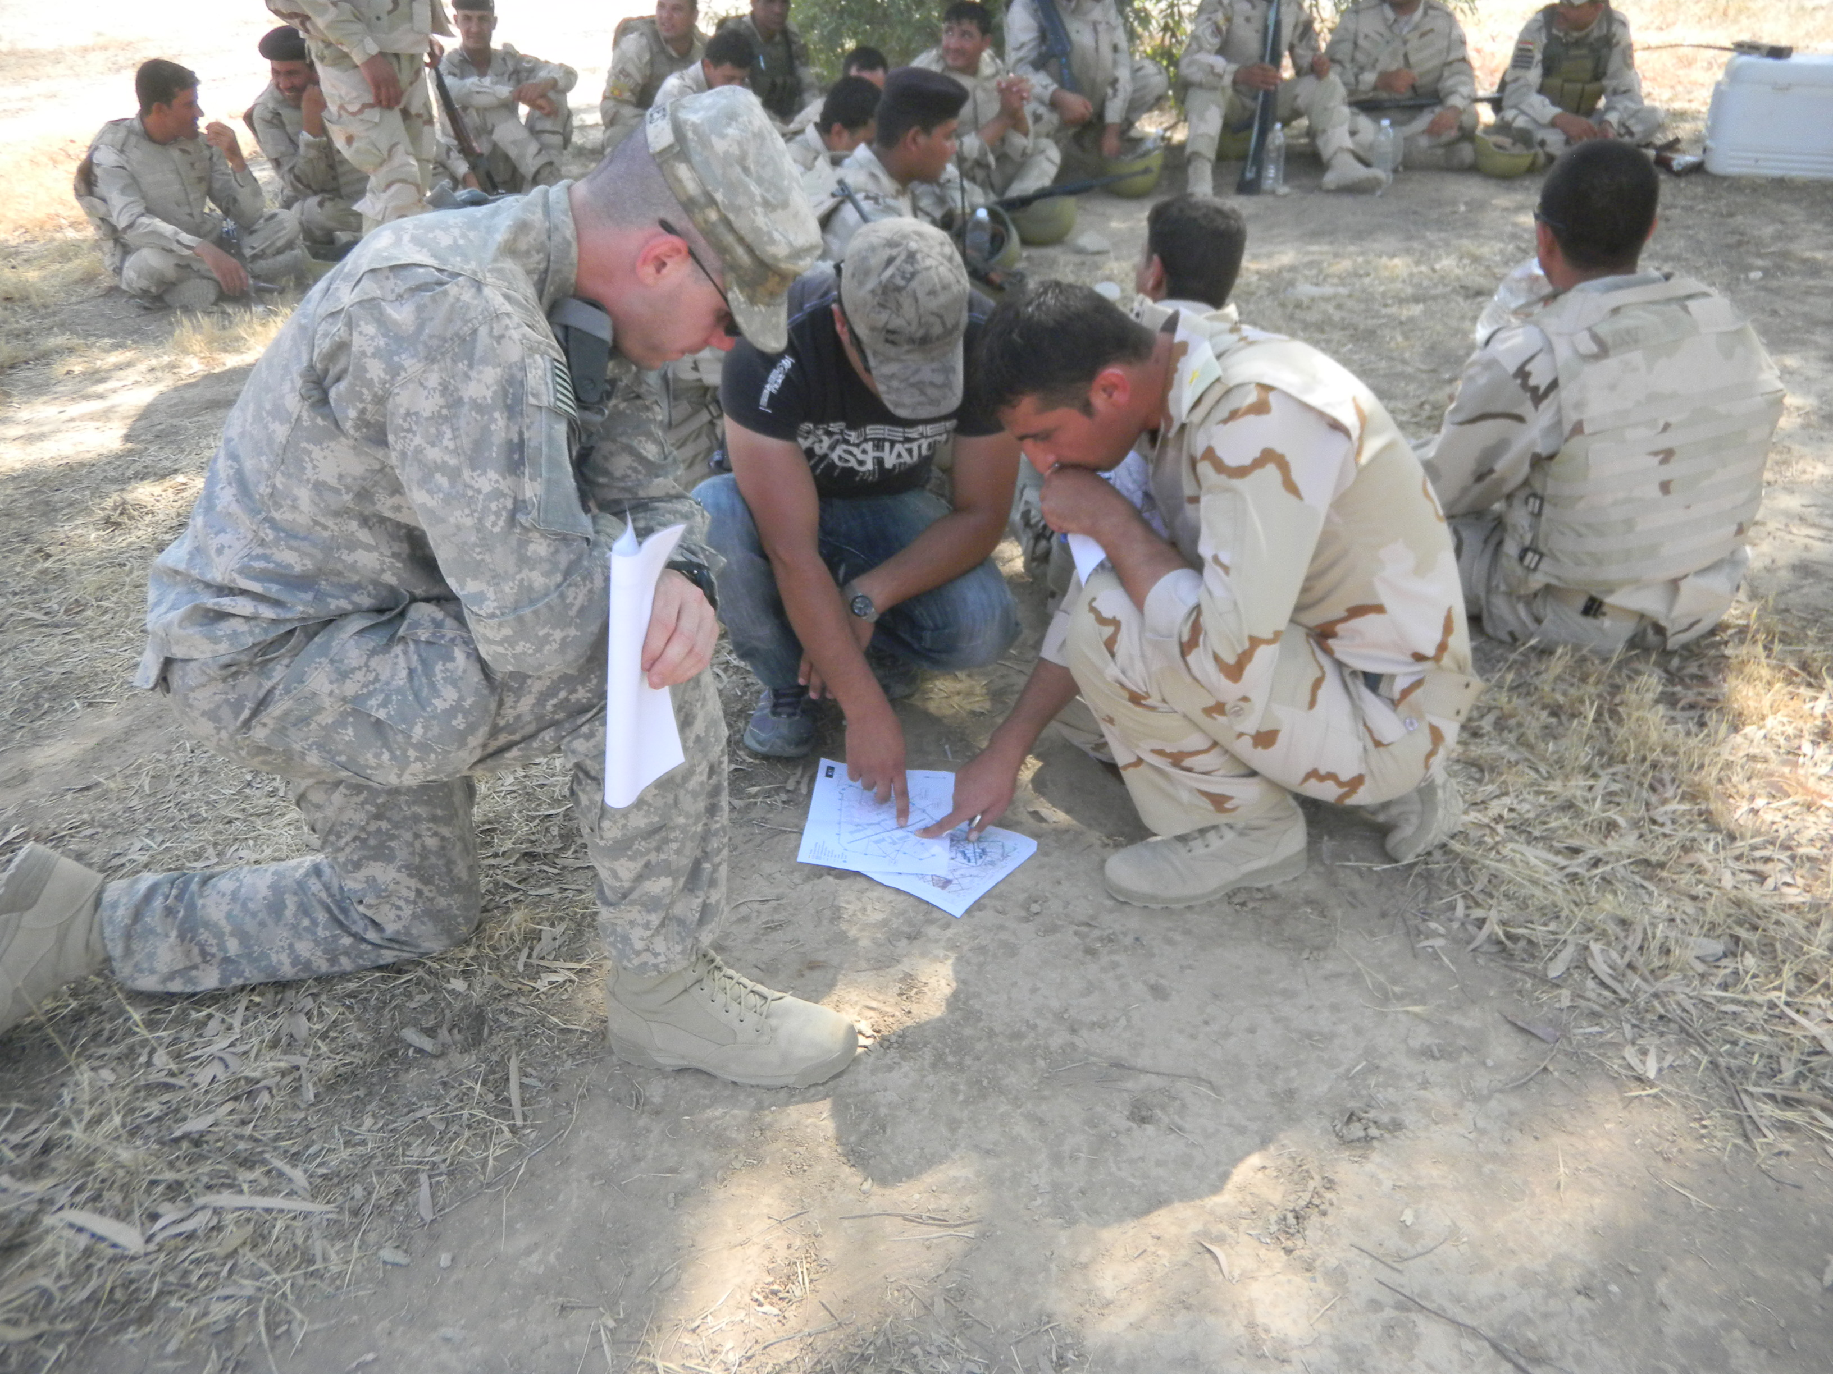
Lt. Jones, reviewing documents in the field in joint training with the Iraqi military.

Lt. Jones and his unit returned to the United States in October of 2011, at the end of their deployment to Iraq and Operation Enduring Freedom. Press reports indicate they may be one of the final units to leave that country as the US begins to end one of the longest wars in the nation’s history.

After his return to the United States, Jones completed his assignment at Ft. Riley and was promoted to the rank of Captain in October of 2012, one year after completing his second Middle East tour. With his promotion came a transfer to Ft. Leonard Wood, Missouri, for completion of training at the military officers school there. Ft. Wood is the home of the US Army Engineers and also maintains a museum for the specialized unit at the post in southwest Missouri.

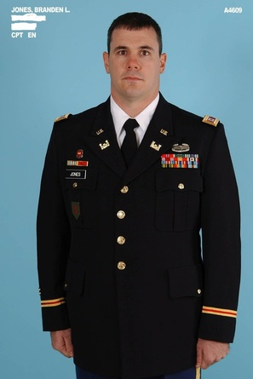
Capt. Branden Jones military ID photo, 2012.

Shorty after moving his family to nearby Waynesville, Missouri, at the end of 2012, the Army Engineers were deployed on an emergency basis to the east coast of the US to assist with the recovery from Hurricane Sandy. Jones and his fellow engineers worked on a variety of projects to help restore power and services in the New Jersey region. Capt. Jones specialized in management of generators for power at locations around New Jersey.

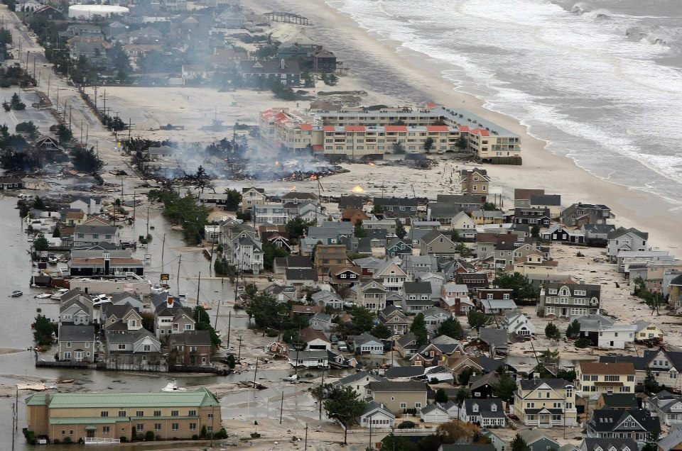
Damage along the New Jersey coast from Hurricane Sandy in the fall of 2012.

Jones is currently completing officers schooling at Ft. Leonard Wood, Missouri in 2013 and will look for a new command upon graduation late in the year.

