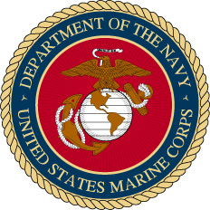
Eugene R. Anderson
United States Marine Corps
(1942-1946 WWII)
(1951-1953 Korean War)

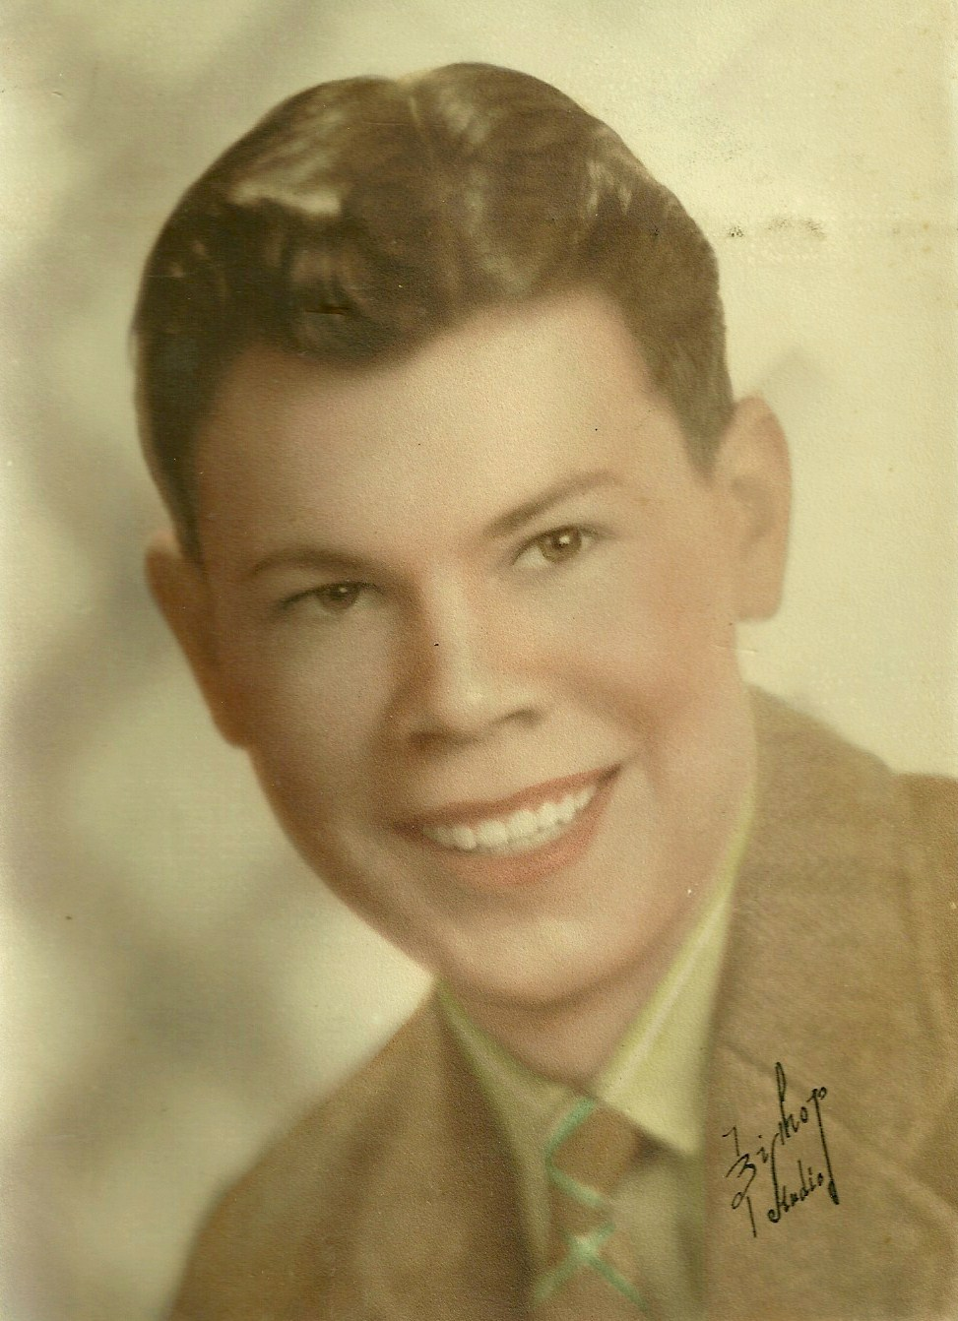
Gene Anderson as a teenager in Kansas. (Family portrait)

Master Sgt. Eugene R. Anderson
United States Marines (1942-1946 & 1951-1953)

Eugene “Gene” Anderson, was born February 4, 1921, to Swedish immigrants Elizabeth and Victor Anderson in Osage City, Kansas. His siblings included a sister Irene and a brother Raymond, who would suffer from cerebral palsy. Growing up in the depression era of the 1930’s, Gene attended Topeka High School while working part time jobs to help the family make ends meet.

With the clouds of World War II darkening the horizon, Gene Anderson enlisted in the United States Marine Corps Reserves. He was quickly activated to full time service and assigned duties as a fighter plane mechanic. Basic training would be in San Diego, California, in January of 1942. During his initial training, Gene traveled about the United States to various airfields and training camps as he learned his craft.

In the early months, the young Marine wrote many letters home and to friends. While stationed at Jacksonville, Florida in 1942, he used the “propaganda” version of the military stationary and envelopes to write home to his parents. The inside stationary bore cartoons of the enemy much like the envelope that accompanied a letter assuring his mother he was fine.

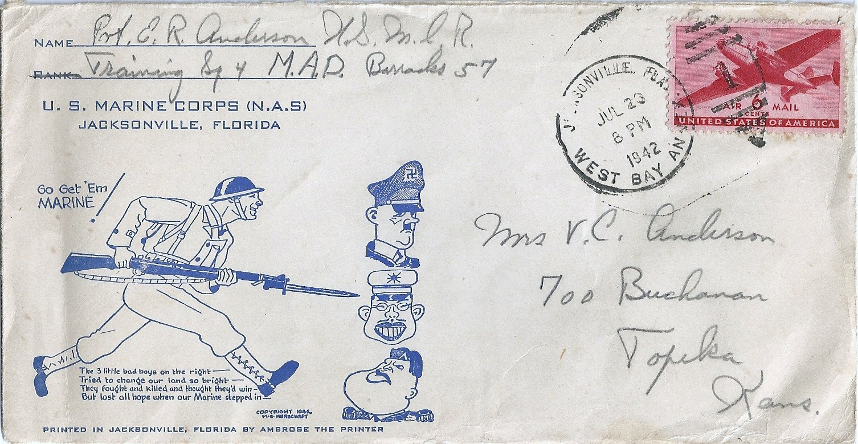
Airmail envelope with military cartoons, sent to family on July 23, 1942.

It was while the young Marine was training in Florida in September, 1942, that he learned of his father’s heart attack and death in Topeka, Kansas. With money from the Red Cross paying for a bus ticket, Gene made a long bus journey home for the funeral and then left immediately after the funeral to return to duty. In an interview about his military experiences, Gene Anderson described this event as one of the low points of his life.

Shortly after the death of his father, Gene wrote his mother a letter from his new base in San Francisco, California. He proudly informed her he had already been promoted to Technical Sgt. He also discussed with the new widow the fact she was not entitled to an allotment as his dependent because he was a non-commissioned officer. However, he noted he was sending her $50.00 per month, plus a $25.00 dollar war bond each month. This stipend would be much of his monthly military pay.

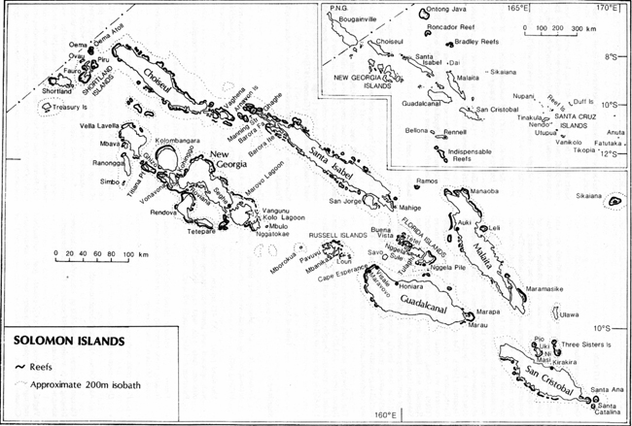

The Marine Unit Gene Anderson was assigned to was soon on its way to the Pacific Theatre. Allied forces had identified a Japanese airfield under construction at Guadalcanal in the Solomon Islands and in August, 1942, 16,000 Allied infantry, made an amphibious landing to capture the airfield. Immediately after landing on the island, the allies began finishing the airfield begun by the Japanese. It was then named Henderson Field.

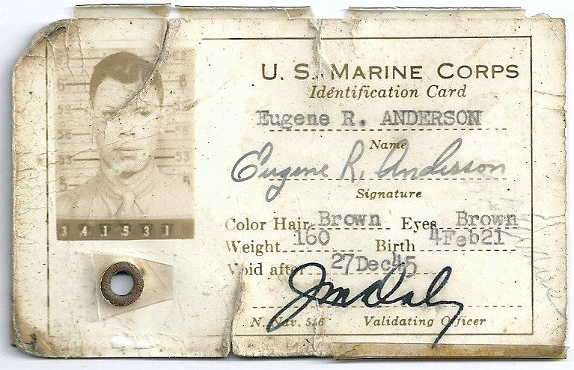
“Dog eared” Marine ID from the early 1940’s.

Aircraft operating from Henderson Field during the campaign were a variety of Marine, Army, Navy and allied aircraft that became known as the “Cactus Air Force.“ They defended the airfield and threatened any Japanese ships that ventured into the vicinity during daylight hours. However, at night, Japanese naval forces were able to shell the airfield and deliver troops with supplies, leaving before daylight. The Japanese used fast ships to make these runs, and this became known as the Tokyo Express. So many ships from both sides were sunk in the naval battles in and around the Solomon Island chain that the nearby waters were called “Ironbottom Sound.”

Gene Anderson would be part of this assault as he was assigned to Henderson after the initial landing and given the daunting task of keeping the fighter planes flying. His assignment would keep him pinned on the island for the better part of a year. After six months of hard combat on Guadalcanal, Allied forces managed to halt the Japanese advance and finally drove the last of the Japanese troops into the sea on January 15, 1943.

In an interview in the 1990’s, Gene would relate how mechanics literally used baling wire and scavenged parts and metal from damaged planes to keep the fighter planes in the air. He also related how it was common to run for a fox hole alongside the run way of Henderson field and grab their rifle to help repel frequent Japanese attacks or hide from artillery shelling. Despite being wounded, Gene Anderson would remain on the island through a bitter year of fighting.
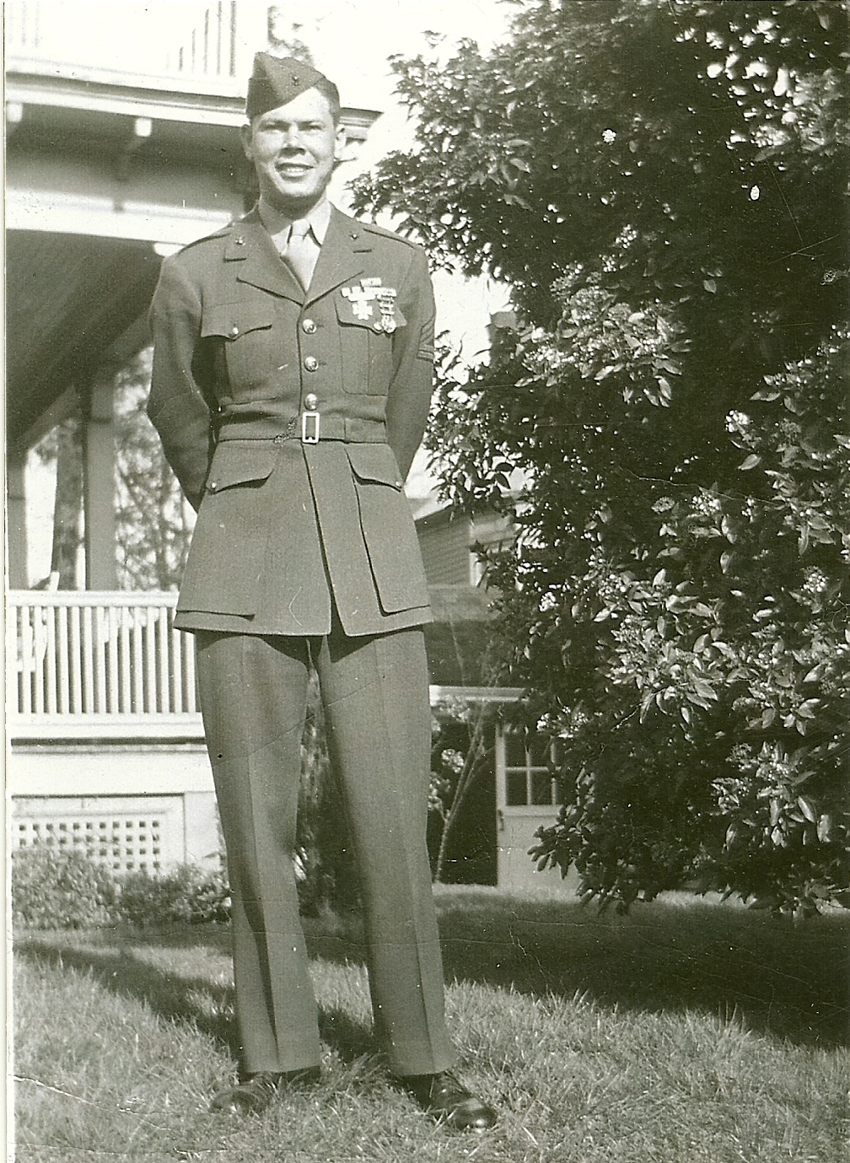
Eugene Anderson on leave in Kansas, mid 1940’s. (Family photo)

Eventually Gene Anderson would return home to Kansas with countless other war veterans at the end of the war, being returned to inactive status with the Marine Corps Reserves. He would receive numerous military decorations for his valor and bravery. Quietly he would try to get back to his own life, including a move to Oregon where he would eventually meet his wife Dorothy.

However, his military career was not quite over yet. As Gene recalled on his memoirs tape, “I never should have listened to my friend who talked me into signing up with a Marine Corps Reserve unit in Oregon.” Gene continued on his tape, “the next thing I knew I was being called up for the Korean war and my friend was staying home!”

In 1951, Gene would be called back to active service with the Corps. Duty in the Korean War would not place Anderson in quite the danger he had experienced in World War II. Although subject to many of the hardships of climate and limited supplies, Gene would rise to the rank of Master Sergeant without the imminent danger of daily attacks. As a high ranking non-commissioned officer, Gene Anderson was able to work behind the lines.

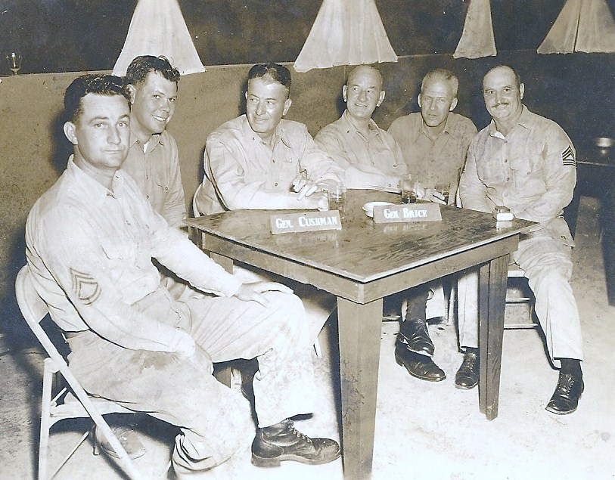
Master Sgt. Gene Anderson (2nd from left), sits with General Cushman and General Brice (behind name tags) in the newly opened Officer’s Club masterminded by Anderson in Korea during the war. (Photo by military personnel on site)

Quickly gaining a reputation for being able to find things, either by “hook or by crook,” the young Marine managed to keep planes flying and Officer’s Clubs in full service. Higher ranking officers often sought out the innovative Kansan whenever something special was needed, but was not available through regular channels. Anderson related in his taped memoirs how on one occasion he even helped sneak an outdated fighter jet to military personnel with the South Korean air force as barter for other needed supplies.
In 1953, Eugene Anderson would leave military service behind for the last time. As with World War II, Anderson would also receive numerous citations for his service during the Korean War. However, he rarely talked about his exploits in combat with the Marine Corps.

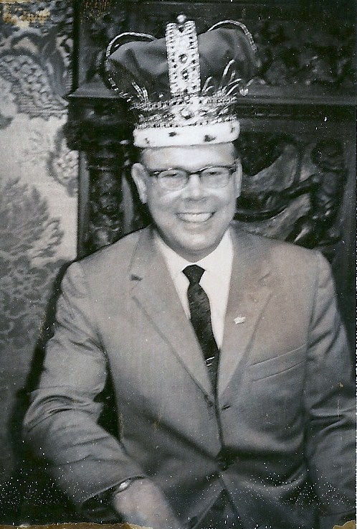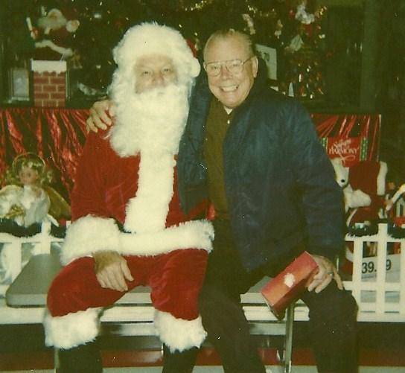
“King Gene,” in a 1960’s photo as Always generous to a fault, Gene often gave to
top salesman for Niagara Chairs. to those in need.

Eventually Gene and his wife Dorothy would adopt their two sons Tom and Joey. Ever the salesman, Gene would work at a variety of jobs, in several places in the Midwest such as Tulsa and Kansas City, Kansas. Finally the Anderson family would land back in the Eugene-Springfield, Oregon, area where Dorothy’s family lived. He would retire there from Lane Transit, the bus company for the region. After retirement, Gene traveled across the United States and to a number of countries, including Sweden and several trips to Japan.

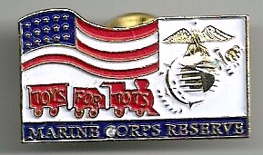
Always true to the Corps, Gene worked hard for events such as “Toys For Tots.”
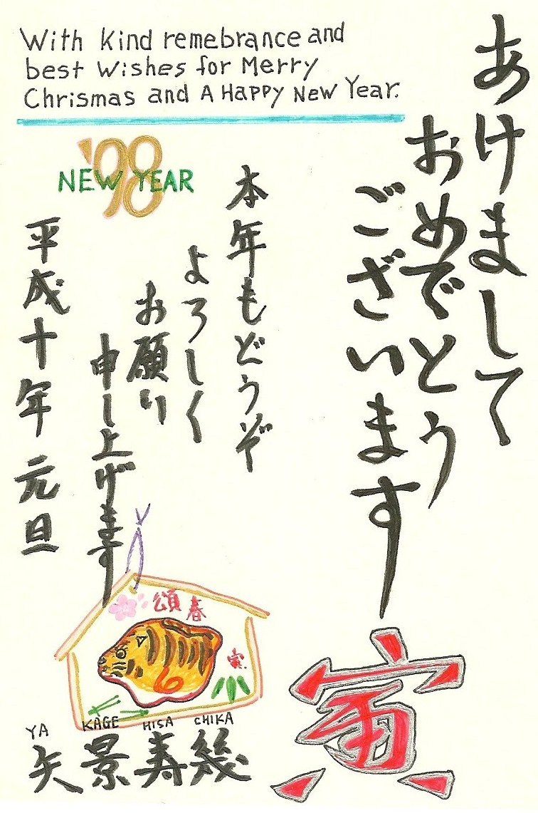

Holiday card to Gene Anderson from Hisachika Yakage of
Mirakata City, Osaka, Japan, in 1998.

It would be on his trips to Japan that Gene Anderson would make peace with those who were once his enemies during World War II. Regularly corresponding with several people in Japan, he developed a friendship with those he once battled and visited them in their homes in later years.
Eugene R. Anderson would pass away in 2002 at home.

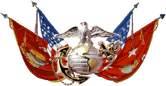
“Semper Fi”

