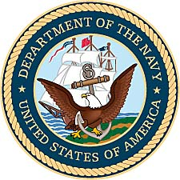

Gordon C. Johnson
United States Navy (1944-1946)

Gordon Clifford Johnson was born December 1, 1926, in Rockford, Illinois. A Swedish American, he was the oldest of four children of Ebba and Sven Arvid Johnson. Gordon completed high school at Kewanee High School at 17 and was Salutatorian. He competed in basketball and football for the Boilermakers, playing in state championship games for both sports and was named to the “all state football team” as a tackle.

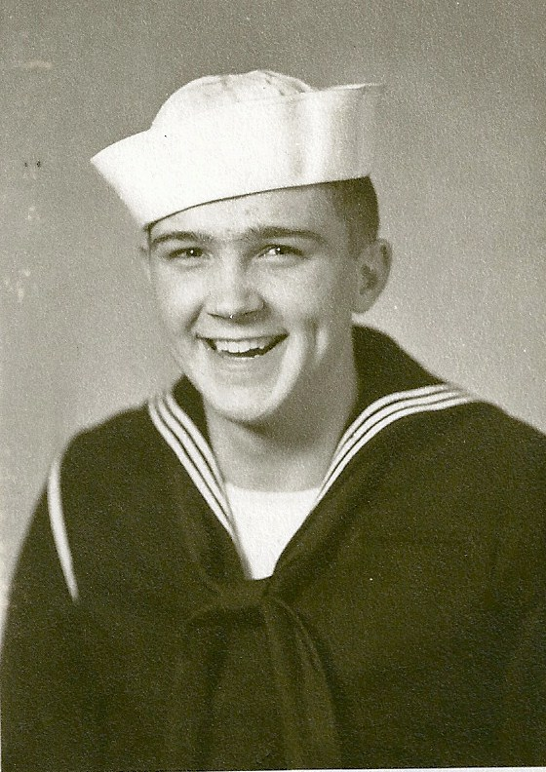

1944 photo from Great Lakes Naval Training Center.

The day before he turned 18, Gordon Johnson enlisted in the United States Navy on November 30, 1944. Within days he was assigned to the Great Lakes Naval Training Station, located in North Chicago, Illinois. After basic training, he moved to the University of Wisconsin-Milwaukee for specialized training as a radio operator.

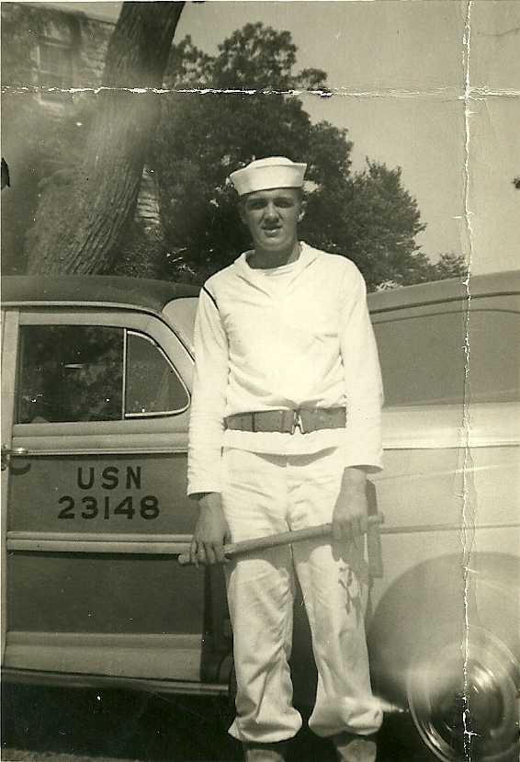

Gordon on Shore Patrol duty while stationed
at radio operators school in 1944.

His next stop was Camp Elliott, California. He stayed there until assignment to a transport ship which conveyed him to the Philippine Islands. After a long and boring thirty day trip across the Pacific Ocean, he arrived in the Philippine Islands on December 7, 1945.

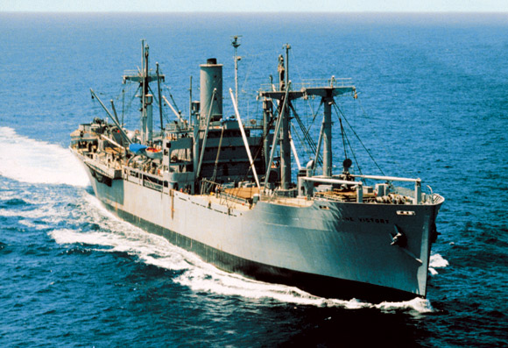
A “Victory Ship” similar to the USS Gratia

The USS Gratia (A.K.) was his first assignment. One of the “Victory Ships,” it had only a top speed of 8 knots. Rough water would cause the boat props to come out of the water occasionally and rattle the crew. The supply ship was desperate for storekeepers and when given a chance to change assignments, Gordon Johnson made the switch and was promoted to SK3 or Store Keeper 3rd Class.

The Victory or Liberty ship Gordon served on saw service all over the world. They were present in the Atlantic and Russian convoys, they anchored off the beachheads in North Africa, Europe and in the Pacific islands. They carried food to civilians as well as supplies and equipment to the armed forces. They served as hospital ships, they transported prisoners away from the fighting, they evacuated rescued Allied prisoners from Asia and in perhaps their most welcome role, they brought the troops home again after the fighting was over.

Johnson says, “our ship was a floating ware house for naval supplies.” The Gratia supplied anything and everything to other ships in the Pacific Fleet. The navy ship was lightly armed with machine guns and one deck gun. Because the USS Gratia was busiest when in port, sailors had little time to enjoy the sights or activities available in the South Pacific. Gordon became known as the “ice cream man.” When at sea, he became the steady supplier to the rest of the crew of one of the few treats available to a ship traveling from place to place.

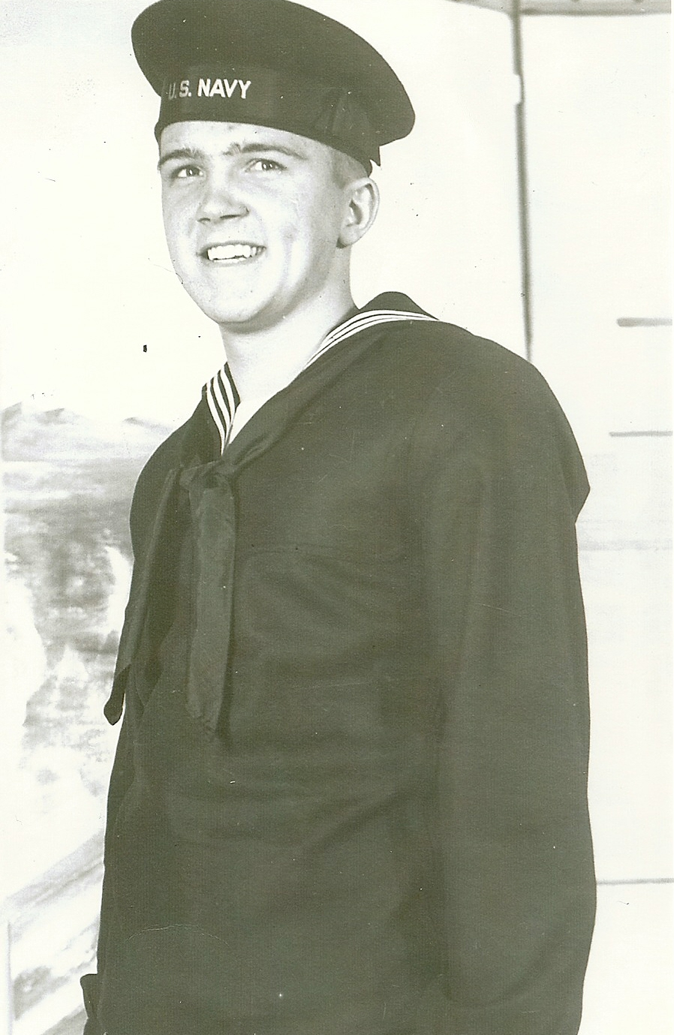
Gordon C. Johnson in US Navy “blues.” (1944)

Johnson toured Japan and visited Hiroshima and Nagasaki just a few months after the war ended. He served for a time in Japan as part of the Occupational Forces there. One of his most vivid memories is of the destruction by the nuclear bombs in Japan. His visits to the bomb sites led him into the central site or near “ground zero.”

Years later when asked about whether or not President Truman did the right thing by unleashing the power of nuclear weapons, Gordon without hesitation said, “I probably wouldn’t be here today if he hadn’t. The Japanese would have killed millions more in a fight to the death.”

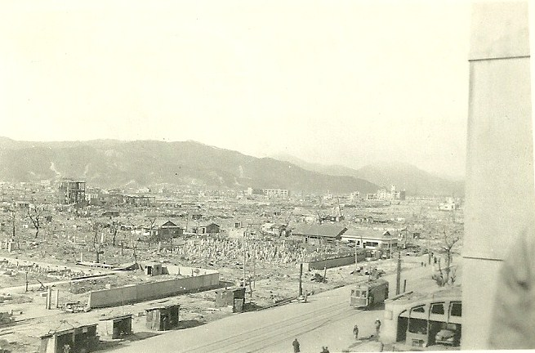

Photo of Hiroshima, Japan taken in February, 1946 by Gordon
Johnson while assigned to duty with Allied Occupational Forces.
His handwritten notes on the back of the 2 inch by 3 inch black
and white photo are below.

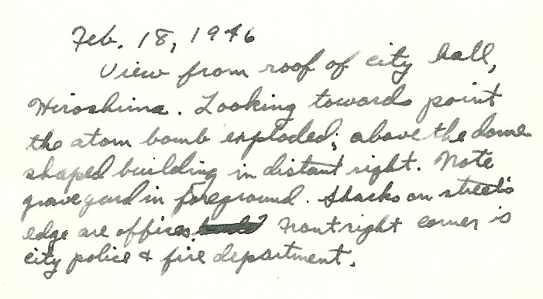

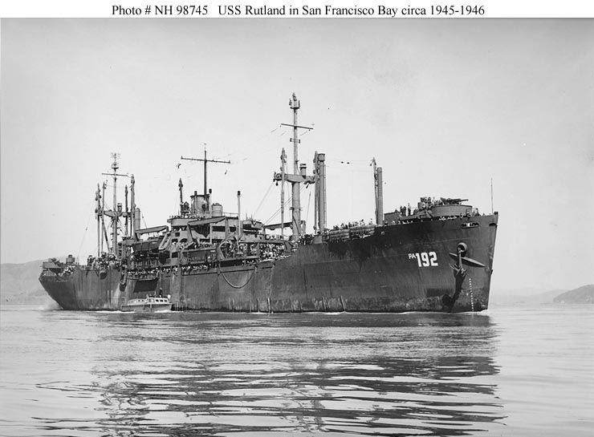

For his final duty with the Navy Gordon Johnson switched ships to the USS Rutland, a troop ship. The Rutland transported marines and soldiers home from the war from across the Pacific.

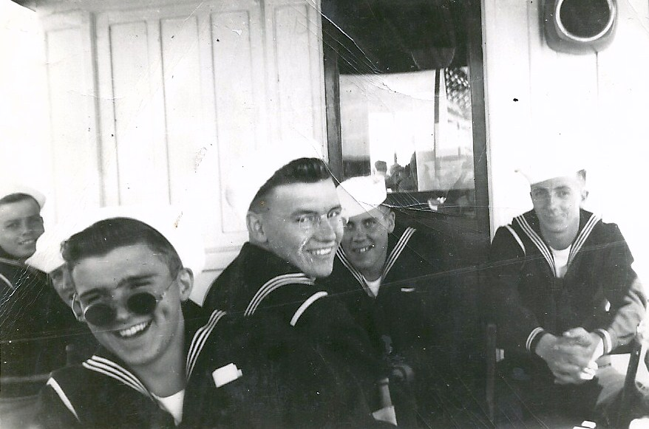
Gordon Johnson (with round glasses) and other sailors while on leave in Japan in 1946.

In August of 1946, Gordon Johnson was discharged from the Navy. He received the Asiatic Pacific Area Campaign Medal, the Victory Medal, and the American Area Campaign Medal for his naval service.
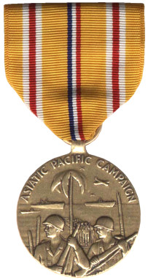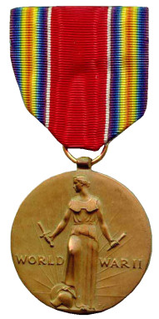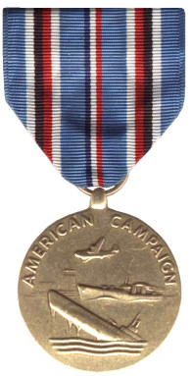

In August of 1949, Gordon Johnson would marry Naomi Neville, a nurse who had served with the Nurses Corp for three years. Together they would have six children. Gordon taught at North Park Academy in Chicago and then at Wyandotte High School in Kansas City, Kansas until his retirement in the early 1990’s. He now resides in Shawnee, Kansas.

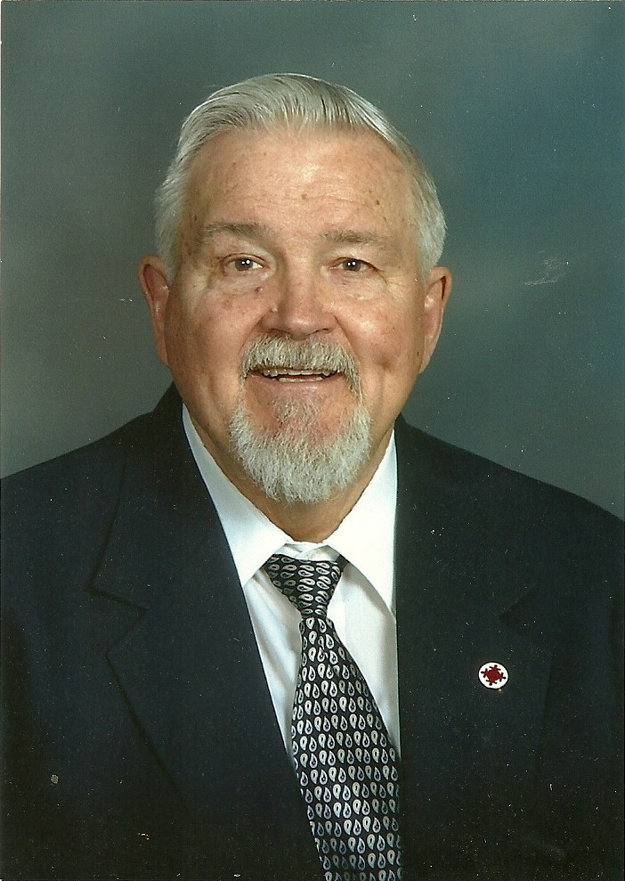
Gordon C. Johnson in 2008 church picture.

Gordon remains committed to the support of veterans and actively sends materials to the troops serving overseas. He has two grandsons and a grand daughter-in-law currently serving in the United States Army, as well as a host of family members who have previously served their country in the various branches of the service.

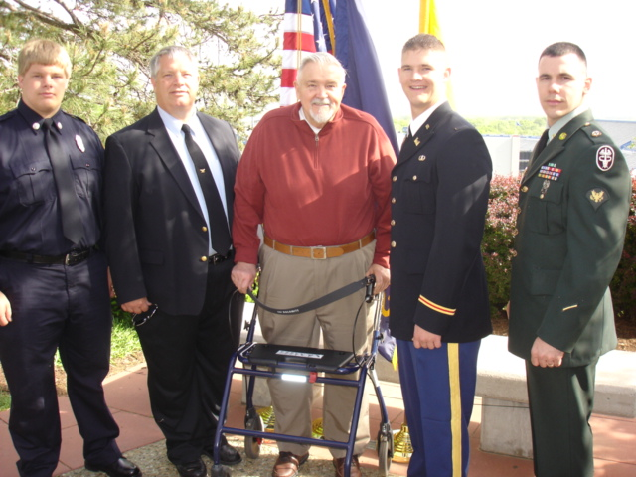
Gordon Johnson at commissioning ceremonies for grandson Lt. Kris Johnson, in 2008, on the hill at the University of Kansas. From left to right, grandson Swede, son Tim, Gordon, grandson Kris, and step-grandson Branden Jones.

