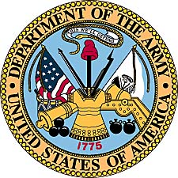
Howard A. Johnson
United States Army
(1951-1953)

Howard A. Johnson was born February 12, 1929, to Arvid and Ebba Johnson. He was one of four children that grew up in the northwest corner of Illinois, helping with duties at the family green house. He graduated from Kewanee High School in the spring of 1947 and from North Park Junior College in 1950. A speedster, Howard was a running back for the Vikings football team and was Juco City Champ of Chicago in the hurdles.

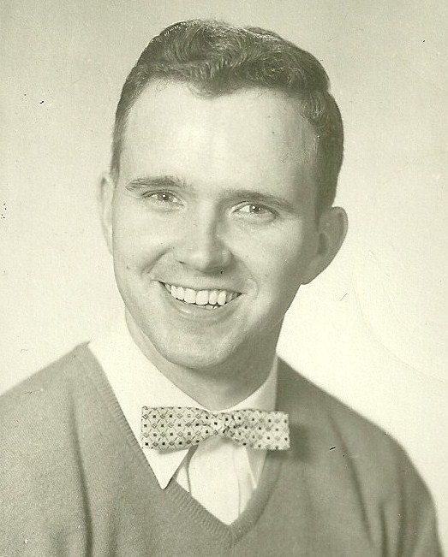

With the Korean War at the forefront of everyone’s attention, Howard Johnson entered the United States Army on March 22, 1951. He almost missed his initial induction however, when his sister Carol tossed his draft notices into a pile of other mail on the table. Howard, busy with wedding preparations somehow missed the vital information and at the last minute was able to arrange to get married and then report. So he married his sweet heart Joyce on February 17, 1951 and after a brief honeymoon, he was off to basic training at Fort Leonard Wood, Missouri.

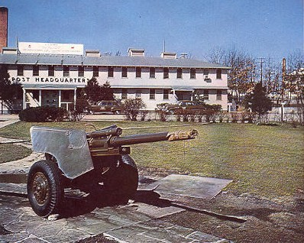
Headquarters at Ft. Leonard Wood , early 1950’s. (Archives photo)

After basic training at “Camp Lost In the Woods,” Howard Johnson shipped out for South Korea in August of 1951. He was assigned to the 8th Army Headquarters in Taegu, South Korea. While many versions exist on how Howard came to work in the military offices, all stories center on his typing abilities as a reason for finding duty in a Quonset Hut instead of on the front lines.

His duty was as a personnel specialist. He was responsible for the files of new officers reporting to this headquarters. He typed allotments, bonds, insurance and travel vouchers , as well as completing a monthly personnel roster for the officers assigned to the 8th Army headquarters.

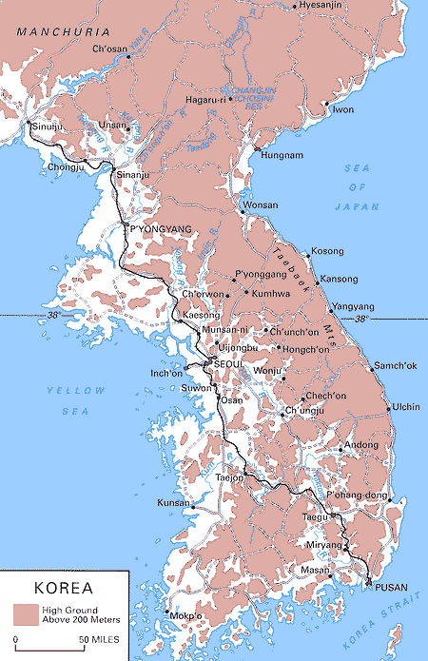

Taegu, the site of Howard Johnson’s primary assignment, is located
in the lower right hand corner of the map. Soldiers generally arrived at the
Port of Pusan and then traveled north on the main highway.
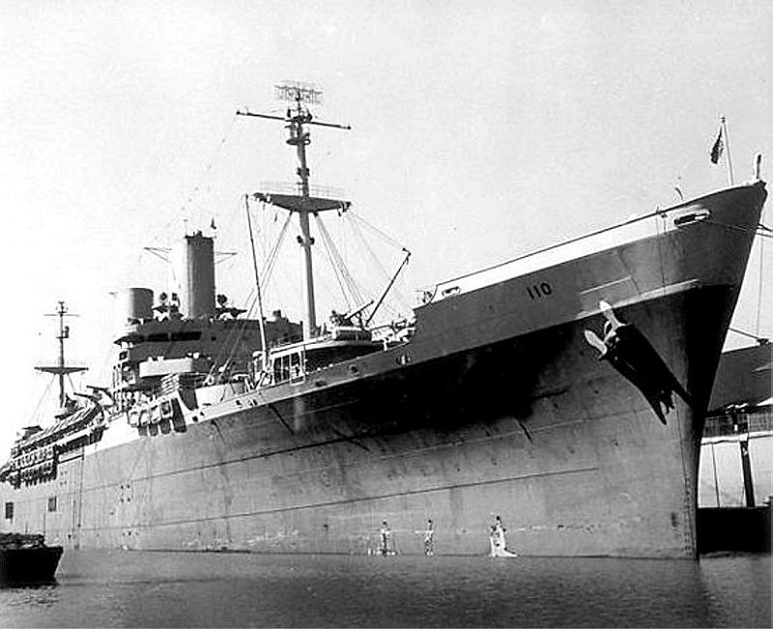
Ship unloading at Pusan, South Korea, July 1950. (US Navy Archives)

While stationed with the 8th Army, Howard received a special assignment to Koge-Do for a few months. This is an island off the coast of South Korea. He traveled by train and Navy ship. This island held the North Korean war prisoners and Howard had to type names and records on the prisoners. He spent his first Christmas in the Korean War on the island. Living in tents, the soldiers faced severe cold and weather conditions. Eventually he returned to his earlier duties at Taegu and remained there until he was sent home.

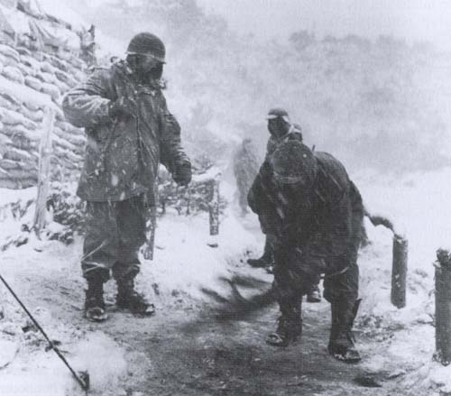

Winter in Korea (National Archives photo)

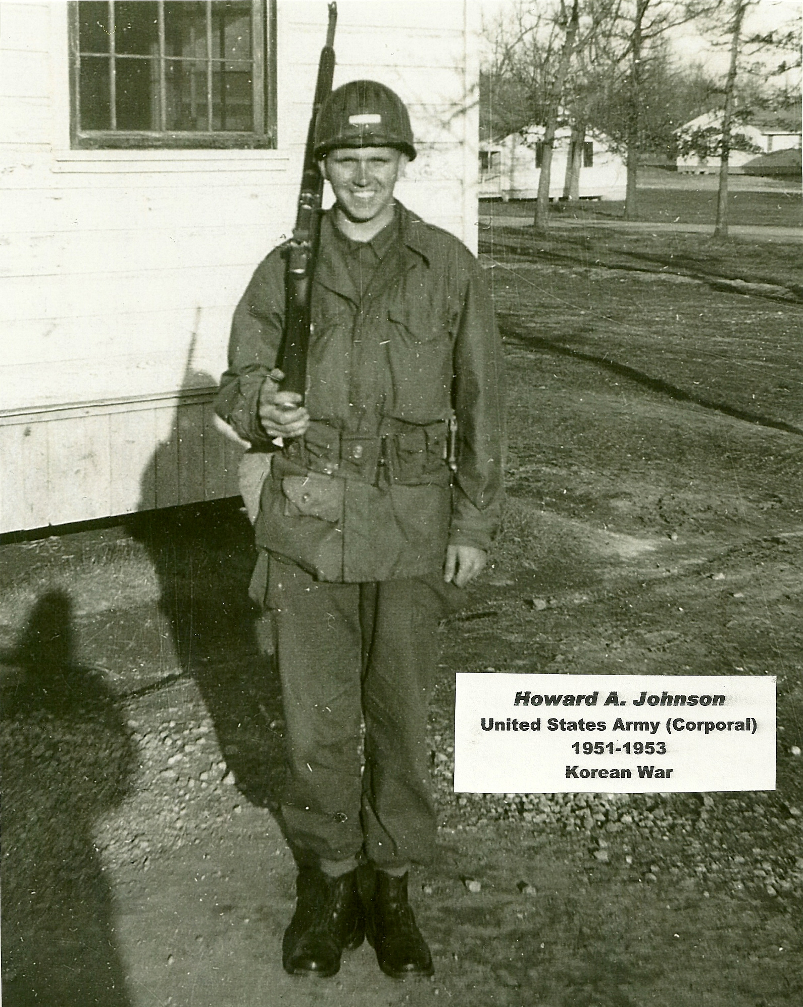

Photo taken at the post in Taegu, South Korea in 1952.

Military Script

During the war, the United States military issued payment to soldiers in “military payment certificates.” The amounts for the paper money, ranged from cents, to dollars and was printed on colored paper. Every so often the military would suddenly change its money colors to help control the use of military script on the black market.

Posts would suddenly be closed and soldiers would have only a short time to trade in their money for the new issue. Villagers and people outside the post would desperately try to cash in so they would not lose out on their money they had taken doing business illegally with soldiers.
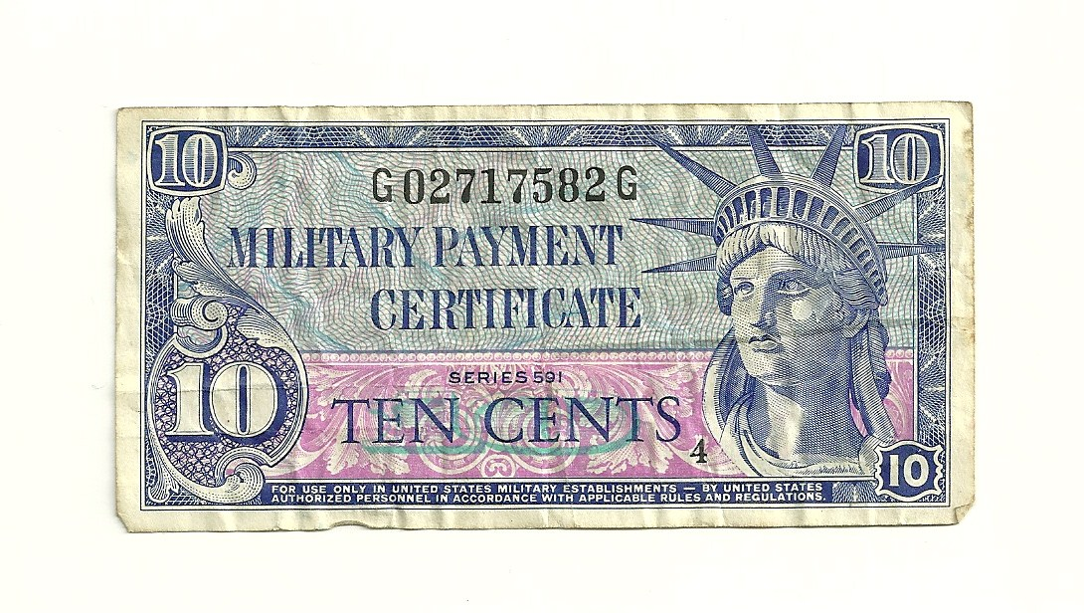
Army script (actual size) from South Korea used to pay military personnel in 1952.
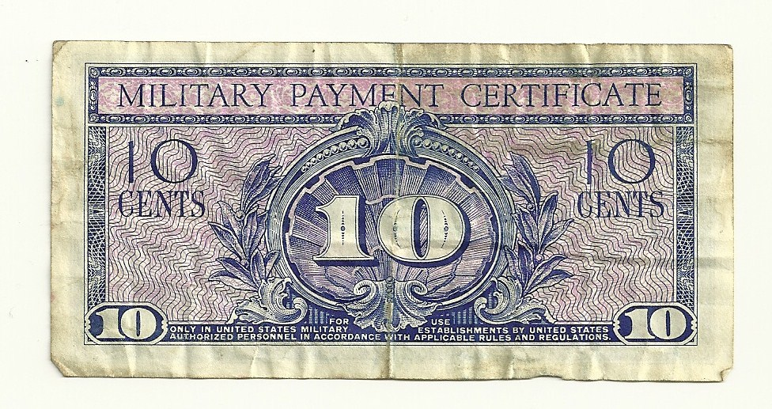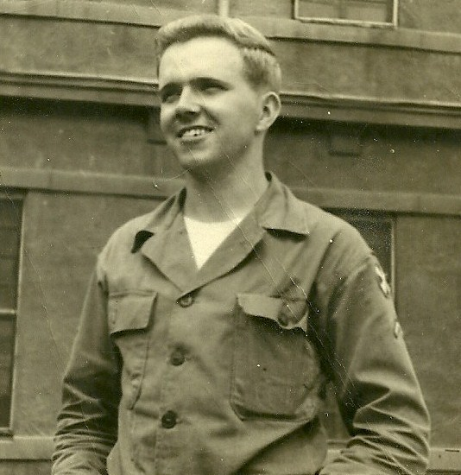
Howard Johnson, August 26, 1952.

With his strong sense of religious convictions, Howard Johnson did not allow his military duty to stop his witness as a Christian. While in Taegu, he and some of his friends regularly visited an orphanage and held Bible studies there. Then in December of 1952, Howard was interviewed for a radio broadcast which was part of an evangelistic tour by the Rev. Billy Graham. Howard was heard in the United States and around the English speaking world. For the family, it was tearful moment as they listened to their son and brother who had been away at war for so long.

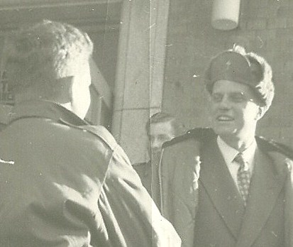
Howard speaks with Graham in Seoul, South Korea.
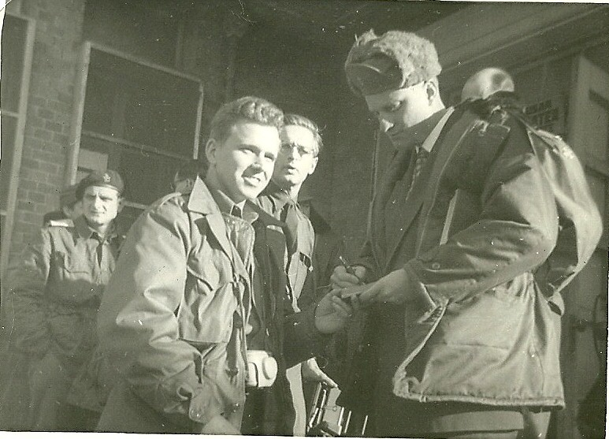
Howard Johnson receives an autograph from the Rev. Billy Graham on December 21,
1952, after taking part in a radio broadcast.

In March of 1953, the young soldier ended his tour of duty to the war called a “Police Action.” For his service during the war, Howard Johnson was awarded the Korean Service Medal with 4 bronze service stars, the United Nations Service Medal, and the Army Good Conduct Medal.

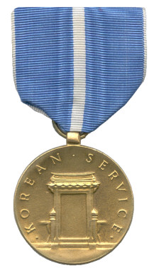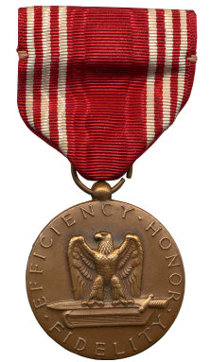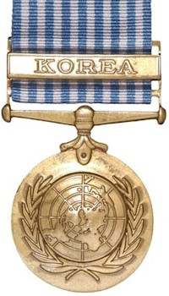
Korean Service Medal Good Conduct Medal United Nations Korean
Service Medal
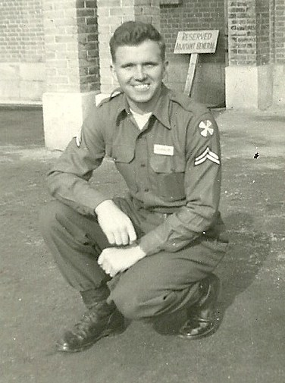
January 1, 1953, showing Howard’s unit patch and rank on the left shoulder.

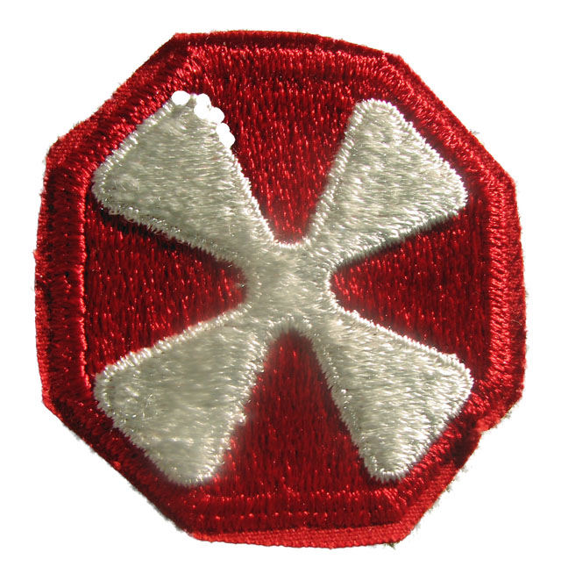
8th Army patch worn during the Korean War

After coming back from the military, Howard worked with his dad for a couple of years in the family greenhouse. In the fall of 1955 he
enrolled at Northern Illinois College in Dekalb, IL, which is now Northern
Illinois University. He received his Bachelor's degree in Education and began teaching business subjects in the fall of 1957 in Yorkville, Illinois, where the growing Johnson family settled. He taught at Yorkville until the spring of 1962 and then moved to Joliet Central High School. While teaching at Yorkville he attended school in Dekalb and received his Master's degree.

Howard’s final assignment was at Joliet West High School, where he retired from teaching in 1991. After retirement from teaching he continued his summer painting job the year around until he eventually retired completely. Howard and Joyce Johnson have four children, ten grandchildren and eight great grandchildren as of January 2010.

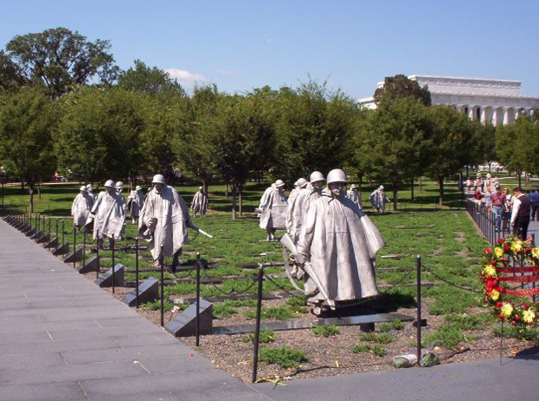
The Korean War Memorial near the Lincoln Memorial on the Mall, Washington, D.C.

Howard has never forgotten the sacrifice of the men he served with in the Korean War. He remains active in his local American Legion and has also visited the Korean War Memorial. The 19 stainless-steel statues at the Korean War Veterans Memorial depict fighting men on patrol.

The statues represent the 1.5 million Army, Navy, Marine Corps, and Air Force men and women who fought in the war. The Memorial was dedicated on July 27, 1995, the 42nd anniversary of the armistice that ended the Korean War. Both Howard and his wife Joyce also visited South Korea for a military reunion.

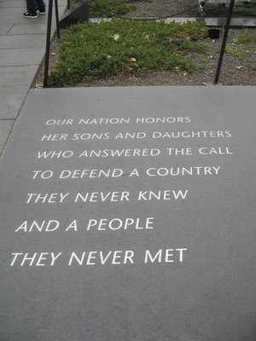
Inscription at the Korean War Memorial

Howard Johnson passed away in September of 2011, at the age of 82 after a lengthy illness. He was buried at the rural Helmar Cemetery near his hometown of Yorktown. The American Legion Honor Guard that Howard Johnson served on for many years stood by at graveside and provided the final tribute to an old soldier, gone, but not forgotten.

