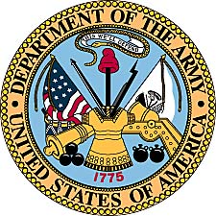
Jack D. Parish
United States Army
(1962-1965)

Jack Parish was born October 1, 1943 in Lowell, Michigan. His family moved across the Midwest during his younger years with stops in Wichita and El Dorado, Kansas. During his high school years Jack moved to Klamath, California where he lived with his aunt and uncle and attended school in Crescent City, California. Baseball and football were two of his passions. During one visit to watch the nearby San Francisco Giants when he was 15, Jack managed to snag a foul ball hit onto the roof by Willie Mays.
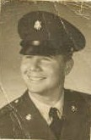

Jack enlisted in the United States Army Nov. 16th, 1962. He was sent to Ft. Ord, California for basic training. Like other soldiers undergoing basic training, he received instruction in weapons, drill, hand-to-hand tactics, and other basic infantryman procedures.
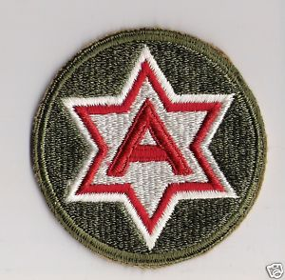
6th Army insignia

Jack remembers one afternoon on the parade ground while the recruits were practicing marching. He booted the company “goof-off” in the rear end from behind after tiring of the man’s mistakes. This sent the other recruit sprawling and brought the attention of a passing officer. Jack quickly explained to the officer, “he tripped,“ and the men went back to drilling.
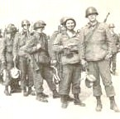
Jack Parish, 2nd from right, in Ft. Ord
yearbook photo during basic training.
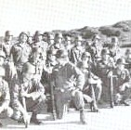
Jack undergoes instruction in field
procedures. (yearbook photo)

After this initial eight weeks of basic training, Jack Parish then went to Ft. Sam Houston, Texas for specialized training as a dental assistant. This medical training lasted six months at the huge military medical facility near San Antonio, Texas.
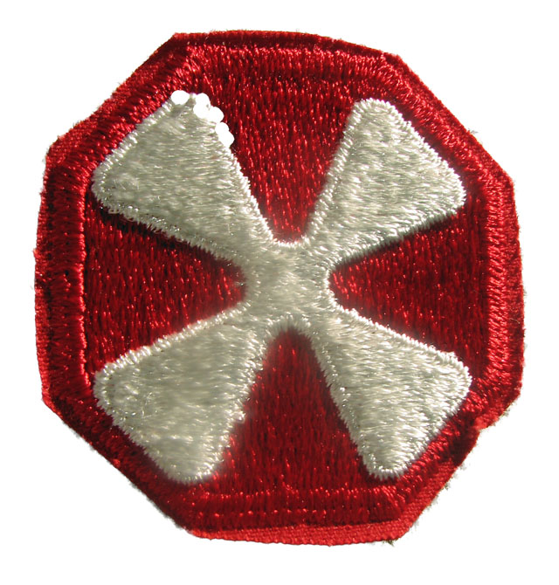
8th Army insignia

With Korea still considered a war zone even though the initial Korean Conflict fighting had ended, the young soldier was deployed to South Korea with the 8th Army, 65th Medical Group in Seoul. Transported on the troop ship USS General Daniel T. Sultan, Parish shipped out from the Oakland Army terminal. The troop ship then proceeded to Pearl Harbor, then to Yokohoma, Japan, and Taipei, Taiwan, before reaching Inchon, South Korea, where he disembarked.
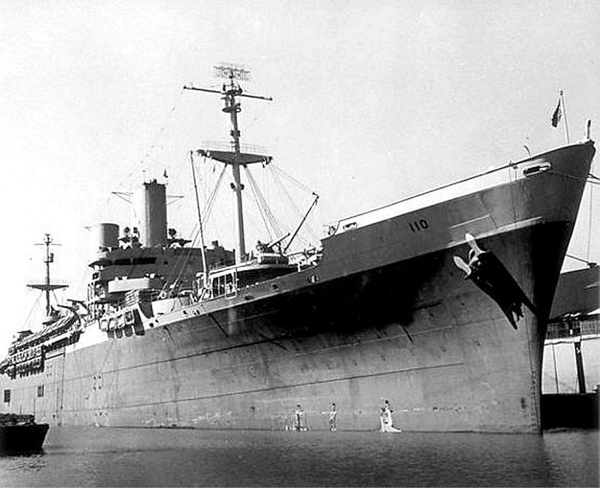
Troop ship waiting to unload soldiers at Inchon,
South Korea. (Photo by Bruce Richards 1961)

Once in South Korea, Parish was assigned to the 207th Medical Detachment, with initial billeting at Camp Red Cloud, South Korea. Camp Red Cloud was located in Uijongbu. The detachment spread out through various I CORPS areas of South Korea and Jack went TDY to Camp Kaiser, located just south of the DMZ on the MSR (Main Supply Route).

The 65th Medical Group was a MASH unit and the 207th Medical Detachment was an all dental unit. The 207th covered Camps Kaiser, Casey, Santa Barbara, Stanley, Beavers, and Red Cloud. As a dental technician Parish assisted a dentist in all facets of dental work including surgery. Much of the work was standard dental care for servicemen at those camps.

Although active fighting ended several years previous, the DMZ was still a hotspot in the early 1960’s. In 1963 during his deployment, a group of North Korean soldiers came over the 38th Parallel near his base and set up an ambush of an American patrol. The North Koreans killed four Americans and wounded several others, taking weapons and munitions except for the new M-14s, which they had no ammunition for. Throughout his deployment to South Korea, troops followed strict security regulations as a result of the tense Cold War conditions and his proximity to the front lines of the DMZ.

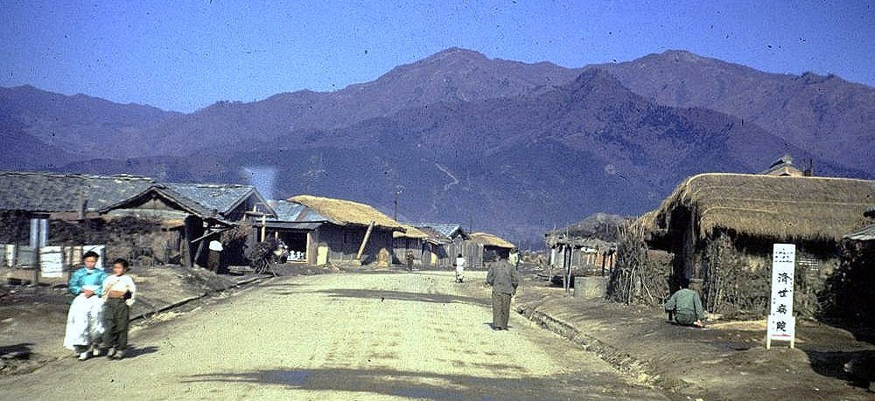
A village up in the area near Camp Kaiser in 1961, with North Korea in the background.

The Kennedy assignation occurred during Parish’s tour of duty in South Korea. The event sent all troops into high alert and Parish recalls sleeping in full gear with rifles at the ready for several weeks before the stand-down order was given.

An all night party to see off a departing Captain placed Jack in possibly his most serious conflict of his tour. The going away party at the BOQ, brought a special invite even though enlisted men were not normally permitted. A 5th of Jim Beam whiskey drew Jack’s attention and before the party was over he was calling colonels and majors names.
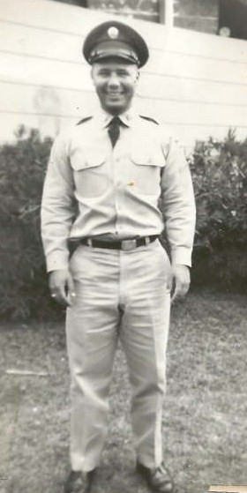
Jack Parish in 1964 on return from duty,
on leave in Pomona, California. (family photo)

After a thirteen month tour of duty, Jack Parish headed home in May of 1964. Back in the United States he had a 30 days leave in Southern California. He was next assigned to Ft. Hood, Texas, with the 4th Army at the hospital there. He was later transferred in January, 1965, when he was assigned to the 1st Armored Division, 47th Medical Division. While with the 47th Medical Battalion, Parish was promoted to SPEC 4. He remained with this unit until honorably discharged Nov. 15th, 1965.
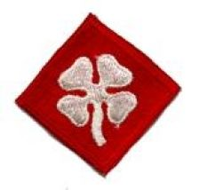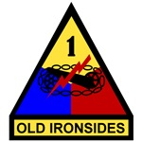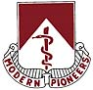
4th Army 1st Armored Division 47th Medical Battalion
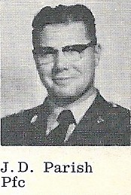
In 1965, the 1st Armored Division, also known as “Old Ironsides,” published a 25th Anniversary Edition book. In the photo above, Jack Parish is shown in his individual photo from that book. In the excerpt below, Jack’s head is pictured at the left, just above a description of the 47th Medical Battalion, 1st Armored Division. In the background picture, Parish is explaining to some high ranking officers from the Pentagon the use of dental instruments. The officers were there on an inspection of the entire 1st Armored Division.

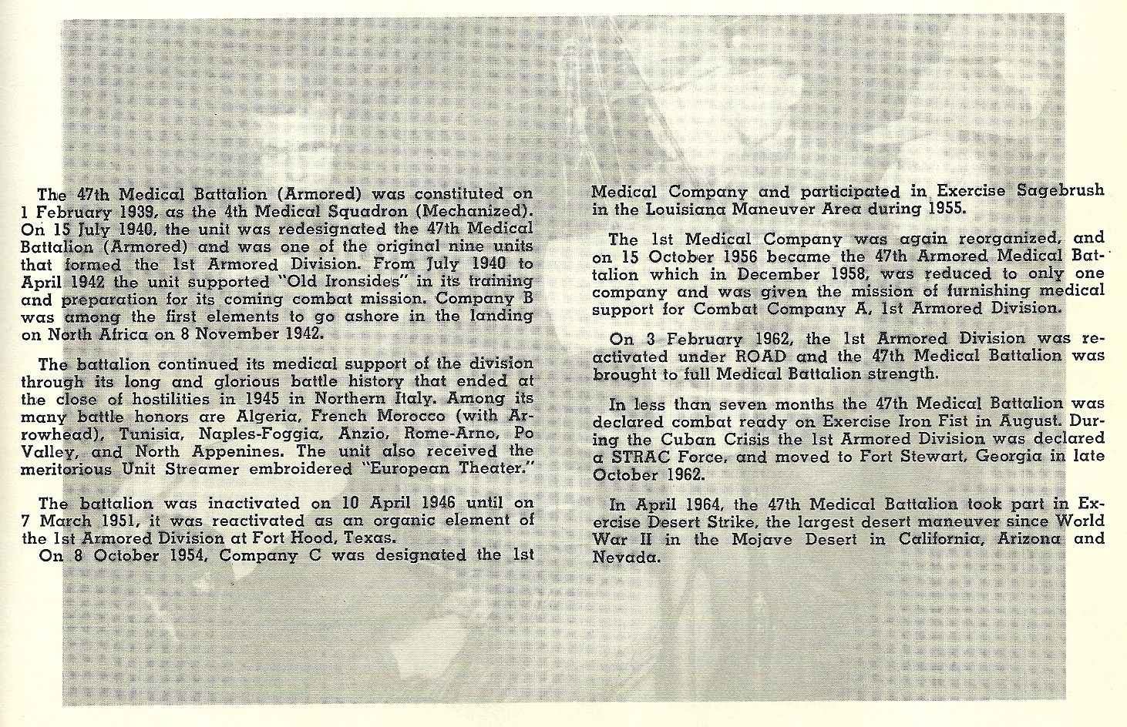
In addition to serving in a combat zone designation, (although not during a time with active warfare), Jack Parish earned the Good Conduct Medal and the Marksman Medal with the United States Army.

Jack Parish has one son David and is married to Bobbie Parish. They reside in Kansas City, Kansas, where Jack is active in working with military veterans throughout the Missouri-Kansas region.

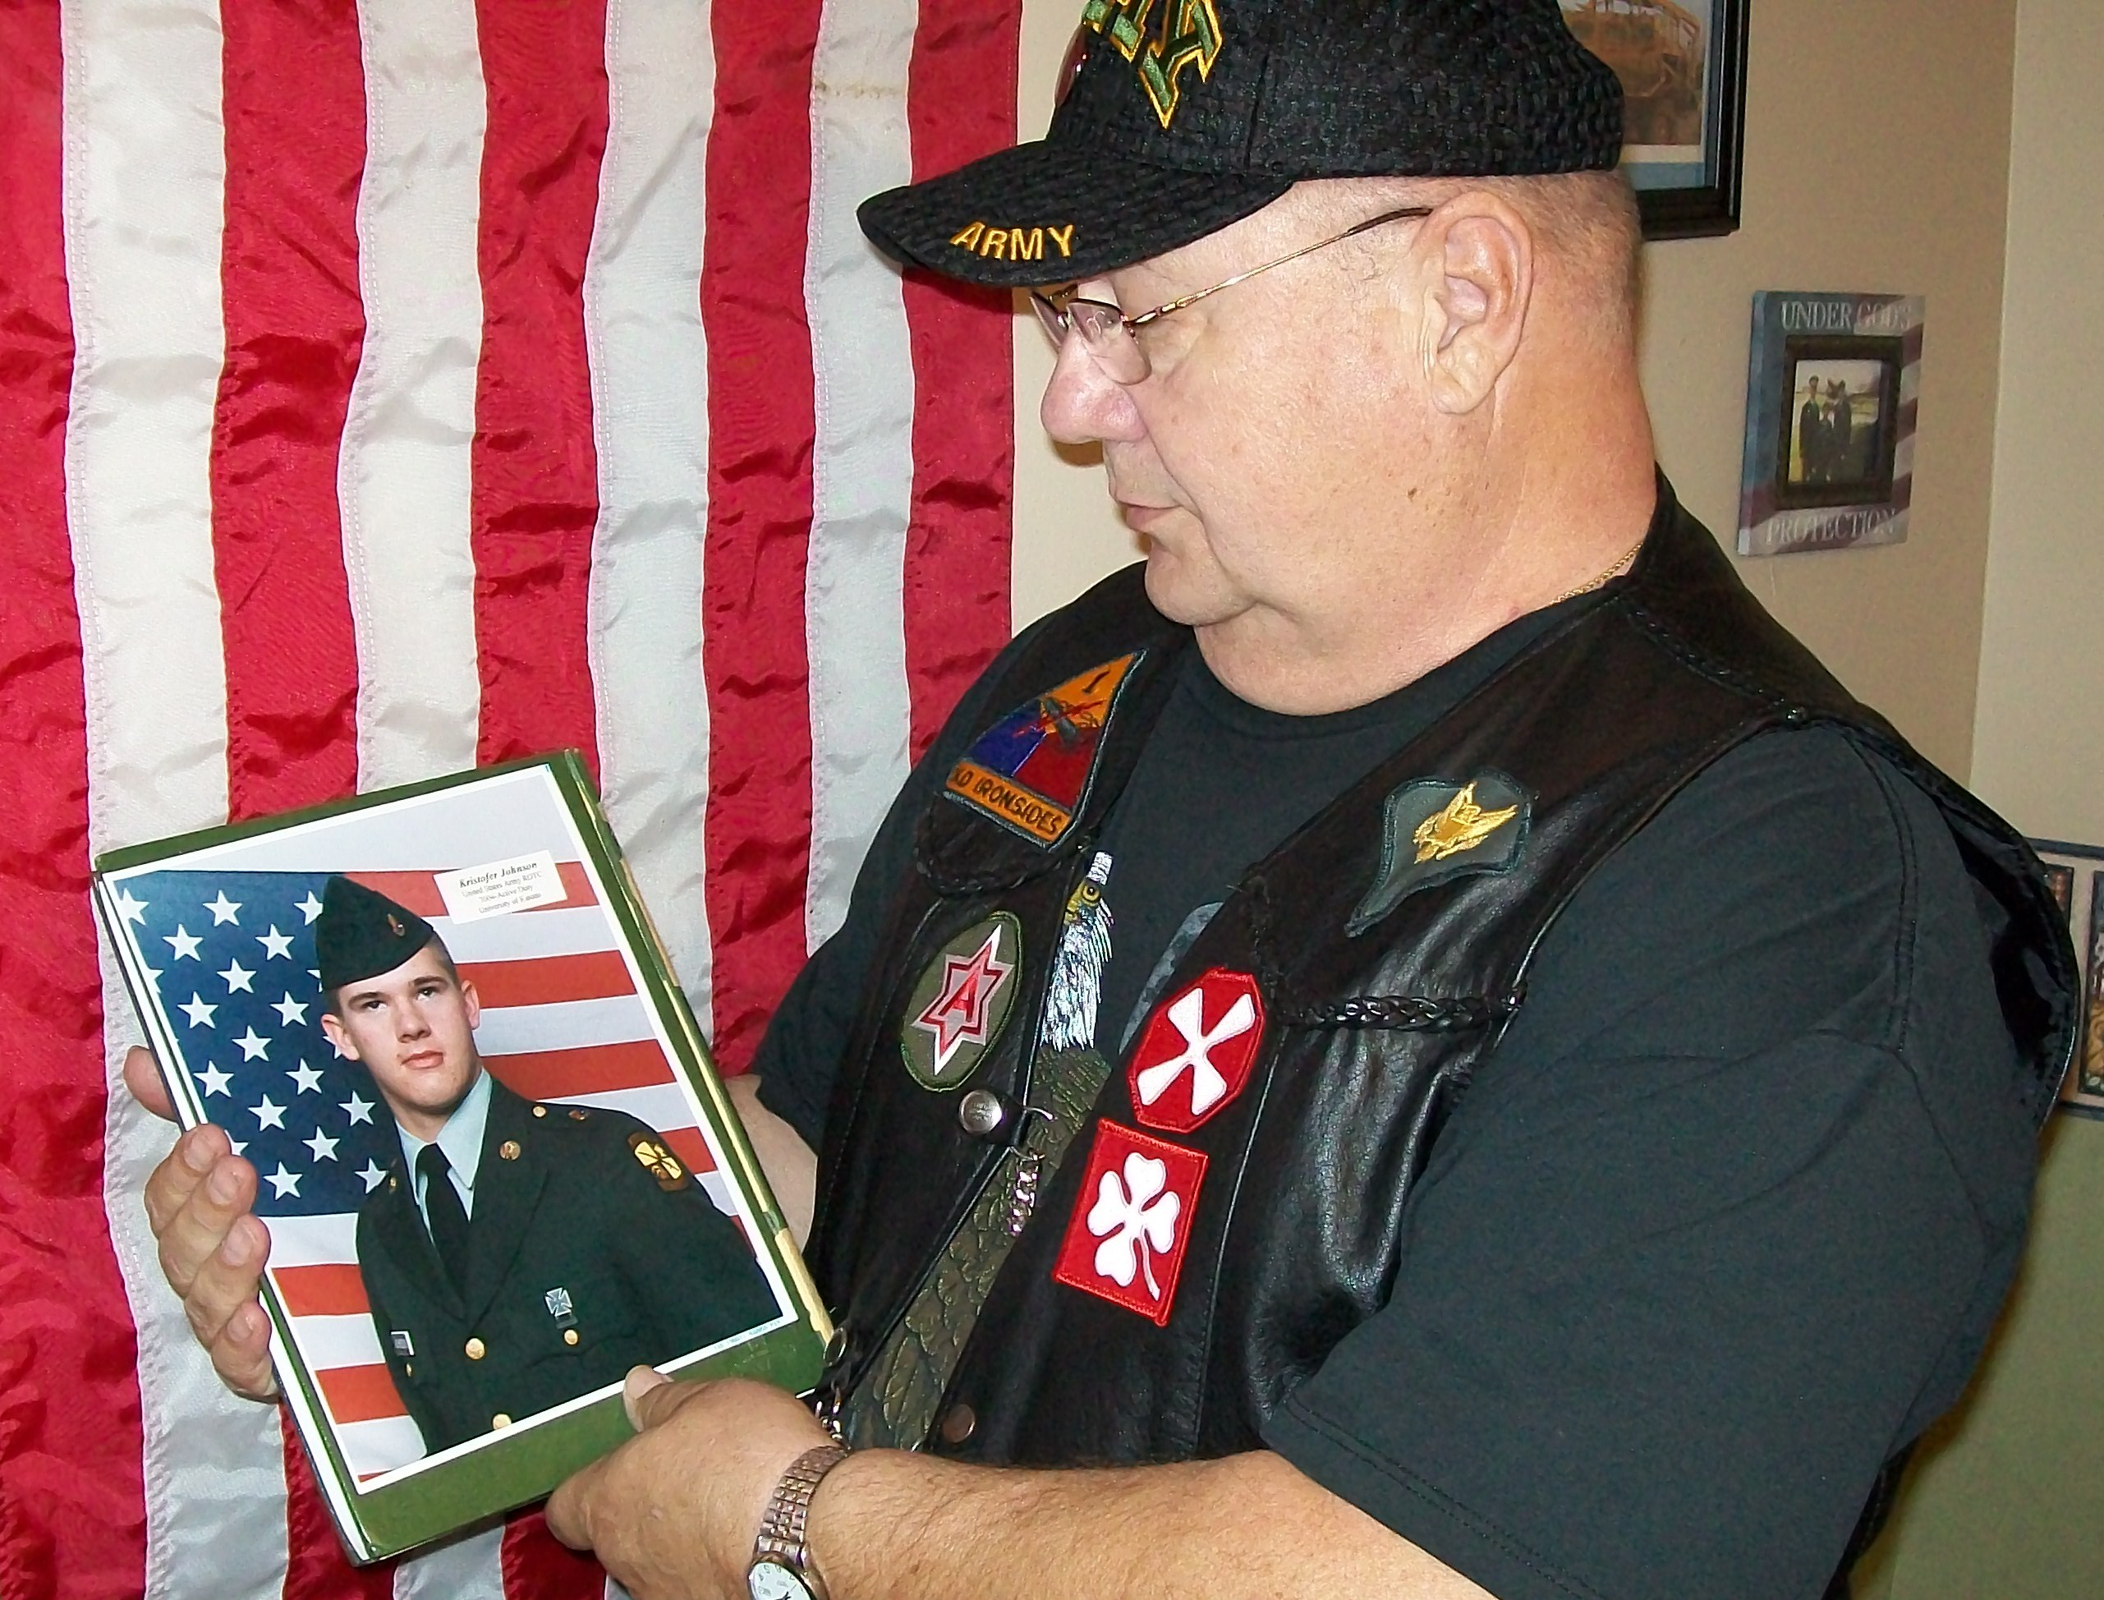
Jack Parish looks at a photo of his Godson Kris Johnson while wearing his
favorite Army hat and vest with his militar patches in this 2010 photo.

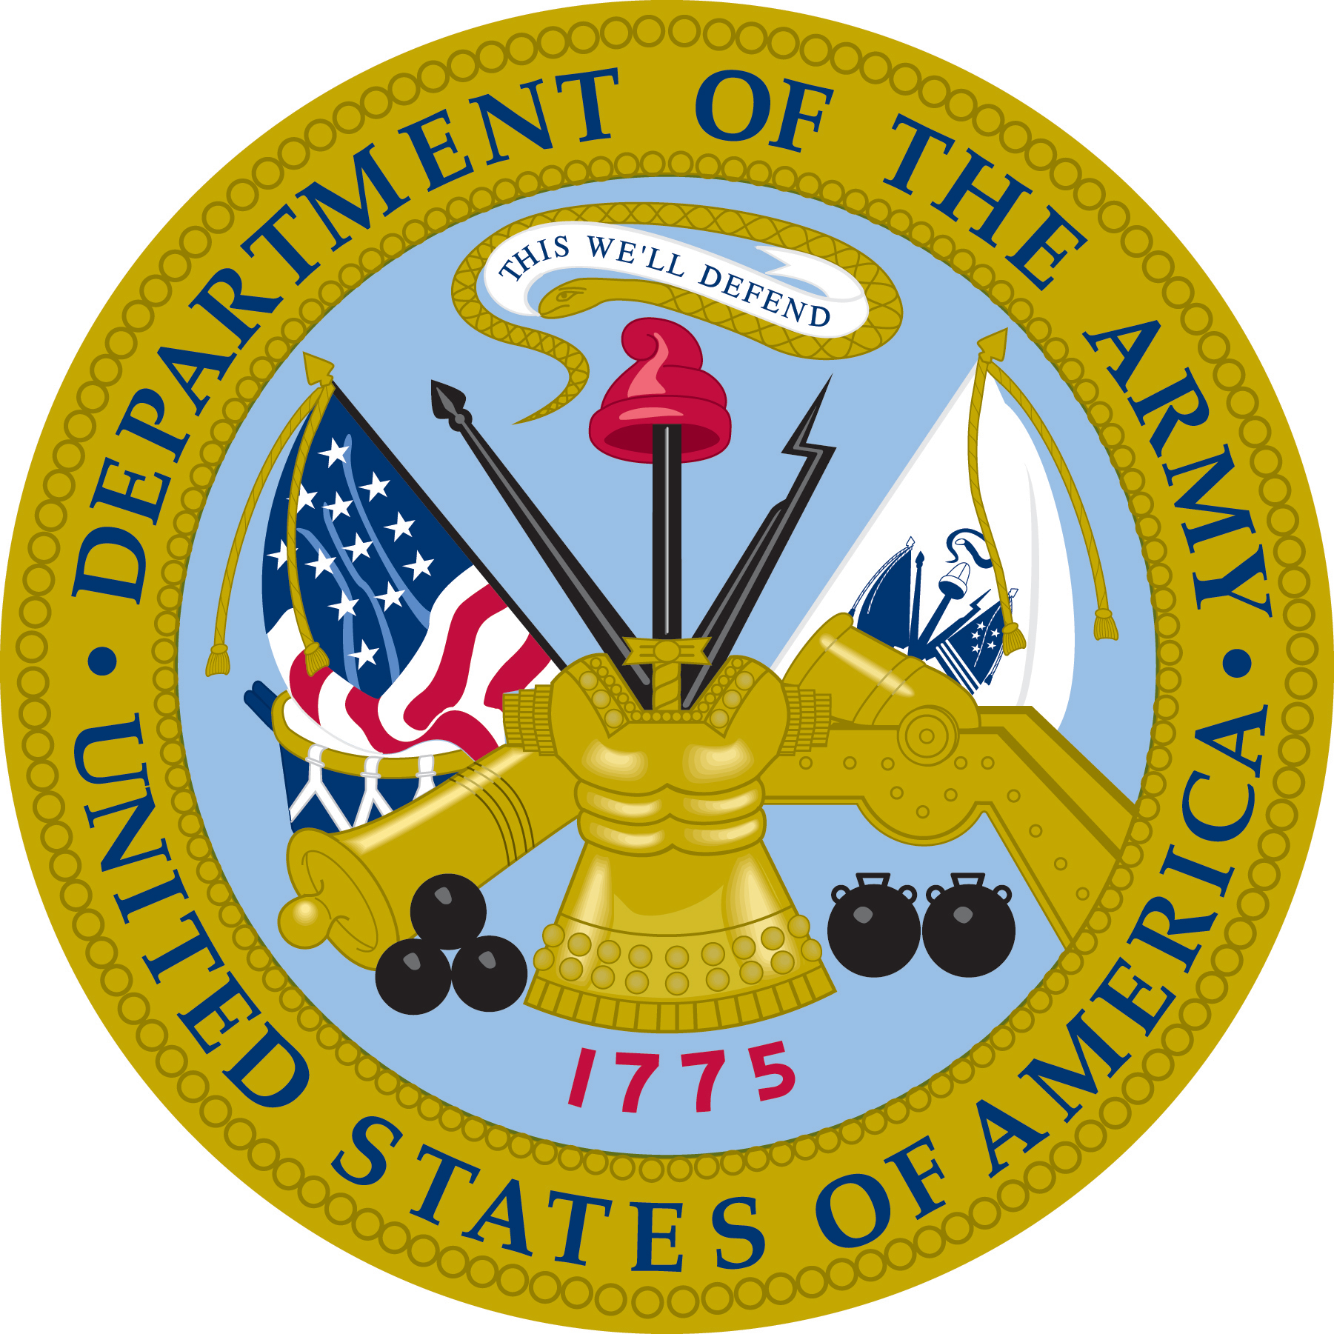
APPENDIX

Military Script

During the war and following occupation in South Korea, the United States military issued payment to soldiers in “military payment certificates.” The amounts for the paper money ranged from cents to dollars and was printed on colored paper. Every so often the military would suddenly change it’s money colors to help control the use of military script on the black market.

Posts would suddenly be closed and soldiers would have only a short time to trade in their money for the new issue. Villagers and people outside the post would desperately try to cash in so they would not lose out on their money they had taken doing business illegally with soldiers.
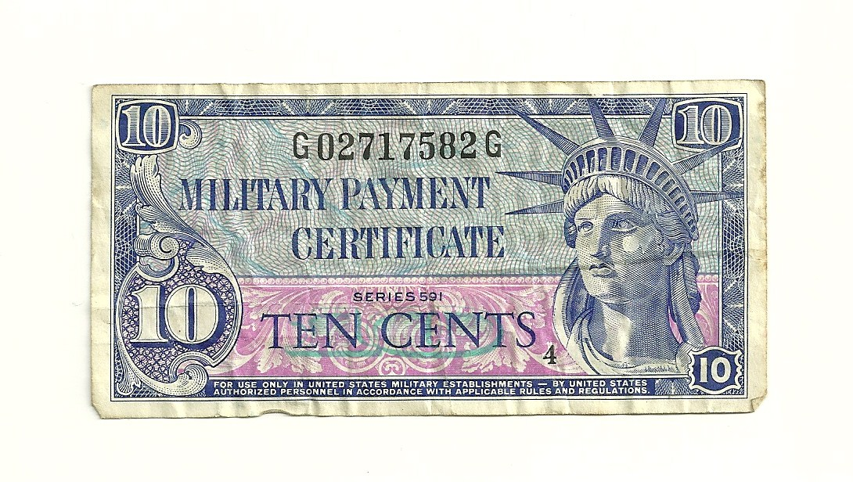
Army script from South Korea used to pay military personnel.
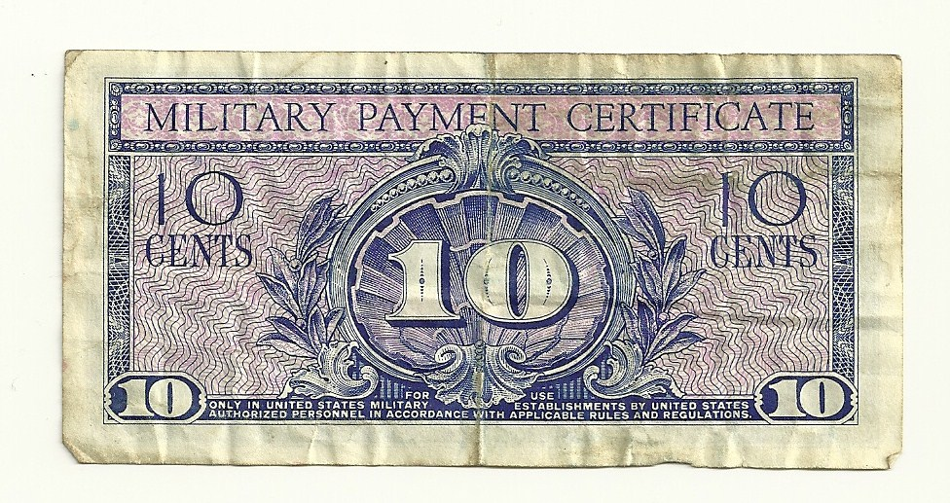

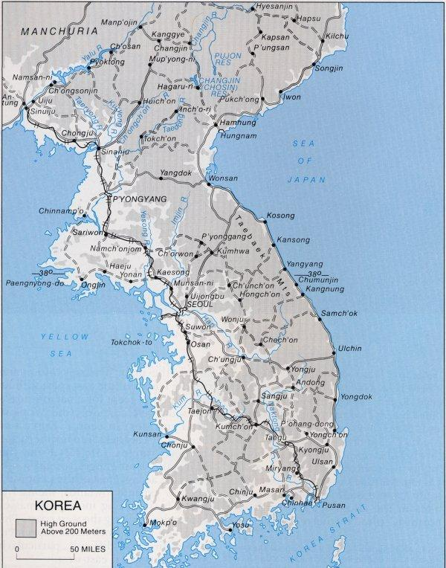

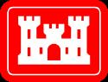
2nd Lt Kristofer Johnson
3rd Platoon
41st Engineers Company
Ft. Riley, Kansas
________________________________________________________________________

20 November 2009

Jack Parish
Kansas City, Ks
USA

Dear Jack:

Although it is hard to stay in touch with everyone from over here in Afghanistan, I wanted to let you know how much your support back home means to me. You have already walked in my shoes having served overseas in Korea, so I know you understand what it is like being away from home in a war zone.

I would be honored if you would accept the United States flag I am sending as a token of my respect for what you and others have done to honor the United States Army in the past. I carried this flag with me on patrol with our Route Clearance Unit in my RG31 Command Unit during action in late October-November, 2009. It has withstood the fire of the Taliban during patrols through the mountains and wastelands of Afghanistan.

Thanks for being such a good God parent to me.

Respectfully yours,

2nd Lt. Kris Johnson

