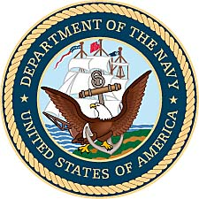
John J. Neff
United States Navy
1942-1945 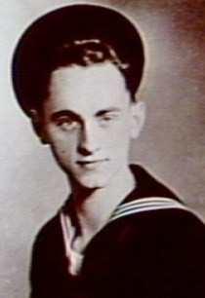
Naval photo of John Neff.
John Junior Neff was born July 22, 1922, in Lyndon, Kansas. He was the oldest of four children and the only son born to Bertha Bryden and John Neff . In June, 1941, John graduated from Osage City High School at the age of 17. During high school John played in the band as first chair in the second clarinet section. His senior year he was drum major for the marching band. Their band marched in the American Royal Parade that year.

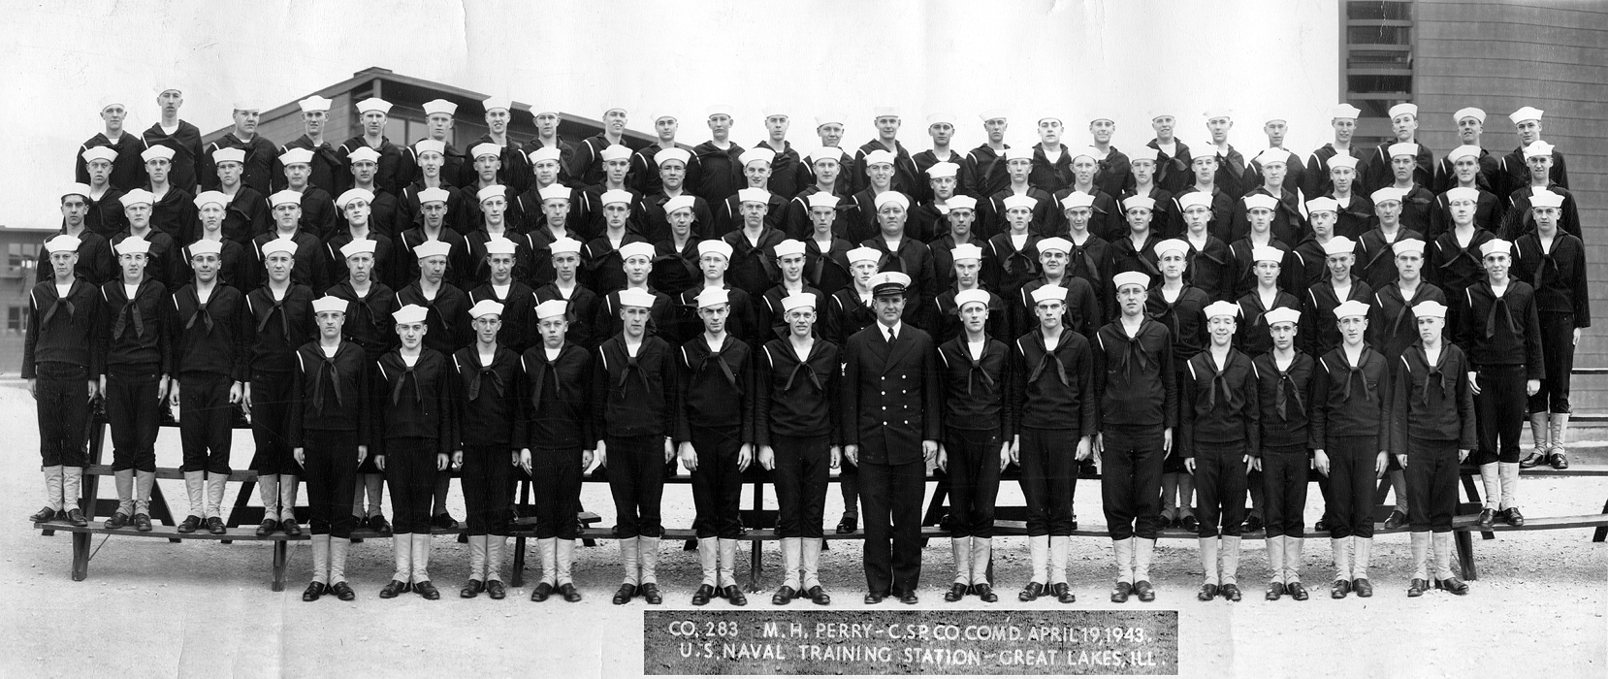
Company 283 at the Great Lakes Training Station, April 19, 1943.
(file photo from Great Lakes Naval Historical Museum)

After graduation, John’s grandfather paid for three years of nurses training at Newman Hospital in Emporia. He studied for one year. Then in August of 1942, with World War II underway, he enlisted in the Navy and with letters from the doctors at Newman Hospital, he was given the rank of Pharmacist Mate 3rd Class. Boot camp was in Illinois at the Great Lakes Naval Station. After boot camp, John was assigned to the Great Lakes Naval Hospital in Great Lakes, Illinois. He served as a nurse and operating technician for twelve months.
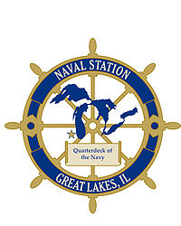

In April, 1943, John was assigned as PHM 2nd Class on the LST 730, to be berthed at Solomon Islands, Maryland. LST (Landing Ship Tank ) was the military designation for naval vessels created during World War II to support amphibious operations by carrying significant quantities of vehicles, cargo, and landing troops directly onto an unimproved shore. The majority, about a thousand, were laid down in the United States during WWII for use by the Allies.

LST 730 was built by the Dravo Corporation of Pittsburgh, Pennsylvania. It was ordered laid down December 13, 1943. It launched January 29, 1944, and was commissioned on March 30, 1944. John Neff went to Pittsburg while the new ship was built and commissioned. It took a period of over a year.

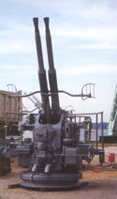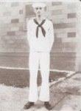
44mm anti-aircraft gun aboard an LST. John Neff in naval white uniform
(photo by LST Memorial Association) (scanned from personal photo)

Specifications for LST 730 were a water displacement of 1,625 tons, with a length of 328 feet. Its beam was 50 feet draft unloaded, with a loaded speed of 12k. Neff’s new ship carried a complement of 8-10 officers and 89-100 Enlisted. It also had the troop capacity for approximately 130 officers and enlisted men. For protection the LST 730 had one single 3"/50 gun mount, eight 40mm guns, and twelve 20mm guns. Propulsion of the Landing Ship was provided by two General Motors 12-567 diesel engines, with two shafts and twin rudders.

On June 12, 1943, John Neff married his high school sweetheart Barbara Lucille Nevelle in their home town of Osage City, Kansas, and they honeymooned in Chicago, Illinois. Then John returned to duty.
When completed, his ship traveled via two rivers to New Orleans in order to pick up supplies and meet up with the 52nd group leaving for England and the Normandy invasion. However, the ship was damaged along the way, possibly on a sand bar and needed a new prop and propeller. This forced the ship into dry dock, missing their overseas connection.

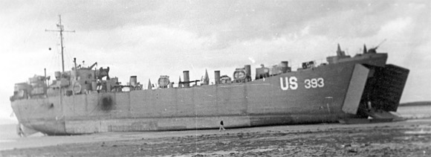A sister ship to the LST 730 off-loads at the beaches of Normandy during the invasion. (photo from US Naval Registry)

Following dry dock, LST 730 was instead sent to South Chesapeake Bay as a training ship. The primary role of a Pharmacists’ Mate aboard a LST was to provide initial medical care for the crew. Because LST 730 was functioning as a training ship off the east coast of the US, it routinely sailed without other medical assistance nearby. John Neff was often called on to provide medical care well beyond his primary training.

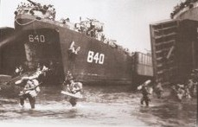
Photos of LSTs in operation.
(Photo from John Neff, scanned from slide negatives)

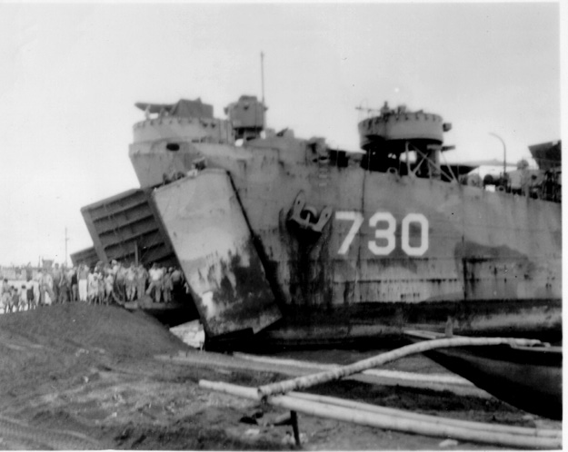
LST 730 at an unknown site during its service in World War II.
(Photo courtesy of the US Navy Fleet Archives)

Following his discharge from the Navy on June 6, 1945, John worked for a short time at the Merrill Packing Plant and then enrolled at Washburn College. The Navy decommissioned his ship the LST 730 on June 8, 1946 and it was sold for scrap metal on December 18, 1947. Other LSTs would remain in service and eventually return to combat operations during the Korean War.

John’s oldest daughter Susan Carol Neff was born October 23, 1944, while he was still in the US Navy. In his junior year of college, his second daughter, Nancy Irene was born on September 12, 1947. To help with expenses during his senior year, he worked at an insurance company while finishing his degree. In the fall of 1948, the family moved to Concordia, Kansas, for John’s first teaching position. The family moved in 1951 to Topeka, where John taught at Topeka High School.

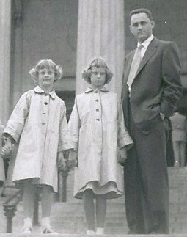
Nancy, Susan, and John Neff, on the steps
of the Museum of Natural History, Chicago,
Illinois, during the 1950’s.
(photo by Gordon Johnson)

The Neff family moved to southern California in the fall of 1956, with John teaching science at Bellflower High School and he remained there until 1958. He then moved to a position in Norwalk, California, teaching anatomy and physiology at Cerritos Junior College. Before retiring, he was instrumental in establishing a nursing program at the junior college.

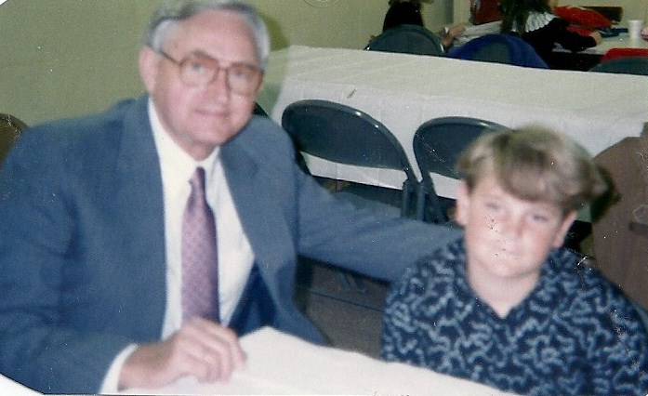
John Neff with his grandson Matt in 1988. (family photo)

John Neff was a charter member of the United States Navy Memorial Foundation, that was established in Washington, DC, in 1990. His naval records can be viewed online with the Navy Memorial Foundation and with the World War II History Center in El Dorado, Kansas. John Neff passed away in the summer of 2010 while living at the Mount Miguel Covenant Home in Spring Valley, California.

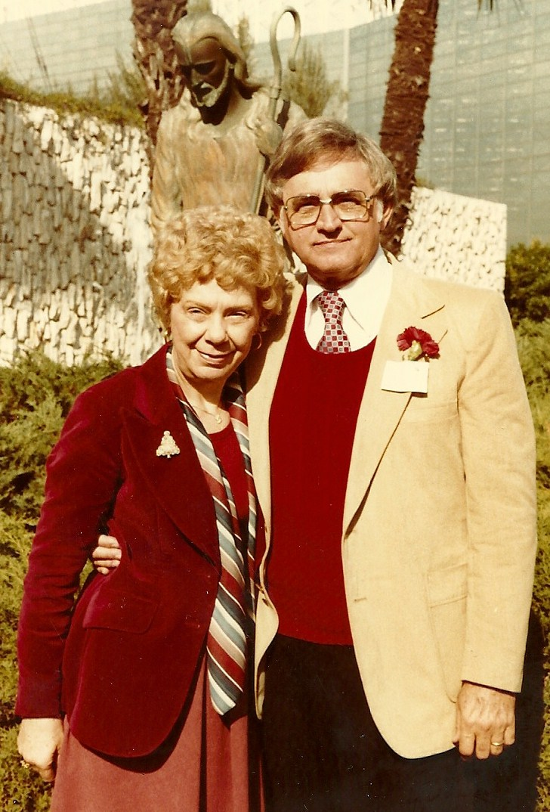
Barbara & John Neff at the Crystal Cathedral in Southern California.

The Pier

The lines are cast I’m on my way to places
new and far away.
Six months will pass till I return, another
sea service ribbon earned.
She stands alone on that Norfolk pier and I
watch her till we disappear.
The tug boats blow and the sea gulls cry
its always tough to say goodbye.
A navy wife is a special breed she fills so
many special needs, like being dad while I'm
away she always knows just what to say.
And now the pier is far from sight but I know
that things will be alright.
And soon these months will turn to days, and
then I will be home to stay, and spend my
years with the ones most dear and forget
the sight of that Norfolk pier.

Marc A. Reyes, USN
©2000 Marc Reyes

