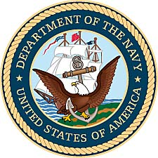

Maurice Houtman
United States Navy (1962-1963)

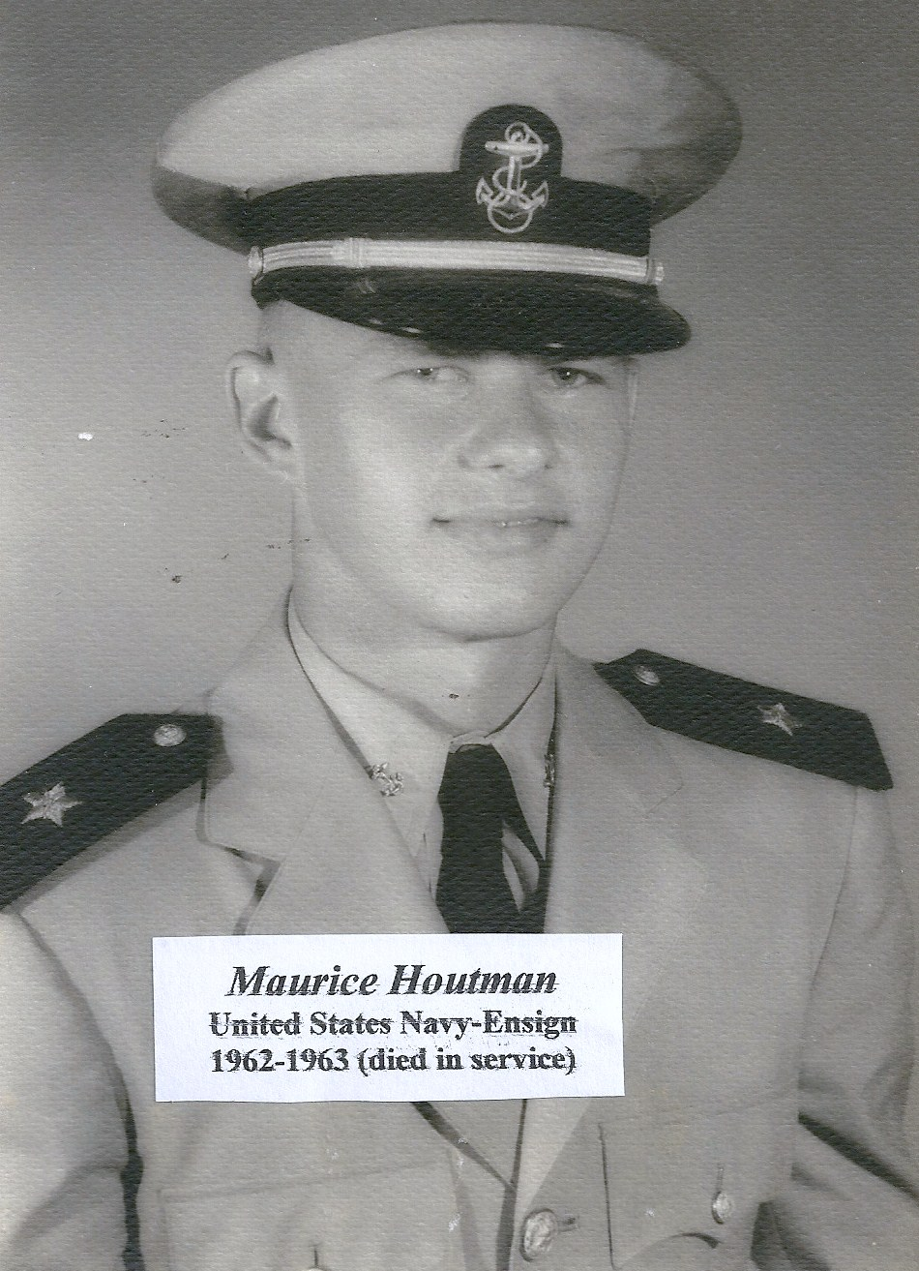
1962 naval photo of Maurice Houtman.

Maurice Houtman was the son of Frieda and John Houtman of Kansas City, Kansas. Of the ten children in the Houtman family, seven boys and three girls, Maurice was the youngest. Born in July of 1941, he attended Grace Lutheran Church and was active in church youth activities. He was a graduate of Wyandotte High School in Kansas City, Kansas.

It was a hope of Maurice to be a pilot, but vision issues that required him to wear glasses prevented that option in the military. However, he enlisted in the United States Navy and trained to become an Air Traffic Controller. Training for that specialty was completed at the Naval Air Base in Pensacola, Florida, in 1963. That base served as a hub for the training of Naval Aviators, the Blue Angels, and related Navy flight specialties.

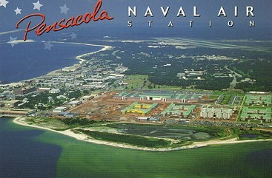
Postcard from the Naval Air Station.

His parents attended his graduation from specialized training, but a tragic traffic accident took the life of the young Ensign in 1963 as he traveled home from his post in Florida, even before he could begin his formal duties with the Navy. He is buried with his family at the cemetery near 18th Street and the Kansas River in Kansas City, Kansas.

