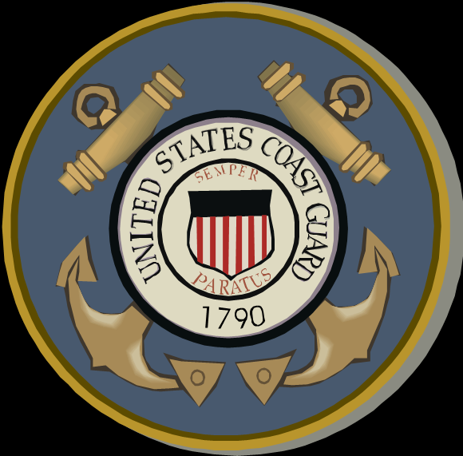

Orville Houtman
United States Coast Guard
1943-1946 (World War II)

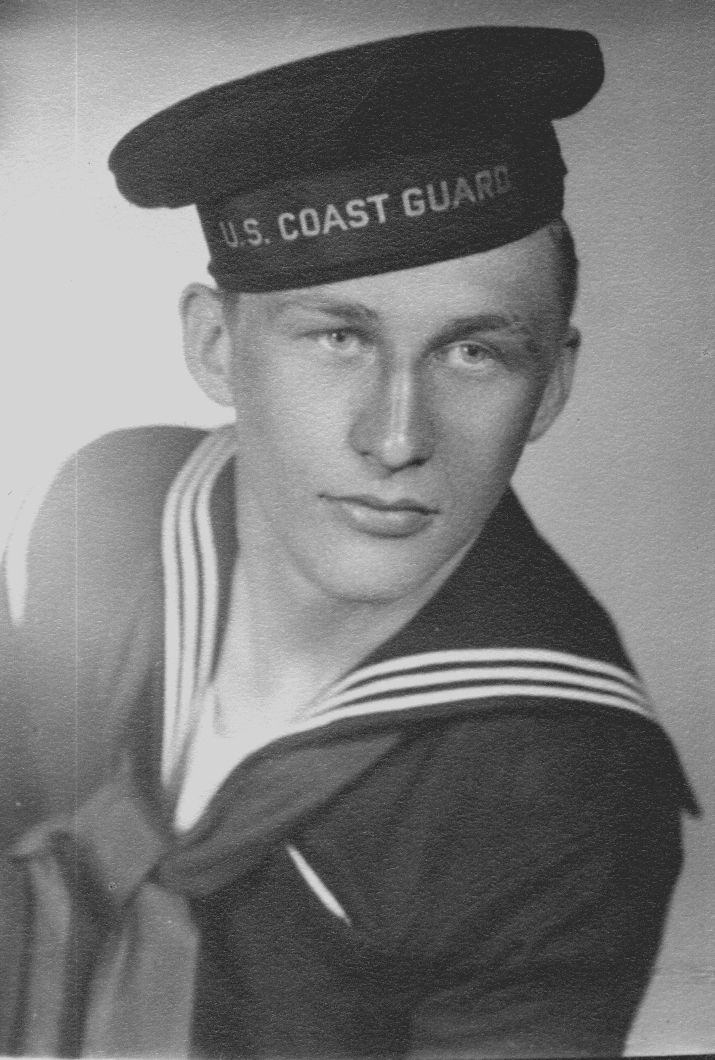
Orville Houtman, Fireman 1st Class, US Coast Guard.

Orville Houtman, brother of Alvin Houtman, would enlist in the United States Coast Guard in 1943 during the early years of World War II. Although expecting to remain stateside, he instead would be shipped to the Pacific Theatre. Many US Coast Guard sailors assisted the Navy in positions that required extra man power during the war in the battle against the Japanese.

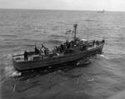

US Coast Guard ships during World War II (File photos from Archives)

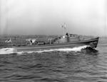

For his tour of duty, Orville would receive the World War II Victory Medal. He was Honorably Discharged in June of 1946.
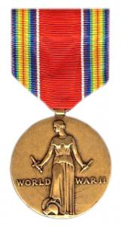
WWII Victory Medal

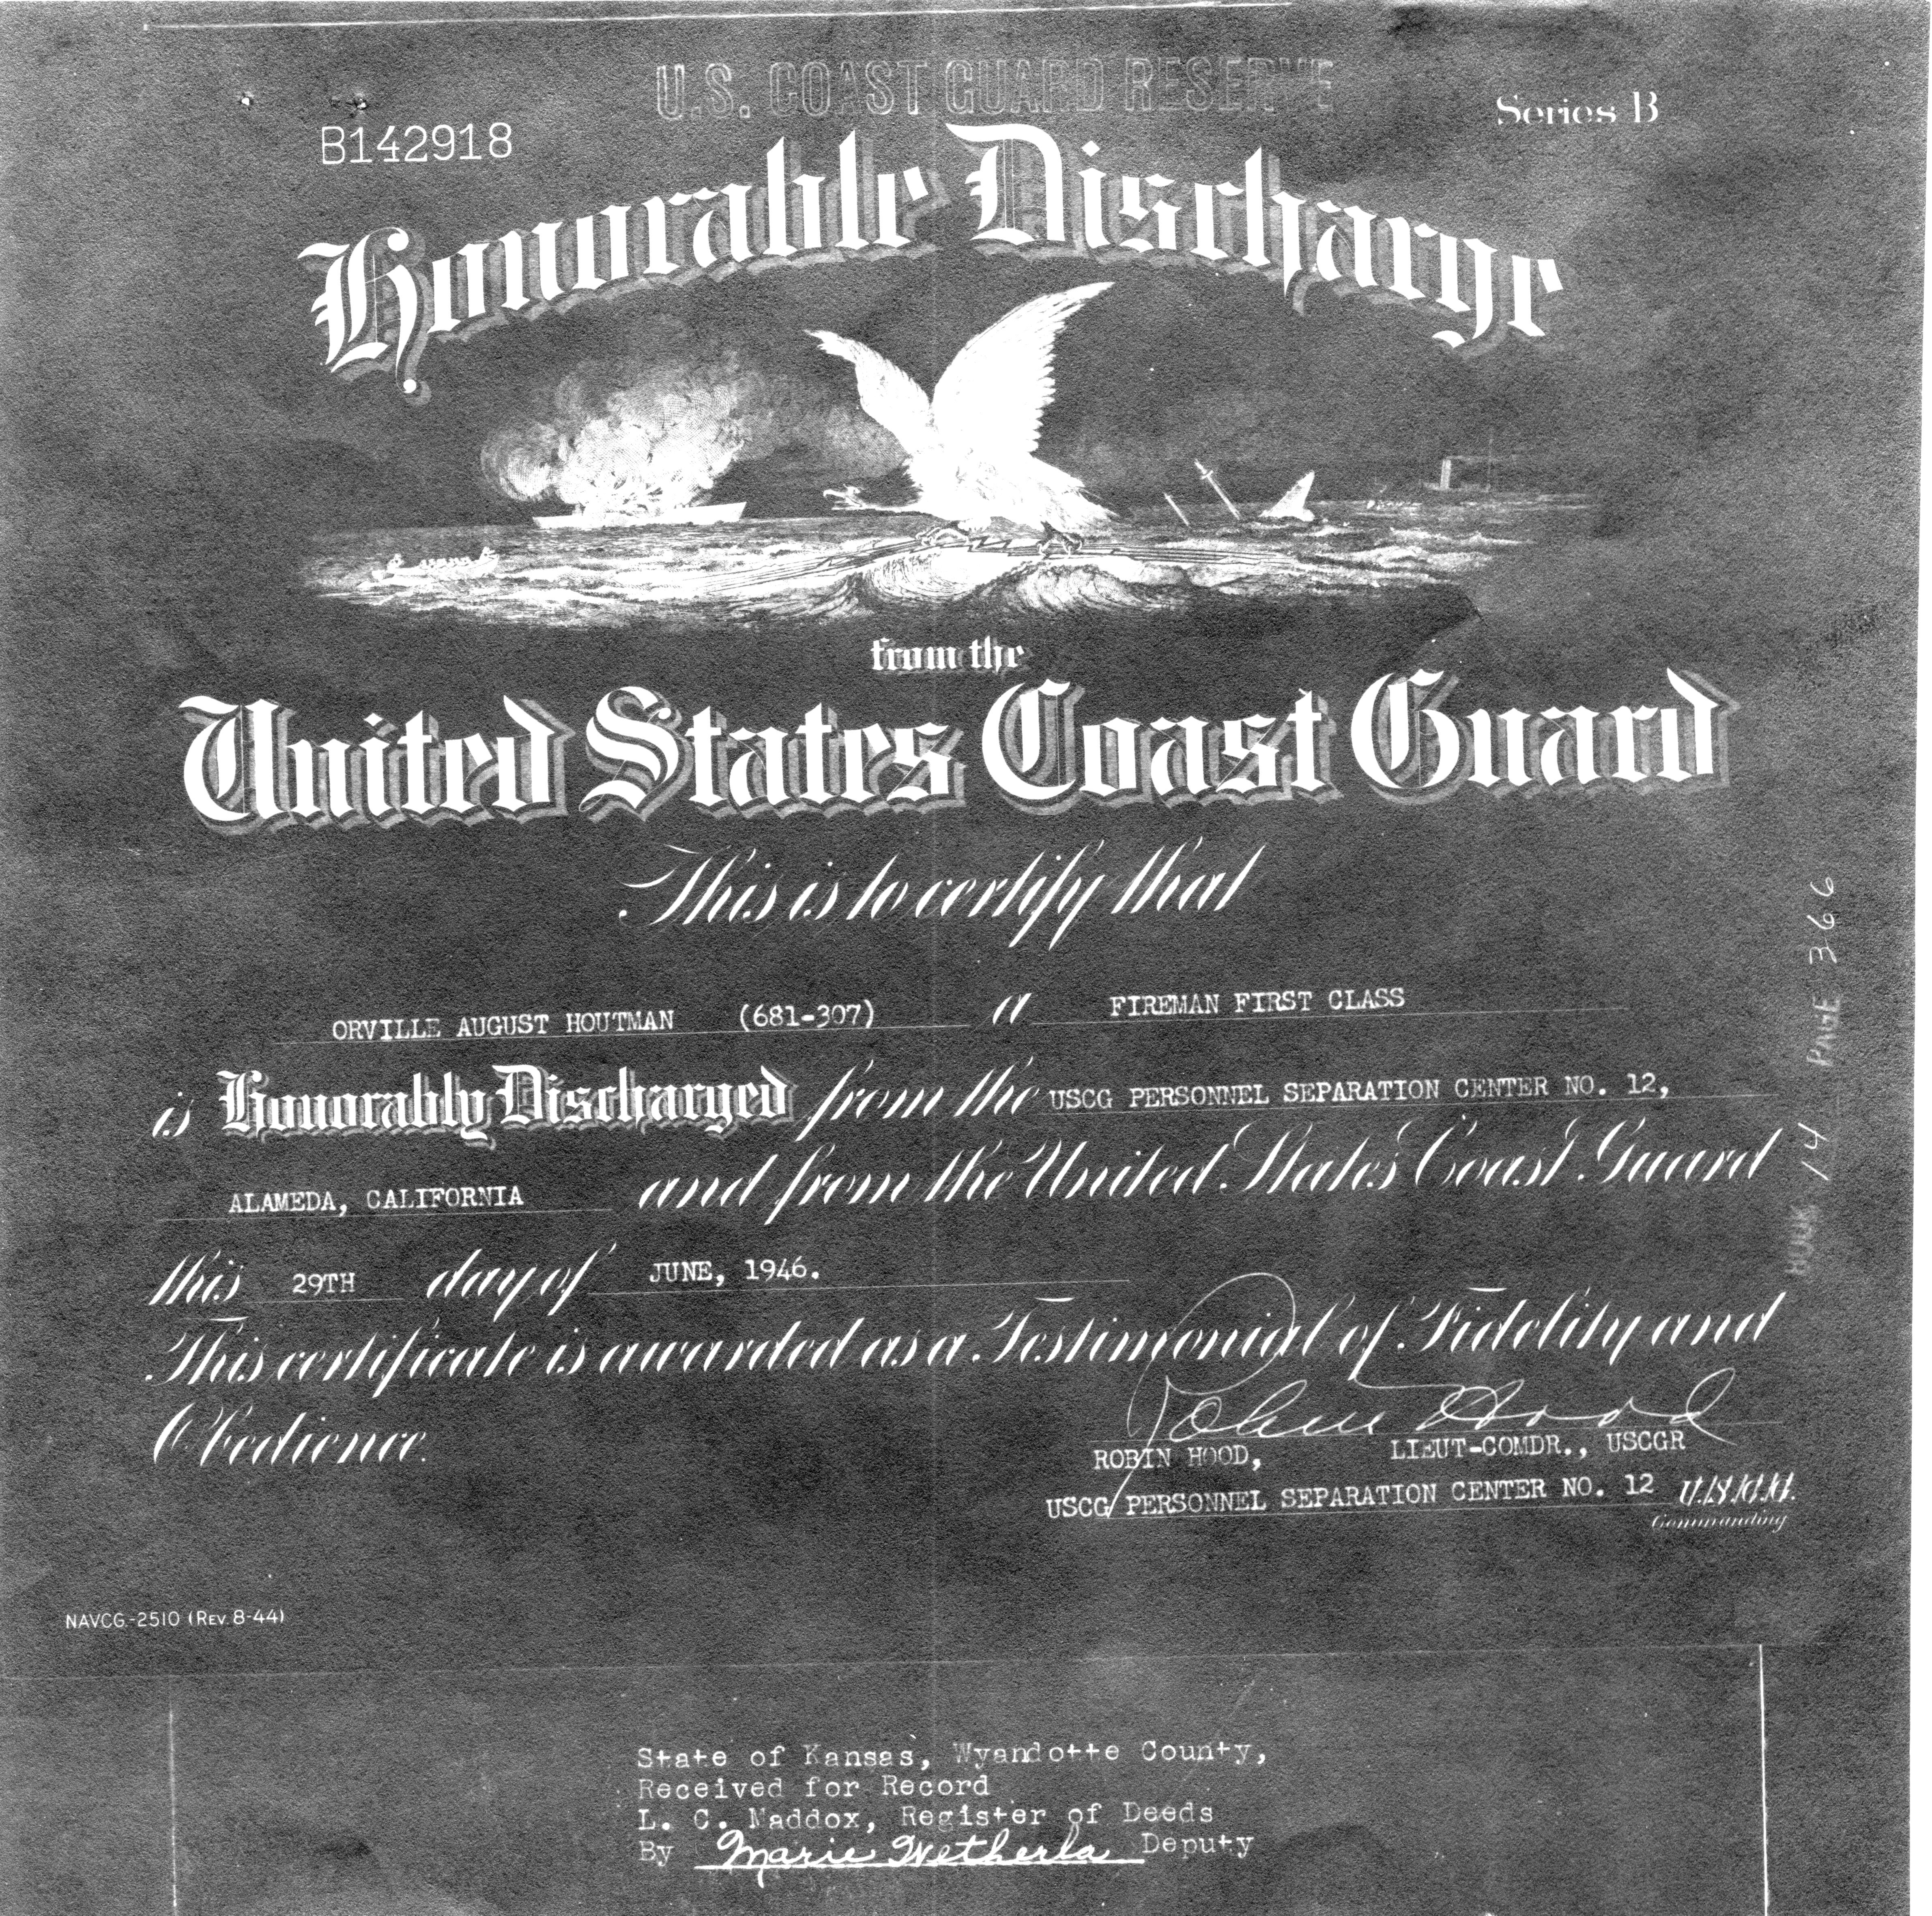
Discharge papers for Orvile Houtman.

