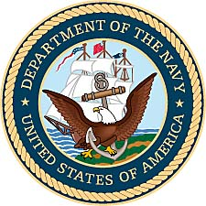

Thomas V. Lewis

United States Navy

(1943-1946)

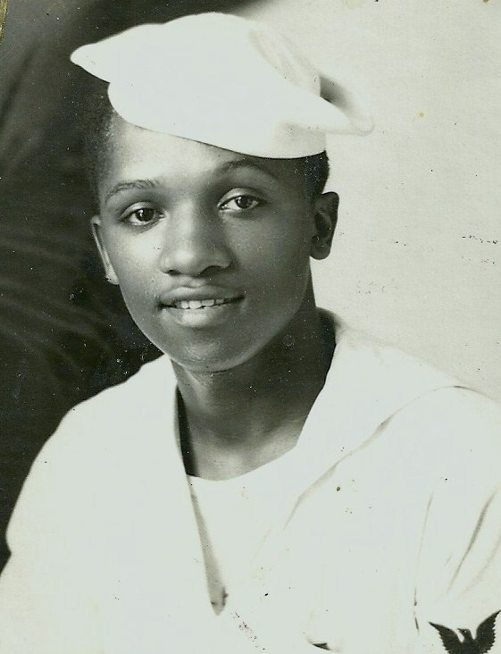

*Thomas Valentino Lewis - Great Lakes Training Center, 1943.*

Thomas Lewis was born July 16, 1925, in Chicago, Illinois, at Cook County Hospital. He was one of five brothers who would serve their country during World War II in the United States Military. A talented athlete, Tom would even box professionally for a brief time before he decided that line of work was sometimes painful.

With the country entering World War II, Thomas would enlist in the United States Navy on October 5, 1943. His basic training was at the nearby Great Lakes Naval Training Center, north of Chicago. His original training and schooling was as a cook and baker and his naval rating was SC3 or Ships Cook 3rd Class. His selection to this assignment came when the entry officer asked him what he had done before the Navy. When Tom told them he had worked for Campbell Soup, they assumed he could cook. He would also train as a machinist during his naval career.

The young sailor was assigned to the USS Henrico, an attack transport after his basic training. Tom traveled to Frontier Base Tompkinsville and the Naval Base there in New York State to meet up with his new ship. His assignment for the remainder of World War II then refitted in Boston and made the long journey to the Pacific.

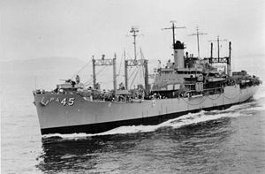

*The USS Henrico was commissioned in 1943 and was part of the Normandy Invasion,*

*before moving to the Pacific Theatre for the war with Japan in 1944.*

Service aboard a naval ship during World War II was not always smooth sailing for African Americans. Discrimination in the US military often relegated blacks to positions that the white officers felt were appropriate. On one occasion the ship’s captain wanted to switch Tom from being a Ship’s Cook for the men to being the Officer’s Cook. Lewis declined, feeling that it was an obvious stereotype. He would later comment to his wife Carol, “I wasn’t going to be nobody’s servant.”

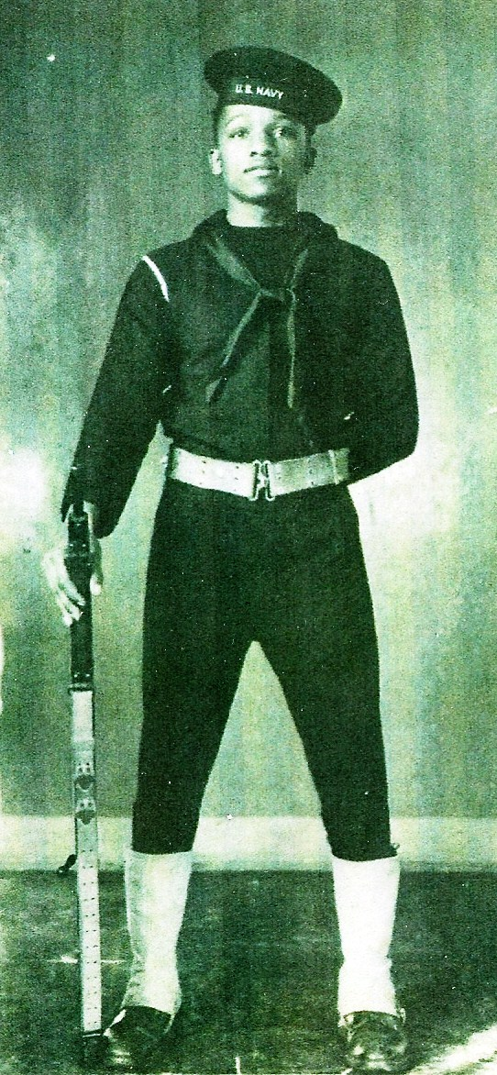

*Thomas Lewis in full dress naval uniform.*

The USS Henrico and Tom Lewis would eventually join up with the main fleet and find themselves embroiled in some of the heaviest naval fighting of the 2nd World War. In addition to his regular duties as a cook, Tom Lewis would also learn to man ammunition shells for the ship’s gun batteries during battle. Before the war was over, the Henrico would earn three Battle Stars, but not before Tom Lewis and his shipmates would find themselves in a life and death struggle for survival.

From March 21, 1945, until the evening of April 2nd, the Henrico participated in the invasion of Okinawa. The ferocity of the fight between ships and planes that occurred off Okinawa in April and May 1945 is unparalleled in modern military history. The U.S. Navy remained on station to lend supply, air support and naval gunfire to the effort.

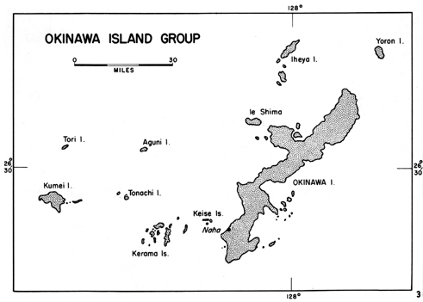

Waves of kamikaze aircraft attacked the U.S. vessels in an effort to force them back from Okinawa waters. In mass attacks known as “kikusui,” or "floating chrysanthemums," Japanese pilots hurled themselves against the fleet. More than 7,000 American GIs and Marines died on Okinawa. Offshore, the U.S. Navy lost nearly 5,000 sailors killed and 4,800 wounded. A total of 13 destroyers and one destroyer escort went to the bottom, while 13 aircraft carriers, 10 battleships and five cruisers were heavily damaged. Nearly 50 more destroyers and destroyer escorts were damaged. Ships large and small were kamikaze victims.

From the start of the landing on Okinawa, the Henrico remained under constant attack by the Japanese air force. Then while proceeding to night retirement during the evening of the 2nd, about four miles from Kerama Retto Harbor, Okinawa, the ship was hit by a "Francis" twin engine Kamikaze Bomber.

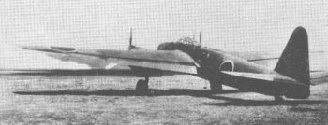

*A Japanese Frances, a two engine bomber used in kamikaze*

*attacks against American ships at Okinawa.*

The kamikaze struck the starboard side of the Navigation Bridge causing extensive damage. Two 250 pound bombs penetrated two deck levels and exploded on the main deck, resulting in fires and flooding that were not brought under control until 2100. Two hours later the ship was taken in tow by the USS Suffolk. As a result of the attack, thirty-seven Navy and fourteen Army personnel were killed, including the Transport Division Commander, the Commanding Officer, and the Troop Commander. The heroism of the crew would save the ship from sinking and Tom Lewis would receive a Bronze Star for his bravery.

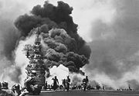

*A sister ship to the USS Henrico, the* [*USS Bunker Hill*](/wiki/USS_Bunker_Hill_(CV-17))



*burns after being hit by two* [*kamikaze*](/wiki/Kamikaze) *within 30 seconds.*

On April 14, 1945, after completing temporary repairs, the USS Henrico got underway for the United States. Upon arrival at San Francisco on May 13, 1945, the ship entered the Bethlehem Shipyard for extensive repairs of her battle damage.

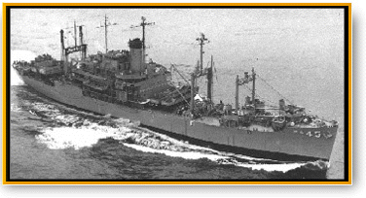

*Attack Transport 45, USS Henrico during operations in the Pacific*

Thomas Lewis would muster out of the United States Navy on February 25, 1946. Thomas would rarely talk about his wartime combat service and the events at the battle for Okinawa. Many in his own family would never even be aware of his heroism. However, official Naval records underscore his dedication and bravery to his country.

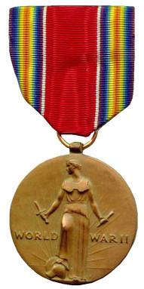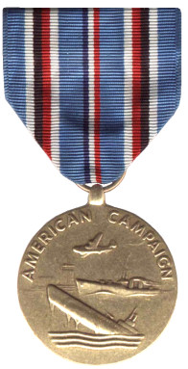

*Victory Medal American Area Campaign Medal*

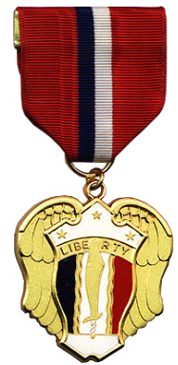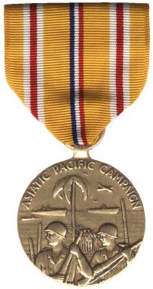

*Philippine Liberation Medal Asiatic-Pacific Medal with Bronze Star*

*for Bravery & Heroism*

In 2010, the United States Postal Service recognized the achievements and bravery of African-American sailors during World War II with the issuance of a stamp of seaman Doris Miller. Holder of the Navy Cross for outstanding bravery at Pearl Harbor, Hawaii, Ship's Cook Third Class Doris (Dorie) Miller was one of the earliest American heroes of World War II. Although at the time the U.S. entered World War II, the Navy did not offer African Americans opportunities to rise above the menial labor of the mess hall, Miller took advantage of the chance fate gave him to distinguish himself in battle.

When the Japanese attacked Pearl Harbor, Miller manned a machine gun on the deck despite never having trained on it. He shot down several Jap planes, leaving only when the ship itself began to sink. He would later tour the United States helping to sell war bonds, but returned to duty in the Pacific. Two years after his heroism at Pearl Harbor, Miller lost his life aboard the USS *Liscome Bay* in the Gilbert Islands in November of 1944.

The story of Thomas V. Lewis is almost a mirror image of the young sailor portrayed on the stamp commemorating the World War II African American sailors.

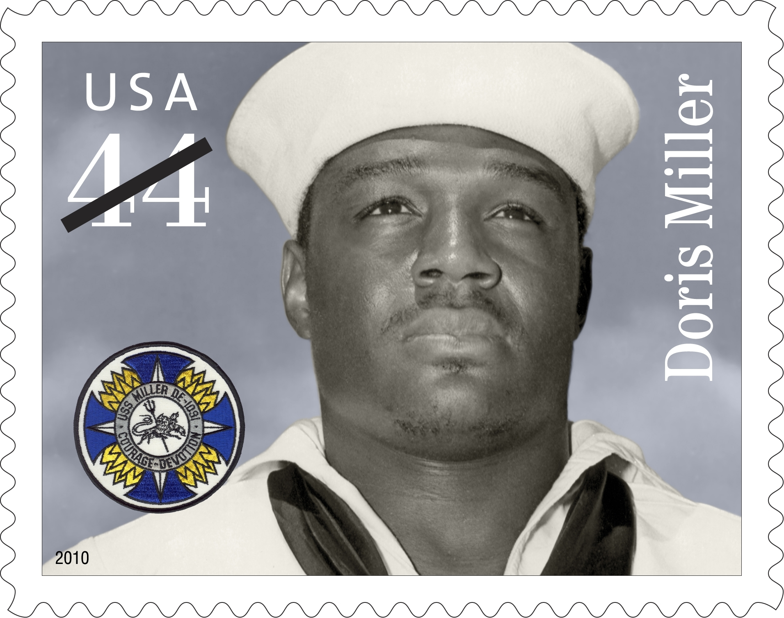

*United States commemorative stamp issued in 2010, honoring the*

*heroism and bravery of African-American sailors during World War II.*

In the years after risking his life for his country, Thomas Lewis would quietly go about his business. Working for many years in Chicago and northern Illinois, he would eventually move to a rural setting near Rochester, Indiana. He passed away in November of 2003 at the age of 78, gone, but not forgotten by his wife Carol, his children, his family and his

friends.

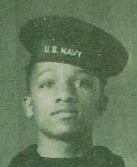

*Thomas V. Lewis*

*United States Navy*